xCelerator Adobe PDF Forms xTractor Installation and User Guide
Version 1.0

Preface

Purpose
This document provides step-by-step instructions on how to install and configure the xCP xCelerator Adobe PDF Form xTractor.

Intended audience
The information in this guide is intended for Adobe PDF Form xTractor. The objective of this xCelerator is to provide Property lookup.

Support information
The xCP PDF Form xTractor xCelerator is not supported by EMC.

Related documentation
The EMC Documentum xCelerator home page (https://community.emc.com/docs/DOC-9863) provides access to xCP xCelerators.

Revision history
Date | Version | Author | Change
20110302 | 1.0 | noktay | Created
20121031 | 2.0 | J Chadet / Aerow | Migration to xcp 2.0

Contents
Preface 2
Purpose 2
Intended audience 2
Support information 2
Related documentation 2
Revision history 2
Contents 3
Overview 4
What is an xCelerator? 4
Adobe xCP PDF Form xTractor xCelerator 4
Bill of Materials 5
Installing xCP Adobe PDF Form xTractor xCelerator 6
Prerequisites 6
Install the PDF Form xTractor xCelerator file 6
Using the PDF Form xTractor xCelerator 8
How it works 8
How to Use Adobe PDF Form xTractor in Your Process 8
Overview of the provided methods 9
Form Creation 10
Screen Shots 11

Overview

What is an xCelerator?
An xCelerator is one or more artifacts that can be used to accelerate the creation, adoption, and/or implementation of an EMC Documentum xCelerated Composition Platform (xCP) solution. An xCelerator is not necessarily a running application; instead, it is intended to hasten application development by providing key pieces of functionality out-of-the-box. Examples of this include:
- A sample business process flow created by Process Builder
- A sample high fidelity form using Forms Builder
- A sample Business Activity Monitor (BAM) dashboard
- A sample bit of code or configuration that connects the workflow with a third-party product
- Documentation that focuses on best practices and troubleshooting when developing and implementing an xCP solution
- A sample application
xCelerators are:
- Technology focused and can be samples, examples, starting points, or guides that accelerate the creation of an xCP solution
- Free and are not EMC-supported products, yet they do go through a formal release cycle, including quality assurance and documentation
- EMC intellectual property
- Sharable with multiple partners or anyone who wants to download them from the xCP community site

Adobe xCP PDF Form xTractor xCelerator
PDF Forms are the de facto standard for offline forms. Virtually every commercial entity as well as public sector agency uses Adobe PDF Forms for online and offline data collection. This xCelerator allows you to re-use existing PDF forms within an xCP process. More importantly, the data from the forms is extracted and intelligent routing decisions can be made. Essentially, the PDF form is no longer just another content file in the repository. With this xCelerator, you can make your PDF forms intelligent without having to write any custom code.

The particular demo shipped with this xCelerator allows the user to fill out the PDF form on the desktop, and submit the form by HTTP by clicking on the Submit button. The data is extracted from the form and a case folder is created. The form gets sent to a reviewer who can make edits to the form. Once the activity completes, the data is synced again before going on to the next reviewer in the process.
.

Bill of Materials
The previous version of xCP Adobe PDF Form xTractor xCelerator is accessible through the Community xCelerator xChange home page (https://community.emc.com/docs/DOC-10001) by selecting the xCP Adobe PDF Form xTractor xCelerator download link.
The Adobe PDF Form xTractor contains:
Artifact | Path / File Name
Overview guide (this document) | xCelerator_PDF_Form_xTractor.pdf
Installation files | Package/xcp2_PDFFormxTractor.jar
Source code | Source code

Installing xCP Adobe PDF Form xTractor xCelerator

Prerequisites
XCP Designer 2.0 must be installed

Install the PDF Form xTractor xCelerator file
Download the xcp2_PDFFormxTractor_xcelerator.zip file which is accessible through the EMC Documentum xCelerator community home page (https://community.emc.com/docs/DOC-10586) by selecting the PDF Form xTractor xCelerator link.
Unzip the xcp2_PDF Form xTractor_xcelerator.zip file and locate the xcp2_PDF Form xTractor.jar at following path : <Install folder>/ xcp2_PDFFormxTractor_xcelerator.zip /Package/xcp2_PDFFormxTractor.jar
Open your application in xCPDesigner and select “Model” in the “Application” tab:
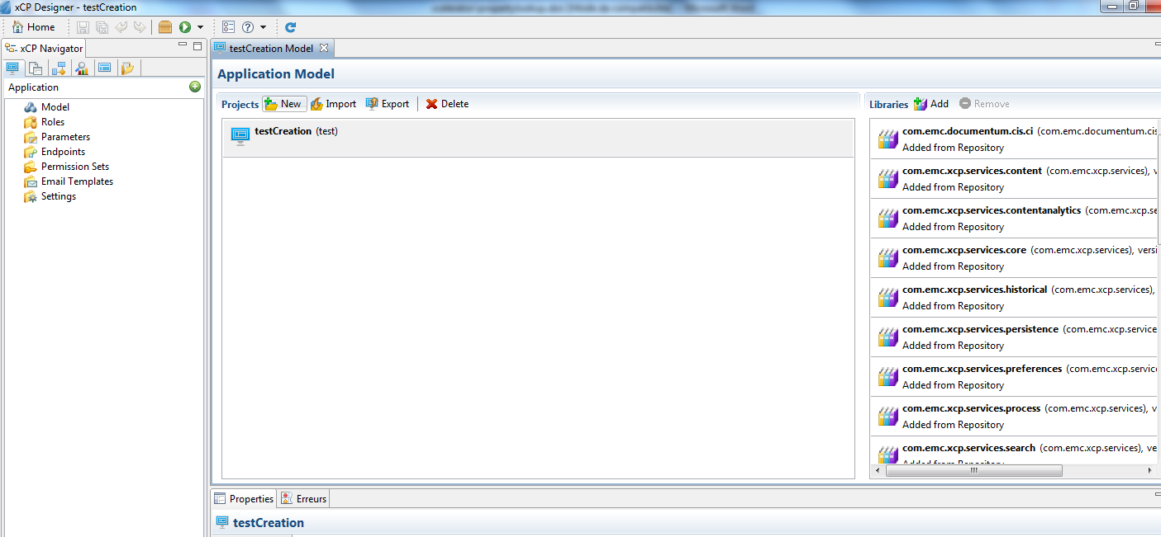

In the Libraries part, click on the button “Add”. A pop-up will open. Click on the “Browse” button and navigate to the folder <Install folder>/xcp2_PDFFormxTractor_xcelerator/Package and select PDF Form xTractor in “Libraries to copy”. Click on Next button.

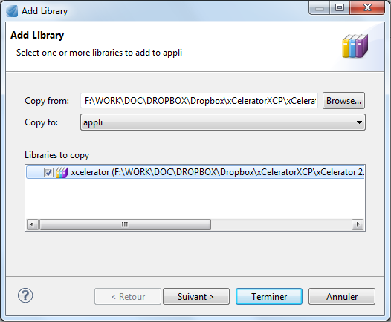

Check if the name and the namespace are well filled and click on Finish button.
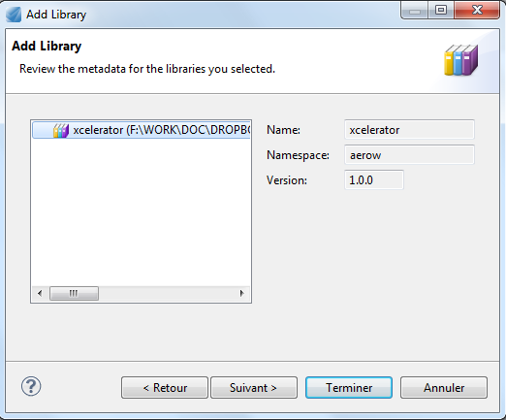

Using the PDF Form xTractor xCelerator

How it works

The Extract PDF Form Fields activity template does a one-way sync of the form data onto the object in the repository. The activity can be used multiple times within a process. The java extension module performs the following operations:
- Extracts the XML file from the PDF binary and add as a rendition to the object.
- Parses the XML and loops through each element to find a matching attribute on the repository object type
- Once a match is found, a determination of the repository data type is made (String, Integer, Double, Time, Boolean), and the value is converted to the target data type

How to Use Adobe PDF Form xTractor in Your Process
Using the Adobe PDF Form xTractor methods in your process is an easy 4 step process.
Add an Execute Java Service Activity Template to your process. In the Execute Java Service Configuration tab, choose the PDF Form xTractor as the Java Module.
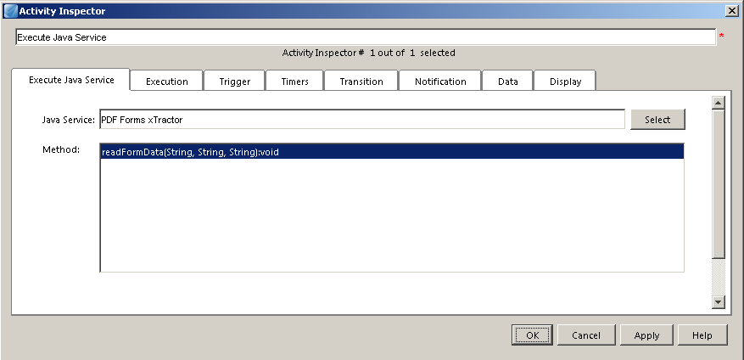

Select the method readFormData (refer to the next chapter for an overview of the method and the input argument).
Map your process data into the functions.

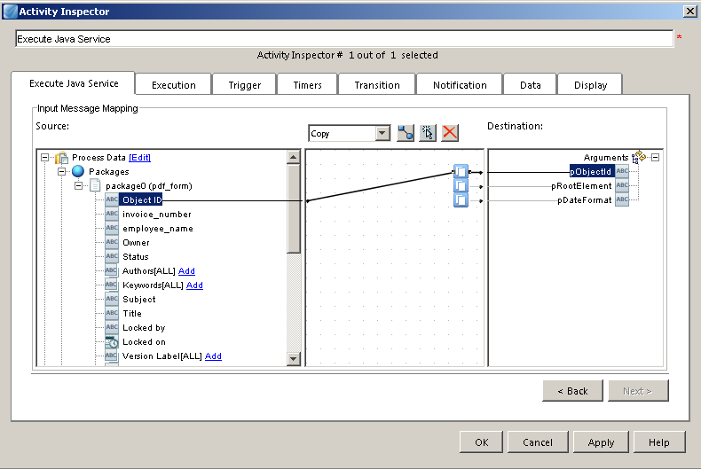

Overview of the provided methods
There is one method that can be used by the Adobe PDF Form xTractor xCelerator.
Read Form Data

void readFormData(String pObjectId, String pRootElement, String pDateFormat)

Extract the pdf forms fields and create a XML rendition.
There are 3 parameters that need to be supplied:
- pObjectId : The r_object_id of the document package.
- pRootElement : The root element of your XML schema.
- pDateFormat : The date format that matches the date format you have defined in your form. This allows for flexibility across different locales.

Form Creation
The xCelerator allows for the re-use of existing Adobe PDF form templates. The creation of Adobe PDF forms are out-of-scope for this xCelerator. Detailed instructions on creating forms can be found on this page, https://community.emc.com/docs/DOC-9300.
The underlying XML must follow the same structure below. You can have as many object types listed that are part of the object’s hierarchy so that you can use those attributes. As mentioned above, the xCelerator assumes that the XML elements match the name of the custom attributes.
This is the same structure you will get if you followed the instructions in the link above.
<pdf_contact_info_form>
<dm_sysobject>
<object_name>….</object_name>
</dm_sysobject>
<contact_info_form>
<employee_name>…..</employee_name>
<employee_address>…</employee_address>
<employee_phone>……</employee_phone>
</contact_info_form>
</pdf_contact_info_form>

Screen Shots

User submits form directly from desktop

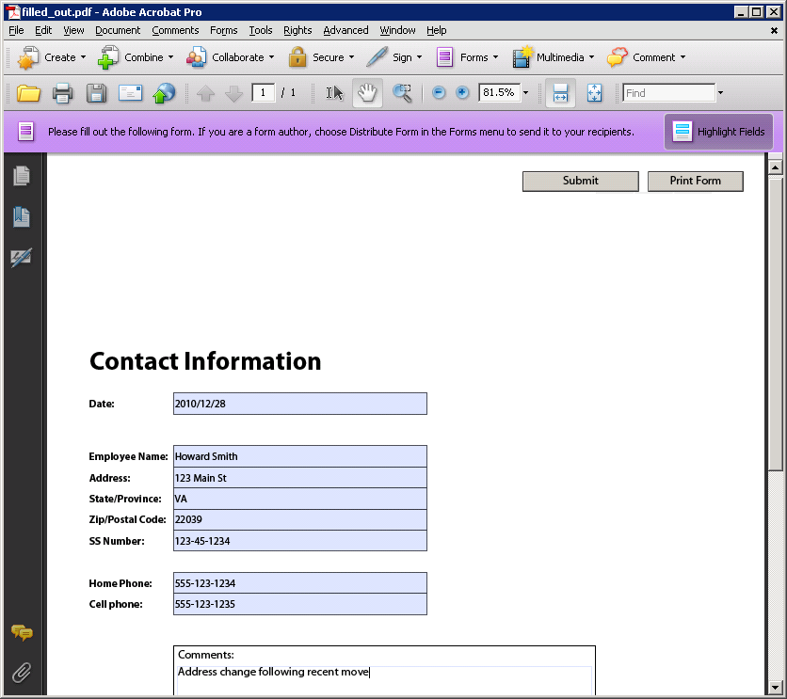

Object type properties
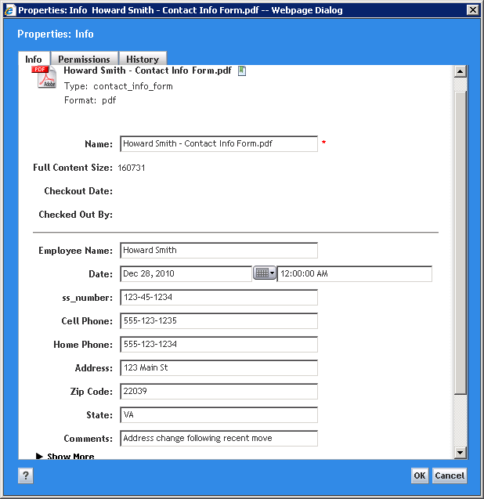

XML rendition
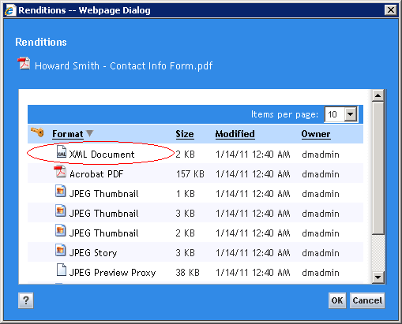
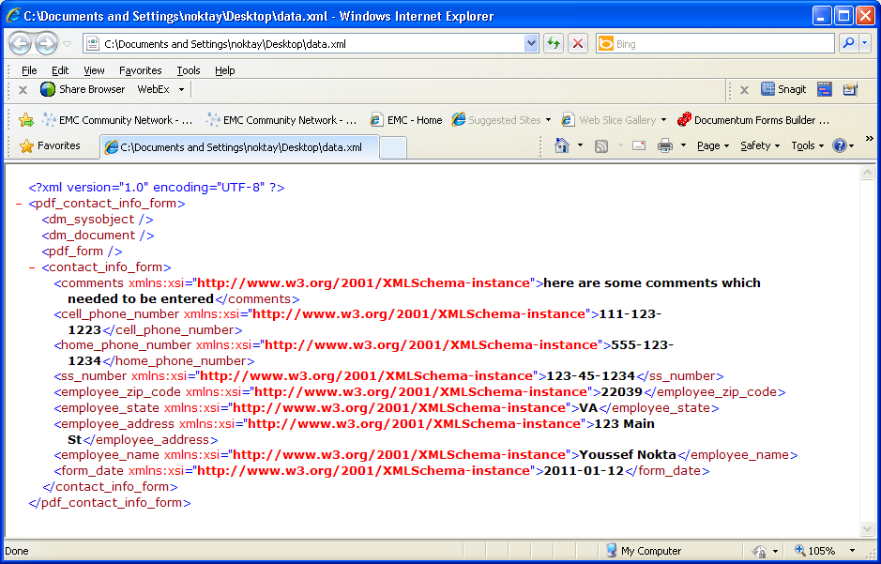

Another Sample Form (W-4 form - includes digital signature field)
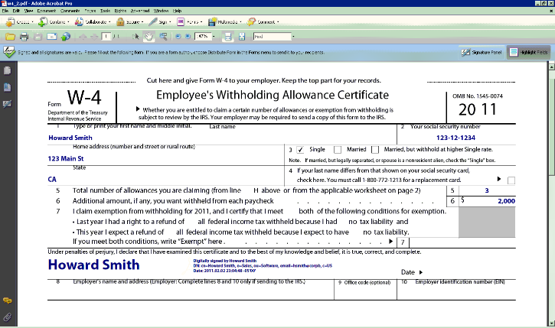

W-4 Form XML rendition
