**CS321 Project Proposal (Group 8)**

*Meeting Scheduler*

**TEAM MEMBERS**

Bailey J. Knight, Christopher Fechter, Eric M. Sung, Kyungjae Lee

**MOTIVATION**

College students often have busy schedules, which more often than not, have little flexibility when it comes to coordinating more events within them. This applies heavily to group projects that arise spontaneously from new classes each semester. It would be nice to have a method of inputting all of the members’ schedules of a particular group into some program, which can take those and convert them into one unified schedule that shows the available times of everyone without much hassle. This is what we’re building our software for.

**OBJECTIVE**

The program we are developing will be able to take a group’s schedules, and if time permits, maybe even more students, so that it can output all of the free time for a specific set of students, helping them collaborate easier. Initially for our real-world data set, the plan is to use our personal weekly college schedules from the members of our group, and if necessary, we can ask other students to provide their own schedules to add to the pool of options.

**CONCEPT**

This program is expected to read in the schedules of students from an XML file, in which the file specifies the times of the week where the students may be busy for any reason. Once the data has been read, the program will generate a one-week schedule with 7 blocks of information, for each of the 7 days of the week. Every block will have the time presented from the hours 8 am to 10 pm. The time slots for each day where all students are available will be highlighted in a specific color like blue, outlining when all members are free. This could potentially also show the second-best time slots of the day too, which might be represented in a different color, such as red. Besides this display, the GUI might also allow for filtering group members, to exclude or include specific people, or to see someone’s individual availability.

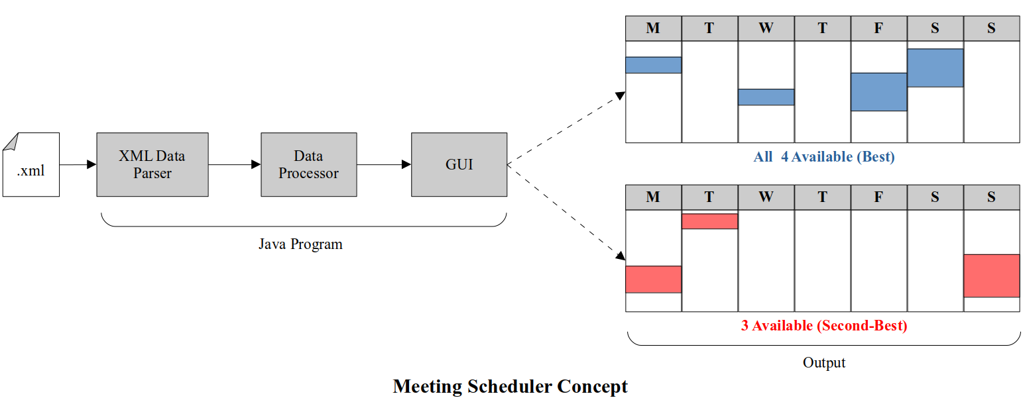

**MEETING THE CRITERIA (REQUIREMENTS)**

As for meeting the criteria for the required components of the project, our program’s model-view-control will utilize the information placed in the objects created for the students and display it in a generated table, depending on the specified filters that a user might change in the program. The set of options for a user to interact with will be displayed to the right of the table. Whenever a user changes a filter, such as disabling a group member or toggling the usage of second-best time slots, the table view will update to show the correct schedule. This part is considered the GUI as the user can interact with these specific controllers to alter the view presented on the table. For the data model, each student will be considered as an object that holds information for their name and each of the days of the week’s individual schedules of availability. The data will be loaded into the model from the XML file previously mentioned. The GUI will add the new data and display the schedule based on the toggled filters. The XML file is the data source we’re using. The results of the program will allow different displays of the schedule with filters, potentially second-best alternatives for 3 groups members, checking to see if a certain time frame is available, like Monday from 1pm-2pm, and the best times for meetings that recur throughout the week.