Hibernate is one of the most widely used Java ORM tool. Most of the applications use relational databases to store application information and at the low level we use JDBC API for connecting to databases and perform CRUD operations.

Hibernate is an Object Relational Mapping (ORM) framework for Java, which simplifies database operations by mapping Java classes to database tables. It eliminates the need for manual JDBC code, providing cleaner and more maintainable applications.
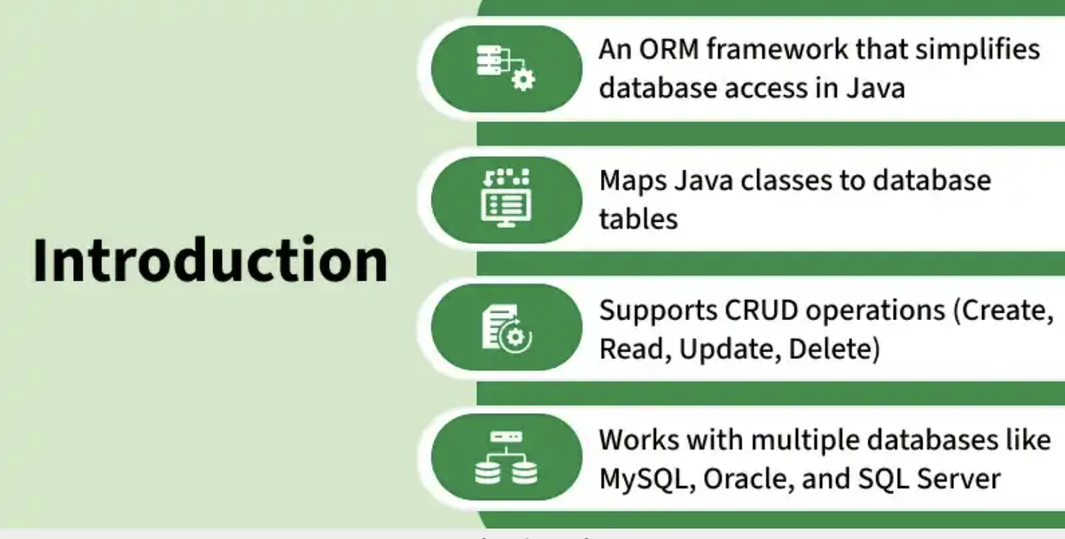

Key features of Hibernate
- ORM Support: Maps Java objects to database tables, reducing boilerplate JDBC code.
- Database Independence: Works with multiple databases using SQL dialects.
- HQL (Hibernate Query Language): Provides database-independent, object-oriented querying.
- Caching Mechanism: Improves performance with first-level and second-level caching.

Hibernate Basics
Covers the foundation of Hibernate, including its architecture, lifecycle and key comparisons like JDBC vs Hibernate, JPA vs Hibernate and ORM vs JDBC
Introduction to Hibernate Framework

Hibernate is an open-source Object Relational Mapping (ORM) framework for Java. It simplifies database connection by mapping Java classes (objects) to database tables and Java data types to SQL data types. Instead of writing long SQL queries, developers can use Hibernate APIs or HQL (Hibernate Query Language) to perform CRUD operations.
- Maps Java objects to database tables, reducing the need for manual SQL.
- Supports CRUD operations through Hibernate APIs or HQL.
- Handles database connections, caching, and transaction management automatically.
- Hibernate acts as a bridge between Java objects and relational databases.
Why Use Hibernate?
When working with JDBC, several challenges often arise:
- Database Portability Issues: Changing the database in the middle of a project is costly because JDBC code is not portable across different database systems.
- Mandatory Exception Handling: JDBC requires explicit handling of exceptions for every database operation, which increases code complexity.
- Lack of Object-Level Relationships: JDBC works at the table level, so there is no direct support for managing object relationships.
- Boilerplate Code: For every project, repetitive code is needed for tasks like establishing connections, executing queries and handling results. This increases code length and reduces readability.
To overcome the above problems we use ORM tool i.e. nothing but Hibernate framework. By using Hibernate we can avoid all the above problems and we can enjoy some additional set of functionalities.
- ORM (Object-Relational Mapping): Maps Java classes to database tables and Java objects to rows, enabling object-oriented database interaction.
- Database Independence: Hibernate applications can run on multiple databases with minimal changes, providing portability.
- HQL (Hibernate Query Language): Supports database-independent, object-oriented queries for fetching and manipulating data.
- Transaction Management: Integrates with JDBC or JTA to provide reliable and consistent transaction handling.
- Caching: Improves performance with first-level (session) and optional second-level caching across sessions.
- Relationship Mapping: Supports mapping of object relationships like one-to-one, one-to-many, many-to-one and many-to-many.
Hibernate Architecture
The architecture of Hibernate is layered and consists of several key components working together.
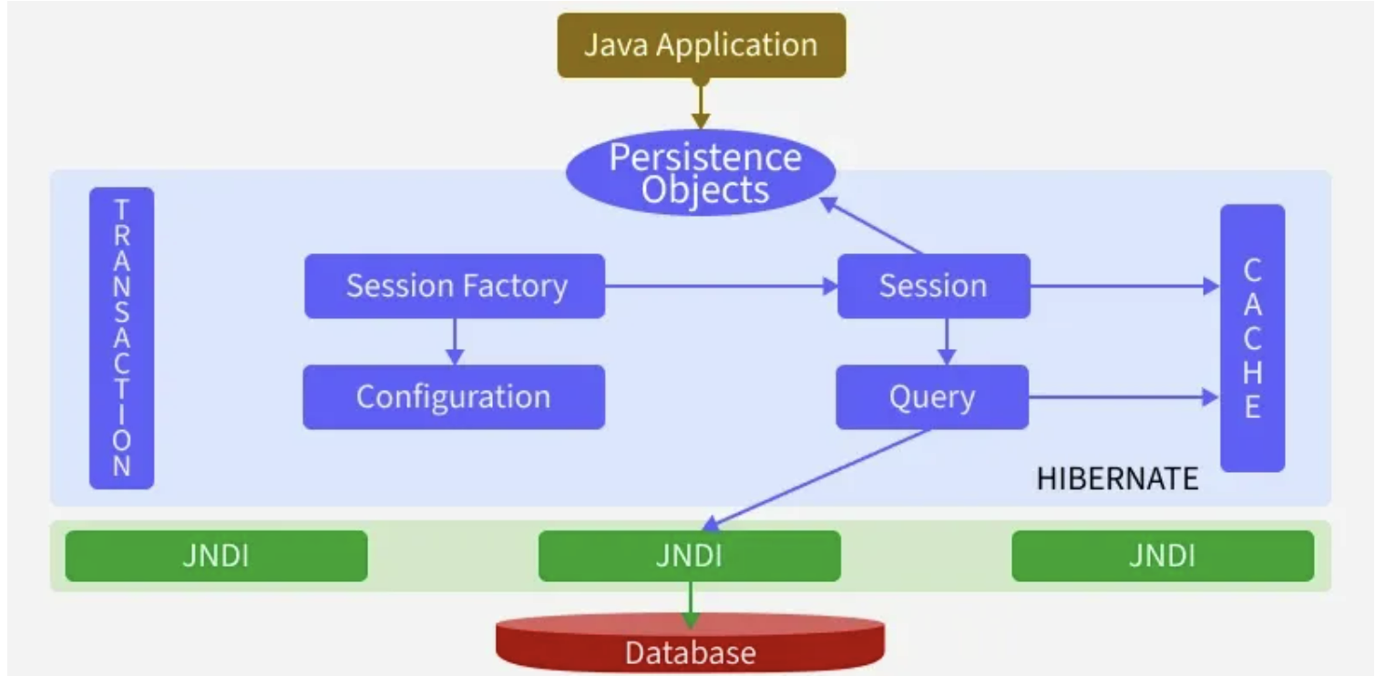
Architecture
Hibernate Workflow
1. Application loads configuration (hibernate.cfg.xml).
2. Hibernate builds a SessionFactory.
3. Application requests a Session from SessionFactory.
4. Inside a Session:
- Begin Transaction
- Perform CRUD operations
- Commit or Rollback transaction
5. Hibernate translates operations -> SQL-> executes via JDBC.
6. Results are returned as Java objects
Key Components of Hibernate Architecture
1. Configuration
Configuration is a class which is present in org.hibernate.cfg package. It activates Hibernate framework. It reads both configuration file and mapping files.
- Activates Hibernate framework.
- Reads configuration (hibernate.cfg.xml) and mapping files.
- Throws an exception if the configuration is invalid.
- Creates in-memory metadata representing the configuration.
Configuration cfg = new Configuration();
cfg.configure(); // Reads and validates hibernate.cfg.xml
2. SessionFactory
The SessionFactory interface creates Session objects and maintains a second-level cache. It is heavyweight and thread-safe, so usually one per application.
- Factory for Session objects.
- Thread-safe and heavy-weight.
- One per database is sufficient.
SessionFactory factory = cfg.buildSessionFactory();
3. Session
The Session interface interacts with the database and provides CRUD operations. It maintains a first-level cache (session-level).
Session session = factory.openSession();
4. Transaction
The Transaction interface handles atomic database operations, ensuring data integrity through commit or rollback.
Transaction tx = session.beginTransaction();
tx.commit(); // or tx.rollback();
5. Query
The Query interface executes HQL, Criteria API or native SQL queries to fetch or manipulate data.
Query<Student> query = session.createQuery("from Student");
List<Student> students = query.list();
6. Persistent Classes (Entities)
Java classes annotated with @Entity represent database tables. Each object maps to a row.
- Represents database tables.
- Mapped via annotations or XML.
- Enables object-oriented access to data.
@Entity
class Student {
@Id
private Long id;
private String name;
}
7. Mapping
Defines the relationship between Java classes and database tables. Can be done via annotations or XML files.
- Maps classes to tables and fields to columns.
- Supports relationships: One-to-One, One-to-Many, Many-to-One, Many-to-Many.
@Entity
@Table(name="student")
class Student { ... }
8. JDBC Layer
Handles low-level database communication. Hibernate internally uses JDBC to execute SQL and retrieve results.
- Connects to database using JDBC API.
- Executes SQL queries generated by Hibernate.
- Manages connection pooling and result fetching.
Step-by-Step Implementation of Hibernate Setup
Step 1 Create a Hibernate Project
- Open IntelliJ IDEA ->New Project-> Maven.
- Set GroupId ->com.example
- Set ArtifactId-> HibernateDemo.
- Select JDK 17+.
- Finish
Project Structure:
Structure
Step 2: Add Dependencies
<project xmlns="http://maven.apache.org/POM/4.0.0"
xmlns:xsi="http://www.w3.org/2001/XMLSchema-instance"
xsi:schemaLocation="http://maven.apache.org/POM/4.0.0
http://maven.apache.org/maven-v4_0_0.xsd">

<modelVersion>4.0.0</modelVersion>

<groupId>com.example</groupId>
<artifactId>HibernateDemo</artifactId>
<version>1.0-SNAPSHOT</version>
<packaging>jar</packaging>

<name>HibernateDemo</name>

<properties>
<project.build.sourceEncoding>UTF-8</project.build.sourceEncoding>
<maven.compiler.source>17</maven.compiler.source>
<maven.compiler.target>17</maven.compiler.target>
</properties>

<dependencies>
<!-- Hibernate Core -->
<dependency>
<groupId>org.hibernate.orm</groupId>
<artifactId>hibernate-core</artifactId>
<version>6.2.7.Final</version>
</dependency>

<!-- JPA API -->
<dependency>
<groupId>jakarta.persistence</groupId>
<artifactId>jakarta.persistence-api</artifactId>
<version>3.1.0</version>
</dependency>

<!-- MySQL Connector/J -->
<dependency>
<groupId>com.mysql</groupId>
<artifactId>mysql-connector-j</artifactId>
<version>8.0.33</version>
</dependency>

<!-- Optional: Logging (Hibernate requires slf4j) -->
<dependency>
<groupId>org.slf4j</groupId>
<artifactId>slf4j-api</artifactId>
<version>2.0.9</version>
</dependency>
<dependency>
<groupId>org.slf4j</groupId>
<artifactId>slf4j-simple</artifactId>
<version>2.0.9</version>
</dependency>
</dependencies>

<build>
<plugins>
<!-- Maven Compiler Plugin -->
<plugin>
<groupId>org.apache.maven.plugins</groupId>
<artifactId>maven-compiler-plugin</artifactId>
<version>3.11.0</version>
<configuration>
<source>17</source>
<target>17</target>
</configuration>
</plugin>
</plugins>
</build>

</project>
Step 3: Add Hibernate Configuration File
- Go to src/main/resources.
- Create hibernate.cfg.xml:
<!DOCTYPE hibernate-configuration PUBLIC
"-//Hibernate/Hibernate Configuration DTD 3.0//EN"
"http://hibernate.sourceforge.net/hibernate-configuration-3.0.dtd">
​
<hibernate-configuration>
<session-factory>
<property name="hibernate.connection.driver_class">com.mysql.cj.jdbc.Driver</property>
<property name="hibernate.connection.url">jdbc:mysql://localhost:3306/hibernate_db</property>
<property name="hibernate.connection.username">root</property>
<property name="hibernate.connection.password">password</property>
​
<property name="hibernate.dialect">org.hibernate.dialect.MySQL8Dialect</property>
<property name="hibernate.show_sql">true</property>
<property name="hibernate.hbm2ddl.auto">update</property>
​
<!-- Entities mapping will be added later -->
<!-- <mapping class="com.example.Student"/> -->
</session-factory>
</hibernate-configuration>
Step 4: Test Hibernate Setup
Open main class and run the application
import org.hibernate.SessionFactory;
import org.hibernate.cfg.Configuration;

public class HibernateSetupTest {
public static void main(String[] args) {
try {
SessionFactory sessionFactory = new Configuration().configure().buildSessionFactory();
System.out.println("Hibernate setup successful!");
} catch (Exception e) {
e.printStackTrace();
}
}
}
If you see the message Hibernate setup successful! in the console, your Hibernate database connection is correctly configured and ready to use.
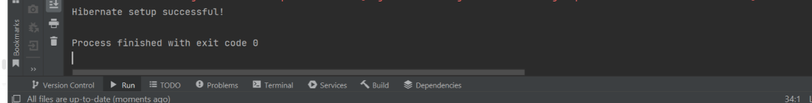

Hibernate Architecture

Hibernate is a framework which is used to develop persistence logic which is independent of Database software. In JDBC to develop persistence logic we deal with primitive types. Whereas Hibernate framework we use Objects to develop persistence logic which are independent of database software.
- Provides database-independent persistence by mapping Java objects to database tables.
- Uses layers like SessionFactory, Session, and JDBC to manage CRUD operations efficiently.
Hibernate Internal Architecture
Hibernate Architecture Shows how Java objects interact with the database through Hibernate layers and APIs.
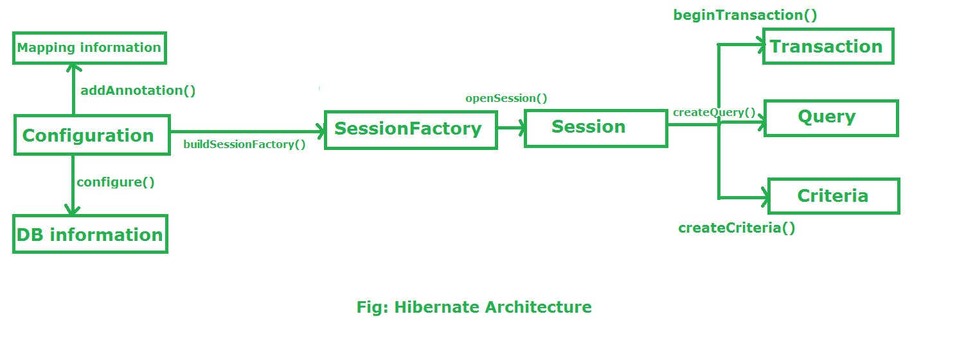
Configuration
- Configuration is a class which is present in org.hibernate.cfg package. It activates Hibernate framework. It reads both configuration file and mapping files.
- It checks whether the config file is syntactically correct or not.
- If the config file is not valid then it will throw an exception. If it is valid then it creates a meta-data in memory and returns the meta-data to object to represent the config file.
It activate Hibernate Framework Configuration cfg=new Configuration();
it read both cfg file and mapping files cfg.configure();
SessionFactory
- SessionFactory is an Interface which is present in org.hibernate package and it is used to create Session Object.
- It is immutable and thread-safe in nature.
buildSessionFactory() method gathers the meta-data which is in the cfg Object.
From cfg object it takes the JDBC information and create a JDBC Connection.
SessionFactory factory=cfg.buildSessionFactory();
Session
- Session is an interface which is present in org.hibernate package. Session object is created based upon SessionFactory object i.e. factory.
- It opens the Connection/Session with Database software through Hibernate Framework.
- It is a light-weight object and it is not thread-safe.
- Session object is used to perform CRUD operations.
Session session = factory.openSession();
openSession(): is a method provided by the SessionFactory that creates and returns a new Session instance. This session is not bound to any transaction or context and is independent of any ongoing transactions in the application.
getCurrentSession: it returns a Session bound to the current context, which is usually managed by a transaction manager or a framework like Spring.
Session session = sessionFactory.getCurrentSession();
Transaction
- Transaction object is used whenever we perform any operation and based upon that operation there is some change in database.
- Transaction object is used to give the instruction to the database to make the changes that happen because of operation as a permanent by using commit() method.
Transaction tx=session.beginTransaction();t
x.commit();
Query
- Query is an interface in the org.hibernate package used to execute HQL queries.
- It is created using the Session.createQuery() method to interact with the database.
- It supports advanced features like pagination (setMaxResults(), setFirstResult()) and named parameters for better query handling.
Criteria
- Criteria is a simplified API for retrieving entities by composing Criterion objects.
- The Session is a factory for Criteria. Criterion instances are usually obtained via the factory methods on Restrictions.
Flow of working during operation in Hibernate Framework
The below image showing how the hibernate application internally works:
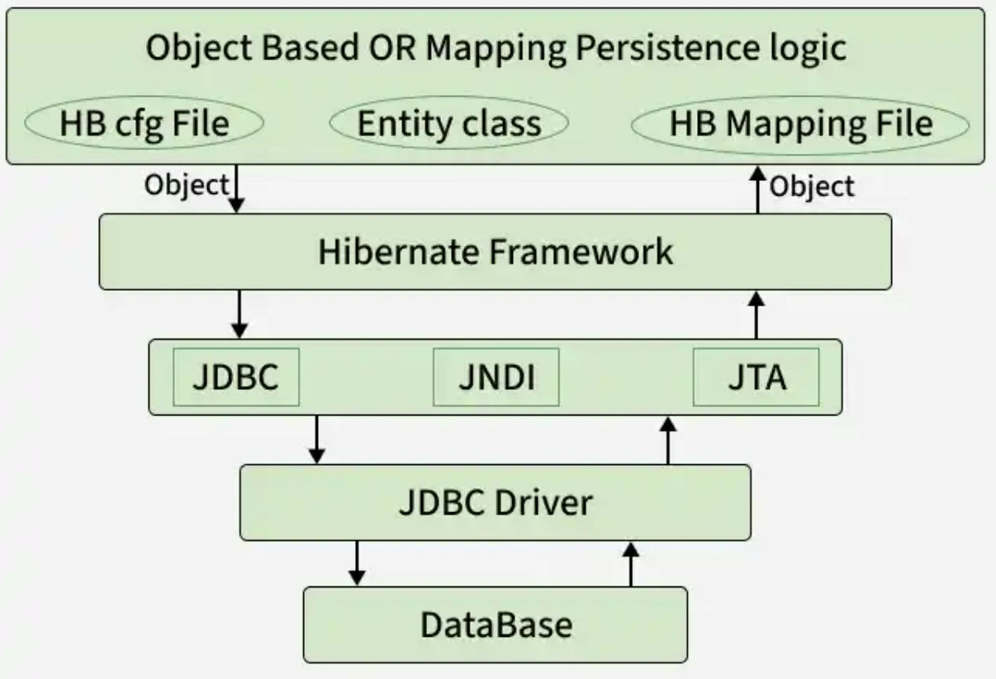
Hibernate flow of working
Stage I: Transient State
- Create a Java object using new keyword.
- Not associated with Hibernate or database yet.
Stage II: Persistent State
- Object is associated with a Hibernate Session using save() or persist().
- Any changes are automatically tracked and synchronized with the database.
Stage III: Detached State
- Session is closed or object is evicted.
- Object exists in memory but is no longer tracked by Hibernate.
- Can be reattached using update() or merge().
Stage IV: Removed State
- Object is marked for deletion using delete().
- Removal happens when the transaction is committed to the database.
Stage V: Data Flow to Database
- Hibernate interacts with JDBC to execute the CRUD operation.
- For retrieval, database results are mapped back to Java objects.

Hibernate Lifecycle
In Hibernate, every entity object passes through a set of well-defined states from creation to deletion. This progression is known as the Hibernate Object Lifecycle. Understanding these states is essential to manage persistence operations effectively.
Hibernate defines four primary states in an entity lifecycle:
- Transient State
- Persistent State
- Detached State
- Removed State
Hibernate Lifecycle Diagram
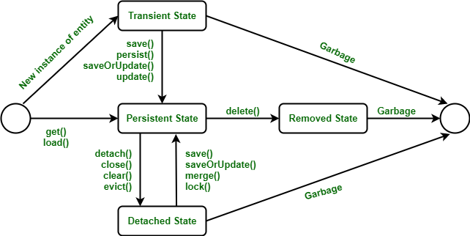Hibernate Lifecycle
1. Transient State
- When an entity object is created using the new operator, it starts in the transient state.
- It is not associated with any Hibernate session and not stored in the database.
- Any modification to this object does not affect the database since Hibernate does not track it yet.
Changing new object to Transient State
Example:
Employee e = new Employee();
e.setId(21);
e.setFirstName("Neha");
e.setMiddleName("Shri");
e.setLastName("Rudra");
Here, the Employee object exists only in heap memory and has no database connection.
Key Points:
- Created using new.
- Not associated with Hibernate Session.
- No corresponding database row.
State 2: Persistent State
- When a transient object becomes associated with a Hibernate session, it moves into the persistent state.
- Hibernate starts tracking changes to the object. Any modification to fields automatically updates the corresponding database record during transaction commit.
Transition from Transient → Persistent: Occurs when you call any of these methods:
- session.save(e)
- session.persist(e)
- session.saveOrUpdate(e)
- session.update(e)
- session.merge(e)
- session.lock(e)
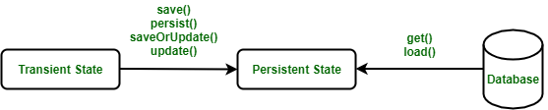Converting Transient State to Persistent State
Example:
Employee e = new Employee("Neha Shri Rudra", 21, 180103);
session.save(e); // The object is now persistent
- Associated with an open Hibernate Session.
- Represents a database row.
- Changes are synchronized with the database.
State 3: Detached State
- When a persistent object’s session is closed or cleared, it enters the detached state.
- The object still exists in memory but is no longer managed by Hibernate.
- Any modification made to it will not be reflected in the database unless reattached.
Transition from Persistent → Detached: Occurs when you call any of these methods:
- session.close()
- session.clear()
- session.detach(e)
- session.evict(e)
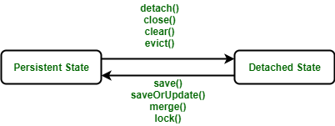Converting Persistent State to Detached State
Example:
Employee e = new Employee("Neha Shri Rudra", 21, 180103);
session.save(e);
session.close(); // The object is now detached
To reattach a detached object:
- session.update(e)
- session.merge(e)
- session.refresh(e)
- session.load(e)
Key Points:
- Session closed or cleared.
- No synchronization with the database.
- Can be reattached later.
4. Removed State
- The removed state represents a deleted entity.
- When a persistent object is deleted using session.delete(), it is removed from both the session and the database.
- Any further changes to the object will not affect the database.
Converting Persistent State to Removed State
Example:
Employee e = new Employee();
Session s = sessionFactory.openSession();
s.save(e);
s.delete(e); // The object is now removed
- Object is deleted from the database.
- No longer tracked by Hibernate.
- Further changes have no effect.

