Spring MVC Tutorial
Spring MVC is a Java framework that follows the Model-View-Controller (MVC) pattern for developing web applications. It separates data (Model), business logic (Controller) and presentation (View) for cleaner, maintainable code.
- Built around a DispatcherServlet that handles and routes incoming requests.
- Provides clean, modular and maintainable code for web application development.

1. Introduction to Spring MVC
Spring MVC is a framework within the Spring ecosystem used for building web applications. It follows the Model-View-Controller design pattern to separate concerns.
Spring MVC follows the Model-View-Controller pattern centered around the Front Controller, DispatcherServlet, which routes all HTTP requests to the appropriate controller. The @Controller annotation marks a class as a controller, and @RequestMapping maps web requests to specific controller methods.
The terms model, view, and controller are defined as follows:
- Model: The Model encapsulates the application data.
- View: The View renders the model data and generates HTML output that the client's browser can interpret.
- Controller: The Controller processes the user requests and passes them to the view for rendering.
Dispatcher Servlet
The DispatcherServlet is the central component of Spring MVC:
- Acts as the Front Controller for all HTTP requests.
- Determines the appropriate controller to handle a request.
- Dispatches the request to the selected controller.
- Resolves the view using the View Resolver and renders the response.
Spring MVC Flow Diagram
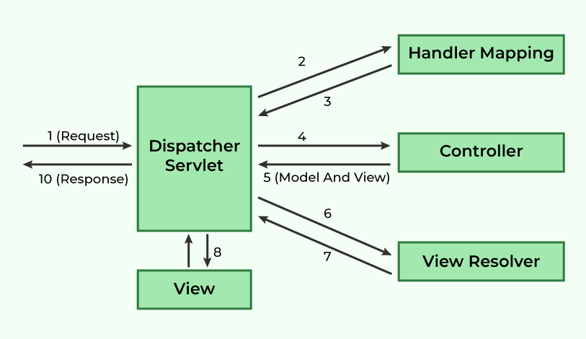
- DispatcherServlet intercepts incoming requests.
- Retrieves the handler mapping and forwards the request to the controller.
- The controller processes the request and returns a ModelAndView object.
- DispatcherServlet uses the view resolver to render the appropriate view.
Steps to Create a Spring MVC Application
Step 0: Set Up the Project
Create a Maven-based Spring MVC project. Ensure the required folder structure and server configuration are in place.
Step 1: Add dependencies in pom.xml
Include the following dependencies
pom.xml:
<dependencies>
<!-- Spring Web MVC -->
<dependency>
<groupId>org.springframework</groupId>
<artifactId>spring-webmvc</artifactId>
<version>5.3.30</version>
</dependency>

<!-- Jakarta Servlet API -->
<dependency>
<groupId>jakarta.servlet</groupId>
<artifactId>jakarta.servlet-api</artifactId>
<version>5.0.0</version>
<scope>provided</scope>
</dependency>
</dependencies>
Step 2: Define the Controller
Create a controller class to handle requests.
HelloGeek.java:
@Controller
public class HelloGeek {

@RequestMapping("/")
public String display(Model model) {
model.addAttribute("message", "Spring MVC Tutorial!!");
return "index";
}
}
Step 3: Configure web.xml
Specify the DispatcherServlet in the web.xml file:
web.xml:
<web-app xmlns="http://xmlns.jcp.org/xml/ns/javaee"
xmlns:xsi="http://www.w3.org/2001/XMLSchema-instance"
xsi:schemaLocation="http://xmlns.jcp.org/xml/ns/javaee
http://xmlns.jcp.org/xml/ns/javaee/web-app_3_0.xsd"
version="3.0">

<display-name>SpringMVC</display-name>

<servlet>
<servlet-name>spring</servlet-name>
<servlet-class>org.springframework.web.servlet.DispatcherServlet</servlet-class>
<load-on-startup>1</load-on-startup>
</servlet>

<servlet-mapping>
<servlet-name>spring</servlet-name>
<url-pattern>/</url-pattern>
</servlet-mapping>

</web-app>
Step 4: Define Bean Configuration (spring-servlet.xml)
Place the configuration in WEB-INF to enable component scanning and view resolution:
spring-servlet.xml:
<beans xmlns="http://www.springframework.org/schema/beans"
xmlns:context="http://www.springframework.org/schema/context"
xmlns:mvc="http://www.springframework.org/schema/mvc"
xmlns:xsi="http://www.w3.org/2001/XMLSchema-instance"
xsi:schemaLocation="http://www.springframework.org/schema/beans
http://www.springframework.org/schema/beans/spring-beans.xsd
http://www.springframework.org/schema/context
http://www.springframework.org/schema/context/spring-context.xsd
http://www.springframework.org/schema/mvc
http://www.springframework.org/schema/mvc/spring-mvc.xsd">

<context:component-scan base-package="com.geeksforgeeks.controller"/>
<mvc:annotation-driven/>

<bean class="org.springframework.web.servlet.view.InternalResourceViewResolver">
<property name="prefix" value="/WEB-INF/views/"/>
<property name="suffix" value=".jsp"/>
</bean>

</beans>
In this configuration,
- We have added the necessary XML namespaces and schema locations.
- <context:component-scan> tells Spring where to look for annotated components.
- <mvc:annotation-driven> enables Spring MVC annotations.
- The InternalResourceViewResolver bean is defined to resolve view names. It looks for JSP files in the /WEB-INF/views/ directory and appends .jsp to the view name.
Step 5: Create a JSP File
We will now create a JSP file to display the message.
index.jsp in /WEB-INF/views/:
<%@ page contentType="text/html; charset=UTF-8" language="java" %>
<!DOCTYPE html>
<html>
<head>
<title>Spring MVC Example</title>
</head>
<body>
<h2>${message}</h2>
</body>
</html>
This JSP file will display the message passed from the controller.
Step 6: Run the Application
Start the server and access the application:
http://localhost:8080/
Output:
Spring MVC Tutorial!!
Advantages of Spring MVC Framework
- Uses a lightweight servlet container for the development and deployment of applications.
- Enables rapid and parallel development.
- Facilitates fast application development.
- Allows multiple developers to work together efficiently.
- Makes updating the application easier.
- Enhances debugging due to multiple levels in the application.
Disadvantages of Spring MVC Framework
- It has high complexity when developing applications using this pattern.
- It is not suitable for small applications as it may affect performance and design.

