**Introduction**

In today’s fast-paced technological world, the ability to perform multiple tasks simultaneously is not just a convenience but a necessity. Concurrent programming in Java is a pivotal concept that allows this multitasking to occur efficiently. This post will explore the fundamentals of concurrent programming in Java, delve into its key components, and offer insights into best practices and common pitfalls.

**Understanding Concurrency in Java**

**What is Concurrency?**

Concurrency in programming is a complex but essential concept, especially in the world of Java. It refers to the ability of a system to perform multiple operations or tasks simultaneously, which is particularly crucial in today’s multi-core processor systems. This capability allows applications to handle more tasks at once, enhancing performance and efficiency.

**The Role of Threads in Java**

In Java, concurrency is primarily achieved through the use of threads. A thread is the smallest unit of processing that can be scheduled by an operating system. When a Java program starts, it begins as a single thread created by the JVM, known as the “main” thread. From this, the program can spawn additional threads, each executing a part of the code independently.

**Threads vs Processes**

It’s important to differentiate between threads and processes. A process is a self-contained execution environment and contains its own memory space. Threads, on the other hand, exist within processes and share the same memory space, allowing for more efficient communication and resource sharing.

**Creating Threads in Java**

Java offers two primary ways to create a thread:

1. **Extending the Thread Class:** You can create a new class that extends the Thread class and override its run() method. Once instantiated, calling the start() method on the thread object will execute the run() method in a new thread.
2. **Implementing the Runnable Interface:**Alternatively, you can implement the Runnable interface and define its run() method. You then pass an instance of the class to a Thread object and start it.

**Code Example: Extending the Thread Class**

class MyThread extends Thread {  
 public void run() {  
 System.out.println("Thread running by extending Thread class");  
 }  
}  
  
public class Main {  
 public static void main(String[] args) {  
 MyThread thread = new MyThread();  
 thread.start();  
 }  
}

**Code Example: Implementing the Runnable Interface**

class MyRunnable implements Runnable {  
 public void run() {  
 System.out.println("Thread running by implementing Runnable interface");  
 }  
}  
  
public class Main {  
 public static void main(String[] args) {  
 Thread thread = new Thread(new MyRunnable());  
 thread.start();  
 }  
}

**Thread Lifecycle in Java**

Understanding the lifecycle of a thread is crucial in concurrency. A thread in Java can be in one of the following states:

1. **New:**When a thread is created, it’s in the new state and not yet started.
2. **Runnable:** Once start() is invoked, the thread is in the runnable state, where it's executing or ready to execute.
3. **Blocked/Waiting:** A thread can enter this state when it’s waiting for a resource or another thread.
4. **Timed Waiting:** When a thread is sleeping or waiting for a certain period.
5. **Terminated:** Once the run() method exits, the thread is terminated.

**Multithreading Challenges**

While multithreading can significantly improve performance, it also introduces challenges such as:

* **Thread Interference:**When multiple threads access shared data, they can interfere with each other and corrupt the data.
* **Deadlock:** This occurs when two or more threads are blocked forever, each waiting for the other.
* **Starvation:** A thread is perpetually denied access to shared resources and is unable to proceed.
* **Livelock:** Threads are active but unable to make any progress in their tasks.

Understanding concurrency and threading in Java is a foundational skill for any Java programmer. By leveraging threads, Java applications can perform multiple operations simultaneously, leading to more efficient and faster performance. However, it’s crucial to be aware of and manage the complexities and challenges that come with multithreading to ensure robust and error-free applications.

**Synchronization and Thread Safety**

**The Need for Synchronization**

In a multithreaded environment, threads often need to interact with the same resources, such as data structures or files. Without proper management, this concurrent access can lead to inconsistent data states and unpredictable behavior. This is where synchronization comes into play. Synchronization in Java is a mechanism that controls the access of multiple threads to any shared resource to prevent data inconsistency and ensure thread safety.

**Understanding Thread Safety**

Thread safety in Java refers to making sure that our objects maintain a consistent state even when accessed by multiple threads simultaneously. A piece of code is considered thread-safe if it functions correctly during simultaneous execution by multiple threads. In Java, thread safety is often achieved through synchronized code blocks or methods.

**Implementing Synchronization in Java**

Java provides several ways to synchronize access to resources:

**Synchronized Methods:**

* You can define an entire method as synchronized. This means that the method can be accessed by only one thread at a time per instance of the class.
* It’s a simple way to achieve synchronization but can lead to reduced performance if the method contains time-consuming operations that don’t need synchronization.

public synchronized void synchronizedMethod() {  
 // Critical code section  
}

**Synchronized Blocks:**

* Synchronized blocks allow you to synchronize a specific part of a method or a specific object.
* This approach is more flexible and often leads to better performance, as it reduces the time that a lock is held.

public void method() {  
 synchronized(this) {  
 // Code block that needs synchronization  
 }  
}

**Lock Objects:**

* The java.util.concurrent.locks package provides a framework for locking and waiting for conditions that's more flexible than synchronized methods and blocks.
* Locks allow more granular control over the lock acquisition and release.

Lock lock = new ReentrantLock();  
  
public void method() {  
 lock.lock();  
 try {  
 // Critical section  
 } finally {  
 lock.unlock();  
 }  
}

**Volatile Keyword**

In addition to synchronized methods and blocks, Java provides the volatile keyword. When a field is declared as volatile, it ensures that updates to that field are immediately visible to other threads. This is a lighter alternative to synchronization but has its limitations and should be used only when you fully understand its implications.

**Thread Communication: wait(), notify(), and notifyAll()**

Java provides intrinsic methods like wait(), notify(), and notifyAll() that allow threads to communicate about the lock status of an object. These methods are used to coordinate the activities of multiple threads using the same resources.

* **wait():** Causes the current thread to wait until another thread invokes notify() or notifyAll() for this object.
* **notify():**Wakes up a single thread that is waiting on this object's monitor.
* **notifyAll():**Wakes up all the threads waiting on this object's monitor.

Synchronization and thread safety are crucial aspects of concurrent programming in Java. Proper implementation of synchronization ensures that concurrent modifications to shared resources are handled safely, preventing issues like data corruption and deadlocks. While synchronization can introduce some performance overhead, its proper use is indispensable for reliable and consistent multi-threaded applications.

**Advanced Concurrency Tools in Java**

**Overview of Java’s Concurrency API**

Java’s java.util.concurrent package, introduced in Java 5, provides a set of advanced tools that make it easier to write efficient, scalable, and thread-safe code. These tools address the complexity of directly managing threads and provide high-level constructs for concurrency.

**Executors and Executor Services**

The Executor framework abstracts the explicit management of threads. Instead of manually creating threads, you can use executor services to manage a pool of threads.

* **Executor Interface:** Provides a way to submit tasks for execution.
* **ExecutorService:** A subinterface of Executor, which adds features like managing the lifecycle of both tasks and executor itself.

**Code Example: Using ExecutorService**

ExecutorService executor = Executors.newFixedThreadPool(5);  
  
executor.execute(new Runnable() {  
 public void run() {  
 System.out.println("Asynchronous task");  
 }  
});  
  
executor.shutdown();

This example demonstrates how to create a fixed-size thread pool and submit a task for execution.

**Callable and Future**

While Runnable tasks cannot return results or throw checked exceptions, the Callable interface overcomes these limitations. Callable tasks return a result and can throw exceptions.

* **Callable Interface:** Similar to Runnable, but it can return a value and throw exceptions.
* **Future:** Represents the result of an asynchronous computation. You can use Future to check if the computation is complete, wait for its completion, and retrieve the result.

**Code Example: Using Callable and Future**

Callable<Integer> task = () -> {  
 TimeUnit.SECONDS.sleep(1);  
 return 123;  
};  
  
ExecutorService executor = Executors.newFixedThreadPool(1);  
Future<Integer> future = executor.submit(task);  
  
System.out.println("Future done? " + future.isDone());  
  
Integer result = future.get(); // Waits for the task to complete and retrieves the result  
  
System.out.println("Future done? " + future.isDone());  
System.out.println("Result: " + result);  
  
executor.shutdown();

This code shows how to submit a Callable task to an executor service and how to retrieve the result with a Future.

**Concurrent Collections**

Java provides thread-safe variants of standard collections, such as ConcurrentHashMap, CopyOnWriteArrayList, and BlockingQueue. These collections help in managing data in a multi-threaded environment.

* **ConcurrentHashMap:** A thread-safe variant of HashMap.

**The ConcurrentHashMap**Klassewas introduced in JDK 1.5 and belongs to the **java.util.concurrent** package , which implements both ConcurrentMap and the Serializable interface. ConcurrentHashMap is an extension of HashMap because we know that HashMap is not a good choice when dealing with threads in our application because HashMap does not meet the requirements in terms of performance.

ConcurrentHashMap is a thread-safe implementation of the Map interface in Java, which means that multiple threads can access it simultaneously without encountering synchronization issues. It is part of the java.util.concurrent package and was introduced in Java 5 as a scalable alternative to the traditional HashMap class.

One of the key features of ConcurrentHashMap is that it provides fine-grained locking, meaning it only locks the part of the map that is being modified and not the entire map. This makes it highly scalable and efficient for concurrent operations. In addition, ConcurrentHashMap provides several methods for atomic operations such as putIfAbsent(), replace() and remove().

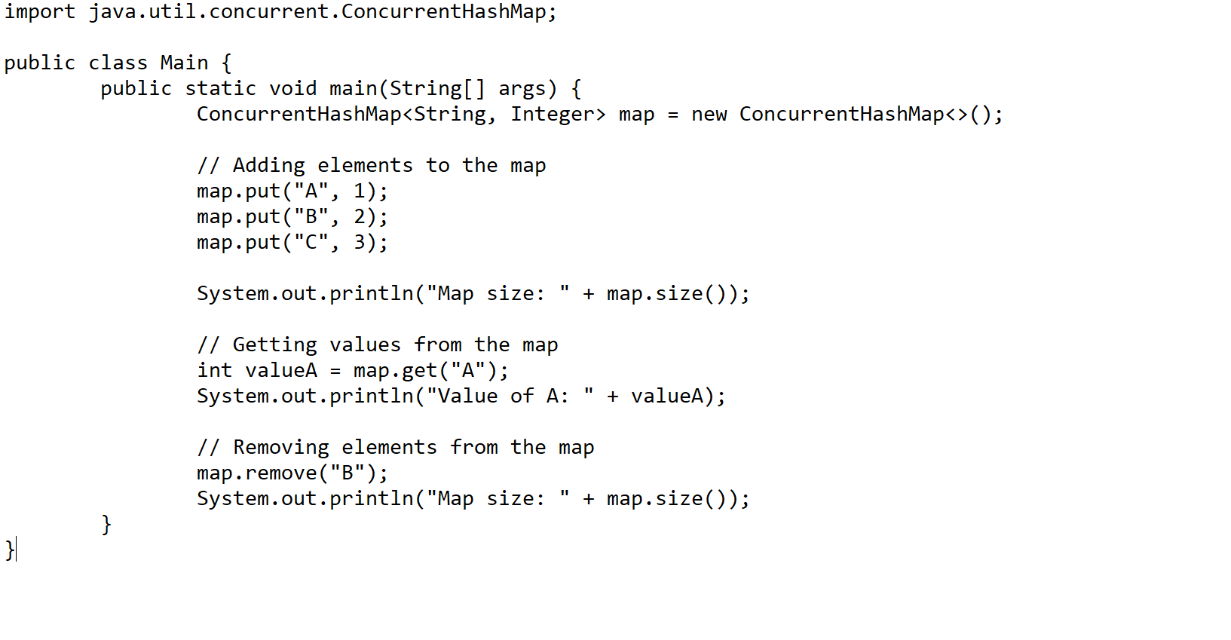

* **CopyOnWriteArrayList:** A variant of List where all mutative operations (add, set, and so on) are implemented by making a fresh copy.
* **BlockingQueue:** A Queue that additionally supports operations that wait for the queue to become non-empty when retrieving an element, and wait for space to become available in the queue when storing an element.

The **BlockingQueue interface** in Java was added in Java 1.5 along with various other concurrent utility classes like [ConcurrentHashMap](https://www.geeksforgeeks.org/concurrenthashmap-in-java/) , **Counting Semaphore** , [CopyOnWriteArrrayList](https://www.geeksforgeeks.org/copyonwritearraylist-in-java/) etc. The BlockingQueue interface (in addition to queuing) supports flow control by introducing blocking when the BlockingQueue is full or empty. A thread attempting to enqueue an element into a full queue will be blocked until another thread makes room in the queue by either dequeuing one or more elements or clearing the queue entirely. Similarly, a thread attempting to delete from an empty queue will be blocked until another thread inserts an element. BlockingQueue does not accept a null value. If we try to enqueue the null element, a **NullPointerException** is thrown.  
Java provides several BlockingQueue implementations such as [LinkedBlockingQueue](https://www.geeksforgeeks.org/linkedblockingqueue-class-in-java/) , [ArrayBlockingQueue](https://www.geeksforgeeks.org/arrayblockingqueue-class-in-java/) , [PriorityBlockingQueue](https://www.geeksforgeeks.org/priorityblockingqueue-class-in-java/#:~:text=PriorityBlockingQueue%20is%20an%20unbounded%20blocking,resource%20exhaustion%20resulting%20in%20OutOfMemoryError.) , **SynchronousQueue** , etc. Java BlockingQueue interface implementations are thread-safe. All methods of BlockingQueue are atomic in nature and use internal locks or other forms of concurrency control. Java 5 includes BlockingQueue implementations in the **java.util.concurrent package** .

**Synchronizers**

Java provides several synchronization aids, including:

* **CountDownLatch:** Allows one or more threads to wait until a set of operations performed by other threads completes.

CountDownLatch is used to make sure that a task waits for other threads before it starts. To understand its application, let us consider a server where the main task can only start when all the required services have started.

**Working of CountDownLatch:**  
When we create an object of CountDownLatch, we specify the number of threads it should wait for, all such thread are required to do count down by calling CountDownLatch.countDown() once they are completed or ready to the job. As soon as count reaches zero, the waiting task starts running.

* **CyclicBarrier:**A barrier that all threads must wait at until all threads reach it before any are allowed to proceed.

CyclicBarrier is used to make threads wait for each other. It is used when different threads are processing a part of the computation and when all the threads have completed the execution, the result needs to be combined in the parent thread. In other words, a CyclicBarrier is used when multiple threads are executing different subtasks and the output of these subtasks needs to be combined to form the final output. After the execution is complete, threads call the await() method and wait for other threads to reach the barrier. Once all the threads have reached it, the barriers clear the way for the threads to continue.

Java’s advanced concurrency tools provide a robust and flexible framework for writing concurrent applications. These tools simplify the task of developing multithreaded applications, offering high-level abstractions for task execution, thread management, data structures, and synchronization mechanisms. Proper use of these tools can lead to highly scalable and efficient applications.

**Best Practices and Common Pitfalls in Concurrent Programming**

**Best Practices in Java Concurrency**

**Choose the Right Concurrency Tool**

* Use higher-level concurrency tools like Executors, Concurrent Collections, and Synchronizers whenever possible. They simplify thread management and are more robust than manual synchronization methods.

**Prefer Immutability**

* Immutable objects are naturally thread-safe since their state cannot be modified after creation. Using immutable objects can significantly reduce the need for synchronization.

**Minimize the Scope of Synchronization**

* Synchronize only the critical section of code that needs it. Over-synchronization can lead to contention and reduce performance.

**Avoid Blocking Threads Unnecessarily**

* Use non-blocking algorithms and data structures where feasible. Blocking threads can lead to performance bottlenecks.

**Handle Thread Interruption Properly**

* Respect the interrupted status of threads. When catching InterruptedException, restore the interrupted status by calling Thread.currentThread().interrupt().

**Understand Thread Confinement**

* Use thread confinement to ensure that object modification is restricted to a single thread, thereby avoiding synchronization.

**Document Thread-Safety Guarantees**

* Clearly document how your code is designed to be thread-safe. This helps other developers understand and maintain your code correctly.

**Conclusion**

Concurrent programming in Java is a powerful feature that, when used correctly, can significantly improve the performance and efficiency of your applications. Understanding the basics of threads, synchronization, and advanced concurrency tools, along with adhering to best practices, can help you avoid common pitfalls and achieve effective parallel task execution.