**Kubernetes** is a tool that helps us to run and manage applications in containers. It was developed by Google Lab in 2014, and it is also known as k8s. It is an open-source container orchestration platform that automates the deployment, management, and scaling of container-based applications in different kinds of environments like physical, virtual, and cloud-native computing foundations. Containers are isolated from each other so that multiple containers can run on the same machine without interrupting anyone else. It allows us to deploy and manage container-based applications across a Kubernetes cluster of machines.

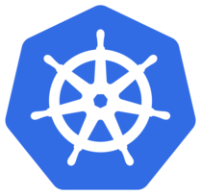

Kubernetes is an open-source platform that manages Docker containers in the form of a cluster. Along with the automated deployment and scaling of containers, it provides healing by automatically restarting failed containers and rescheduling them when their hosts die. This capability improves the application’s availability.

**Features of Kubernetes:**

1. **Automated Scheduling**– Kubernetes provides an advanced scheduler to launch containers on cluster nodes. It performs resource optimization.
2. **Self-Healing Capabilities**– It provides rescheduling, replacing, and restarting the containers which are dead.
3. **Automated Rollouts and Rollbacks**– It supports rollouts and rollbacks for the desired state of the containerized application.
4. **Horizontal Scaling and Load Balancing**– Kubernetes can scale up and scale down the application as per the requirements.
5. **Resource Utilization**– Kubernetes provides resource utilization monitoring and optimization, ensuring containers are using their resources efficiently.
6. **Support for multiple clouds and hybrid clouds**– Kubernetes can be deployed on different cloud platforms and run containerized applications across multiple clouds.
7. **Extensibility**– Kubernetes is very extensible and can be extended with custom plugins and controllers.
8. **Community Support-** Kubernetes has a large and active community with frequent updates, bug fixes, and new features being added.

## Architecture of Kubernetes

Kubernetes follows the client-server architecture where we have the master installed on one machine and the node on separate Linux machines. It follows the master-slave model, which uses a master to manage Docker containers across multiple Kubernetes nodes. A master and its controlled nodes(worker nodes) constitute a **“Kubernetes cluster”**. A developer can deploy an application in the docker containers with the assistance of the Kubernetes master.

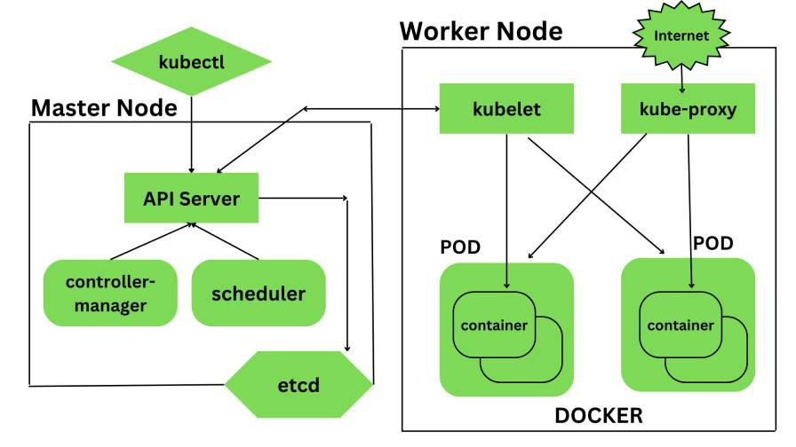

*Architecture of Kubernetes*

### 1. Kubernetes- Master Node Components –

Kubernetes master is responsible for managing the entire cluster, coordinates all activities inside the cluster, and communicates with the worker nodes to keep the Kubernetes and your application running. This is the entry point of all administrative tasks. When we install Kubernetes on our system we have four primary components of Kubernetes Master that will get installed. The components of the Kubernetes Master node are:

**a.) API Server**– The API server is the entry point for all the REST commands used to control the cluster. All the administrative tasks are done by the API server within the master node. If we want to create, delete, update or display in Kubernetes object it has to go through this API server.API server validates and configures the API objects such as ports, services, replication, controllers, and deployments and it is responsible for exposing APIs for every operation. We can interact with these APIs using a tool called **kubectl**. *‘kubectl’ is a very tiny go language binary that basically talks to the API server to perform any operations that we issue from the command line. It is a command-line interface for running commands against Kubernetes clusters*

**b.) Scheduler**– It is a service in the master responsible for distributing the workload. It is responsible for tracking the utilization of the working load of each worker node and then placing the workload on which resources are available and can accept the workload. The scheduler is responsible for scheduling pods across available nodes depending on the constraints you mention in the configuration file it schedules these pods accordingly. The scheduler is responsible for workload utilization and allocating the pod to the new node.

**c.) Controller Manager**– Also known as controllers. It is a daemon that runs in a non terminating loop and is responsible for collecting and sending information to the API server. It regulates the Kubernetes cluster by performing lifestyle functions such as namespace creation and lifecycle event garbage collections, terminated pod garbage collection, cascading deleted garbage collection, node garbage collection, and many more. Basically, the controller watches the desired state of the cluster if the current state of the cluster does not meet the desired state then the control loop takes the corrective steps to make sure that the current state is the same as that of the desired state. The key controllers are the replication controller, endpoint controller, namespace controller, and service account, controller. So in this way controllers are responsible for the overall health of the entire cluster by ensuring that nodes are up and running all the time and correct pods are running as mentioned in the specs file.

**d.) etcd**– It is a distributed key-value lightweight database. In Kubernetes, it is a central database for storing the current cluster state at any point in time and is also used to store the configuration details such as subnets, config maps, etc. It is written in the Go programming language.

### 2. Kubernetes- Worker Node Components –

Kubernetes Worker node contains all the necessary services to manage the networking between the containers, communicate with the master node, and assign resources to the containers scheduled. The components of the Kubernetes Worker node are:

**a.) Kubelet**– It is a primary node agent which communicates with the master node and executes on each worker node inside the cluster. It gets the pod specifications through the API server and executes the container associated with the pods and ensures that the containers described in the pods are running and healthy. If kubelet notices any issues with the pods running on the worker nodes then it tries to restart the pod on the same node. If the issue is with the worker node itself then the Kubernetes master node detects the node failure and decides to recreate the pods on the other healthy node.

**b.) Kube-Proxy**– It is the core networking component inside the Kubernetes cluster. It is responsible for maintaining the entire network configuration. Kube-Proxy maintains the distributed network across all the nodes, pods, and containers and exposes the services across the outside world. It acts as a network proxy and load balancer for a service on a single worker node and manages the network routing for TCP and UDP packets. It listens to the API server for each service endpoint creation and deletion so for each service endpoint it sets up the route so that you can reach it.

**c.) Pods**– A pod is a group of containers that are deployed together on the same host. With the help of pods, we can deploy multiple dependent containers together so it acts as a wrapper around these containers so we can interact and manage these containers primarily through pods.

**d.) Docker**– Docker is the containerization platform that is used to package your application and all its dependencies together in the form of containers to make sure that your application works seamlessly in any environment which can be development or test or production. Docker is a tool designed to make it easier to create, deploy, and run applications by using containers. Docker is the world’s leading software container platform.

### Application of Kubernetes

* Microservices architecture: Kubernetes is well-suited for managing microservices architectures, which involve breaking down complex applications into smaller, modular components that can be independently deployed and managed.
* Cloud-native development: Kubernetes is a key component of cloud-native development, which involves building applications that are designed to run on cloud infrastructure and take advantage of the scalability, flexibility, and resilience of the cloud.
* Continuous integration and delivery: Kubernetes integrates well with CI/CD pipelines, making it easier to automate the deployment process and roll out new versions of your application with minimal downtime.
* Hybrid and multi-cloud deployments: Kubernetes provides a consistent deployment and management experience across different cloud providers, on-premise data centers, and even developer laptops, making it easier to build and manage hybrid and multi-cloud deployments.
* High-performance computing: Kubernetes can be used to manage high-performance computing workloads, such as scientific simulations, machine learning, and big data processing.
* Edge computing: Kubernetes is also being used in edge computing applications, where it can be used to manage containerized applications running on edge devices such as IoT devices or network appliances.

## Kubernetes Basic Concepts

Now we know broadly what Kubernetes is and a little bit about its most important partner Docker, but what does Kubernetes look like once you jump into it?

Below we’ll break down the basic components present in any Kubernetes app and show how they build on each other. We’ll also look at some of the additional tools sure to help you along the way.

### Pods

These are the smallest unit of application in Kubernetes. Pods represent a single, isolated instance of an application and the resources needed to execute it, each having their own IP address.

Pods are made up of one or more containers that work together and share a life cycle on the same node; each pod could be composed of a single container or multiple containers, depending on its complexity.

This can be advantageous as all containers within the same pod can communicate without the need for additional setup from the user.

These pods, however, are highly isolated and cannot communicate with other pods. This is where our next component, services, comes into the picture.

### Services

Services are an abstraction that sit one level above pods, acting as a director between individual pods and the outside world.

Services define a policy to access selected pods. Once this is done, pods in this service’s set can communicate freely until the policy to access is changed.

Services are also convenient when creating complex, interdependent programs as they set a single Domain Name Service (DNS) record for all pods within their service. Another part of the program, a deployment (see below), can then use this DNS name to access information from these pods without needing to know the IP addresses for each.

In other words, another part of the program can connect to this pod group through the shared DNS record without needing to track status or information of each pod.

Group based access allows for greater flexibility than individual access as pods can be added or removed from the service group without code revision.

### Deployments

Our final component of Kubernetes, Deployments, takes the hassle out of upgrading pods. Normally, when upgrading a system, one would have to shut off all old instances then reboot the system using the upgraded instances, resulting in a period of downtime.

Kubernetes’ deployments allow us to sidestep this problem by allowing for “rolling updates” during which pods are taken down one-by-one, upgraded to the new version, and verified as functional before moving onto the next.

In doing so, Kubernetes ensures that not only is there no downtime but also that each pod is upgraded as it should. This process can also be repeated in the opposite order should the new program contain an error, resulting in an automated rollback to the previous version.

For a closer look at pods, services, deployments, and replication controllers check out our [previous article](https://www.educative.io/blog/pods-services-deployments).

### Minikube

The first of our additional tools, Minikube creates a virtual testing ground for all your containerized programs. When run, Minikube creates a Virtual Machine (VM) on your computer which will simulate the behavior of a physical system without the risk of making unwanted changes to your machine.

This VM is a simple single-node cluster, meaning that it behaves like a group of computers with only one machine hooked up. This simplified cluster form and simulated behavior make Minikube the perfect development and testing environment for unfinished programs or for simply [learning container-based programming](https://www.educative.io/catalog/kubernetes).

While this is ideal for Linux and Mac users, Windows users may have a hard time getting it started. For Windows, instead, try Docker Desktop; it has the same test environment functionality with a simpler fit into Windows’ infrastructure.

### kubectl

For our next tool, we have kubectl, a command-line application to manage Kubernetes clusters. In many ways, the kubectl command is its own coding language with exclusive syntax and complexity. While difficult to pick up due to its extensiveness, kubectl offers unmatched control to developers, making it the most popular cluster manipulation tool for Kubernetes out there right now.

Combined with Minikube, these two tools are essential for those seeking to dive into Kubernetes.

### Kubernetes Cluster

Clusters are groups of servers all working together as a system toward the same goal. These servers are commonly referred to as nodes and can each work on independent tasks which culminate to accomplishing the system’s goal.

Each cluster has a list of conditions defined in its config files which the cluster expects in order to run correctly, known as a “desired state”. This state could feature specifications such as which workloads should be running, container images the cluster will need access to, or hardware resources that should be available on a given machine.

### Master and worker nodes

Nodes in a cluster have different functions; some are masters and others are workers. In each cluster, there is a master node and at least one worker node.

The master node is charged with maintaining the cluster’s desired state, freeing up resources, checking the status of each condition, and so on.

It also manages the scheduling of pods across nodes in a cluster, distributing jobs to ensure all nodes are working while not becoming overloaded. The master node has various components like API Server, Controller Manager, Scheduler, and ETCD.

Worker nodes are responsible for everything else involved in running a program and do most of the lifting. These nodes can have multiple pods running on them, working on each as assigned by the master nodes. As worker nodes are mostly isolated, clusters can be scaled with more worker nodes without issue.

## How to create a Kubernetes Cluster

To begin, we’ll create our cluster. Thanks to our tools, Minikube or Docker Desktop, this is simple. This will be the only step where the inputs deviate based on the tool.

Minikube users, enter:

minikube start

For Docker Desktop, your cluster has begun automatically.

Now to test that our cluster was made correctly, enter:

kubectl get svc

The following table will print. Yours may look slightly different, but the two leftmost fields, Kubernetes and clusterIP, will be the same.

NAME         TYPE        CLUSTER-IP   EXTERNAL-IP   PORT(S)   AGE  
kubernetes   ClusterIP   10.96.0.1    <none>        443/TCP   6s

This shows us that the default service, Kubernetes, is currently running. As this service is always initialized at cluster startup, we know the cluster is running as expected!

## How to deploy a Kubernetes app

Now we’ll create our first deployment. For this, we’ll be pulling a test image from the Google Container Registry (GCR) called hello-node. Creating this deployment will come with one pod built-in.

To do this, paste the following line:

kubectl create deployment hello-node --image=gcr.io/hello-minikube-zero-install/hello-node

Now, to check that this deployment is running correctly, enter:

kubectl get deployments

NAME         READY   UP-TO-DATE   AVAILABLE   AGE  
hello-node   1/1     1            1           170m

This will print a list of the deployments currently running on this cluster. As we’ve only created the one, you’ll only see hello-node listed. Congratulations, you’ve deployed your app!

## Exploring your Kubernetes app

While we’ve got it, might as well look around! We’ll use the get command to see that all the parts we learned about above are now present and working on our app!

First, let’s look at our nodes, enter:

kubectl get nodes

NAME             STATUS   ROLES    AGE    VERSION  
docker-desktop   Ready    master   1d2h   v1.15.5

This will list the names, status, and roles of all the nodes in our cluster. Since our cluster is just a single device test environment, there will be only one.

Now we’ll look at our pods, enter:

kubectl get pods

Again, a table will print with some useful information.

NAME                          READY   STATUS    RESTARTS   AGE  
hello-node-55b49fb9f8-wwpwr   1/1     Running   0          36s

Here, it’s important to note that our pod has only one instance, shown by the 1/1 in the ready column. We can also see that it is currently running from the status column, letting us know that it has not failed.

As a result, the get pods command is useful when troubleshooting a more complex system as it allows you to see which of your many pods is malfunctioning.

If you need more information, you can also use the describe command for specific pods, nodes or even deployments to see a plethora of information available on each resource.

Let’s try it for our deployment, enter:

kubectl describe deployment hello-node

Name:                   hello-node  
Namespace:              default  
CreationTimestamp:      Mon, 01 Jan 2020 19:26:58 -0700  
Labels:                 app=hello-node  
Annotations:            deployment.kubernetes.io/revision: 1  
Selector:               app=hello-node  
Replicas:               1 desired | 1 updated | 1 total | 1 available | 0 unavailable  
StrategyType:           RollingUpdate  
MinReadySeconds:        0  
RollingUpdateStrategy:  25% max unavailable, 25% max surge  
Pod Template:  
  Labels:  app=hello-node  
  Containers:  
   hello-node:  
    Image:        gcr.io/hello-minikube-zero-install/hello-node  
    Port:         <none>  
    Host Port:    <none>  
    Environment:  <none>  
    Mounts:       <none>  
  Volumes:        <none>  
Conditions:  
  Type           Status  Reason  
  ----           ------  ------  
  Available      True    MinimumReplicasAvailable  
  Progressing    True    NewReplicaSetAvailable  
OldReplicaSets:  <none>  
NewReplicaSet:   hello-node-55b49fb9f8 (1/1 replicas created)  
Events:  
  Type    Reason             Age   From                   Message  
  ----    ------             ----  ----                   -------  
  Normal  ScalingReplicaSet  95s   deployment-controller  Scaled up replica set hello-node-55b49fb9f8 to 1

You’ll not recognize most of this information if you’re just starting out, however for the experienced Kubernetes user, this ready access to information is one of the aspects which makes Kubernetes so appealing. With both get and describe commands, all the information needed to troubleshoot a failure is just a command-line away!

## How to expose your Kubernetes app

Up until now, our app has been fully isolated in our test environment. With real programs, you’ll almost always need to have your app send web requests to other outside web apps.

To do this, we’ll use the expose command which will create a new service instance with the same name as our deployment and will automatically define the port configuration to allow a connection. As part of the command, we define which port the service should listen on. In this case, we’ll use port 8080.

To try this yourself, enter:

kubectl expose deployment hello-node --type=LoadBalancer --port=8080

To see this service in action, we can once again enter:

kubectl get svc

NAME       TYPE         CLUSTER-IP     EXTERNAL-IP  PORT(S)         AGE  
hello-node LoadBalancer 10.108.188.234 localhost    8080:32505/TCP  7s  
kubernetes ClusterIP    10.96.0.1      <none>       443/TCP         1h

Here we see that where we once had only one service, we now have two, the original kubernetes and new service hello-node. Notice how the latter differs in both the EXTERNAL-IP and the PORT(S) field due to it being public. NodePorts are the published IP addresses for external users to access the services.

Now that our app is exposed, we can access the web application running inside the hello-node pod to print a message.

To do this, enter:

 curl http:///localhost:8080

Hello World!

And like that, we’ve called an external IP to execute our pod and had it print!

## How to scale a Kubernetes app

While our app now works fully and is reachable by external sources, what happens if our pod fails? Or what happens if the number of requests reaching our program suddenly spikes?

To protect against these cases, we need to scale up our app; creating more instances of our hello-node pod to delineate requests to or to step in if a pod fails. The best part is, with Kubernetes this takes but a single command to create and will do the above jobs automatically from then on!

To scale up our app, enter:

kubectl scale --replicas=3 deployment/hello-node

This will set our program to maintain a state of three running instances of the hello-node pod rather than just one.

To check this, enter:

kubectl get deployment hello-node

This should print a screen like so:

NAME         READY   UP-TO-DATE   AVAILABLE   AGE  
hello-node   3/3     3            3           135m

Notice the three pods under this deployment listed in the ready column.

Or to see the pods independently you can enter:

kubectl get pods

NAME                          READY   STATUS    RESTARTS   AGE  
hello-node-55b49fb9f8-fxjnj   1/1     Running   0          2m34s  
hello-node-55b49fb9f8-jlfwq   1/1     Running   0          2m34s  
hello-node-55b49fb9f8-zhf9f   1/1     Running   0          136m

This once again shows us that where there was once only a single pod, we now have three separate but identical instances of the hello-node pod.

## How to update a Kubernetes app

Finally, we know that no app rules forever; eventually, a new version will replace the old. In our case, say a new version of our hello-node pod is created and we want to use it to replace all of our old pods. Well as we discussed previously, Kubernetes has us covered as we can make this upgrade with no downtime using a rolling update.

As there is no new version of hello-node, this would give an error message if entered.

However, if there were an updated version, you would apply it by entering:

kubectl set image deployments/hello-node hello-node=myContainers/hello-node:v2

To break this down, we first mark that we’d like to set a new image, then specify the type we’re going to adapt, deployments, then which deployment, hello-node. After the first mention of our deployment, we’ve told the command what we’d like to edit, at which point we then provide the new image, myContainers/hello-node:v2.

Kubernetes will then take each of our old pods down one by one and replace them with our upgraded version. This takes a moment and does get longer depending on the number of pods which must be upgraded. To check if the upgrade rollout is successful, we would enter:

 kubectl rollout status deployments/hello-node

Which, if completed, would return:

 deployment "hello-node" successfully rolled out

With that, we’ve finished our creation and exploration of a Kubernetes basic program. To conclude your masterpiece, now simply enter the two lines:

kubectl delete service hello-node  
kubectl delete deployment hello-node

This will clean up your system and leave your system ready for your next Kubernetes project!

Kubernetes is the most popular orchestrator for deploying and scaling containerized systems. You can use Kubernetes to reliably build and distribute your applications in the cloud.

In this getting started beginner’s guide, you’ll learn what Kubernetes can do and how to get started running your own containerized solutions.

1. What is Kubernetes?
2. Kubernetes features
3. How does Kubernetes work?
4. Kubernetes installation and setup example
5. Kubernetes basic terms and concepts
6. Using Kubectl to interact with Kubernetes

**What is Kubernetes?**

Kubernetes is an open-source system that automates container deployment tasks. It was originally developed at Google but is now maintained as part of the Cloud Native Computing Foundation (CNCF).

Kubernetes has risen to prominence because it solves many of the challenges around using containers in production. It makes it easy to launch limitless container replicas, distribute them across multiple physical hosts, and set up networking so users can reach your service.

**What is Kubernetes used for?**

Kubernetes is used to manage and scale applications running in containers, which are small, isolated environments. It simplifies the reliable management of numerous apps and services, even when they are distributed across multiple servers.

Kubernetes automates things like:

1. **Starting new apps** when needed.
2. **Restarting apps**if they crash.
3. **Spreading out work** so that no one part of the system is overloaded.
4. **Scaling up or down** based on demand.

**Is Kubernetes easy to learn?**

Learning Kubernetes can be challenging, particularly for those who are new to container orchestration and cloud-native environments. Most developers begin their container journey with Docker. While this is a comprehensive tool, it’s relatively low-level and relies on CLI commands that interact with one container at a time. Kubernetes provides much higher-level abstractions for defining applications and their infrastructure using declarative schemas you can collaborate on.

Check out our Docker vs. Kubernetes Comparison.

**Kubernetes features**

Kubernetes has a comprehensive feature set that includes a full spectrum of capabilities for running containers and associated infrastructure:

* **Automated rollouts, scaling, and rollbacks** – Kubernetes automatically creates the specified number of replicas, distributes them onto suitable hardware, and takes action to reschedule your containers if a node goes down. You can instantly scale the number of replicas on-demand or in response to changing conditions such as CPU usage.
* **Service discovery, load balancing, and network ingress** – Kubernetes provides a complete networking solution that covers internal service discovery and public container exposure.
* **Stateless and stateful applications** – While Kubernetes initially focused on stateless containers, it’s now also got built-in objects to represent stateful apps too. You can run any kind of application in Kubernetes
* **Storage management** – Persistent storage is abstracted by a consistent interface that works across providers, whether in the cloud, on a network share, or on a local filesystem.
* **Declarative state** – Kubernetes uses object manifests in YAML files to define the state you want to create in your cluster. Applying a manifest instructs Kubernetes to automatically transition the cluster to the target state. You don’t have to manually script the changes you want to see.
* **Works across environments** – Kubernetes can be used in the cloud, at the edge, or on your developer workstation. Many different distributions are available to match different use cases. Major cloud providers like AWS and Google Cloud offer managed Kubernetes services, while single-node distributions such as Minikube and K3s are great for local use.
* **Highly extensible** – Kubernetes packs in a lot of functionality, but you can add even more using extensions. You can create custom object types, controllers, and operators to support your own workloads.

With so many features available, Kubernetes is ideal for any situation where you want to deploy containers with declarative configuration.

**How does Kubernetes work?**

Kubernetes has a reputation for complexity because it has several moving parts. Understanding the basics of how they fit together will help you start out on your Kubernetes journey.

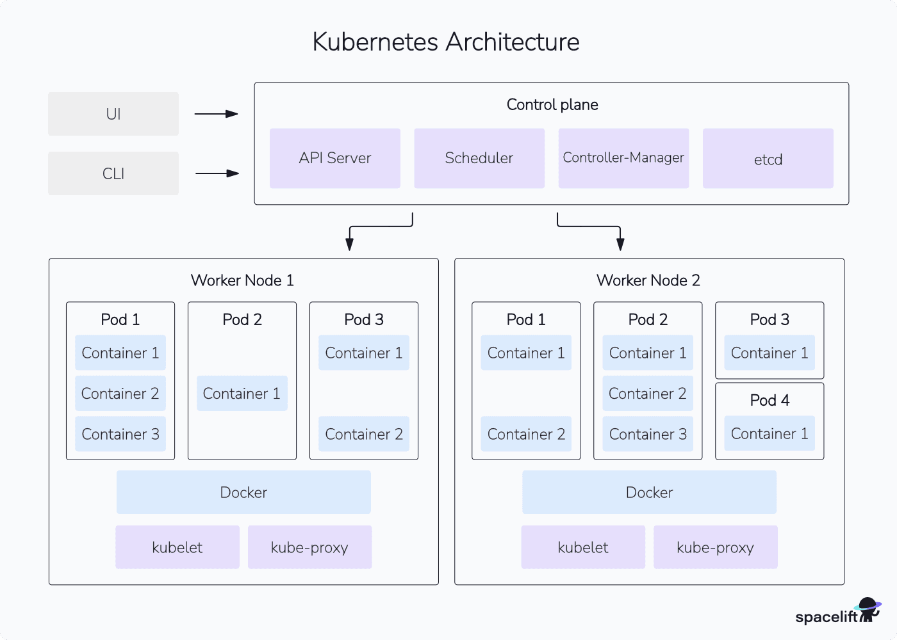

A Kubernetes environment is termed a **cluster**. It includes one or more **nodes**. A node is simply a machine that will run your containers. It could be physical hardware or a VM.

The cluster has nodes and a control plane. The **control plane** coordinates the entire cluster’s operations, schedules new containers onto available nodes and provides the API server that you interact with. It’s possible to run a cluster with multiple control plane instances to create a highly available setup with greater resiliency.

Here are the most important Kubernetes elements:

|  |  |
| --- | --- |
| **Kubernetes component** | **Description** |
| **kube-apiserver** | This is the part of the control plane that runs the API server. It’s the only way to interact with a running Kubernetes cluster. You can issue commands to the API server using the Kubectl CLI or an HTTP client. |
| **kube-controller-manager** | The controller manager starts and runs Kubernetes’ built-in controllers. A controller is essentially an event loop that applies actions after changes in your cluster. They create, scale, and delete objects in response to events such as an API request or increased load. |
| **kube-scheduler** | The scheduler assigns new Pods (containers) onto the nodes in your cluster. It establishes which nodes can fulfill the Pod’s requirements, then selects the most optimal placement to maximize performance and reliability. |
| **kubelet** | Kubelet is a worker process that runs on each of your nodes. It maintains communication with the Kubernetes control plane to receive its instructions. Kubelet is responsible for pulling container images and starting containers in response to scheduling requests. |
| **kube-proxy** | Proxy is another component found on individual nodes. It configures the host’s networking system so traffic can reach the services in your cluster. |

Kubectl is usually the final piece in a functioning Kubernetes environment. You’ll need this CLI to interact with your cluster and its objects. Once your cluster’s set up, you can also install the official dashboard or a third-party solution to control Kubernetes from a GUI.

**Kubernetes installation and setup example**

There are many different ways to get started with Kubernetes because of the range of distributions on offer. Creating a cluster using the official distribution is relatively involved so most people use a packaged solution like Minikube, MicroK8s, K3s, or Kind.

https://medium.com/@sidhupkc/how-to-install-chocolatey-in-windows-5ecee6430ae9

**To install Minikube on Windows using PowerShell, follow these steps:**

**Step 1: Install Prerequisites**

1. **Install Hyper-V or VirtualBox:**
   * Minikube requires a hypervisor. Enable Hyper-V if it's not already enabled:
   * Enable-WindowsOptionalFeature -Online -FeatureName Microsoft-Hyper-V -All

Restart your machine after enabling Hyper-V.

* + Alternatively, download and install VirtualBox if Hyper-V is unavailable.

1. **Install kubectl:** Download the kubectl binary for Kubernetes command-line operations:
2. choco install kubernetes-cli

Ensure Chocolatey is installed before running this command. If not, install Chocolatey from [here](https://chocolatey.org/install).

**Step 2: Download and Install Minikube**

1. Open PowerShell as an Administrator.
2. Run the following command to download Minikube using Chocolatey:
3. choco install minikube

Alternatively, download the Minikube executable directly:

Invoke-WebRequest -Uri https://github.com/kubernetes/minikube/releases/latest/download/minikube-windows-amd64.exe -OutFile minikube.exe

Move-Item -Path .\minikube.exe -Destination "C:\Program Files\Minikube\minikube.exe"

[Environment]::SetEnvironmentVariable("Path", $env:Path + ";C:\Program Files\Minikube", [EnvironmentVariableTarget]::Machine)

1. Confirm installation by checking the version:
2. minikube version

**Step 3: Start Minikube**

1. Start Minikube with the desired driver (Hyper-V or VirtualBox):
   * For Hyper-V:

minikube start --driver=hyperv

* + For VirtualBox:

minikube start --driver=virtualbox

1. Verify that Minikube is running:
2. minikube status

**Step 4: Test Kubernetes Cluster**

Check the nodes in your Kubernetes cluster:

kubectl get nodes

Deploy a sample application:

kubectl create deployment hello-minikube --image=kicbase/echo-server:1.0

kubectl expose deployment hello-minikube --type=NodePort --port=8080

minikube service hello-minikube

**Troubleshooting**

* **Environment Variable Issues:** Ensure minikube and kubectl are in your system PATH.
* **Driver Errors:** Switch drivers if Hyper-V or VirtualBox fails:
* minikube delete
* minikube start --driver=docker

Let me know if you encounter any issues!

Next run this command:

$ kubectl get nodes

NAME STATUS ROLES AGE VERSION

ubuntu22 Ready control-plane,master 102s v1.24.4+k3s1

You should see a single node appear, named with your machine’s hostname. The node shows as Ready so your Kubernetes cluster can now be used!

**Kubernetes basic terms and concepts**

Your cluster’s running, but what can you do with it? It’s worth getting familiar with some key Kubernetes terms before you continue.

**1. Nodes**

Nodes represent the physical machines that form your Kubernetes cluster. They run the containers you create. Kubernetes tracks the status of your nodes and exposes each one as an object. You used Kubectl to retrieve a list of nodes in the example above.

While your fresh cluster has only one node, Kubernetes advertises support for up to 5,000 nodes. It’s theoretically possible to scale even further.

**2. Namespaces**

Kubernetes namespaces isolate different groups of resources. They avoid name collisions by scoping the visibility of your resources.

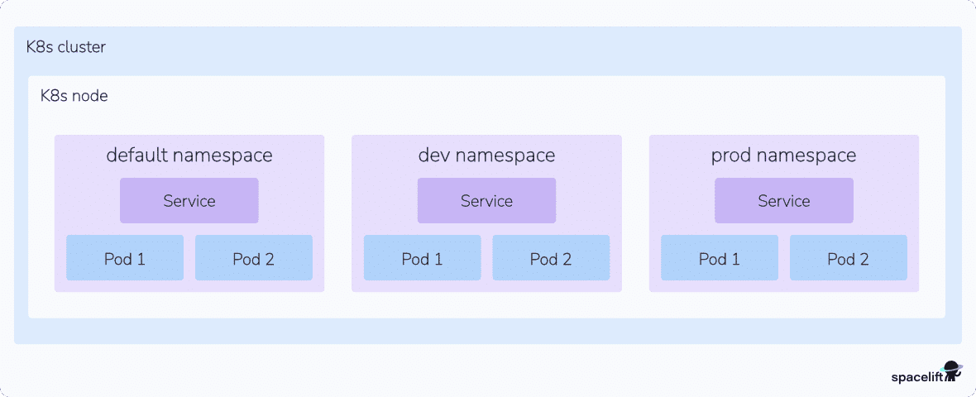

Creating two objects with the same name is forbidden within the same namespace. If you’re in the default namespace, you can’t create two Pods that are both called database, for example. Namespaces resolve this by providing logical separation of resources. Two namespaces called app-1 and app-2 could each contain a Pod called database without causing a conflict.

Namespaces are flexible and can be used in many different ways. It’s a good idea to create a namespace for each workload in your cluster. You can also use namespaces to divide resources between users and teams by applying role-based access control.

**3. Pods**

Pods are the fundamental compute unit in Kubernetes. A Pod is analogous to a container but with some key differences. Pods can contain multiple containers, each of which share a context. The entire Pod will always be scheduled onto the same node. The containers within a Pod are tightly coupled so you should create a new Pod for each distinct part of your application, such as its API and database.

In simple situations, Pods will usually map one-to-one with the containers your application runs. In more advanced cases, Pods can be enhanced with init containers and ephemeral containers to customize startup behavior and provide detailed debugging.

**4. ReplicaSets**

ReplicaSets are used to consistently replicate a Pod. They provide a guarantee that a set number of replicas will be running at any time. If a node goes offline or a Pod becomes unhealthy, Kubernetes will automatically schedule a new Pod instance to maintain the specified replica count.

**5. Deployments**

Deployments wrap ReplicaSets with support for declarative updates and rollbacks. They’re a higher level of abstraction that’s easier to control.

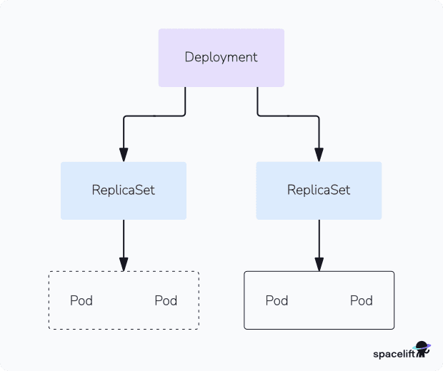

A Deployment object lets you specify the desired state of a set of Pods. This includes the number of replicas to run. Modifying the Deployment will automatically detect the required changes and scale the ReplicaSet as required. You can pause the rollout or revert to an earlier revision, features that aren’t available with plain ReplicaSets.

Learn how to create a Kubernetes Deployment YAML file.

**6. Services**

Kubernetes Services are used to expose Pods to the network. They allow defined access to Pods either within your cluster or externally.

Ingresses are closely related objects. These are used to set up HTTP routes to services via a load balancer. Ingresses also support HTTPS traffic secured by TLS certificates.

Read more: Kubernetes Ingress with NGINX Ingress Controller Example

**7. Jobs**

A Kubernetes Job is an object that creates a set of Pods and waits for them to terminate. It will retry any failed Pods until a specified number have exited successfully. The Job’s then marked as complete.

Jobs provide a mechanism for running ad-hoc tasks inside your cluster. Kubernetes also provides CronJobs that wrap Jobs with cron-like scheduling support. These let you automatically run a job on a regular cadence to accommodate batch activities, backups, and any other scheduled tasks your application requires.

**8. Volumes**

Volumes mount external filesystem storage inside your Pods. They abstract away the differences between different cloud providers’ storage implementations.

Volumes can and shared between your Pods. This allows Kubernetes to run stateful applications where data must be preserved after a Pod gets terminated or rescheduled. You’ll need to use a volume whenever you’re running a database or file server in your cluster.

**9. Secrets and ConfigMaps**

Secrets are used to inject sensitive data into your cluster such as API keys, certificates, and other kinds of credential. They can be supplied to Pods as environment variables or files mounted into a volume.

ConfigMaps are a similar concept for non-sensitive information. These objects should store any general settings your app requires.

**10. DaemonSets**

Kubernetes DaemonSets are used to reliably run a copy of a Pod on each of the Nodes in your cluster. When a new Node joins, it will automatically start an instance of the Pod. You can optionally restrict DaemonSet Pods to only running on specific Nodes in more advanced situations.

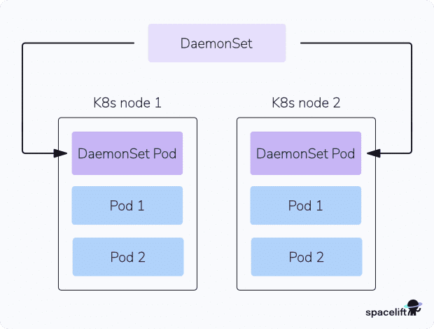

DaemonSets are useful when you’re adding global functionality to your cluster. DaemonSets are often used to run monitoring services and log aggregation agents. Placing these workloads into a DaemonSet guarantees they’ll always be running adjacent to your application’s Pods. It ensures metrics and logs will be collected irrespective of the Node a Pod gets scheduled to.

**11. Networking policies**

Kubernetes supports a policy-based system for controlling network traffic flows between your Pods. You can isolate sensitive Pods from other resources to prevent attackers moving through your infrastructure.

Network policies are expressed as an object that targets one or more matching Pods. Each Pod can be the subject of both ingress and egress policies. Ingress policies define whether incoming traffic is allowed, while egress rules affect outbound flows. Communications between two Pods are only permitted when no networking policy on either Pod denies ingress or egress from the other.

Learn more: What Is Kubernetes Architecture?

**Using Kubectl to interact with Kubernetes**

Now you’re familiar with the basics, you can start adding workloads to your cluster with Kubectl. Here’s a quick reference for some key commands.

**List Pods**

This displays the Pods in your cluster:

$ kubectl get pods

No resources found in default namespace

Specify a namespace with the -n or --namespace flag:

$ kubectl get pods -n demo

No resources found in demo namespace

Alternatively, get Pods from all your namespaces by specifying --all-namespaces:

$ kubectl get pods --all-namespaces

NAMESPACE NAME READY STATUS RESTARTS AGE

kube-system coredns-b96499967-4xdpg 1/1 Running 0 114m

...

This includes Kubernetes system components.

**Create a Pod**

Create a Pod with the following command:

$ kubectl run nginx --image nginx:latest

pod/nginx created

This starts a Pod called nginx that will run the nginx:latest container image.

**Create a Deployment**

Creating a Deployment lets you scale multiple replicas of a container:

$ kubectl create deployment nginx --image nginx:latest --replicas 3

deployment.apps/nginx created

You’ll see three Pods are created, each running the nginx:latest image:

$ kubectl get pods

NAME READY STATUS RESTARTS AGE

nginx-7597c656c9-4qs55 1/1 Running 0 51s

nginx-7597c656c9-gdjl9 1/1 Running 0 51s

nginx-7597c656c9-7sxrc 1/1 Running 0 51s

**Scale a Deployment**

Now use this command to increase the replica count:

$ kubectl scale deployment nginx --replicas 5

deployment.apps/nginx scaled

Kubernetes has created two extra Pods to provide additional capacity:

$ kubectl get pods

NAME READY STATUS RESTARTS AGE

nginx-7597c656c9-4qs55 1/1 Running 0 2m26s

nginx-7597c656c9-gdjl9 1/1 Running 0 2m26s

nginx-7597c656c9-7sxrc 1/1 Running 0 2m26s

nginx-7597c656c9-kwm6q 1/1 Running 0 2s

nginx-7597c656c9-nwf2s 1/1 Running 0 2s

**Expose a Service**

Now let’s make this NGINX server accessible.

Run the following command to create a service that’s exposed on a port of the Node running the Pods:

$ kubectl expose deployment/nginx --port 80 --type NodePort

service/nginx exposed

Discover the port that’s been assigned by running this command:

$ kubectl get services

NAME TYPE CLUSTER-IP EXTERNAL-IP PORT(S) AGE

kubernetes ClusterIP 10.43.0.1 <none> 443/TCP 121m

nginx NodePort 10.43.149.39 <none> 80:30226/TCP 3s

The port is 30226. Visiting <node-ip>:30226 in your browser will show the default NGINX landing page.

You can use localhost as <node-ip> if you’ve been following along with the single-node K3s cluster created in this tutorial. Otherwise run the get nodes command and use the INTERNAL-IP that’s displayed.

$ kubectl get nodes -o wide

NAME STATUS ROLES AGE VERSION INTERNAL-IP

ubuntu22 Ready control-plane,master 124m v1.24.4+k3s1 192.168.122.210

**Using port forwarding**

You can access a service without binding it to a Node port by using Kubectl’s integrated port-forwarding functionality. Delete your first service and create a new one without the --type flag:

$ kubectl delete service nginx

service/nginx deleted

$ kubectl expose deployment/nginx –port 80

service/nginx exposed

This creates a ClusterIP service that can be accessed on an internal IP, within the cluster.

Retrieve the service’s details by running this command:

$ kubectl get services

NAME TYPE CLUSTER-IP EXTERNAL-IP PORT(S) AGE

nginx ClusterIP 10.100.191.238 <none> 80/TCP 2s

The service can be accessed inside the cluster at 10.100.191.238:80.

You can reach this address from your local machine with the following command:

$ kubectl port-forward service/nginx 8080:80

Visiting localhost:8080 in your browser will display the NGINX landing page. Kubectl is redirecting traffic to the service inside your cluster. You can press Ctrl+C in your terminal to stop the port forwarding session when you’re done.

Port forwarding works without services too. You can directly connect to a Pod in your deployment with this command:

$ kubectl port-forward deployment/nginx 8080:80

Visiting localhost:8080 will again display the NGINX landing page, this time without going through a service.

**Apply a YAML file**

Finally, let’s see how to apply a declarative YAML file to your cluster. First, write a simple Kubernetes manifest for your Pod:

apiVersion: v1

kind: Pod

metadata:

name: nginx

spec:

containers:

- name: nginx

image: nginx:latest

Save this manifest to nginx.yaml and run kubectl apply to automatically create your Pod:

$ kubectl apply -f nginx.yaml

pod/nginx created

You can repeat the command after you modify the file to apply any changes to your cluster.

Now you’re familiar with the basics of using Kubectl to interact with Kubernetes!