Digital Legal Case Search and Management System (Digilegal)

ER Diagram
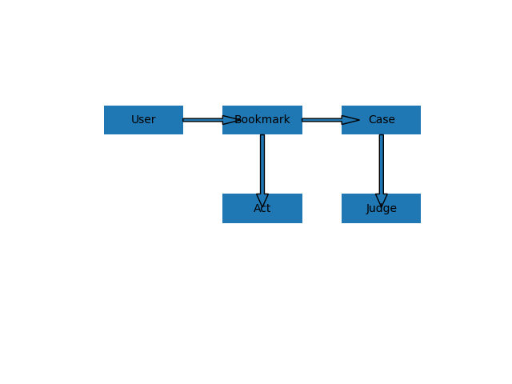

System Architecture Diagram
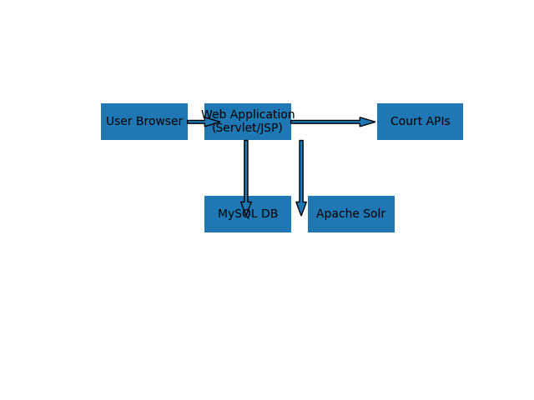

Kubernetes Deployment Diagram
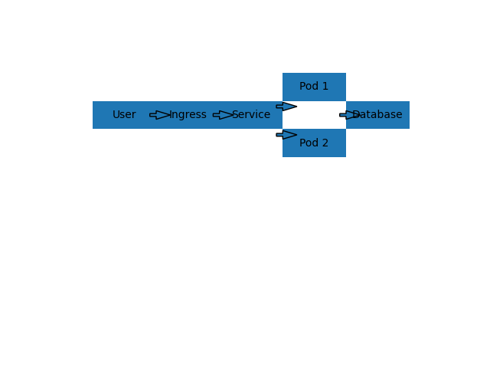

UML Use Case Diagram
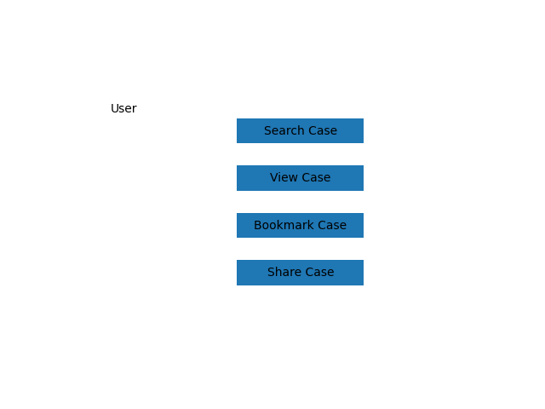

Project Gantt Chart
