**JDBC (Java Database Connectivity)**

**JDBC (Java Database Connectivity)** is an API in Java that enables applications to interact with databases. It allows **a**Java program to **connect to a database**,**execute queries,**and r**etrieve and manipulate data.** By providing a standard interface, JDBC ensures that Java applications can work with different relational databases like MySQL, Oracle, PostgreSQL, and more.

**JDBC Architecture**

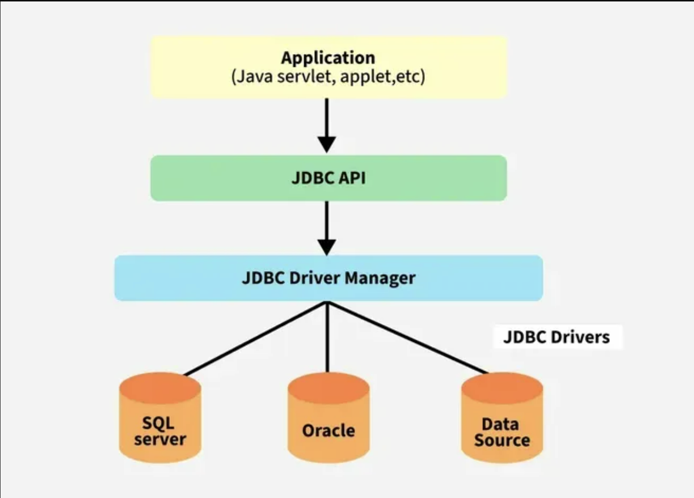

**Explanation:**

* **Application:** It is a Java applet or a servlet that communicates with a data source.
* **The JDBC API:** It allows Java programs to execute SQL queries and retrieve results. Key interfaces include Driver, ResultSet, RowSet, PreparedStatement, and Connection. Important classes include DriverManager, Types, Blob, and Clob.
* **DriverManager:** It plays an important role in the JDBC architecture. It uses some database-specific drivers to effectively connect enterprise applications to databases.
* **JDBC drivers:**These drivers handle interactions between the application and the database.

The JDBC architecture consists of[two-tier and three-tier processing models](https://www.geeksforgeeks.org/dbms-architecture-2-level-3-level) to access a database. They are as described below:

**1. Two-Tier Architecture**

A Java Application communicates directly with the database using a JDBC driver. Queries are sent to the database, and results are returned directly to the application. In a client/server setup, the user’s machine (client) communicates with a remote database server.

**Structure:**

*Client Application (Java) -> JDBC Driver -> Database*

**2. Three-Tier Architecture**

In this, user queries are sent to a middle-tier services, which interacts with the database. The database results are processed by the middle tier and then sent back to the user.

**Structure:**

*Client Application -> Application Server -> JDBC Driver -> Database*

**JDBC Components**

There are generally **4** **main components of JDBC** through which it can interact with a database. They are as mentioned below:

**1. JDBC API**

It provides various methods and interfaces for easy communication with the database. It includes two key packages

* **java.sql**: This package, is the part of**Java Standard Edition (Java SE) ,** whichcontains the core interfaces and classes for accessing and processing data in relational databases. It also provides essential functionalities like establishing connections, executing queries, and handling result sets
* **javax.sql**: This package is the part of **Java Enterprise Edition (Java EE) ,**whichextends the capabilities of **java.sql** by offering additional features like connection pooling, statement pooling, and data source management.

It also provides a standard to connect a database to a client application.

**2. JDBC Driver Manager**

[Driver manager](https://www.geeksforgeeks.org/jdbc-drivers/) is responsible for loading the correct database-specific driver to establish a connection with the database. It manages the available drivers and ensures the right one is used to process user requests and interact with the database.

**3. JDBC Test Suite**

It is used to test the operation(such as insertion, deletion, updating) being performed by JDBC Drivers.

**4. JDBC Drivers**

JDBC drivers are client-side adapters (installed on the client machine, not on the server) that convert requests from Java programs to a protocol that the DBMS can understand. There are 4 types of JDBC drivers:

1. Type-1 driver or JDBC-ODBC bridge driver
2. Type-2 driver or Native-API driver (partially java driver)
3. Type-3 driver or Network Protocol driver (fully java driver)
4. Type-4 driver or Thin driver (fully java driver) – It is deprecated and no longer supported since[Java 8](https://www.geeksforgeeks.org/java-8-features/). Instead modern drivers like the [Type – 4 driver](https://www.geeksforgeeks.org/jdbc-type-4-driver/)are widely used.

**JDBC Classes and Interfaces**

| **Class/Interfaces** | **Description** |
| --- | --- |
| DriverManager | Manages JDBC drivers and establishes database connections. |
| Connection | Represents a session with a specific database. |
| Statement | Used to execute static SQL queries. |
| PreparedStatement | Precompiled SQL statement, used for dynamic queries with parameters. |
| CallableStatement | Used to execute stored procedures in the database. |
| ResultSet | Represents the result set of a query, allowing navigation through the rows. |
| SQLException | Handles SQL-related exceptions during database operations. |

**Steps to Connect to MySQL Database Using JDBC**

**Step 1: Load the JDBC Driver**

*Class.forName(“com.mysql.cj.jdbc.Driver”);*

**Step 2: Establish a Connection**

*Connection connection = DriverManager.getConnection(*

*“jdbc:mysql://localhost:3306/your_database”,*

*“your_username”,*

*“your_password”*

*);*

**Step 3: Create a Statement**

*Statement statement = connection.createStatement();*

**Step 4: Execute a Query**

*String query = “INSERT INTO students (id, name) VALUES (101, ‘John Doe’)”;*

*int rowsAffected = statement.executeUpdate(query);*

*System.out.println(“Rows affected: ” + rowsAffected);*

**Step 5: Close the Connection**

*statement.close();*

*connection.close();*

**Create a Simple JDBC Application**

The below Java program demonstrates *how to establish a MYSQL database connection using JDBC and execute a query.*

*// Java program to implement a simple JDBC application*

**import** **java.sql.\***;

**public** **class** **Geeks** {

**public** **static** void main(String[] args)

{

*// Database URL, username, and password*

*// Replace with your database name*

String url

= "jdbc:mysql://localhost:3306/your_database";

*// Replace with your MySQL username*

String username = "your_username";

*// Replace with your MySQL password*

String password = "your_password";

*// Updated query syntax for modern databases*

String query

= "INSERT INTO students (id, name) VALUES (109, 'bhatt')";

*// Establish JDBC Connection*

**try** {

*// Load Type-4 Driver*

*// MySQL Type-4 driver class*

Class.forName("com.mysql.cj.jdbc.Driver");

*// Establish connection*

Connection c = DriverManager.getConnection(

url, username, password);

*// Create a statement*

Statement st = c.createStatement();

*// Execute the query*

int count = st.executeUpdate(query);

System.out.println(

"Number of rows affected by this query: "

+ count);

*// Close the connection*

st.close();

c.close();

System.out.println("Connection closed.");

}

**catch** (ClassNotFoundException e) {

System.err.println("JDBC Driver not found: "

+ e.getMessage());

}

**catch** (SQLException e) {

System.err.println("SQL Error: "

+ e.getMessage());

}

}

}

**Output:**

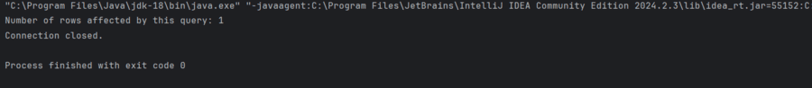

**Note:**When the program runs successfully, a new record is added to the students table as shown below:

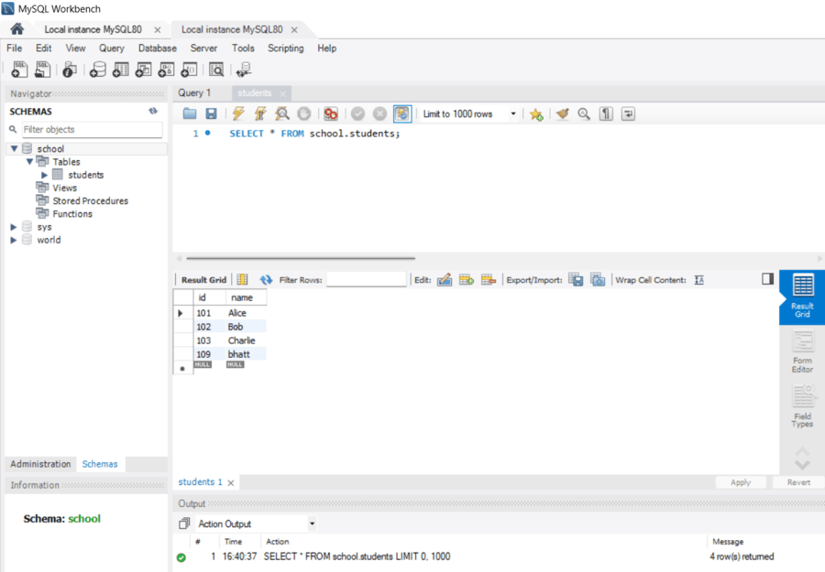

**Key Features**

* **Platform Independence**: It enables database operations across different platforms.
* **Standard API**: It provides a uniform interface for various databases.
* **Support for Multiple Databases**: It works with popular databases like MySQL, PostgreSQL, Oracle, etc.
* **Extensibility**: It offers features like batch processing, connection pooling, and transaction management.