|  |  |  |  |  |  |  |
| --- | --- | --- | --- | --- | --- | --- |
| Source | Element name or image | P / S* | Details of permission if used | Element Description | Details of editing  (this is a very important part of the process, as this is where you will show how you have made the assets fit for audience and purpose) | In which part of the project have you used this asset? |
| Taken Picture from internet  <https://lh5.googleusercontent.com/p/AF1QipPdEkZDUhHnoE1m2molvwPolvg7R0Do0VzK6T4m=w408-h544-k-no> |  | P | Permission not required Public Place | Front of the college. | Image will be cropped and border will be added to the image. | Home Page |
| <http://blog.ixl.com/2012/09/25/how-do-you-manage-your-classroom/>  Taken from Internet |  | S | Website states that image can be used for personal or educational purpose. | Classroom with students. | Border will be added and image will be rotated. | About the College Page |
| <http://www.freesfx.co.uk/>  Taken picture from Internet |  | S | Can use sound free to download from website and choose any sound you want. | Sound effect of a drum beating. | Will use sound for 4secounds merged with voice over. | Video of Place of Interest |
| Taken Picture from Internet  <https://lh5.googleusercontent.com/p/AF1QipNoXiUHtjXuTuNHd1y2GOGatojA4eIU0uOU21YX=w408-h544-k-no> |  | P | Permission granted from the owner of the shop. | The front of the PFC shop. | Image shows | Place of Interest Page |
|  |  |  |  |  |  |  |
|  |  |  |  |  |  |  |

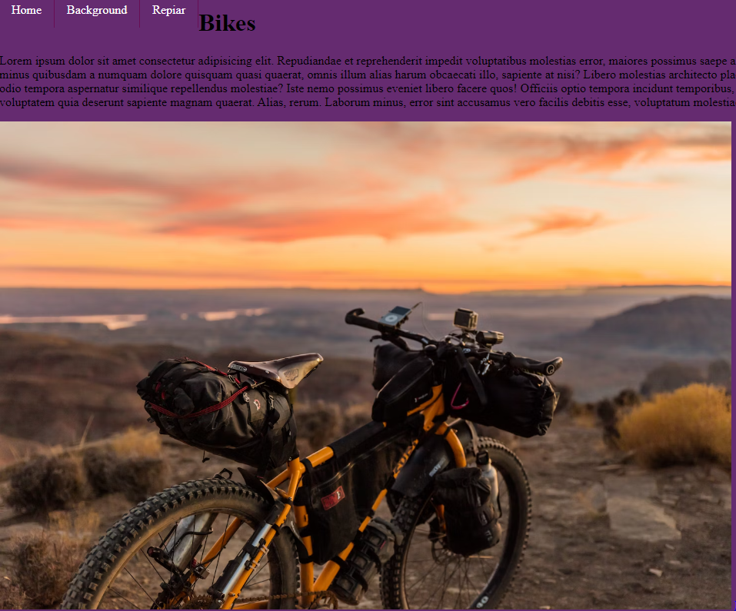

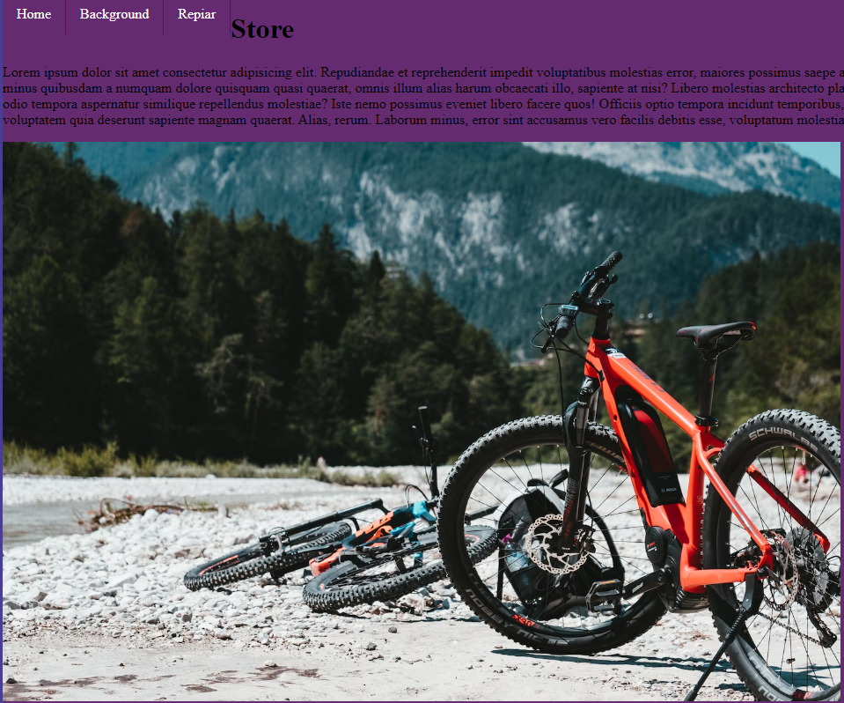

This is the screen

This is the home screen

This is the background screen

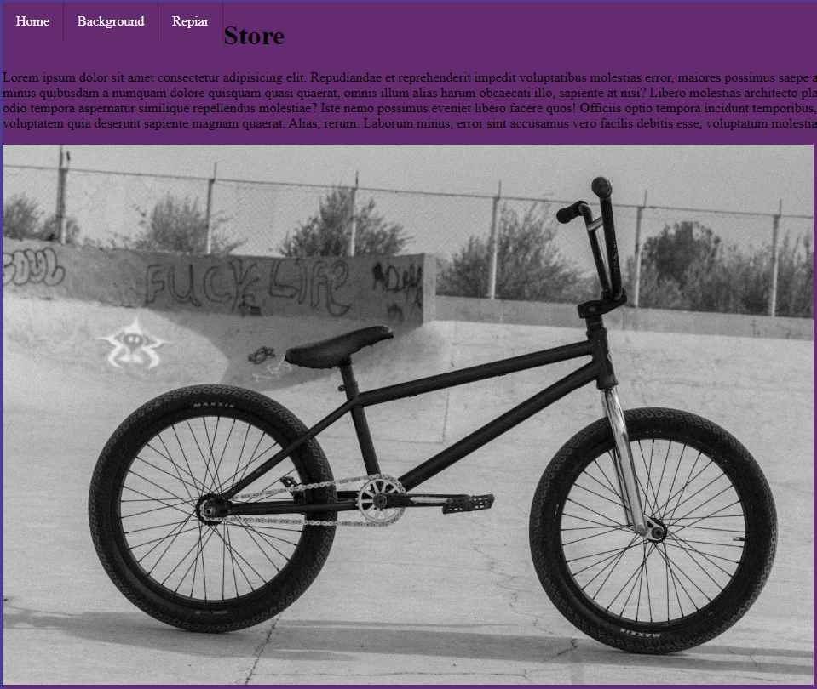

This is the repair screen

The purpose of this website is for people to buy or rent bikes and also get their bike repaired.

Picture of new bicycles

Rent

Repair

NCC Bicycles

Picture of old bicycles

Teams

New Bicycles

Home