**Module -1**

1. **What is SDLC?**

* SDLC means software development life cycle**.**
* SDLC is a structure imposed on the development of a software product that defines the process for planning, implementation, testing, documentation, deployment, and ongoing maintenance and support.
* A Software development life cycle is essentially a series of steps, or phases , that provide a model for the development and life cycle management of an application or piece of software.
* It’s provide model for the development,acquisition ,and configuration of software systems.

1. **What is software testing?**

* Software testing is a process used to identify the correctness,

Completeness,and quality of developed computer software.

* Testing is executing a system in order to identify any gaps,errors or missing requirements in contrary to the actual desire or requirements.

1. **Explain working methodology of agile model and also write pros and cons?**

* It is a combination of iterative and incremental process model.
* Its divided the software into small increment builds,this build

are provide in iteration that mean the big projects are divided into small iteration.

* Each iteration test about one to three weeks.
* Each iteration all the team members working simultaneously or are like planning,requirement,analysis,design,coding,unit testing,&acceptance testing.
* At the end of the iteration the working product displayed to the customer &its relesed in the market.
* After released we check for the feedback of the deployed software.
* If any enhancement is needed in the project its done & its rereleased.
* **Pros:**
* Suitable for fixed or changing requirements .
* Resource requirements are minimum.
* **Cons:**
* Not suitable for handling complex dependencies.
* More risk of sustainability ,maintainability and extensibility.

1. **What is SRS ?**

* Software Requirement Specification.
* A software requirement specification is a complete description of the behavior of the system developed.
* **Types of requirements:**
* **Customer Requirements:**

The customers are those that perform the eight primary functions of systems engineering, with special emphasis on the operators the key customer.

* **Functional Requirements:**

Functional Requirements are very important system requirements in the system design process.

* **Non functional requirements:**

Non functional requirements are requirements that specify criteria that can be used to judge the operation of a system,rather than specific behaviours.

1. **What is oops ?**

* Object oriented programming.
* Identifying objects and assign in responsibilities to these objects.
* Objects communicate too the objects by sending messages.
* Messages are received by the methods of an object.
* An object is like a black box.
* Object oriented programming has a web of interacting objects,each house keeping its own state.

1. **Write Basic Concepts of oops**

* Object
* Class
* Encapsulation
* Inheritance
* Polymorphism
* Abstraction

1. **What is object ?**

* Object gives permission to access the functionality of class.
* This is the basic unit of object oriented programming.
* That is both data and function that operate on data are bundled as a unit called as object.
* Object =Data+Methods.

1. **What is class ?**

* Class is collection of data and function.
* Class represents an abstraction of the object and abstracts the properties and behaviour of that object.
* An object is a particular instance of a class which has actual existence and the can be many objects for a class.
* For Making Class,Creating,extending or reusing abstract datatypes.
* For Making Objects , Creating objects from abstract data .

1. **What is encapsulation ?**

* Encapsulation is the practice of including an object everything it needs hidden from other objects. The internal state is usually not accessible by other objects.
* Its wrapping of data.

1. **What is inheritance?**

* Inheritance means that one class inherits the characteristics of another class.This is also called a“isa” relationship.
* One of the most useful aspects of object-oriented programming is code reusability. As the name suggests Inheritance is the process of forming a new class from an existing class that is from the existing class called as base class,new class is formed called asderived class.

1. **What is Polymorphism?**

* Polymorphism means “having many forms”.
* It allows different objects to respond to the same message in different ways, the response specific to the type of the object.
* **Two Types**
* **Overriding:** Function with same name & parameter.
* **Overloading:** Function with same name but different parameter.

1. **Write SDLC phases with basic introduction?**

* **Requriments:**

* Establish customer needs.
* Features
* Usage scenarios
* Although requirement may be documentes in written

Form,they may be incompleted,unambiguous,even incorrect.

* Functional & non function.
* **Analysis:**

* Ideally,this document states in a clear &precise fashion what is to be built.
* This analysis represent “what” phase.
* **Design:**
* Design architecture document
* Implementation plan
* Performance analysis
* Test plan
* **Implementation:**
* The team builds the component either from scratch or by composition.
* The implementation phase deals with issues of quality,performance,baseline,libraries,debugging.
* **Testing:**
* Simply stated, quality is very important.Many companies have not learned that quality is important and deliver more claimed functionality but at a lower quality level.
* It is much easier to explain to a customer why there is a missing feature than to explain to a customer why the product lacks quality.
* A customer satisfied with the quality of a product will remain loyal and wait for new functionality in the next version.
* Quality is a distinguishing so one of the phases in the System Development Life Cycle(SDLC), as it applies to software development.
* **Maintenance:**
* Its process of changing a system after its has been deployed.
* **Corrective maintenance:** identify and reparing defect.
* **Adaptive maintenance:** the exesting solution to the new plateform.
* **Perfective maintenance:** implementing the new requirement.

1. **Explain Phases of the waterfall model?**

* The waterfall model is a process for software development.
* It’s a linear-sequential life cycle model, which means you need to complete each stage of the model before you can start the next stage.
* Since it follows a logical sequence of steps throughout the software development life cycle, similar to how a waterfall flows down a cascading set of rocks, it’s called the waterfall model.
* The waterfall model has six phases: **Requirements, Analysis, Design, Implementation, Testing, and Maintenance.**
* **Requirements gathering and analysis:** All possible requirements of the system to be developed are captured in this phase and documented in a requirement specification doc.
* **Design:** The requirement specifications from first phase are studied in this phase and system design is prepared. System Design helps in specifying hardware and system requirements and also helps in defining overall system architecture.
* **Implementation:** With inputs from system design, the system is first developed in small programs called units, which are integrated in the next phase. Each unit is developed and tested for its functionality which is referred to as Unit Testing.
* **Testing:** This phase is highly crucial as the quality of the end product is determined by the effectiveness of the testing carried out. The better output will lead to satisfied customers, lower maintenance costs, and accurate results. Unit testing determines the efficiency of individual modules. However, in this phase, the modules are tested for their interactions with each other and with the system.
* **Maintenance:** it includes making the appropriate modification to the product or system or enhancing, changing, or modifying attributes related to performance issues related to the system. its main role is to improve the performance of the system with the maximum accuracy result of the software output.

1. **Write Phases of the spiral model?**

* **Planning phase:**
* Requirements understanding document.
* Finalized list of requirements.
* **Risk analysis phase:**
* identify the potential risks.
* Once the risks are identified , risk mitigation strategy is planned and finalized.
* **Engineering phase:**
* Actual development and testing if the software takes place in this phase.
* **Evaluation phase:**
* Customers evaluate the software and provide their feedback and approval.

1. **Write agile manifesto principles ?**

* **Customer satisfaction through early and continuous software delivery :** Customers are happier when they receive working software at regular intervals, rather than waiting extended periods of time between releases.
* **Accommodate changing requirements throughout the development process :**The ability to avoid delays when a requirement or feature request changes.
* **Deliver working software frequently:** Scrum accommodates this principle since the team operates in software sprints or iterations that ensure regular delivery of working software.
* **Break the Silos of Your Project:Business people and developers must work together daily throughout the project.**

### ****Build Projects Around Motivated Individuals:**** The logic behind the fifth of the Agile principles is that by reducing micromanagement and empowering motivated team members, projects will be completed faster and with better quality.

* **The Most Effective Way of Communication is Face-to-face:****The most efficient and effective method of conveying information to and within a development team is face-to-face conversation**

### ****Working Software is the Primary Measure of Progress:**** It doesn't matter how many working hours you've invested in your project, how many bugs you managed to fix, or how many lines of code your team has written.

* **Maintain a Sustainable Working Pace**:**Agile processes promote sustainable development. The sponsors, developers, and users should be able to maintain a constant pace indefinitely.**

### Continuous Excellence Enhances Agility: continuous attention to technical excellence and good design enhances agility

* **Simplicity is Essential:** Simplicity–the art of maximizing the amount of work not done–is essential.
* **Self-organizing Teams Generate Most Value**: the best architectures, requirements, and designs emerge from self-organizing teams
* **Regularly Reflect and Adjust Your Way of Work to Boost Effectiveness :**At regular intervals, the team reflects on how to become more effective, then tunes and adjusts its behavior accordingly.

1. **What is agile methodology?**

* The Agile methodology is a way to manage a project by breaking it up into several phases.
* It involves constant collaboration with stakeholders and continuous improvement at every stage. Once the work begins, teams cycle through a process of planning,executing,and evaluating.
* Agile is a philosophy ,i.e.,a set of values and principles to make a decision for developing software.
* Agile is based on the iterative-incremental model.

.

1. **Draw usecase on Online shopping product using payment gateway.**

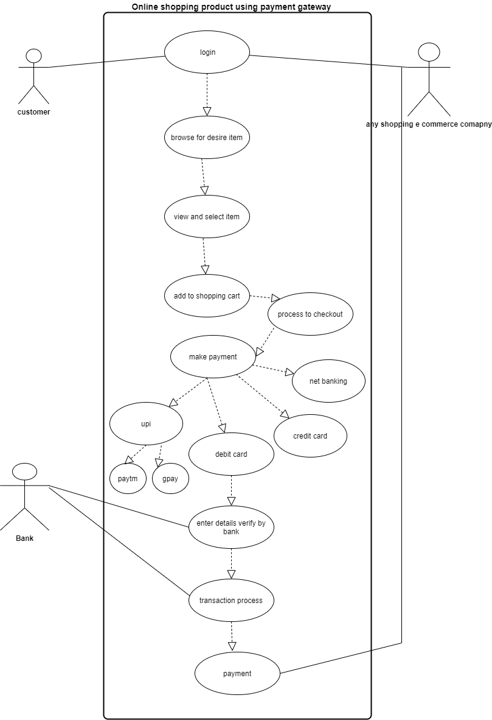

1. **Draw usecase on Online shopping product using COD.**

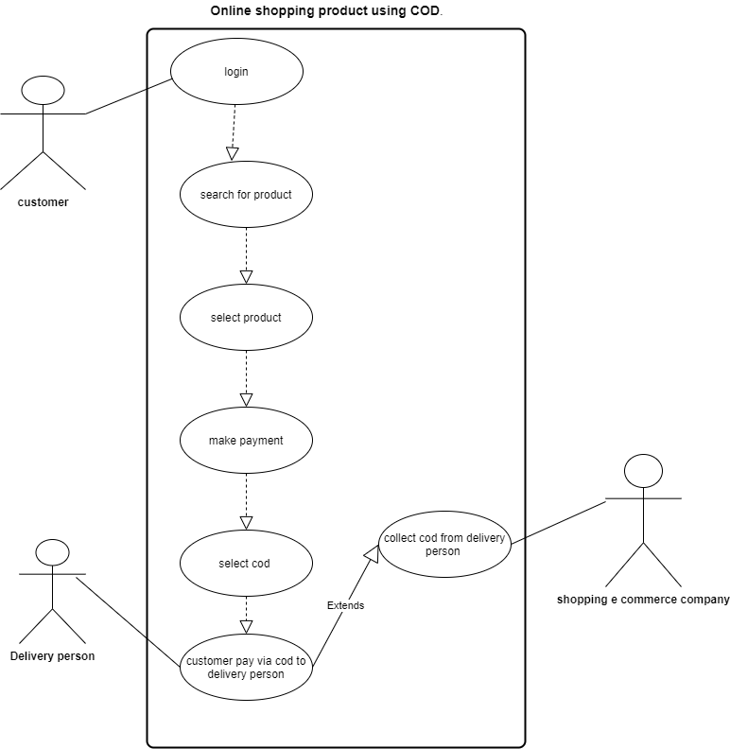

1. **Draw usecase on online book shopping**

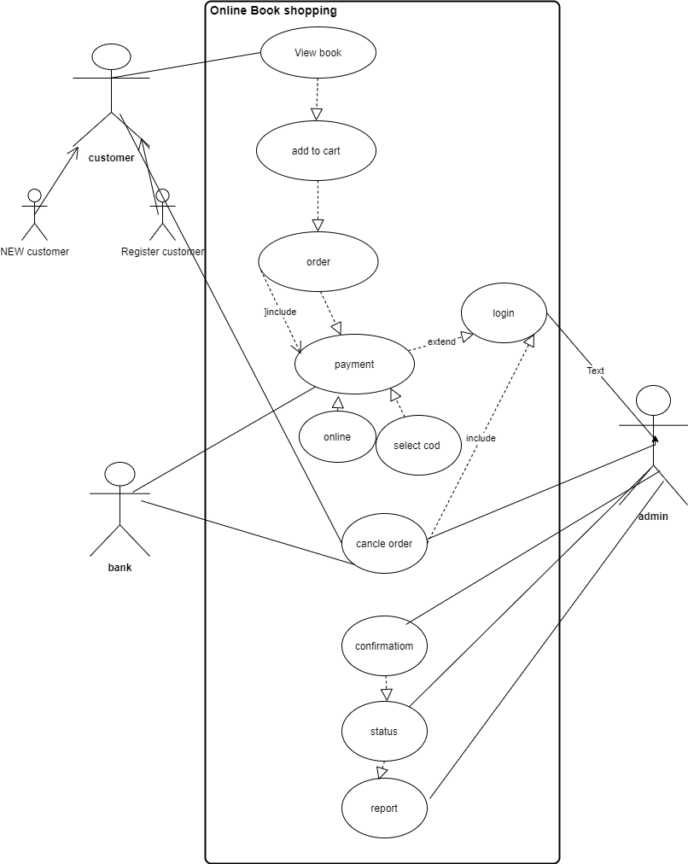

1. **Draw usescase on online payment system(paytm)**

