Simple BLE modem model
BabbleSim 2.4GHz Phy modem model

Copyright 2018 Oticon A/S
Copyright 2025 Nordic Semiconductor ASA

Licensed under the Apache License, Version 2.0 (the "License");
you may not use this file except in compliance with the License.
You may obtain a copy of the License at

http://www.apache.org/licenses/LICENSE-2.0

Unless required by applicable law or agreed to in writing, software
distributed under the License is distributed on an "AS IS" BASIS,
WITHOUT WARRANTIES OR CONDITIONS OF ANY KIND, either express or implied.
See the License for the specific language governing permissions and
limitations under the License.

---------------------------------------------------------

This license applies both to this component’s source code and documentation, including this file.

Introduction
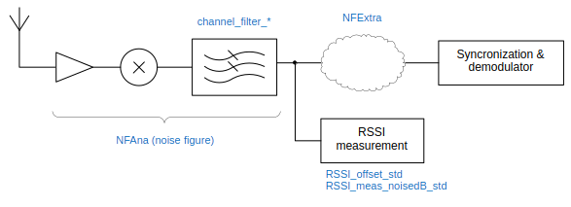Illustration 1: Model assumed receiver pseudo-architecture and parameters

This BabbleSim component is a model of a 2.4GHz BLE modem.
It can be used together with the BabbleSim 2.4GHz physical layer (Phy).
Although a very simple model, it includes the typically dominant impairments that affect BLE receptions:
- Thermal noise
- Co-channel interference
- Adjacent channel interference
It also includes a simple RSSI measurement noise model.
Each of this is described below in its own section
This model does not intend to represent any particular receiver architecture, and due to its simplicity, its parameters may be easily adjusted to roughly match the performance of different real modems.

Thermal noise
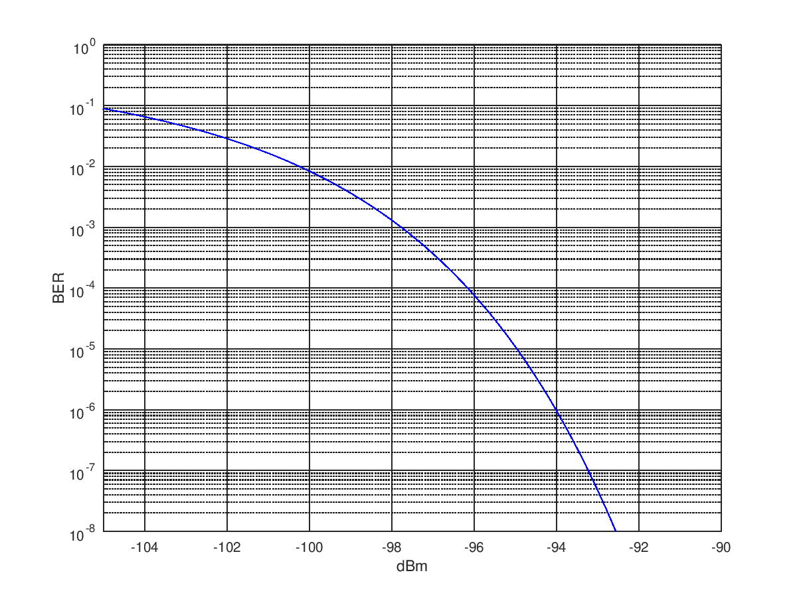Illustration 2: 1Mbps BLE demodulation performance with the default NFAna=4dB, NFExtra=2dB, Nfloor=-35dB
The receiver noise performance is modeled with 2 parameters:
- Its noise figure (command line configurable)
- The channel filter noise BW
The noise figure is divided in two parts (NFAna and NFExtra), to allow for affecting less the RSSI (Received Signal Strength Indication) measurements than the signal to be demodulated.
The channel filter noise bandwidth is dependent on the receiver modulation configuration.

Co-channel and adjacent channel interference
Any non desired signal present at the antenna will be filtered with the receiver channel filter according to its offset from the desired signal.
The total power from these signals will affect both the RSSI measurements and the SNR (Signal to Noise Ratio) in demodulation.

Demodulator
The demodulator, for 1 and 2 Mbps BLE, will behave like an ideal 2FSK demodulator when receiving a signal with an SNR equal to {desired signal power} / ({Thermal noise} + {interference power}), but with a limit to the SNR imposed by the parameter Nfloor_dig.
For BLE Coded Phy (Long Range) and HDT the performance is approximated from empirical values obtained from simulations based on theoretical generic receivers.
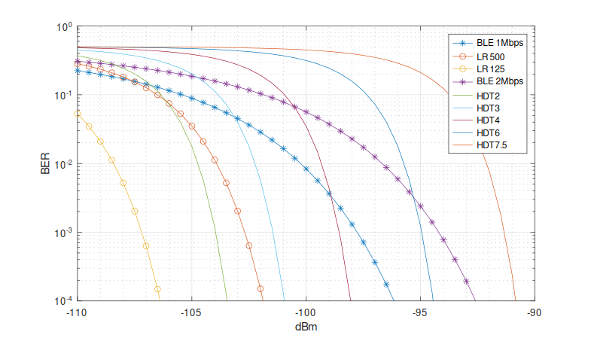Illustration 3: 1 & 2Mbps BLE, Coded Phy and HDT demodulation performance

Synchronization
No model of synchronization effects is included. But a parameter is provided (PER) to adjust the excess packet error rate due to these effects.

RSSI measurements
A simple model of a device (calibration) power measurement offset is included. This offset is modeled as a normal distribution with average 0, and standard deviation configurable from command line with RSSI_offset_std. This offset is drawn for each device during initialization, and is constant during the whole execution and for the whole band.
Also a per-measurement error/noise component is modeled as another normal distribution with average 0 and standard deviation configurable with the command line parameter RSSI_meas_noisedB_std

