1.INTRODUCTION

Pg-1

INTRODUCTION

The “Online Bakery Management System” has been developed to override the problems
Prevailing in the practicing manual system. This website is supported to eliminate and in
Some cases reduce the hardship faced by this existing site. Moreover, this site is designed
For the particular need of the easily shopping a bake and save the money and time carry
Out operation in a smooth and effective manner.
This project is entitled Online Bakery management system This project is an automated
Platform for bakery shop.

This system is reduced as much as possible to avoid errors while entering the data. It also
Provides error message while entering invalid data. No formal knowledge is needed for the
use this system. Thus, by this all it proves it is user-friendly bakery management system, as
described above can lead to error free, secure reliable and fast management system. It can
assist the user to concentrate on the record keeping. Thus, it will help organization in better
utilization of resources.

Pg-2

2.Scope of work

Pg-3

Scope of work

- In computer system the person has to fill the various form and number of copies of the forms can be easily generated at a time.
- In computer system. It is not necessary to create the manifest but we can directly print it
which saves our time.
- To assist the staff in capturing the create the effort spent on their respective working area.
- To utilize resources in an efficient manner by increasing their productivity though automation.
- The system generates types of information that can be used for various purposes.

- It satisfies the user requirement.
- Be easy to understand by the user and operator.
- Be easy to operate.
- Have a good user interface.
- Be expandable.
- Delivered on schedule within the budget.

Pg-4

3. An existing system

Pg-5

An existing system

- In the existing system the exams are done only manually but in proposed system
We have to computerize the exam using this application.

- Lack of security of data
- More man power
- Time consuming
- Consumes large volume of pare work
- Needs manual calculation
- No direct role for the higher officials

Pg-6

4.Need of proposed system

Pg-7

Need of proposed system
- System needs store information about new entry of product.
- System needs to help the internal staff to keep information of product type and find them as per various queries.
- System Need to maintain quantity record.
- System Need to keep the record of product company.
- System Need to keep update and delete the record.
- System also needs a search area.
- It also needs a security system to prevent data.
The first advantage of the proposed system is that its front end provides easy and précised information to the user to interact with the system and hence it is faster to complete the work. The next advantage of the present system is that its faster capability to interact with the database. Even the database also provides its inbuilt features to maintain the records. It also provides the security to the records from the system itself and also from the database itself. Hence it prevents the database conjunction. Another advantage of the proposed system is its fast search the records from the database. The proposed system provides both with the mouse or keyboard handling features to interact with the system.

Pg-8

5.Feasibility Study

Pg-9

Feasibility Study

A. Economic Feasibility

- This is a very important aspect to be considered while developing a project we decided the technology based on minimum possible cost A. economic Feasibility
- All hardware and software cost has to be borne by the organization.
- Overall, we have estimated that the benefits the organization is going to receive from the proposed system will study overcome the initial costs and the later on running cost of system.
B. Technical Feasibility

- This included the study of function, performance and constraints that may affect the ability to achieve an acceptable system for this feasibility study we studied complete functionality to be provided in the system, as described in the system requirement specification (SRS) and checked if everything was possible using different type of frontend and backend platform.
C. Operational Feasibility

- No doubt the proposed system is fully GUI based that is very user friendly and all inputs to be taken all self-explanatory even to a layman. Besides a proper training has been conducted to let know the essence of the system to the users so that they feel comfortable with new system. As far our study is concerned the clients are comfortable and happy as the system has cut down their loads and doing.

Pg-10

6.System Feature

Pg-11

System Feature
- Product and component based.
- Creating and changing issues at ease.
- Query issue list to any depth
- Easy to update information
- Work become very speedy
- Well-designed reports.
- Easy and fast ret ravel of information.
- Robust database back-end.
- Accuracy in work.
- Simple status and resolution.
- Multi-level priorities and severities.
- It contains better storage capacity.

Pg-12

7.Hardware and software

Pg-13

Hardware and software

Hardware Requirement
HARD | WARE
Items | Minimum Value
CPU | INTEL Core2Duo or higher
RAM | 256 MB or more
HARD DISK | 40 GB or more

Software Requirement
SOFTWARE
Items | Minimum Value
FRONT-END | HTML, CSS, JS
BACK-END | PHP, MY SQL
SERVER | XAMMP server, chrome broswer

Pg-14

8.Data flow diagram

Pg-15

Data flow diagram
[8.1] context level DFD

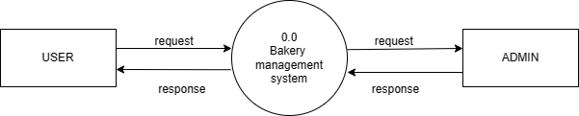

Pg-16
[8.2] Zero Admin side level DFD

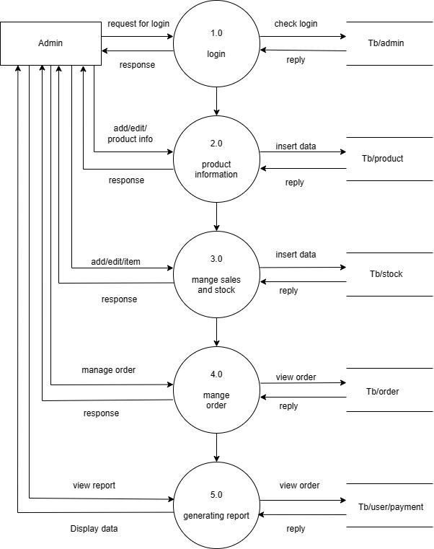

Pg-17

[8.3] Frist level admin side (3.0 &4.0)

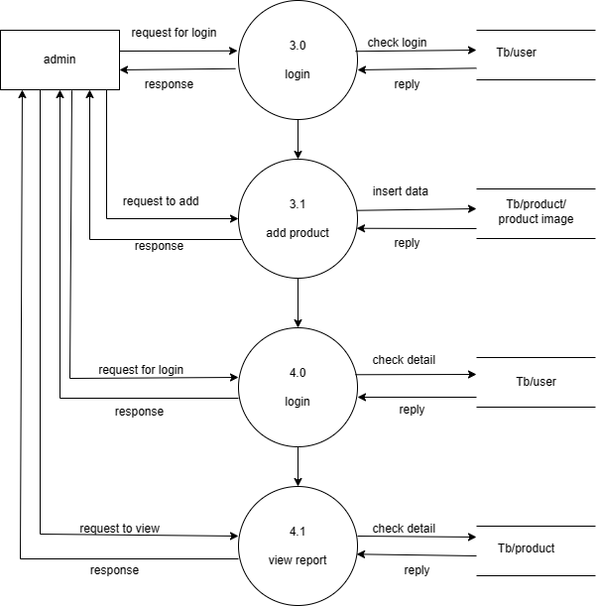

Pg-18

[8.4] zero level user side DFD
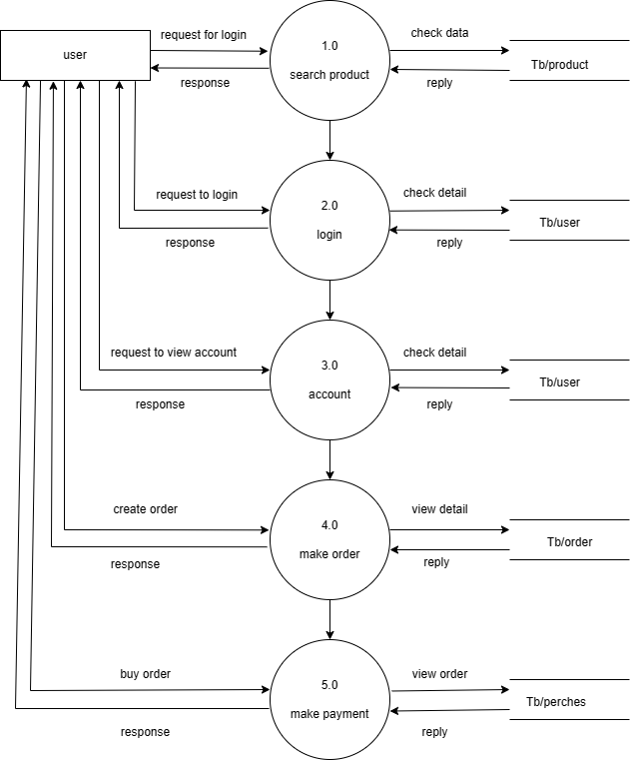

Pg-19

[8.5] Frist level user side DFD

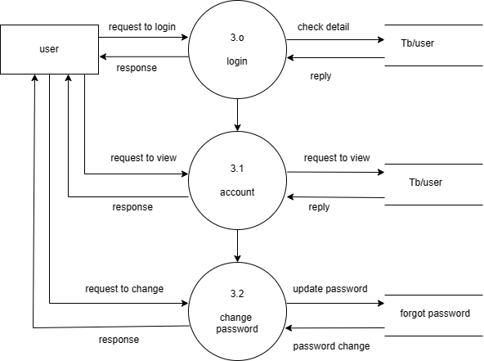

Pg-20

[8.6] Frist level user side DFD

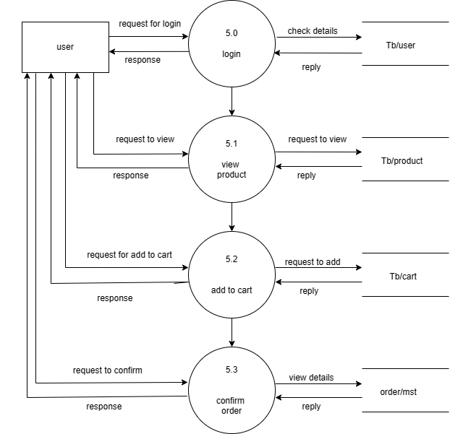

Pg-21

9.Database layout /file layout

Pg-22

Database layout /file layout

Field Name | Data type | Constrain | Description
Admin_id | Int (11) | Primary key | Admin id
Admin_username | Varchar (100) | Not null | Admin name
Admin_email | Varchar (50) | Not null | Admin Email
Admin_password | Varchar (10) | Not nu0ll | Admin password

Admin Table

Category Table
Field Name | Data type | Constrain | Description
category_id | Int (11) | Primary key | Category id
category_name | Varchar (100) | Not null | Category name
category_image | Varchar (150) | Not null | Category image

Order Table
Field Name | Data type | Constrain | Description
orders_id | Int (11) | Primary key | Orders id
User_id | Int (11) | Not null | User id
Delivery_date | Date | Not null | Delivery date
Payment_date | Date | Not null | Payment date
Total_amount | Int (8) | Not null | Total amount

Pg-23

Order Details
Field Name | Data type | Constrain | Description
orderdetails_id | Int (11) | Primary key | Order detail id
Oder_id | Int (11) | Not null | Order id
Product_name | Varchar (150) | Not null | Product name
quantity | Int (11) | Not null | quantity

Field Name | Data type | Constrain | Description
product_id | Int (11) | Primary key | Orders id
Product_name | Varchar (100 | Not null | User id
Product_category | Int (11) | Not null | Delivery date
Product_price | Int (8) | Not null | Payment date
Product_decription | Varchar (300) | Not null | Total amount
Product_image | Varchar (300) | Not null | Product image

Product Table

Users Table
Field Name | Data type | Constrain | Description
user_id | Int (11) | Primary key | User id
user_username | Varchar (100) | Not null | User name
user_email | Varchar (50) | Not null | User email
User_password | Int (10) | Not null | User password
User_mobile | Varchar (10) | Not null | User mobile
User_address | Varchar (150) | Not null | User address

Pg-24

10.Design of input/output screen

Pg-25

Login
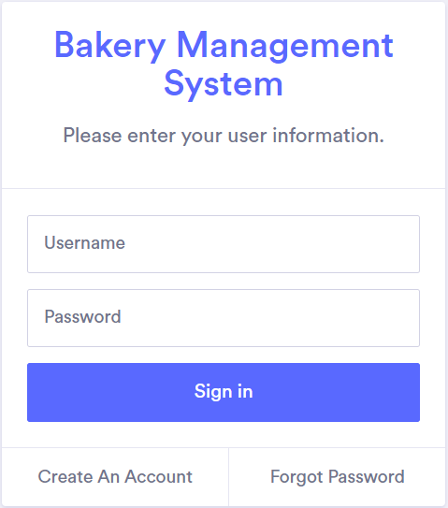

- login page is a crucial component of many web applications, providing the first point of access for authenticated users. It typically consists of two fields: one for the user's username or email address, and another for their password.

Pg-26
Account Details

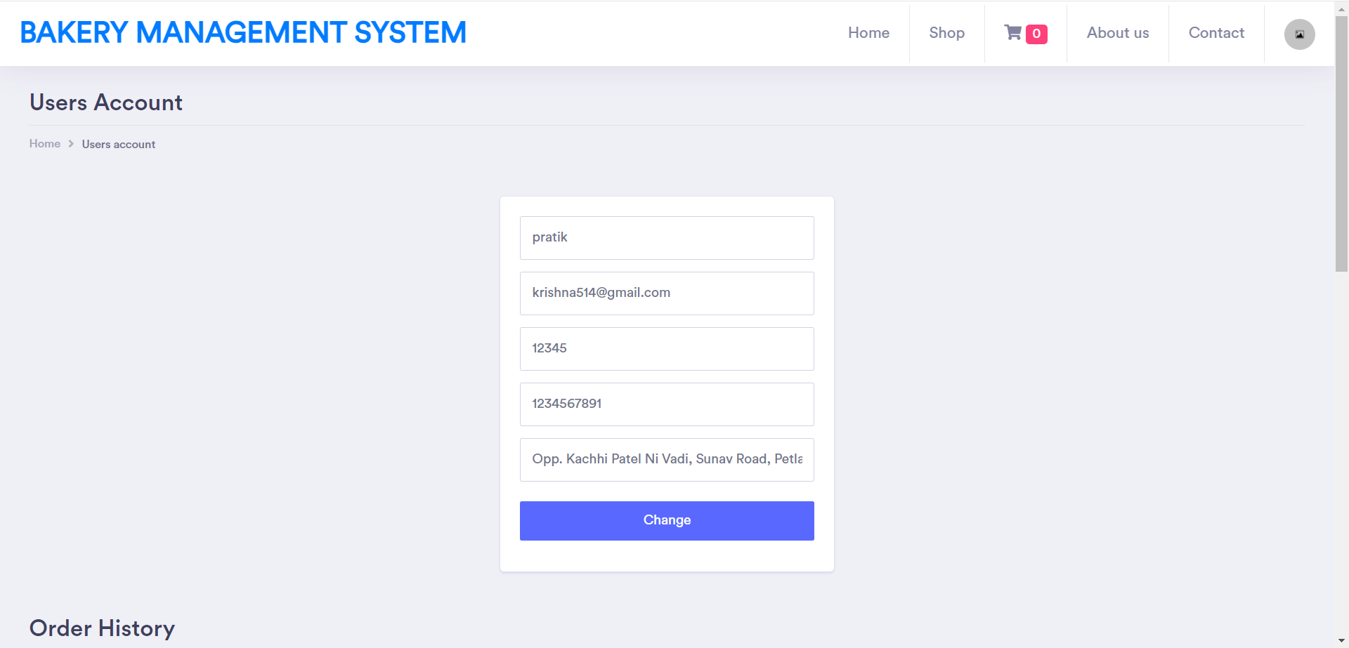

- The account page typically includes several fields that provide information about the account an allow you to manage its settings. Here are some common fields you might see:

- Additionally, the account page may include other fields or options that allow you to manage the account's settings, such as the ability to disable the account if it's no longer needed, or the ability to filter accounts based on their status.

Pg-27

Admin Dashboard

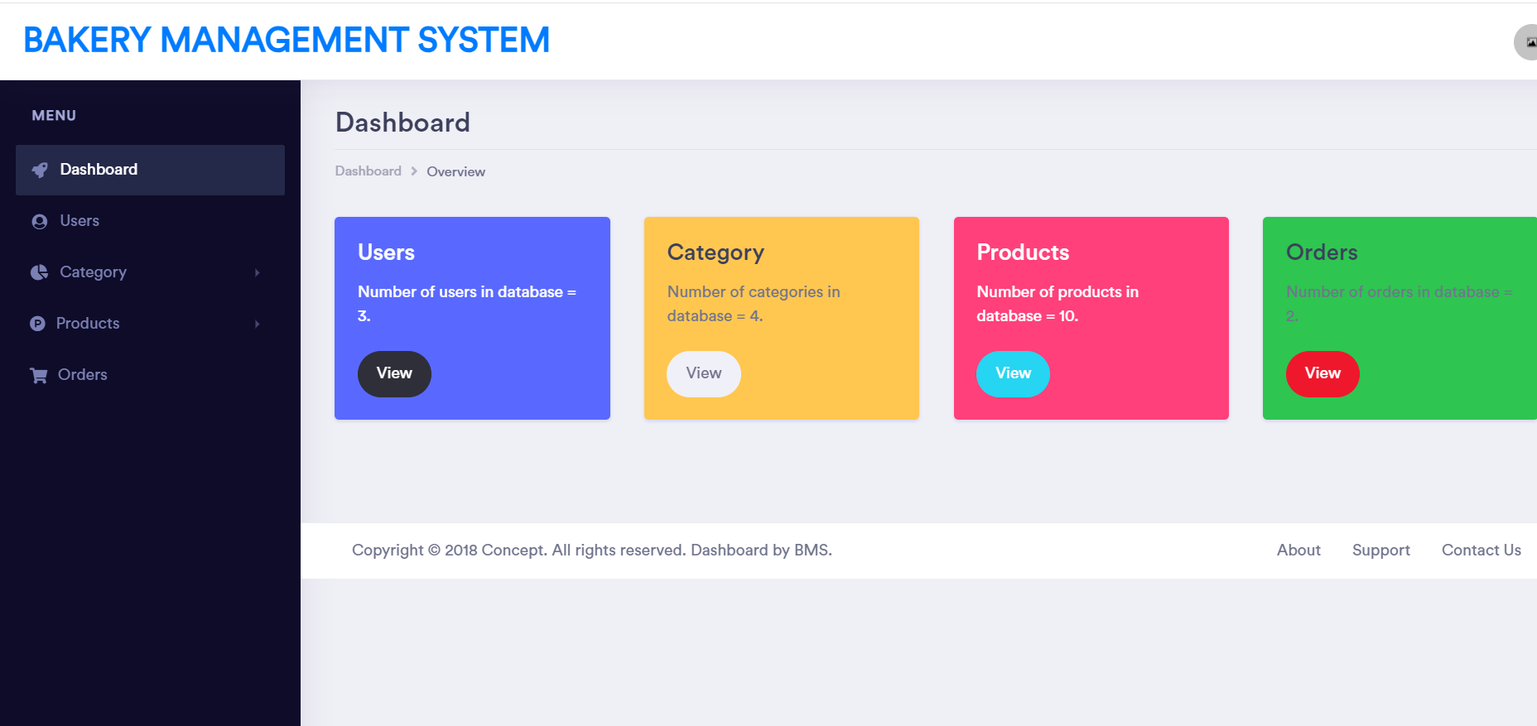

- An admin dashboard provides a centralized location for administrators to manage and monitor various aspects of a website, application, or system. Here are some details about admin dashboards:

Users

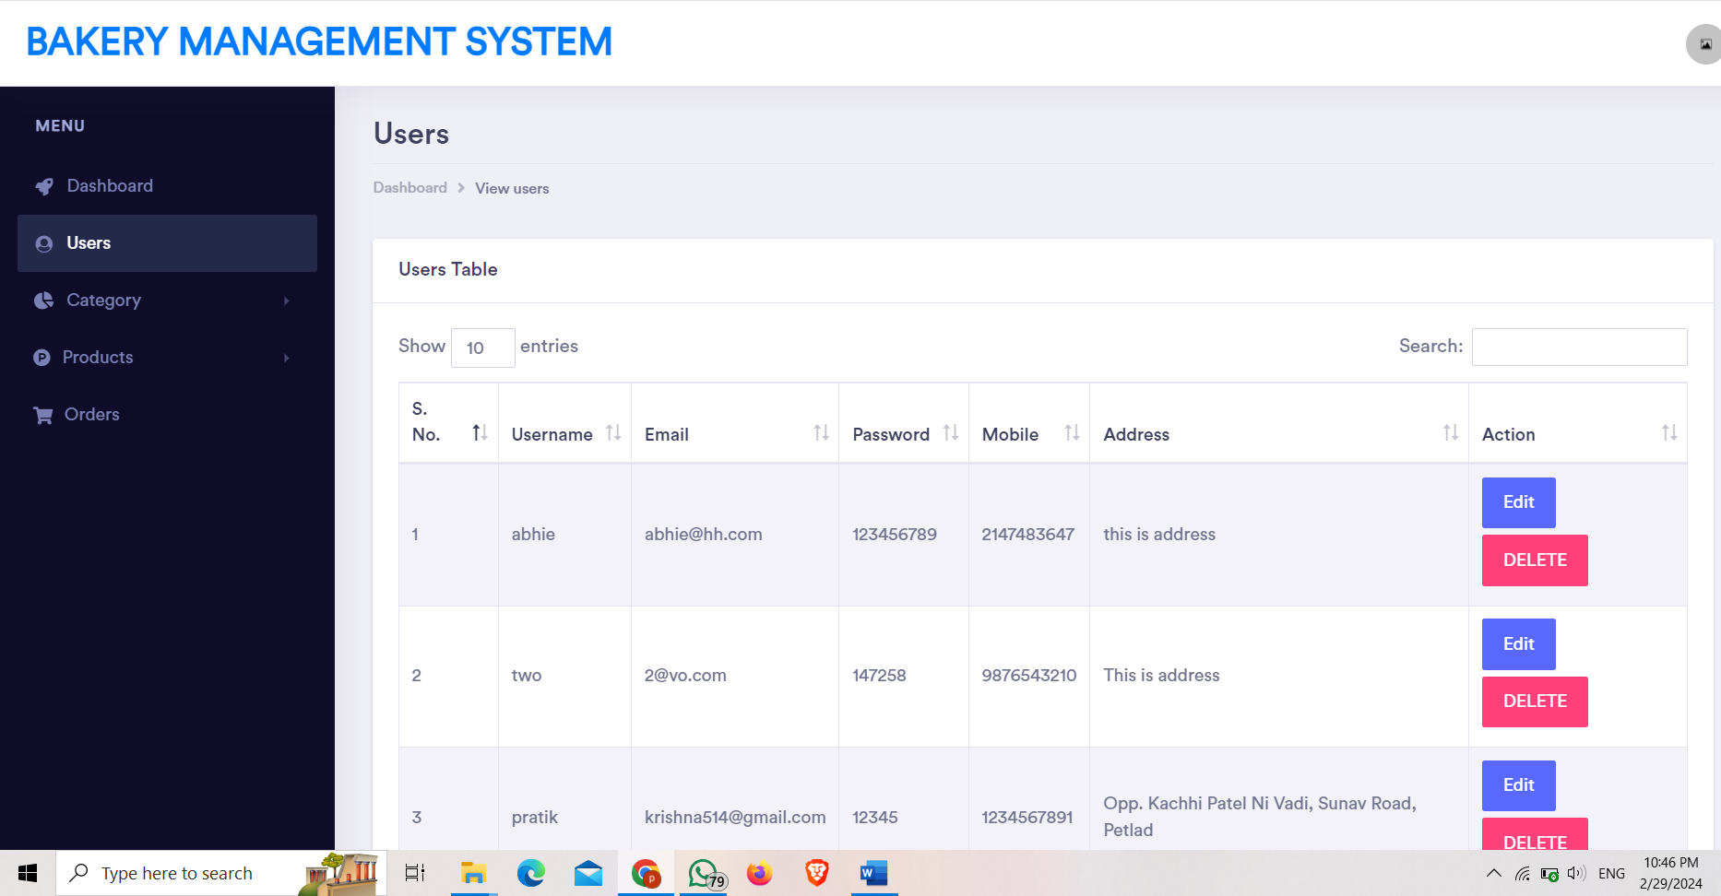
Pg-28

- A user page on Wikipedia is a page associated with a registered user's account. It is primarily used for communication and collaboration, and can be used to better participate in the community. User pages can include information about the user, such as their interests, areas of expertise, and contributions to Wikipedia.

View Category

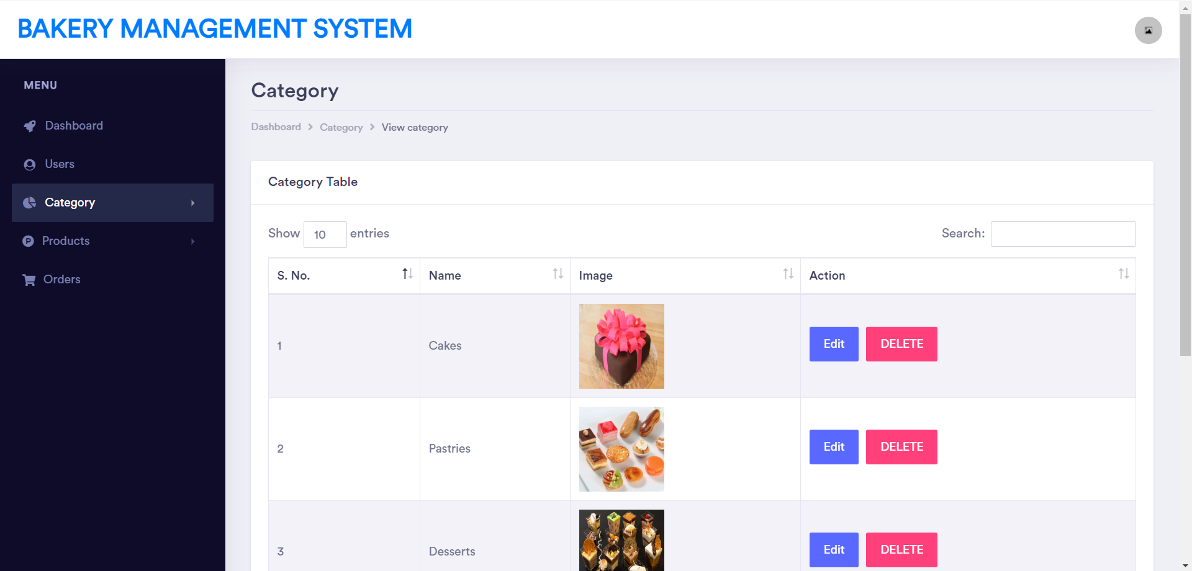

- A category page on Wikipedia is a page that organizes and groups related articles and other pages together. Categories help users find articles on specific topics and help to maintain the organization and structure of the encyclopaedia.

Pg-29
Product

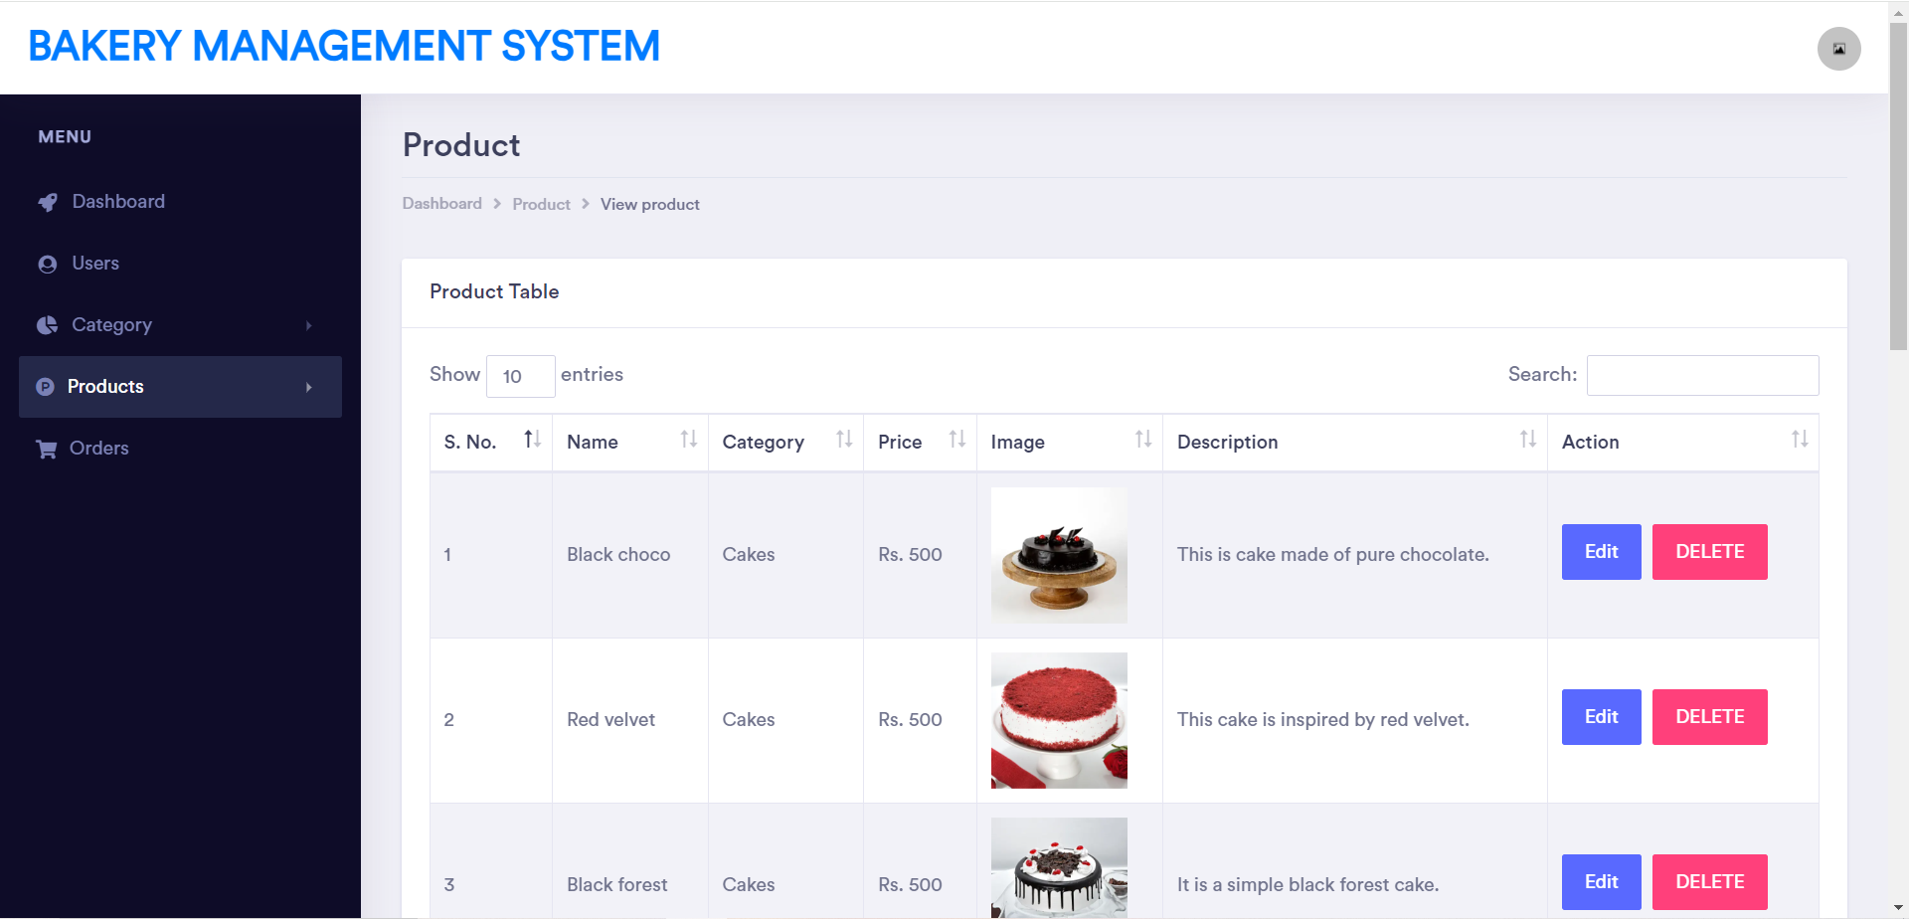

Add Product

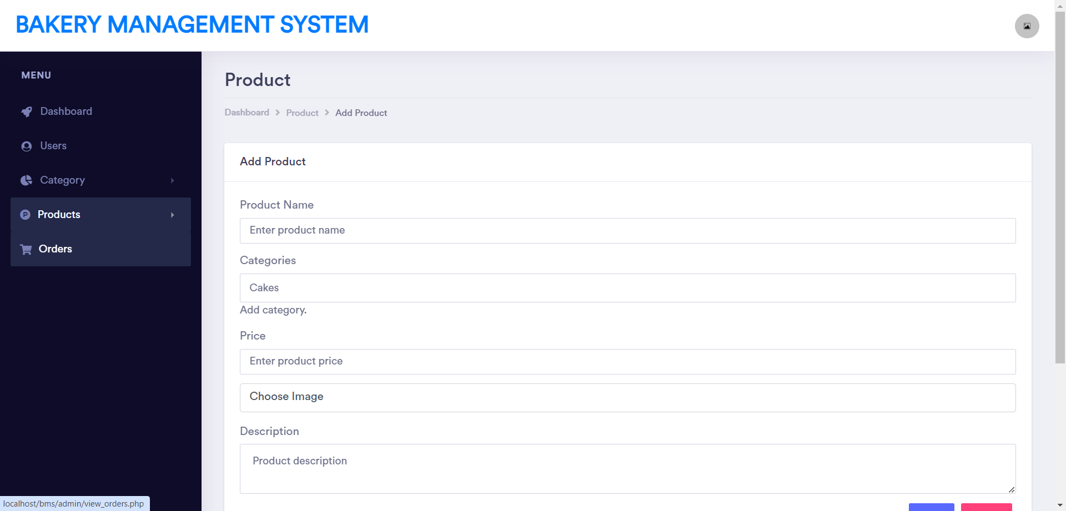

Pg-30

Orders
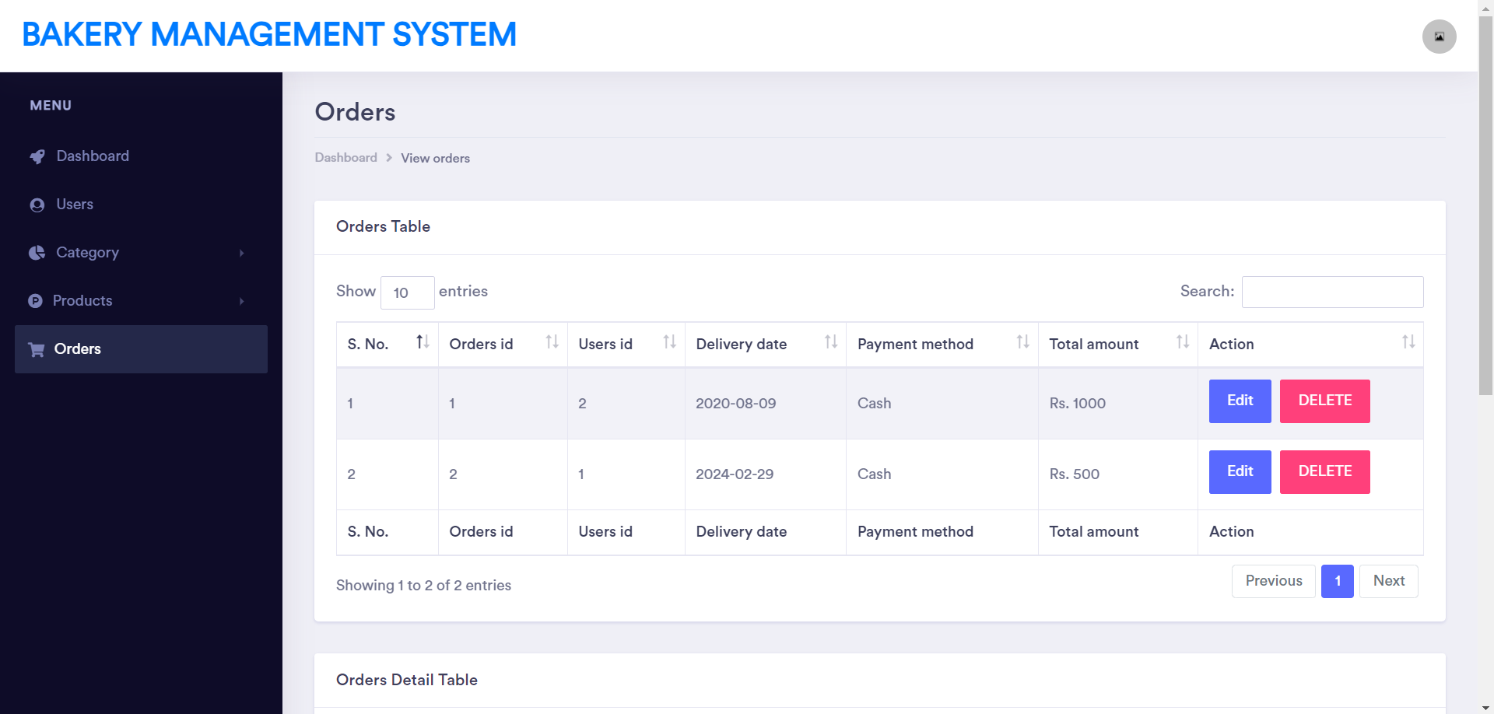

- An order page, also known as an order confirmation page, is the page that appears after a customer has completed a purchase on an e-commerce website. This page typically includes information about the order, such as the order number, a summary of the items purchased, the total cost, and shipping information. It may also include a confirmation of payment and a summary of the customer's account, if applicable.

Home

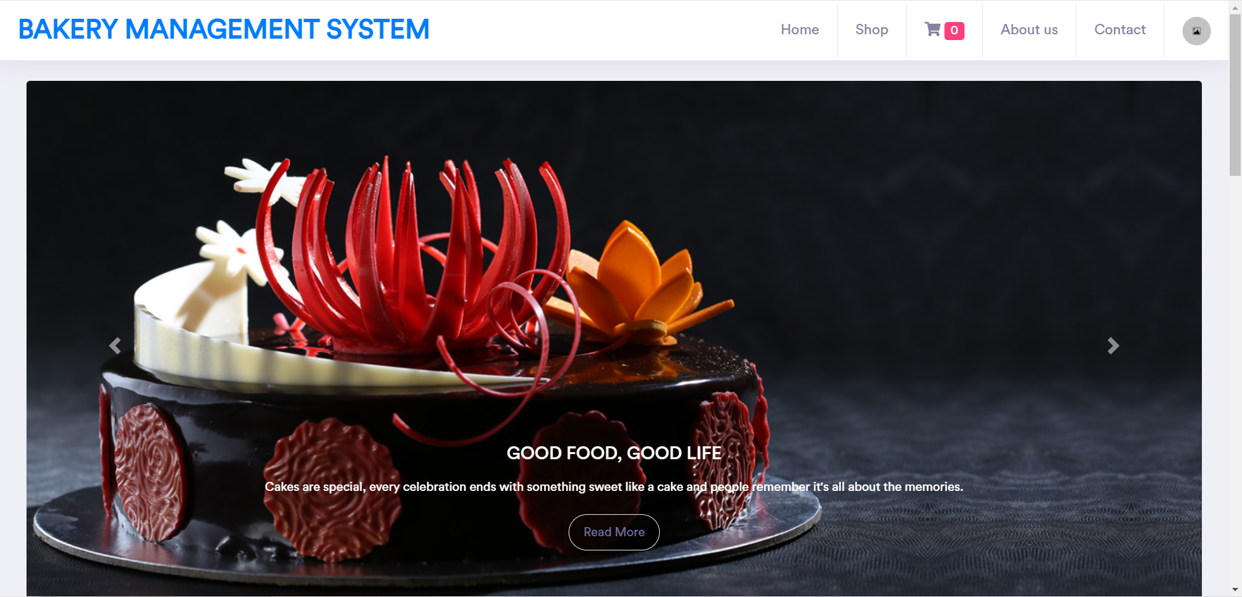

Pg-31

Shop/Products

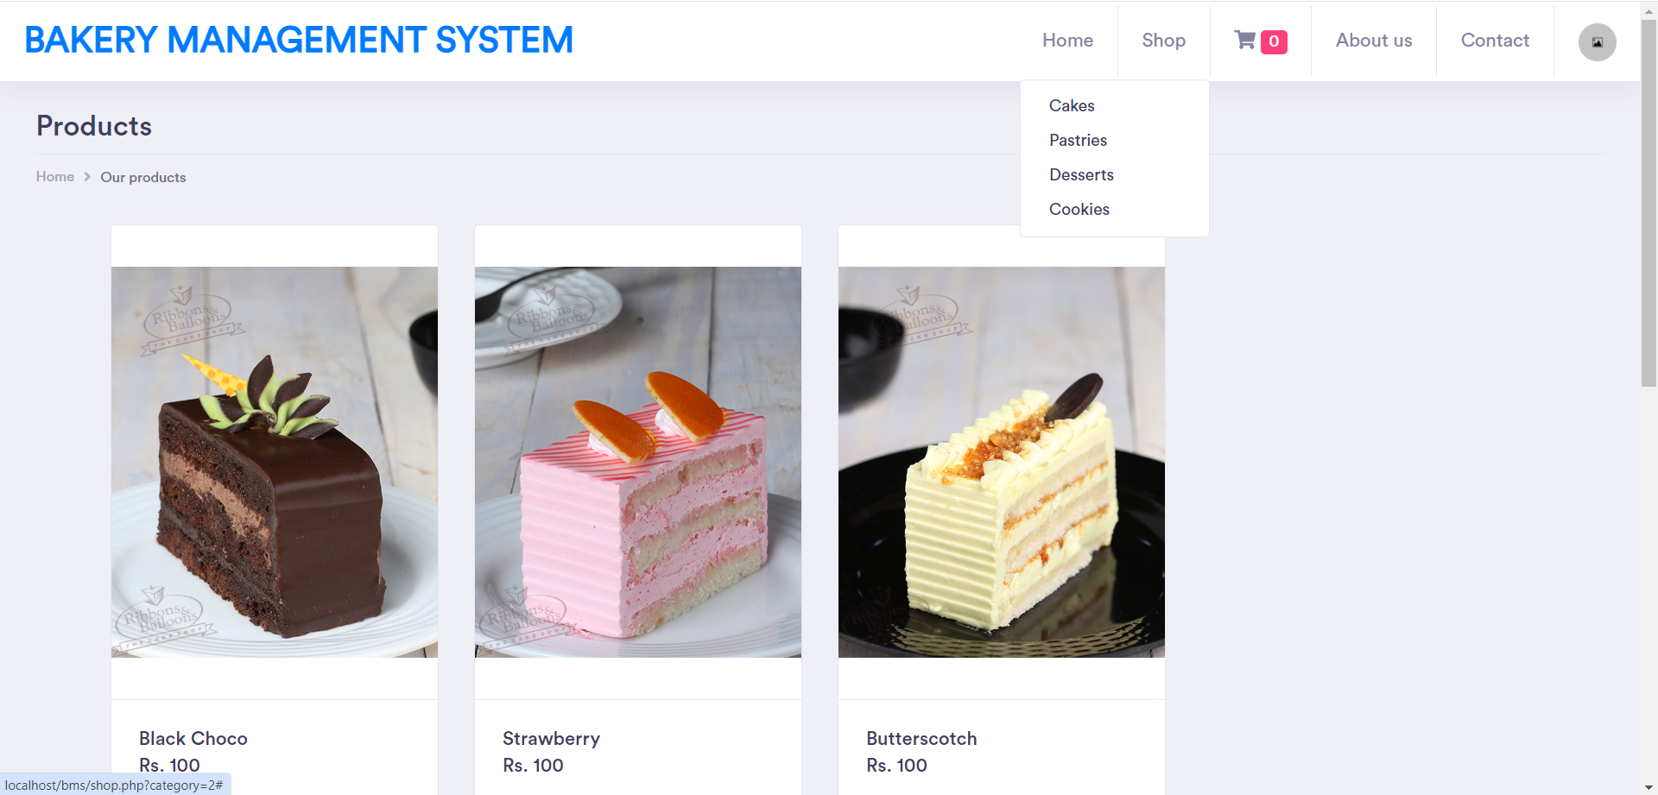

- A product page, also known as a product detail page (PDP), is a web page on an e-commerce website that provides information about a specific product. It typically includes details such as the product's name, price, description, images, availability, and reviews.

Pg-32

Cart

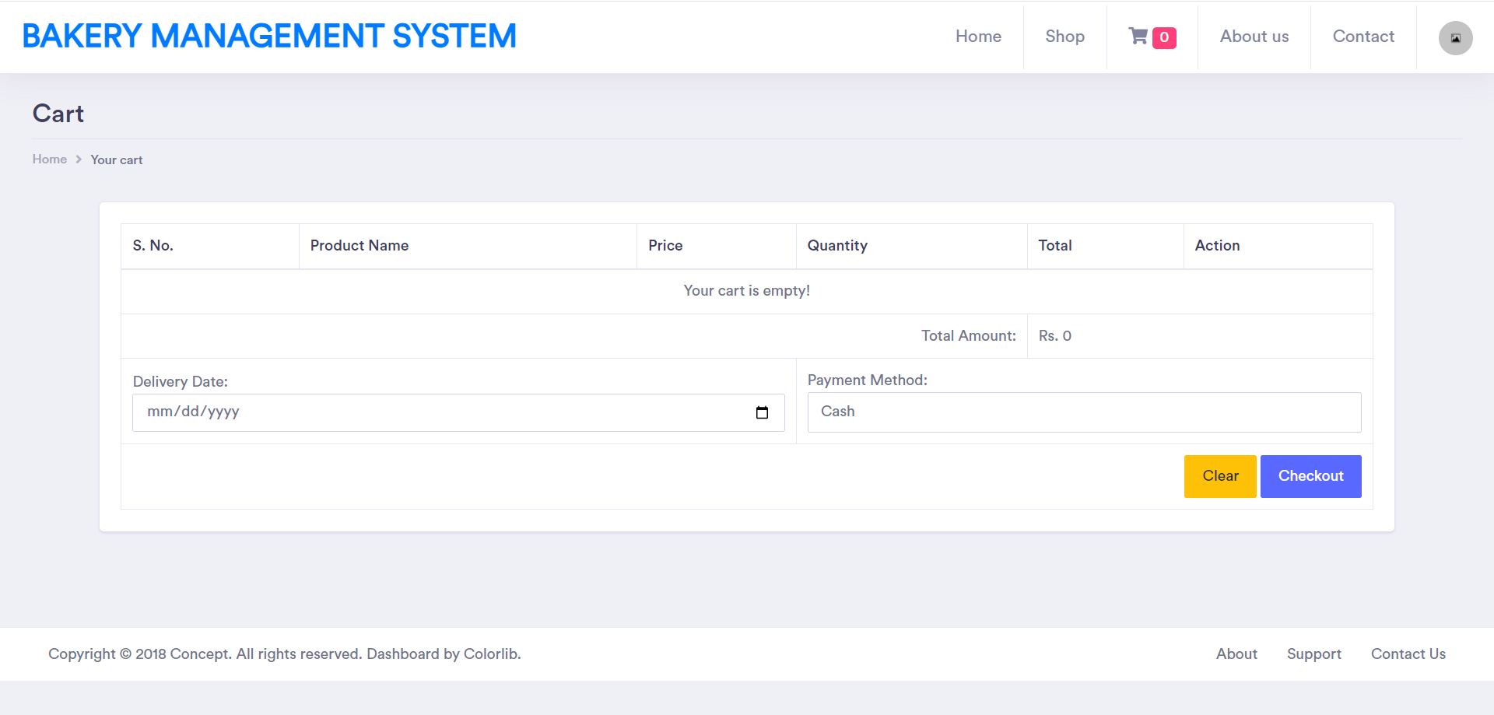

- The add-to-cart page, also known as the shopping cart or cart page, is a web page on an e-commerce website that displays the products a customer has selected for purchase. This page typically includes the product name, image, quantity, price, and total cost.

Pg-33

Validation pages
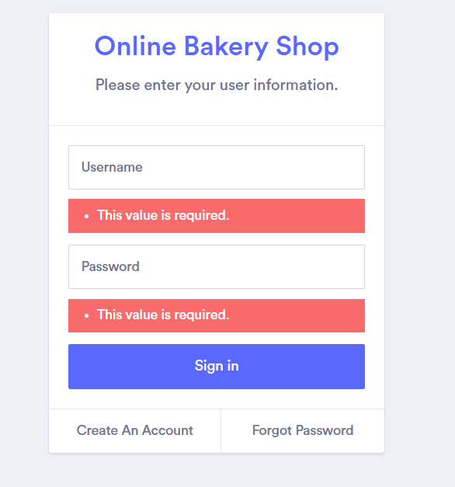
Email validation
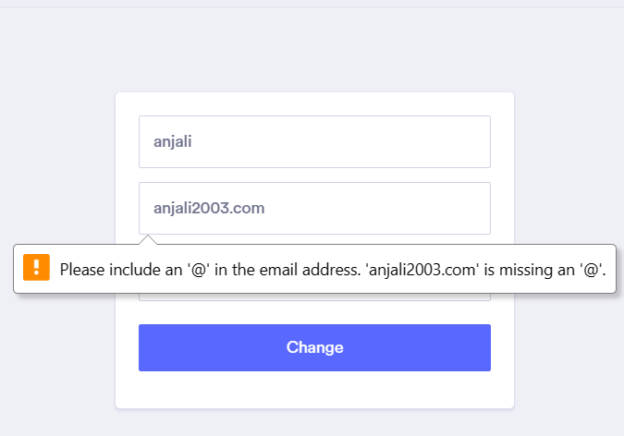

Pg-34

11.Testing Procedures & Implementation Phases

Pg-35

- Testing Procedures & Implementation Phases

Software testing is a critical element of software quality assurance and represents the ultimate review of specification, design and coding. In fact, testing is the one step in the software engineering process that could be viewed as destructive rather than constructive.
A strategy for software testing integrates software test case design methods into a well-planned series of steps that result in the successful construction of software. Testing is the set of activities that can be planned in advance and conducted systematically. The underlying motivation of program testing is to affirm software quality with methods that can economically and effectively apply to both strategic to both large and small-scale systems.

STRATEGIC APPROACH TO SOFTWARE TESTING
The software engineering process can be viewed as a spiral. Initially system engineering defines the role of software and leads to software requirement analysis where the information domain, functions, behaviour, performance, constraints and validation criteria for software are established. Moving inward along the spiral, we come to design and finally to coding. To develop computer software, we spiral in along streamlines that decrease the level of abstraction on each turn.
A strategy for software testing may also be viewed in the context of the spiral. Unit testing begins at the vertex of the spiral and concentrates on each unit of the software as implemented in source code. Testing progress by moving outward along the spiral to integration testing, where the focus is on the design and the construction of the software architecture. Talking another turn on outward on the spiral we encounter validation testing where requirements established as part of software requirements analysis are validated against the software that has been constructed. Finally, we arrive at system testing, where the software and other system elements are tested as a whole.

Pg-36

UNIT TESTING

MODULE TESTING

SUB-SYSTEM TESING

SYSTEM TESTING

ACCEPTANCE TESTING
Component Testing
Integration Testing
User Testing

Pg-37

UNIT TESTING
Unit testing focuses verification effort on the smallest unit of software design, the module. The unit testing we have is white box oriented and some modules the steps are conducted in parallel.

WHITE BOX TESTING
This type of testing ensures that
- All independent paths have been exercised at least once
- All logical decisions have been exercised on their true and false sides
- All loops are executed at their boundaries and within their operational bounds
- All internal data structures have been exercised to assure their validity.
To follow the concept of white box testing we have tested each form. we have created independently to verify that Data flow is correct, All conditions are exercised to check their validity, All loops are executed on their boundaries.

BASIC PATH TESTING
Established technique of flow graph with Cyclomatic complexity was used to derive test cases for all the functions. The main steps in deriving test cases were:
Use the design of the code and draw correspondent flow graph.
Determine the Cyclomatic complexity of resultant flow graph, using formula:
V(G)=E-N+2 or
V(G)=P+1 or
V(G)=Number of Regions
Where V(G) is Cyclomatic complexity,
E is the number of edges,
N is the number of flow graph nodes,
P is the number of predicate nodes.
Determine the basis of set of linearly independent paths.

Pg-38

- CONDITIONAL TESTING
In this part of the testing each of the conditions were tested to both true and false aspects. And all the resulting paths were tested. So that each path that may be generate on particular condition is traced to uncover any possible errors.

- DATA FLOW TESTING
This type of testing selects the path of the program according to the location of definition and use of variables. This kind of testing was used only when some local variables were declared. The definition-use chain method was used in this type of testing. These were particularly useful in nested statements.

- LOOP TESTING

- In this type of testing all the loops are tested to all the limits possible. The following exercise was adopted for all loops:
- All the loops were tested at their limits, just above them and just below them.
- All the loops were skipped at least once.
- For nested loops test the inner most loop first and then work outwards.
- For concatenated loops the values of dependent loops were set with the help of connected loop.
- Unstructured loops were resolved into nested loops or concatenated loops and tested as above.
- Each unit has been separately tested by the development team itself and all the input have been validated.

Pg-39

12. Limitations

Pg-40

Limitations
- The size of the database increases day-by-day, increasing the load on the database back up and data maintenance activity.

- Training for simple computer operations is necessary for the users working on the system.

Pg-41

13.Proposed Enhancement

Pg-42

Proposed Enhancement

- This System being web-based and an undertaking of Cyber Security Division, needs to be thoroughly tested to find out any security gaps.

- A console for the data centre may be made available to allow the personnel to monitor on the sites which were cleared for hosting during a particular period.

- Moreover, it is just a beginning; further the system may be utilized in various other types of auditing operation viz. Network auditing or similar process/workflow-based applications...

Pg-43

14.Conclusion

Pg-44

Conclusion
- The present is manual processes are time consuming and prone to error.
- Manual entries cause errors while registering the data. The computerized system arranges all sequentially which ensures quick
- retrial of required entries whenever necessary.
- It is less time consuming and more accurate.
- This is our sincere efforts to make this software standup to both customer as well as owner.

Pg-45

15.Bibliography

Pg-46

15.1 bibliography:

- www.draw.io.com
- www.w3.com
- www.google.com
- www.youtube.com

Pg-47

