**Introduction:**

Original Project Objective: The original objective of the project was identification of a multivariate regression model using the monthly percentage change in selected economic variables to forecast the monthly percentage in U.S. consumer sentiment. While the best multivariate regression model using the selected economic variables was identified, the predictive value of the model was too low to be considered viable. The result reflected past studies using economic variables to predict U.S. consumer sentiment. The multivariate regression model was rejected.

Additional Research: The application of additional models to fit and forecast the monthly percentage change in U.S. consumer sentiment included Naïve and ARIMA models. The Naïve models did not provide useful outcomes. An ARIMA model using p=1, q=0, d=3, provided a good outcome and was used to generate a forecast in Part 2 of the final project assignment.

However the additional research on outliers from Homework #5, revealed that the monthly percentage change in U.S. consumer sentiment contained multiple negative values that showed as outliers when the confidence level of the distribution of values was relatively low (alpha set to .075), and one negative value was identified as a likely outlier by the Grubb’s test. The larger negative values warranted further investigation. That investigation revealed that larger negative monthly percentage changes, less than -12 %, were associated with unusual negative geopolitical or economic events. Some examples:

Sep, 2005 – Hurricane Katrina and the economic aftermath -13.7 %

Oct, 2008 – Failure of Lehman Brothers -18.1 %

Aug, 2011– Loss of top credit rating on U.S. sovereign debt -12.4 %

The outlier analysis demonstrated that the monthly percentage change in U.S consumer sentiment was materially impacted by negative events. Any resulting model to fit and forecast the data should include an exogenous variable to include these impacts.

The Prophet Model: Another concept introduced after the original objective and analysis was the Prophet model. The Prophet model includes “specials” that allow for controls when fitting the model to time series data. Three specials are of interest. The ‘growth’ special addresses trends. While the monthly percentage change dataset did not have a long-term trend, the data included an unusual lag 2 negative autocorrelation which was difficult to address. Using the growth special and adjusting the trend flexibility, using the changepoint_prior_scale parameter, the unusual trend in the data could be addressed. The season special addresses seasonality in time series data. While the monthly percentage change in U.S. consumer sentiment displayed limited annual seasonality, the season special could address the data feature. The impact of the season special could be increased or decreased by changing the parameter, order, which determines the number of Fourier terms to apply when addressing seasonality. The xreg special allows for an exogenous variable. A binary exogenous variable was created to set months with strong negative events equal to 1 and all other months equal to 0. By adjusting the parameters in the growth and season specials and adding the exogenous variable, a suitable Prophet model was identified. Based on evaluations, the Prophet model outperformed other models that were tested. Therefore, the Prophet model was selected for this project.

**Team:** Team 7 - Andrew Sommers **Date:** April 15, 2022

**Part 3:** Application Details

**Title:** Forecasting U.S. Consumer Sentiment; Can a Sufficiently Robust Forecasting Model Be Developed?

**Details of the Forecasting Functionality:**

An optimized Prophet model, based on the evaluation of several models using different parameter settings, is initially selected for fitting the monthly percentage change in U.S. consumer sentiment. The exogenous variable is set to 0 for each month in the forecast period: No substantial negative geopolitical or economic events are expected. The confidence level is set to 85%. The defaults can be accepted, or the Research can change parameters as follows:

Growth Special – the initial value of the changepoint_prior_scale is set to .20 which allows a material amount of flexibility in the changes in trend and provides a good fit to the short-term trend in the data. The Researcher will be allowed to increase or decrease trend flexibility using a range of .10 to .30. The change will represent the Researcher’s expectation of future month to month volatility of consumer sentiment.

Season Special – the initial value of order is set to 10 Fourier terms which allows for a material amount of flexibility in the seasonal impact. The Research will be allowed to increase or decrease the seasonal impact using the range of 5 to 15 terms. The change will represent the Researcher’s expectation of the future seasonal impact on consumer sentiment.

Exogenous Variable – The Research can either except the default that no substantial negative geopolitical or economic event will occur or select a single month in the forecast period for a negative event. Again, these events are rare, so only one negative event is allowed for the forecast period.

Confidence Level – The Researcher can select a confidence level and view the mean for the forecasted monthly percentage change for U.S. consumer sentiment with expected lower and upper values. The default value is 85%, and the application will allow the Researcher to select the confidence level in the range of 75% to 95%.

After the Researcher has selected the parameters for the forecast, the monthly percentage change for U.S. consumer data, using the historical data from Jan, 2002 to Jan, 2022, will be fitted with the Prophet model, a 12 month forecast will be generated and plotted, and the resulting forecasted mean values with the lower and upper range, based on the confidence level, will be displayed. The Research can reset the parameters and generate a new forecast.

**Updated Project Objective:**

Given the additional findings from the outlier analysis and application of the Prophet model, the monthly percentage change in U.S. consumer sentiment will be fitted using the optimal Prophet model and allow the application user (“Researcher”) to forecast 12 months of data. The Research will be allowed to change the flexibility of the growth and season specials, set one of the forecast periods to be a negative event, and determine the confidence level for the forecast. By setting the flexibility of the growth and season specials, the Researcher can include her expectations of month to month volatility and annual seasonality into the forecast. The exogenous variable allows the Researcher to determine the impact of a future negative geopolitical or economic event over the next 12 months. Note that these events are rare, so only one negative event is allowed for the forecast period. By determining the confidence level of the forecast, the Researcher can interactively review the possible ranges of monthly percentage change in U.S. consumer sentiment for the forecast period.

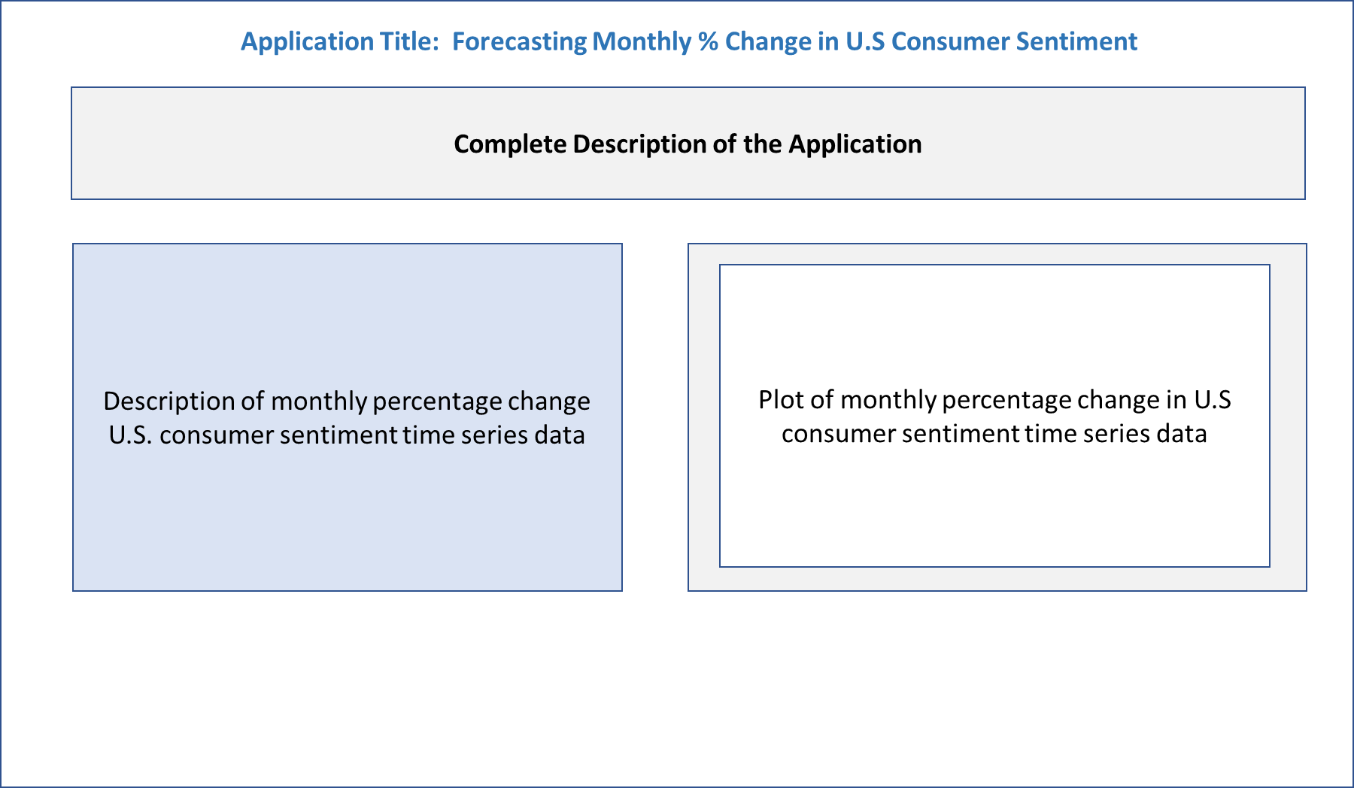

**Tab 2 – Interactive Forecasting**

**Tab 1 – Introduction to the Application**

**Interface Details:**

Functionality: The Research will be presented with an initial screen, Tab 1, that provides an overview of the application and the historical data used to generate the forecast. Tab 2 will provide a description of the forecasting functionality including the output and user definable parameters. All interactive functionality is provided on Tab 2. The growth special flexibility can be set using a slidebar. The default value of .20 is equivalent to medium on the slidebar. The flexibility can be set to any value in the range of .10 to .30. The default value provides the better fit of the historical data, however, the Researcher is allowed to adjust her expectations of the flexibility of the trend. The season special flexibility can be set using a slidebar. The default value is 10 Fourier terms and is equivalent to medium on the slidebar. The number of terms, order, can be set to any value in the range of 10 to 20 terms. The default value provides the better fit of the historical data, however, the Researcher is allowed to adjust her expectations of seasonality for the forecast. The Researcher can input one negative event by entering the forecast month, from 1 to 12, for that event. The default value is 0. The Researcher can input the confidence level, from 75% to 95%, for the forecast. The default value is 85%.

The Forecast Button will generate the 12 month forecast, plot the historical data and the forecast with the selected confidence level, and display an output table of the forecasted values including the month and the lower bound, mean, and upper bound values. Lower and upper bound values are based on the selected confidence level.

The Reset Button will reset all values to the defaults.

**User Interface:**

Overview: The user interface will provide an explanation of the application’s functionality, allow for the Researcher to set parameters for the Prophet model, and generate the forecast. Wireframes for the interface tabs follow. Note that the final application interface will attempt to resemble the wireframes but might different due to the functionality of the HTML generated from Shiny.

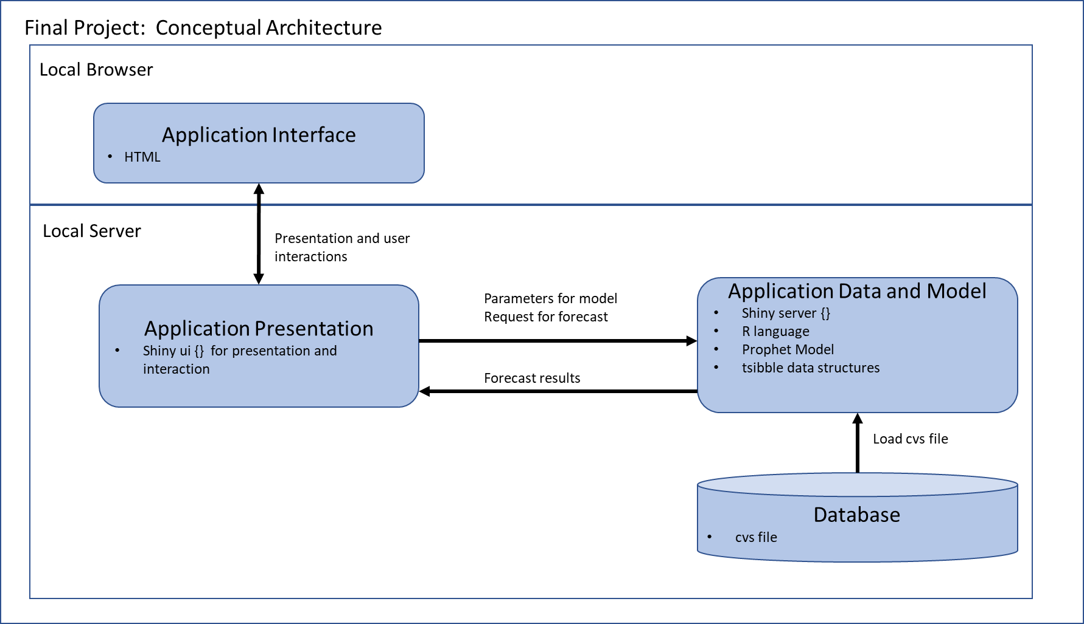

**Details:**

Location of the Application and Data: The application and input data file are located on the local server.

Data: The input dataset, monthly U.S. consumer sentiment scores, is provided as a cvs file. The data is only required in read-only mode for the application and should not be modified by the application user. The input dataset will reside in the same directory as the application and should be installed by the system administrator in read-only mode for all other users and processes. The input file is consumed directly into the application and converted to a tsibble time series structure. The original U.S. consumer sentiment data is a monthly score and is converted to monthly percentage change by the application. An exogenous variable column is added to the data. The default value of the exogenous value is 0, but the value is set to 1 for all months where the percentage change is less than -12%.

Application Language: The application is written in R. The application will read the cvs file, convert the data, fit the Prophet model, and generate a 12 month forecast. The application will fit the Prophet model and generate the forecast based on the parameters selected by the application user. Default values for the Prophet model and forecast are set when the application is launched. Values can be selected through the application interface. The Rest Button will reset all user definable values to the default values.

**Architecture Discussion:**

Overview: A conceptual architecture diagram is provided followed by the specifics of the application.

Presentation : HTML generated from a Shiny application.

Theme: The shinythemes package will be used to provide the presentation theme. The ‘cerulean’ theme with customized colors for certain features will be used. The package and theme provide a simple color scheme but allow for features such as reset and forecast buttons to be customized for improved visual differentiation.

Application Platform: Shiny was selected for the interactive application. The standard ui interface object provides the interactive user interface in HTML. The standard server object contains the functionality of the application written in R.

Deployment: The application is deployed as a standalone application on a local server. The application and input dataset are installed in a single directory. The dataset should be set to read-only by the system administrator. The application file should also be set to read-only by the system administrator to avoid accidental deletion or modification by the application user. The application is for local use and does not require a login.

**Breakdown of Work:**

The project team has a single member, Andrew Sommers.

Remaining work:

Week 14 - Complete core application functionality in R

Week 14 - Generate video of application overview

Week 15 - Create Shiny application for final product

Week 15 – Package and submit final product