Supplementary Material S1 — LASSO Feature Selection
Supplementary Figure S1. LASSO coefficient paths and selected predictors
Panel S1A. LASSO coefficient paths
This panel shows the coefficient shrinkage trajectories across a range of penalty values (λ). As λ increases, coefficients progressively shrink toward zero, with the final set of predictors determined at the cross-validated optimal λ for each outcome (POF, 28-day mortality, and the composite endpoint).
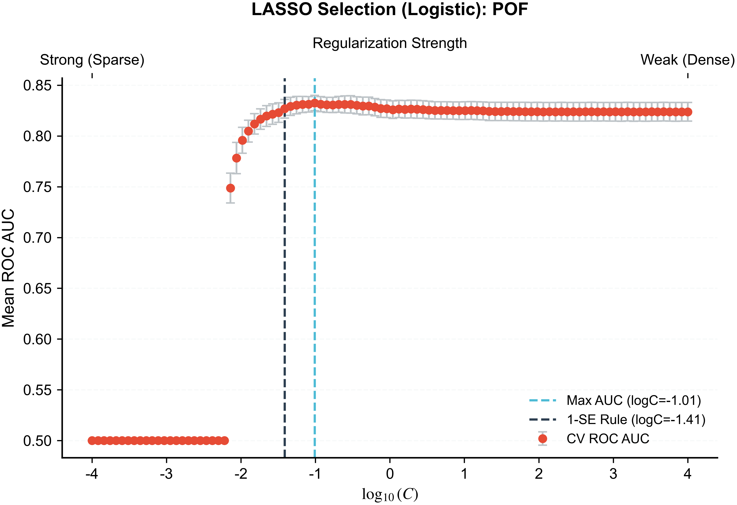
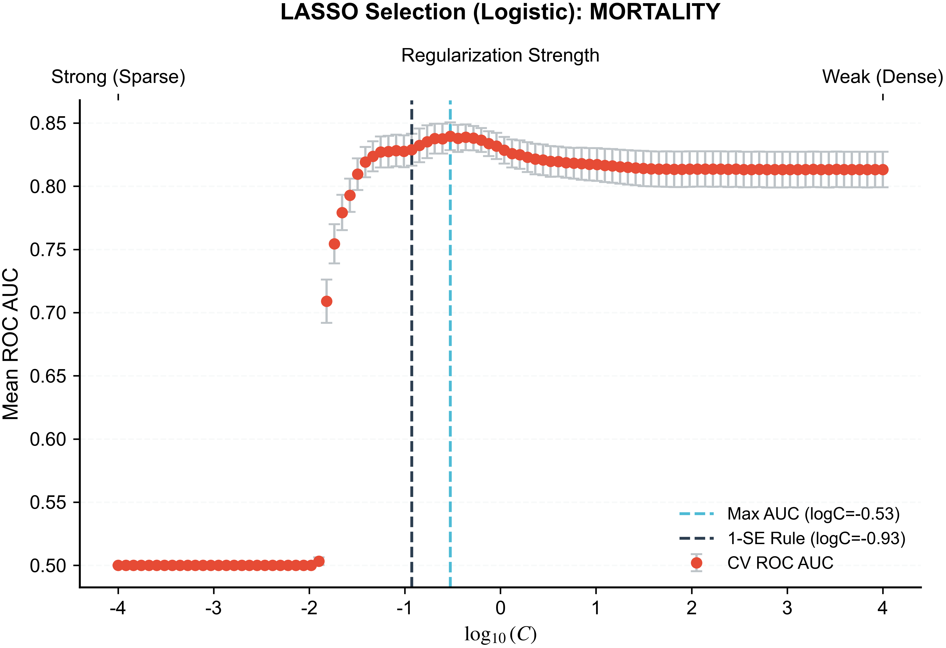
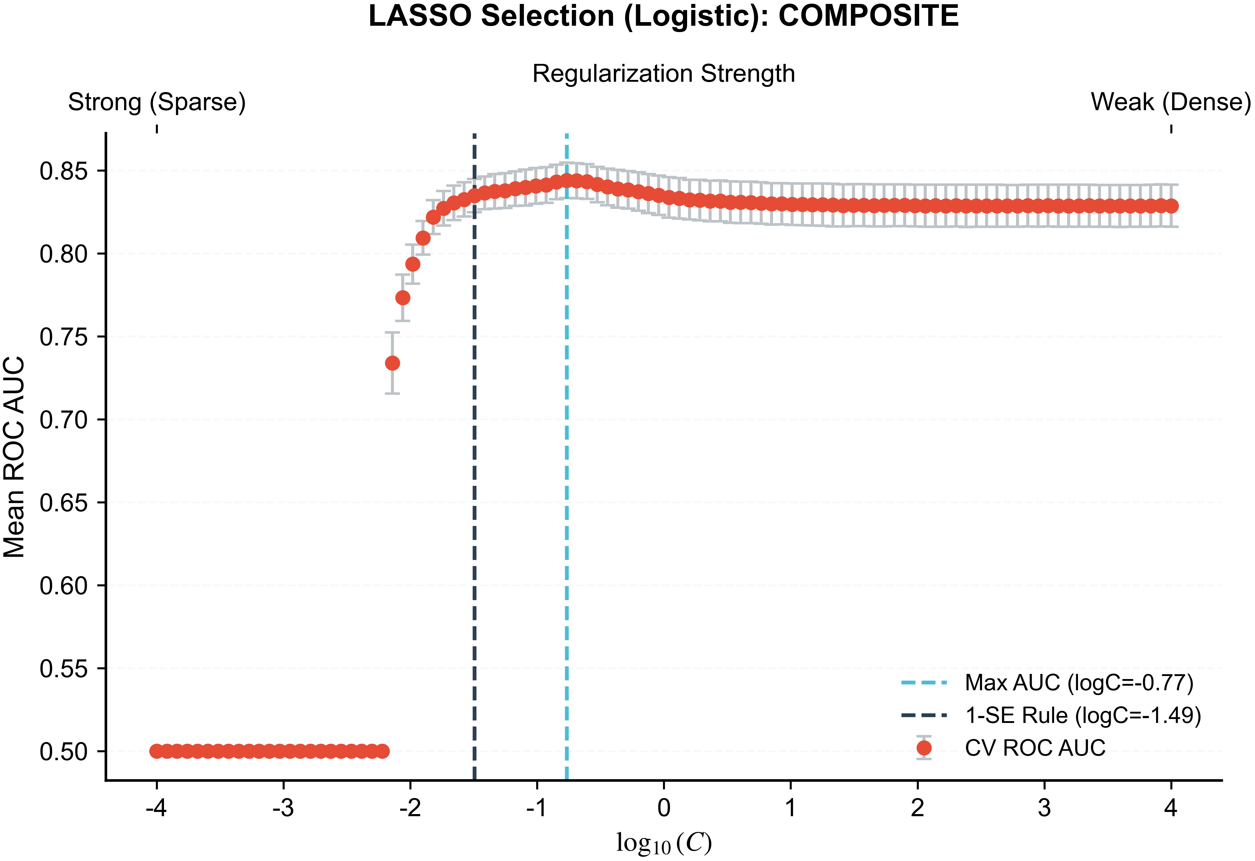
——————————
Panel S1B. Selected predictors and standardized coefficients
This panel displays predictors retained at the optimal λ and their standardized coefficients. Positive coefficients indicate higher predicted risk, and negative values indicate protective associations. Selected predictors primarily reflect renal function, oxygenation, perfusion, and acid–base status.
