Supplementary Material S3 — Diagnostic Performance and Extended Interpretability
Supplementary Figure S3. Diagnostic metrics, extended feature importance, and forest plots
Panel S3A. Diagnostic statistics
This panel summarizes sensitivity, specificity, and predictive values at the optimal Youden-index threshold for each model, illustrating diagnostic performance across clinically relevant cut-points.
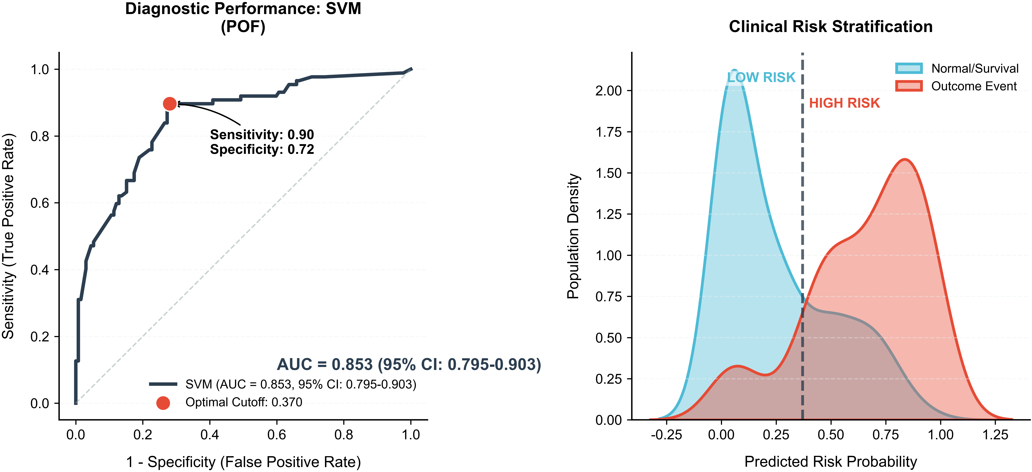
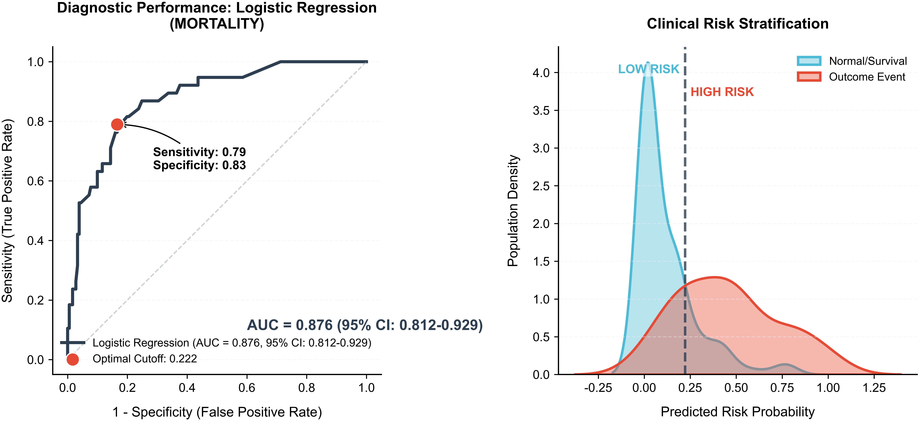
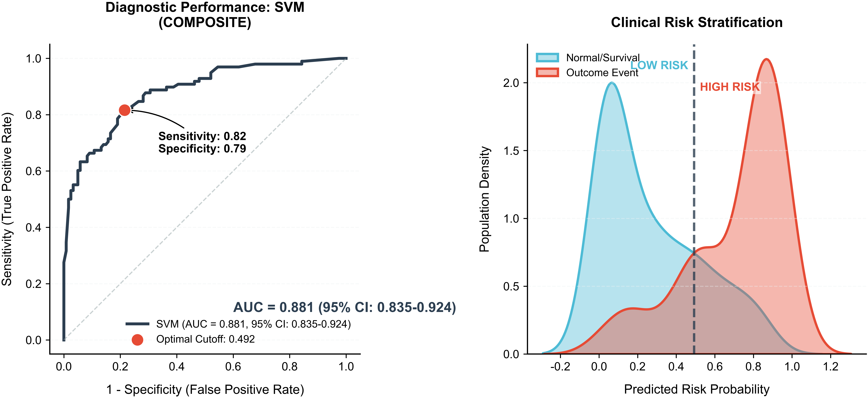
——————————
Panel S3B. Extended feature importance
Feature importance derived from tree-based models (random forest and XGBoost) is presented. The most influential features align with LASSO-selected variables and reflect key physiologic domains.
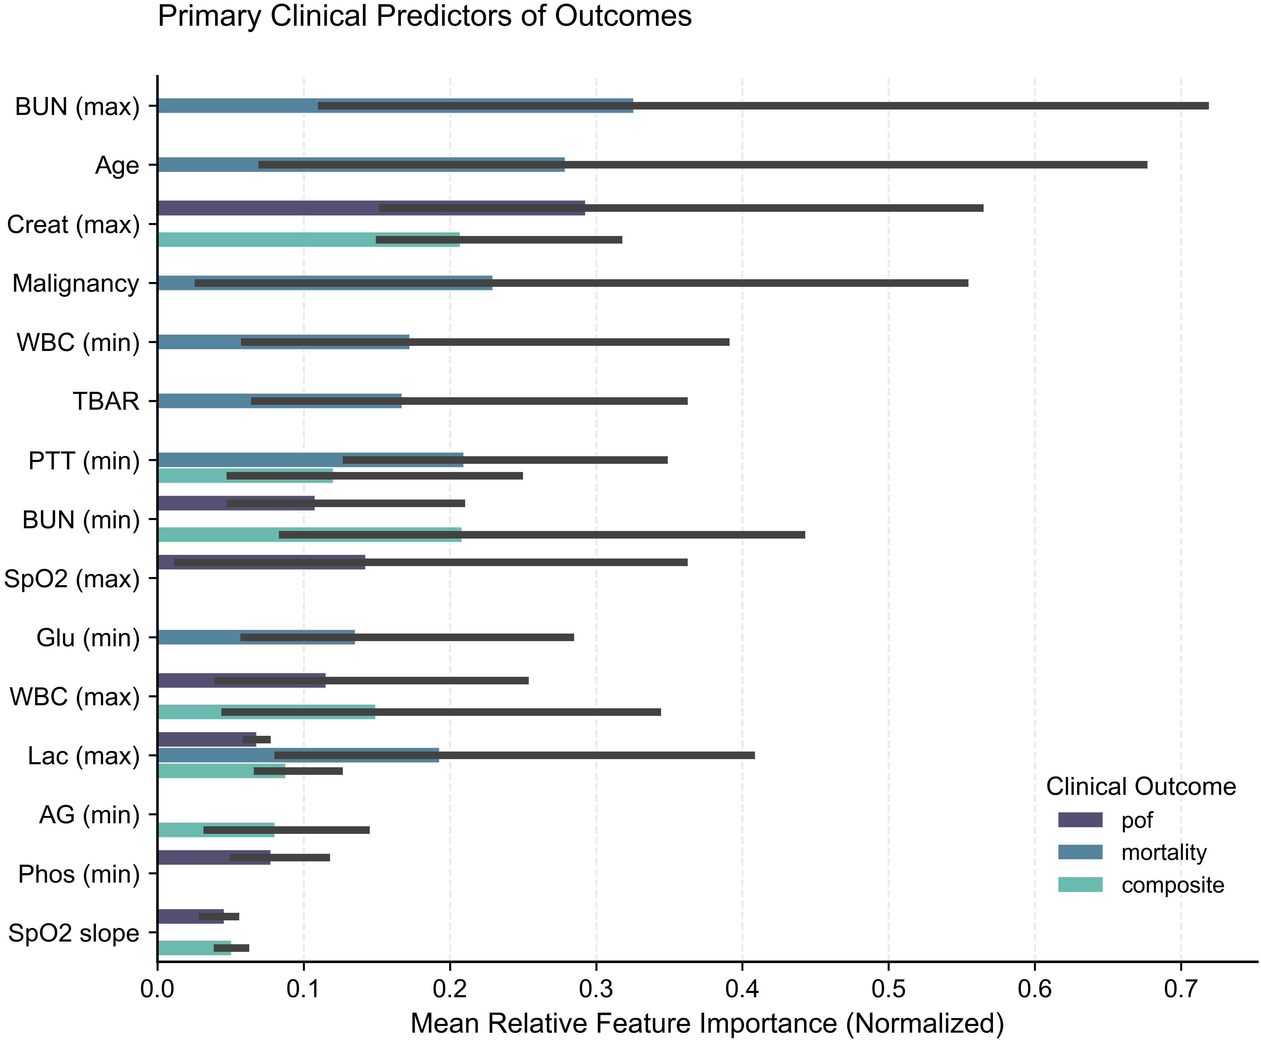
——————————
Panel S3C. Forest plot
Multivariable logistic regression–based odds ratios with 95% confidence intervals are shown for major predictors of POF. Renal dysfunction, impaired oxygenation, and acid–base abnormalities were consistently associated with higher risk.
