Supplementary Material S2 — Internal Validation
Supplementary Figure S2. ROC and calibration curves in the internal validation cohort
Panel S2A. ROC curves
ROC curves for POF, 28-day mortality, and the composite endpoint in the MIMIC-IV internal validation cohort are shown. All models demonstrated good discriminative performance, with AUC values typically ranging from 0.82 to 0.88.
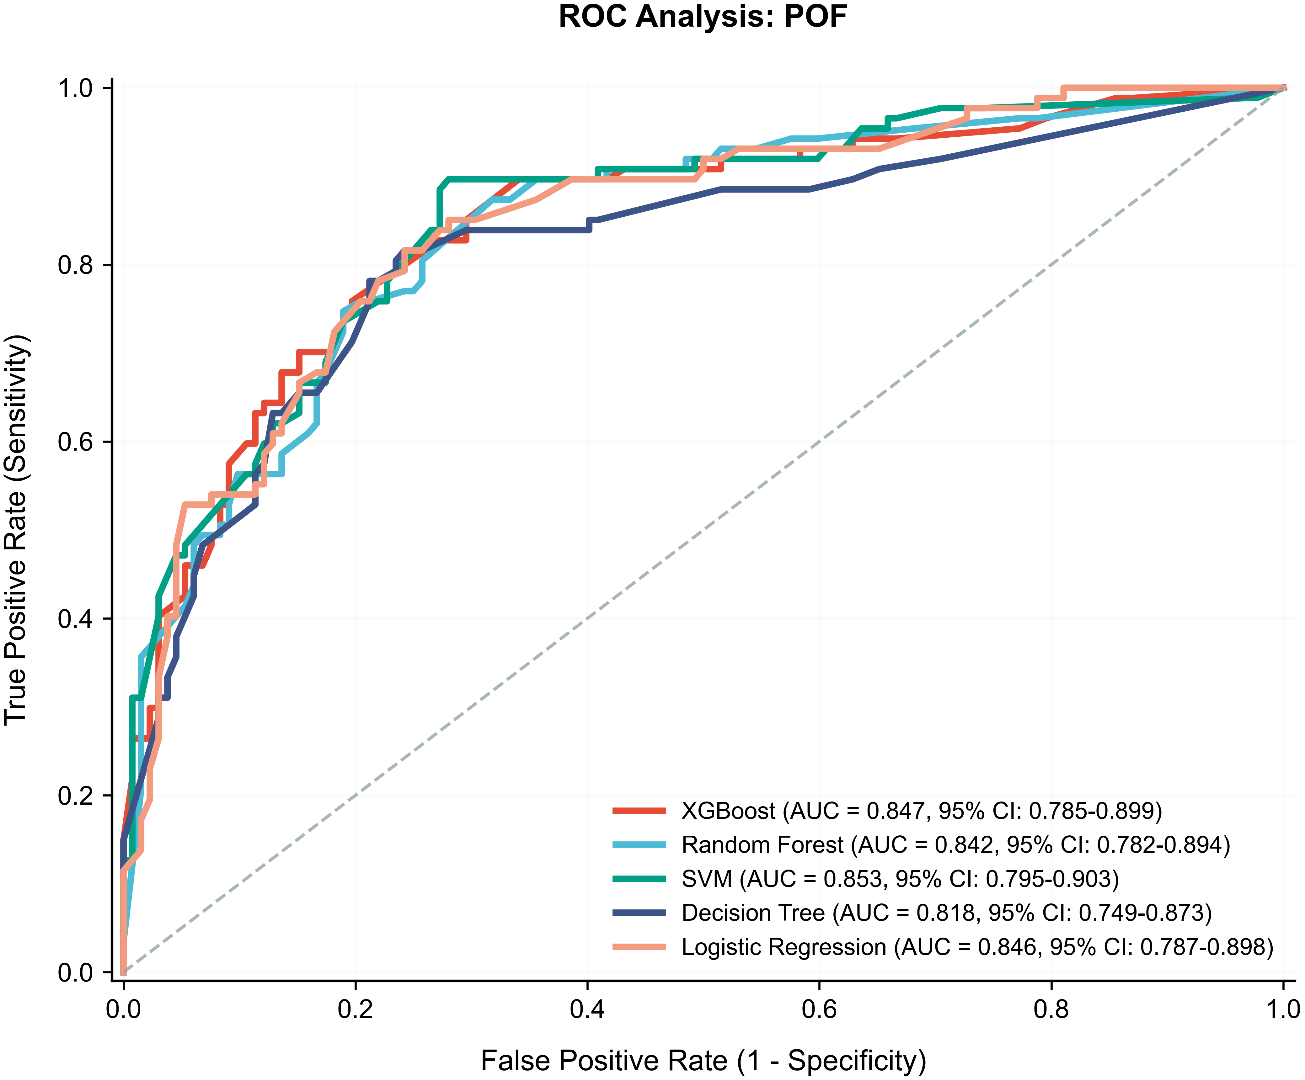
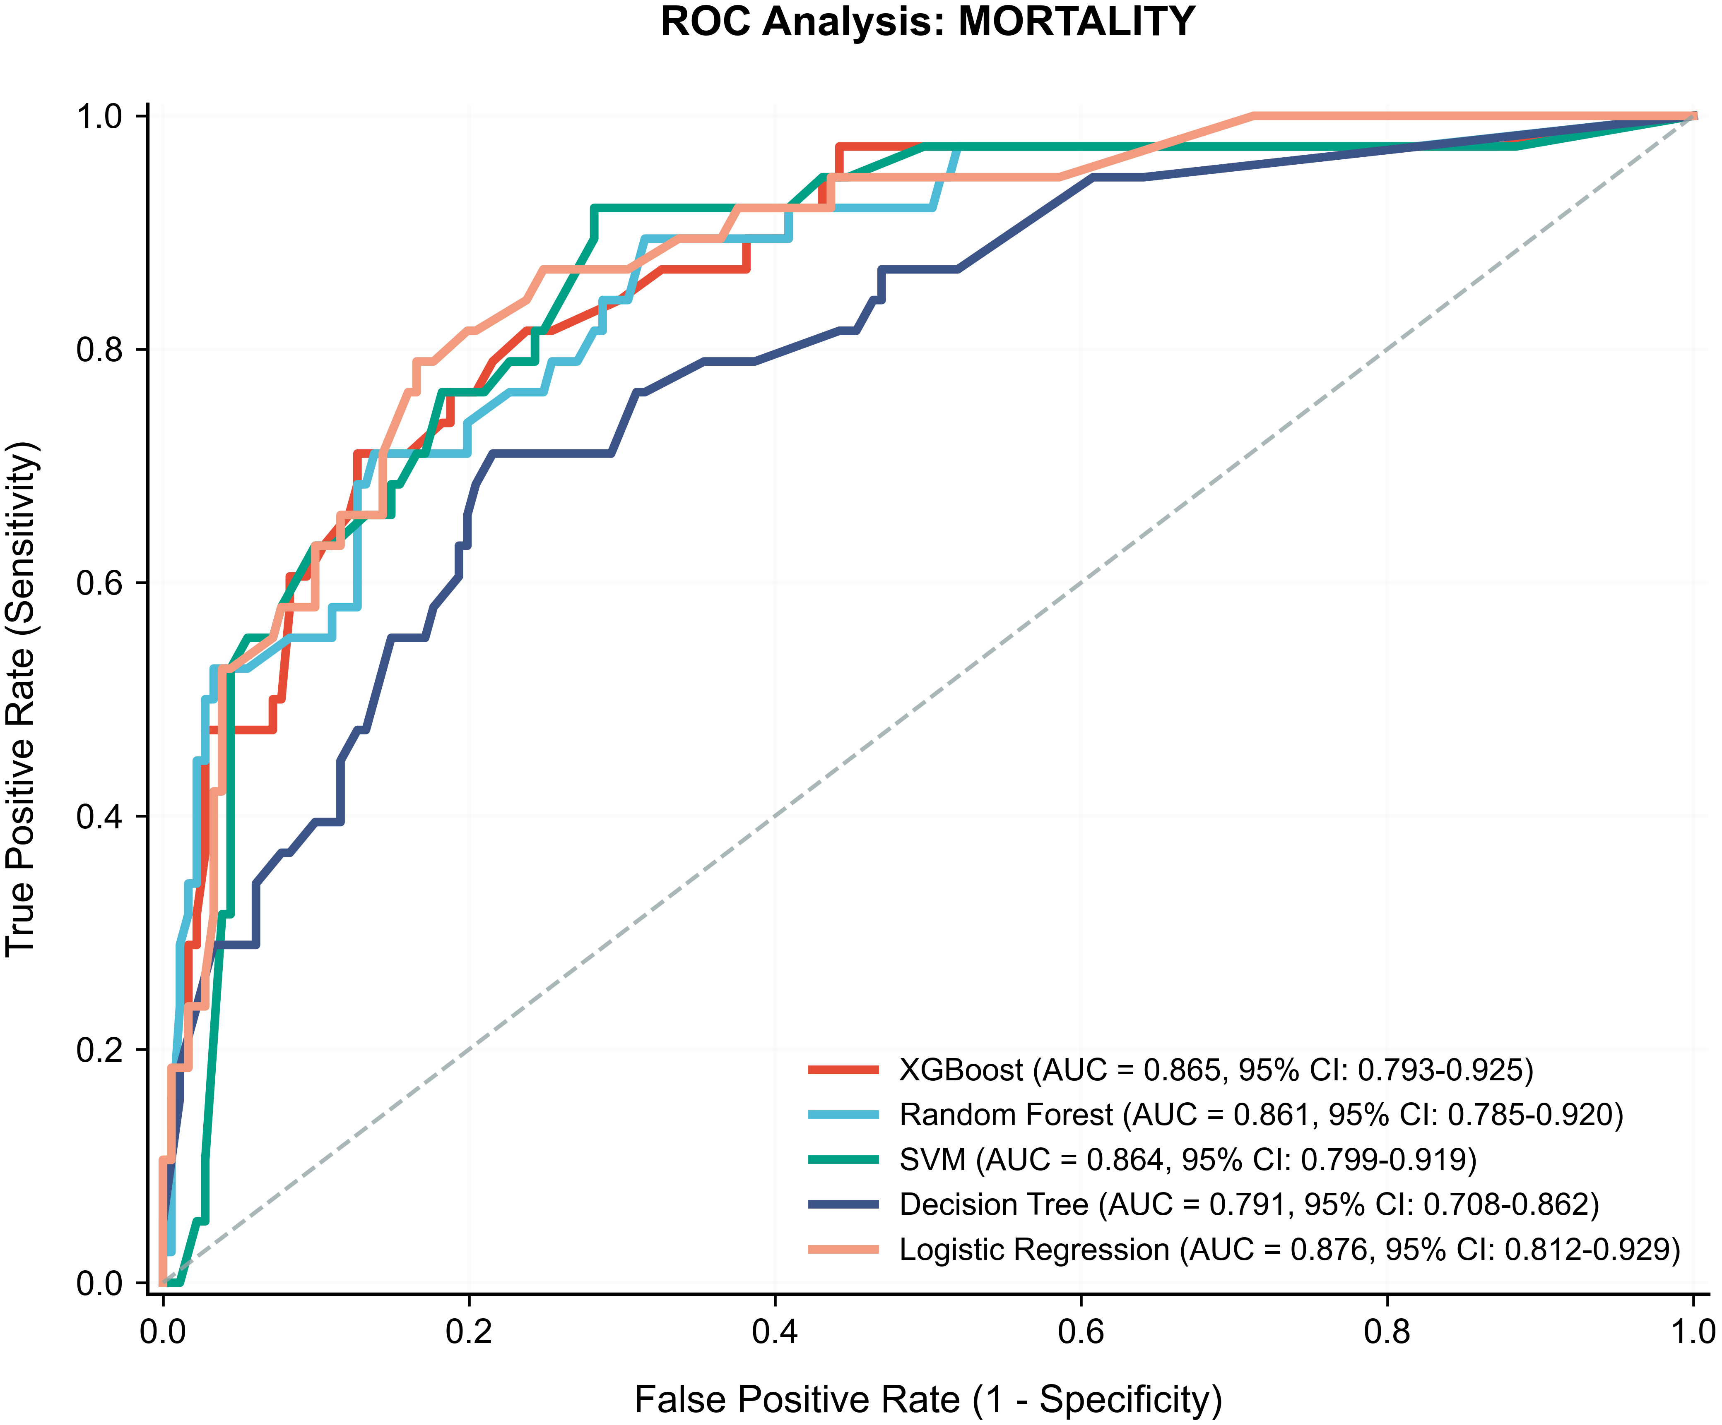
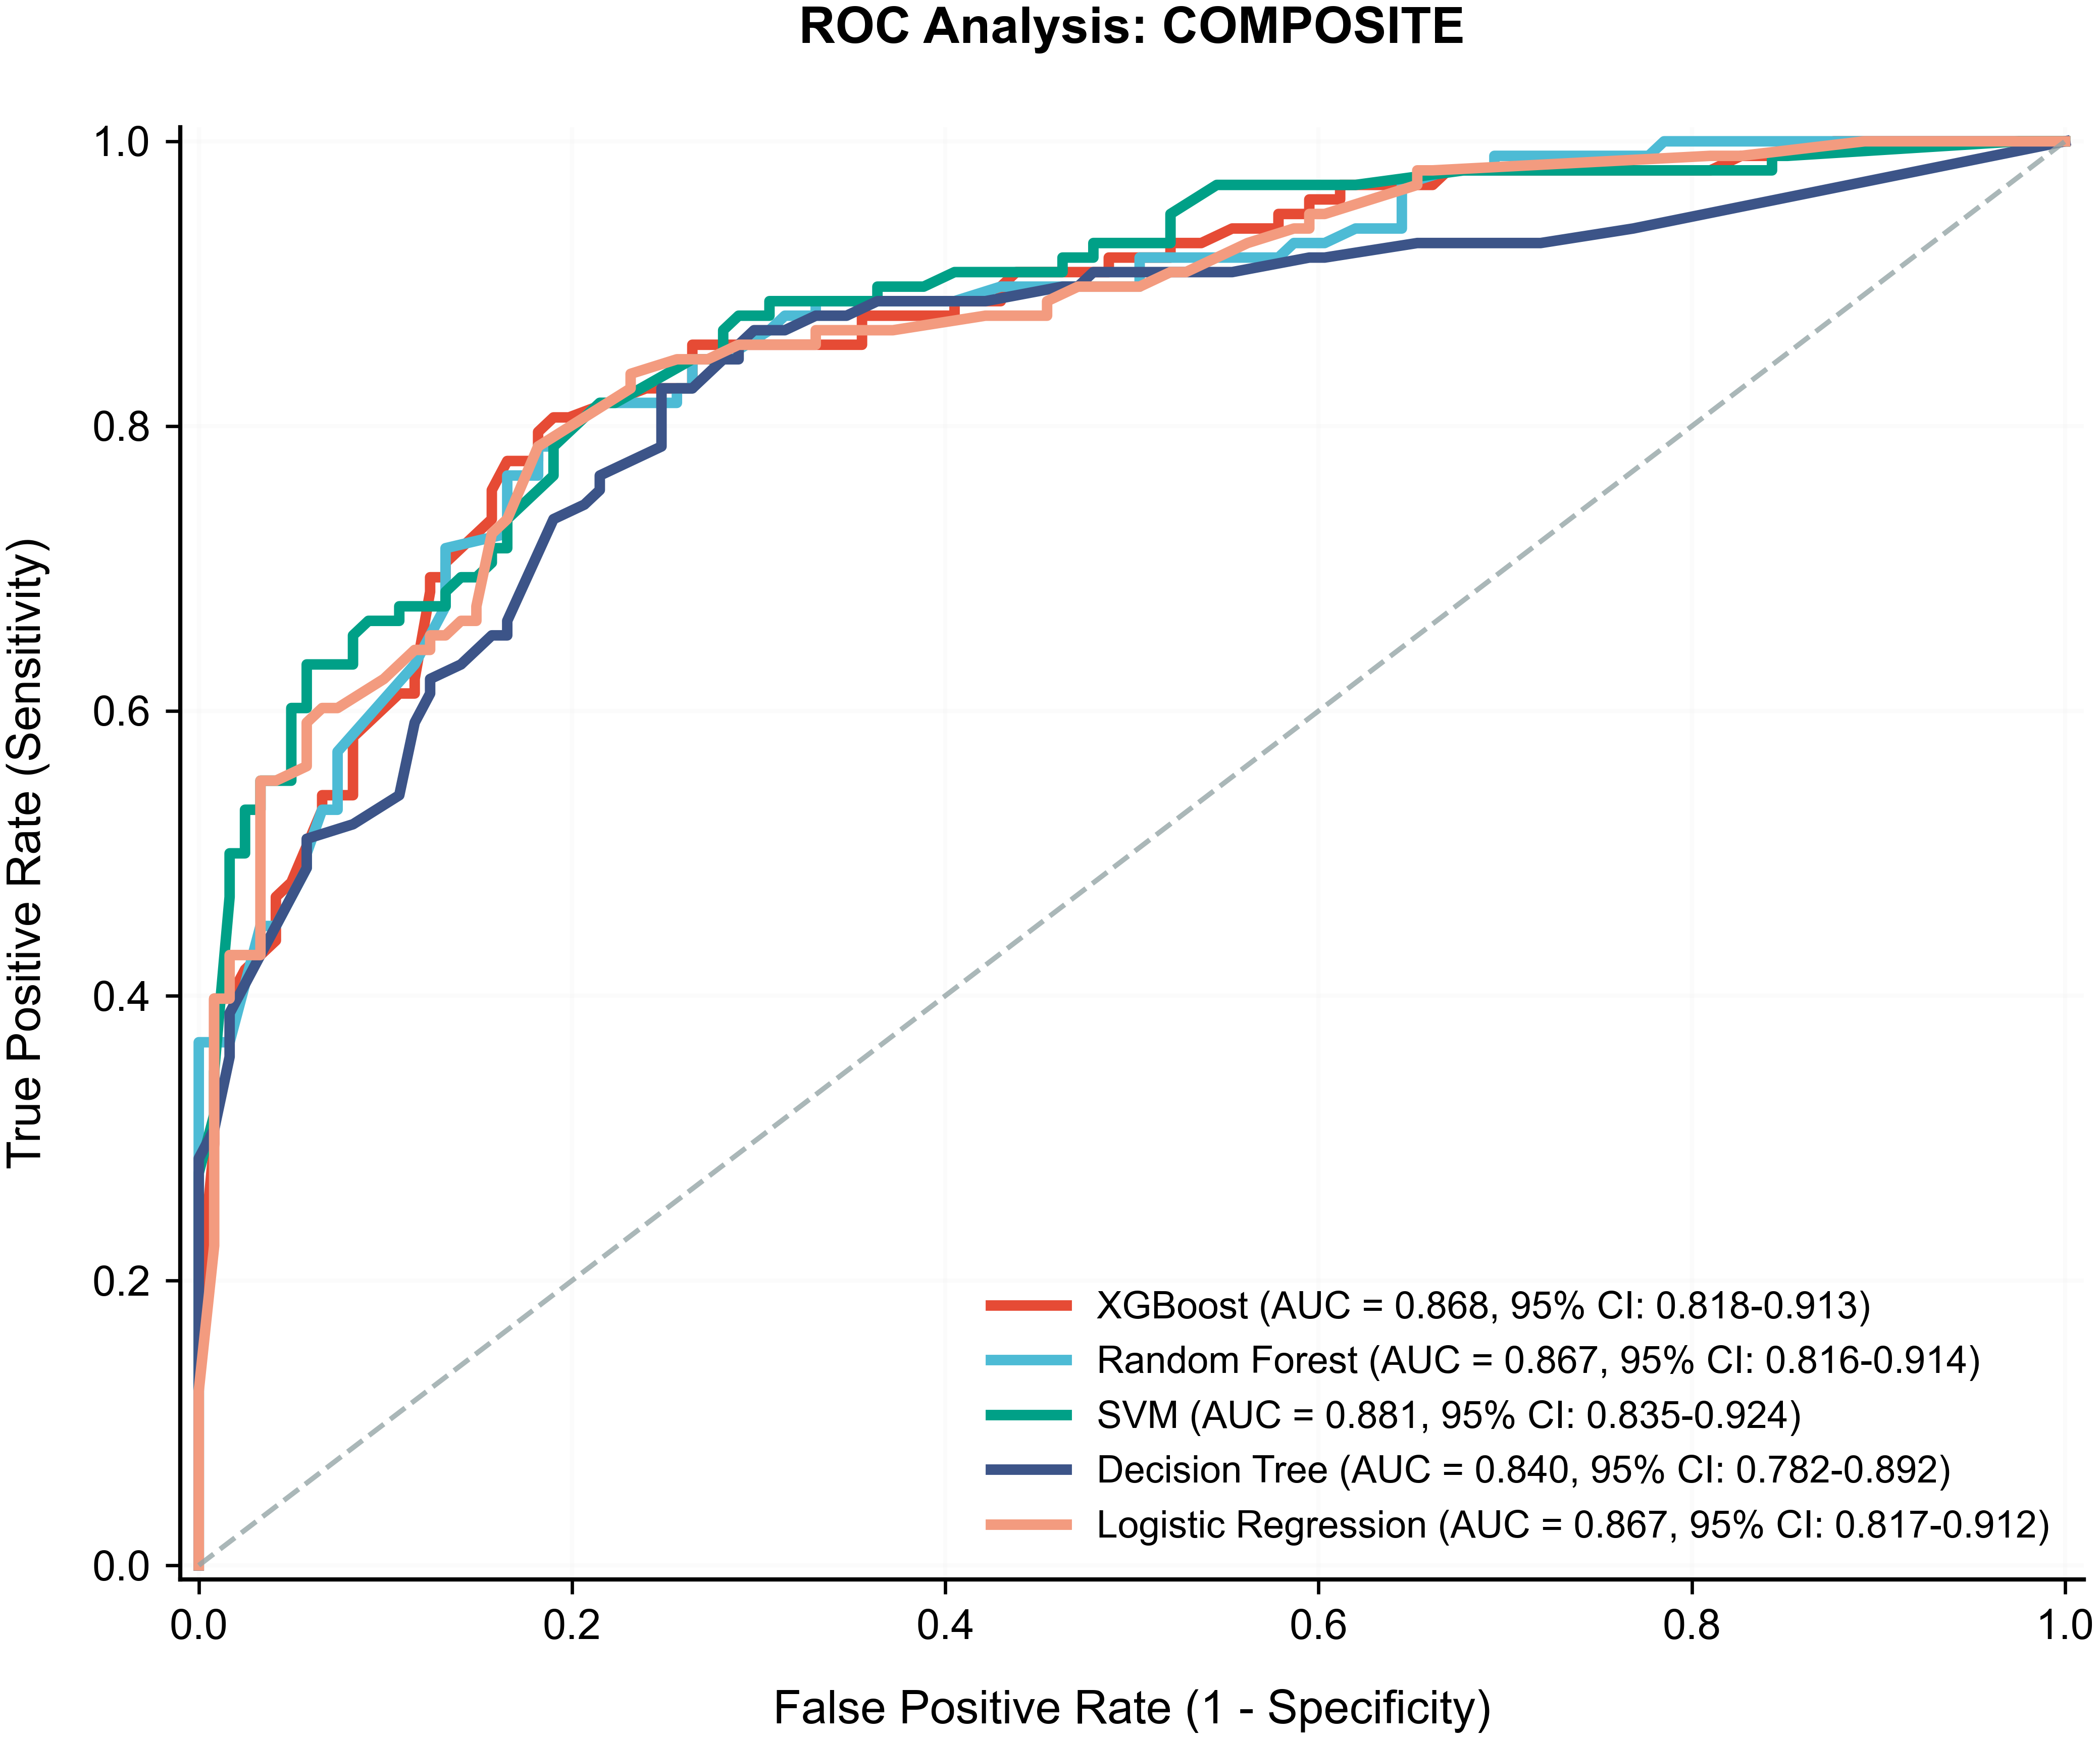
——————————
Panel S2B. Calibration curves
Calibration plots compare predicted and observed risks. Curves close to the reference line indicate good calibration; mild underestimation was observed in the high-risk range.
