Teléfono 333-578-3973

E-mail armando_eg13@hotmail.com

**Android Developer**

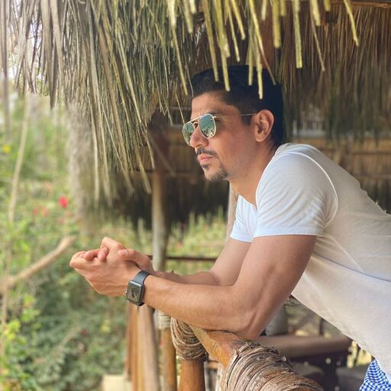

**DIPLOMAS Y HOBBIES**

**Formaciones :** Diplomados, Congresos, xxxxxxxxxx xxxxxx xxxxxxxxx xxxxxxxxxxxxxxxxx

**Hobbies:** xxxxxxxxxxxxxxxxxxxxxxxxxxxxxx



**Armando**

**Esparza**

**WHY ME?**

**WORK EXPERIENCE**

04/07/2022 – 17/02/2023

15/03/2019 – 30/06/2022

05/03/2018 -

01/03/2019

As an Android developer with 6 years of experience, worked with architects, engineers and product management to deliver user- friendly and visually appealing mobile apps for the Android platform.

- Created and tested over 10 high-quality Android apps.

- Wrote clear, efficient, well-tested, maintainable code using design patterns and involved clean architecture like: MVP and MVVM.xxxxxxx xxxxx xxxx xxxx xxxxxx xxxxx xxxx xxxx xxxx xxxx xxxx xxxx xx xxx xxx xxx xx x xxxxxxxxxxxxxxxxx

**Luxoft**

Sr Android Developer

Working on Expedia Group App.

Giving support to the app:

* Update UI.
* Working with Android Jetpack compose.
* App Sync with GraphQL
* Creating custom views.
* Scrum methodology.
* Increasing code coverage (Junit).
* Implementing architectural components like
  + Live data
  + View Binding
  + Room
  + View Model

**RAPPI**

Sr Android Developer

Tech lead on my team.

Giving support to the app:

* Update UI.
* Been part of a design system creation.
* Social networks sdk’s.
* Creating custom views.
* Scrum methodology.
* Increasing code coverage (Junit).
* Implementing architectural components like
  + Live data
  + View Binding
  + Room
  + View Model

**HCL - TECHNOLOGIES**

Sr Software developer

* Developing Android native apps using Android Studio and giving support to apps that are on market
* Implemented custom Views.
* Testing UI using espresso.
* Migration from Activities to Fragments.
* Migration from Java to Kotlin.
* Scrum Methodology.

Java  
90%

Kotlin  
80%

PHP  
40%

Junit

60%

Android SDK  
90%

GIT

85%

Heroku

60%

Github

80%

Android Studio

95%

XAMPP

50%

Postman

70%

Atlassian Suit

70%

Jetpack Compose

20%

**SKILLS**

**LANGUAGES**

Español (Native)

Inglés

01/12/2015 -12/08/2016

**ROBERT BOSCH**

Android Developer

* Developing Android native apps using Android Studio and giving support to apps that are on market.
* Testing UI using espresso.
* Migration from Java to Kotlin.
* Implemented clean architecture MVP.
* Implemented Dagger 2 for dependency Injection.
* Optimizing and bug fixing with tools like Crashlytics and Hockey App and Android Monitor Device.
* Scrum methodology.
* FCM for a chat.
* Retrofit for Restfull.
* Implemented Push notifications.
* Worked with different 3rd Parties.

**Sye software**

Intern Android Developer

* Developing Android native apps using Android Studio and Eclipse
* Scrum methodology.
* Worked with MySQL and SQLWorkbench.
* Developing API’s with PHP
* Hosting API’s at Heroku

16/08/2016 -

02/03/2018

**WORK EXPERIENCE**

**ESTUDIOS**

2010 - 2014  Computational Systems Engineering

Guadalajara*UNIVA*

2014 - 2015  English School

Guadalajara*Quick Learning*

**Ra Acosta**

Qualtop | Project Lead

Teléfono +52 33 3822 1526

E-mail xxxxxxxx@xxxxxxxx.com

**César Mora**

Robert Bosch | Tech Lead

Teléfono +52 331 862 0379

**REFERENCES**