SIE 330R Homework, Spring 2023

**Agustin Espinoza**

**3/28/2023**

**HW 8 (Chapter 6)**

Homework must be readable! Do not just send in numbers or charts. You must explain the homework answers Preferred to receive homework in Word doc format with any excel or Minitab results pasted into word document. You may choose to use pdf which is also OK.

**Put answers to all questions in one document NOT in separate documents**

Due Mar 28

6.2. A 23 factorial is replicated twice. The number of pure error or residual degrees of freedom are

1. 4
2. 12
3. 15
4. 2
5. 8
6. None of the above

The number of pure error or residual degrees of freedom is 1.

**6.5S.** An engineer is interested in the effects of cutting speed (*A*), tool geometry (*B*), and cutting angle on the life (in hours) of a machine tool. Two levels of each factor are chosen, and three replicates of a 23 factorial design are run. The results are as follows:

|  |  |  |  |  |  |  |
| --- | --- | --- | --- | --- | --- | --- |
|  |  |  | Treatment |  | Replicate |  |
| *A* | *B* | *C* | Combination | I | II | III |
| - | - | - | (1) | 22 | 31 | 25 |
| + | - | - | *a* | 32 | 43 | 29 |
| - | + | - | *b* | 35 | 34 | 50 |
| + | + | - | *ab* | 55 | 47 | 46 |
| - | - | + | *c* | 44 | 45 | 38 |
| + | - | + | *ac* | 40 | 37 | 36 |
| - | + | + | *bc* | 60 | 50 | 54 |
| + | + | + | *abc* | 39 | 41 | 47 |

1. Estimate the factor effects. Which effects appear to be large?

The factor effect estimations are provided in the table below. The factor effects of B, C, and AC appear to be large as they are greater than an absolute magnitude of 5.

|  |  |
| --- | --- |
| Effect | Estimate |
| *A* | 0.333 |
| *B* | 11.333 |
| *C* | 6.833 |
| *AB* | -1.667 |
| *AC* | -8.333 |
| *BC* | -2.833 |
| *ABC* | -2.167 |

1. Use the analysis of variance to confirm your conclusions for part (a).

The ANOVA below confirms the significance of the effects of B, C, and AC.

|  |  |  |  |  |  |
| --- | --- | --- | --- | --- | --- |
| ANOVA |  |  |  |  |  |
| *Source of Variation* | *SS* | *df* | *MS* | *F* | *P-value* |
| Model | 1612.667 | 7 | 230.381 | 7.64 | 0.0004 |
| Error | 482.667 | 16 | 30.167 |  |  |
| Correlated Total | 2095.333 | 23 |  |  |  |
|  |  |  |  |  |  |
|  |  |  |  |  |  |
|  |  |  |  |  |  |
| Root MSE | R-Square | 5.492 | 0.77 |  |  |
| Dependent Mean | Adj R-Sq | 40.833 | 0.669 |  |  |
| Coeff Var |  | 13.451 |  |  |  |
|  |  |  |  |  |  |
|  |  |  |  |  |  |
| Parameter Estimates |  |  |  |  |  |
|  |  |  |  |  |  |
| *Variable* | *df* | *Parameter Estimate* | *Standard Error* | *T-Value* | *Pr* |
| Intercept | 1 | 40.833 | 1.121 | 36.42 | 0 |
| x1 | 1 | 0.167 | 1.121 | 0.15 | 0.884 |
| x2 | 1 | 5.667 | 1.121 | 5.05 | 0.0001 |
| x3 | 1 | 3.417 | 1.121 | 3.05 | 0.008 |
| x1x2 | 1 | -0.833 | 1.121 | -0.74 | 0.468 |
| x1x3 | 1 | -4.417 | 1.121 | -3.94 | 0.0012 |
| x2x3 | 1 | -1.417 | 1.121 | -1.26 | 0.225 |
| x1x2x3 | 1 | -1.083 | 1.121 | -0.97 | 0.348 |

1. Write down a regression model for predicting tool life (in hours) based on the results of this experiment.

Based on the results of this experiment, the regression model for predicting tool life is given as:

Y = 40.833 + 0.167A + 5.667B + 3.417AC

1. Analyze the residuals. Are there any obvious problems?

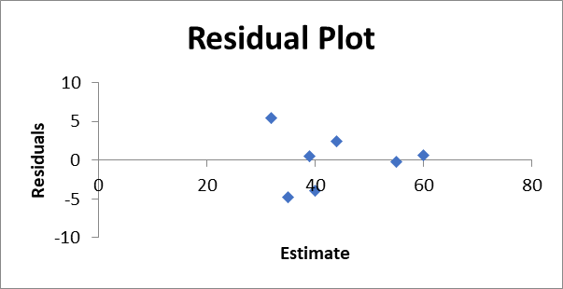

The residual plots do not show any obvious problems. The only possible error might come from the deviation from normality, but the deviation is not significant enough to make this claim.

1. Based on the analysis of main effects and interaction plots, what levels of *A*, *B*, and *C* would you recommend using?

Based on the analysis of main effects and interaction plots, the mean response is highest when (A, B, C) = (-, +, +). These are the level recommendations based on the data analysis.

**6.19.** The effect estimates from a 24 factorial experiment are listed here. Are any of the effects significant?

|  |  |  |  |
| --- | --- | --- | --- |
| *ABCD* = | -2.5251 | *AD* = | -1.6564 |
| *BCD* = | 4.4054 | *AC* = | 1.1109 |
| *ACD* = | -0.4932 | *AB* = | -10.5229 |
| *ABD* = | -5.0842 | *D* = | -6.0275 |
| *ABC* = | -5.7696 | *C* = | -8.2045 |
| *CD* = | 4.6707 | *B* = | -6.5304 |
| *BD* = | -4.6620 | *A* = | -0.7914 |
| *BC* = | -0.7982 |  |  |

The effects of ABD, ABC, AB, D, C, and B are significant as the values are greater than an absolute magnitude of 5.