SIE 431/531 Simulation Modeling and Analysis （Spring 2023） Take home exam (due on 3/21 at noon, 12pm)

Name: Agustin Espinoza

By signing here, Agustin Espinoza, I signify that I have completed the problems below independently and I have not shared my solutions with others.

Problem 1 (20 pts)

Book example 4-1 describes a sealed electronic assembly and test system in which two parts, Part A and Part B, are processed. Suppose the system is now used to process an additional part, Part C. The time between the arrivals of Part C is exponentially distributed with a mean of 25 minutes. Upon arrival, they are transferred to the Part C Prep area and then move to the Sealer Operation which is shared by Parts A and B. The Part C prep time follows a UNIF(1.5, 4.5) distribution (in minutes). The sealer time for Part C is also uniformly distributed between 3 and 6 minutes. Modify Model 4-1 to include Part C in the system and change the number of servers in the Rework station from one to two. Show the following result:

1. A screenshot of the modified model and the parameters inside the modules you have added or modified;

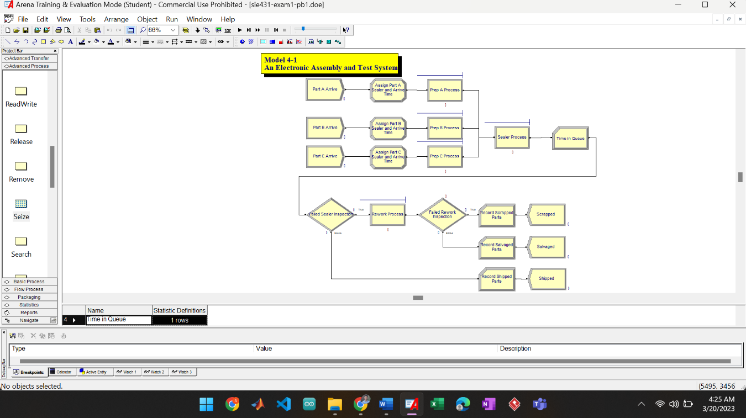

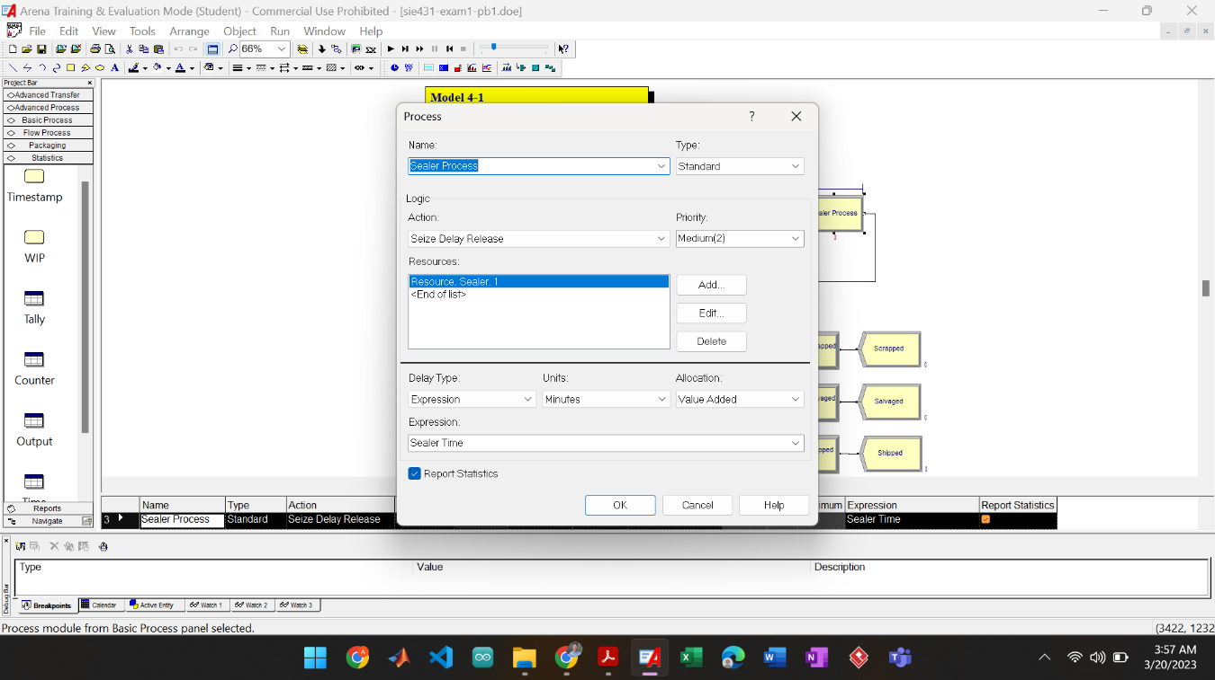

1. The utilization of the rework process before and after the change.

Before the change:

* Rework = 0.9495

After the change:

* Rework = 0.00

1. The waiting time in queue for Parts A, B, and C in the sealer operation respectively?

Queue Waiting Time (Average)

* Prep A Process.Queue = 8.11 min
* Prep B Process.Queue = 25.75 min
* Prep C Process.Queue = 0.35 min

1. The total number of parts shipped before and after the change.

Before change:

* Total Number Out = 625
* Part A = 389
* Part B = 236

After change:

* Total Number Out = 623
* Part A = 324
* Part B = 222
* Part C = 77

Problem 2 (30 pts):

Suppose currently only 1 cookie maker is assigned to 7 machines that must be repaired whenever chocolate gets stuck in the gears. Suppose for each machine the running time before breakdown is known to be exponentially distributed with a mean running time of 4 hours. The service time required by a cookie maker to get the machine running is also exponentially distributed with the mean service time of 1 hour.

1. Draw the rate diagram for the problem.

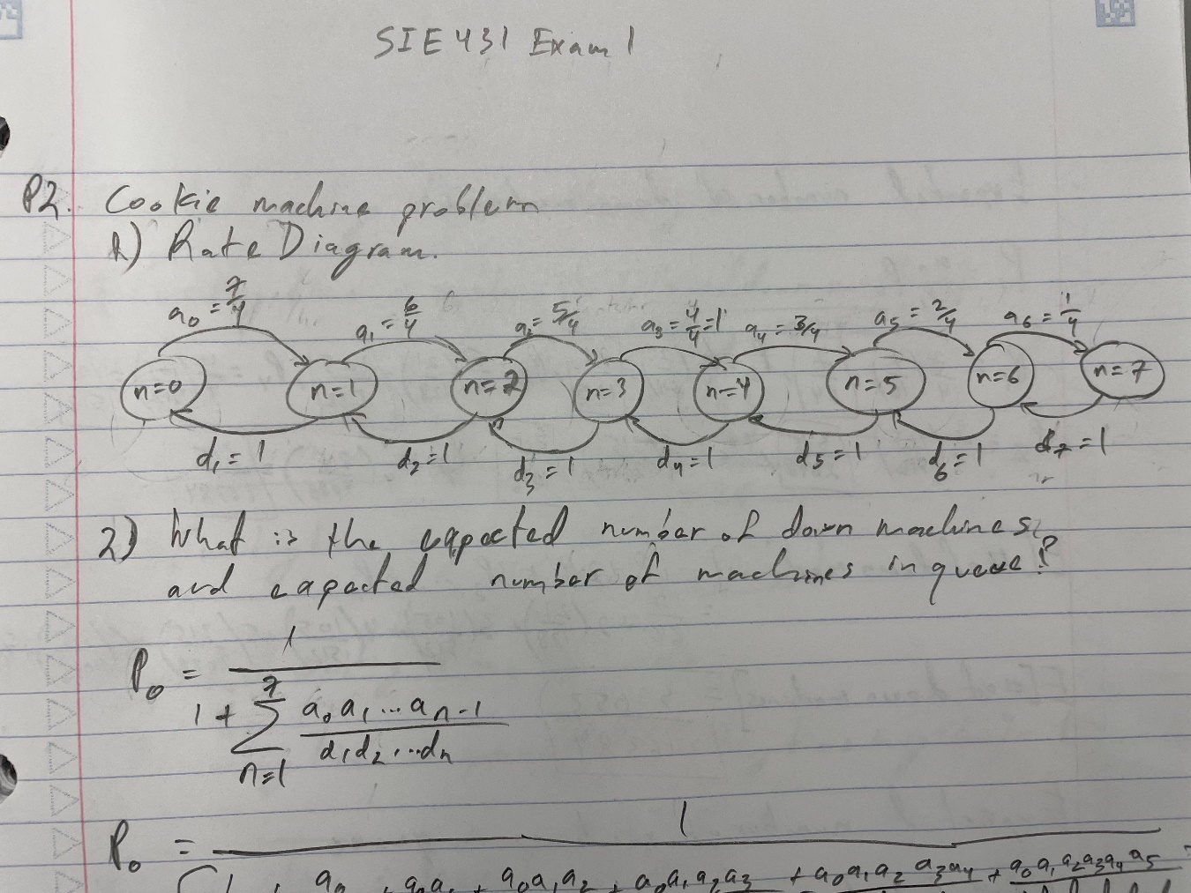

1. What is the expected number of down machines and expected number of machines in queue?

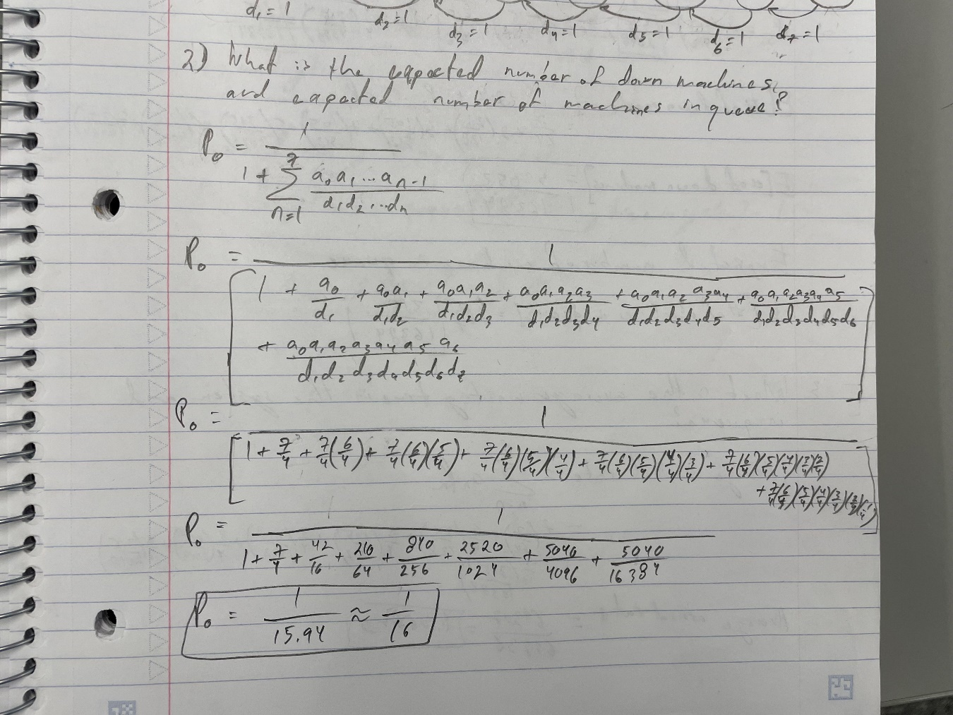

1. What is the average waiting time in the system and in queue?

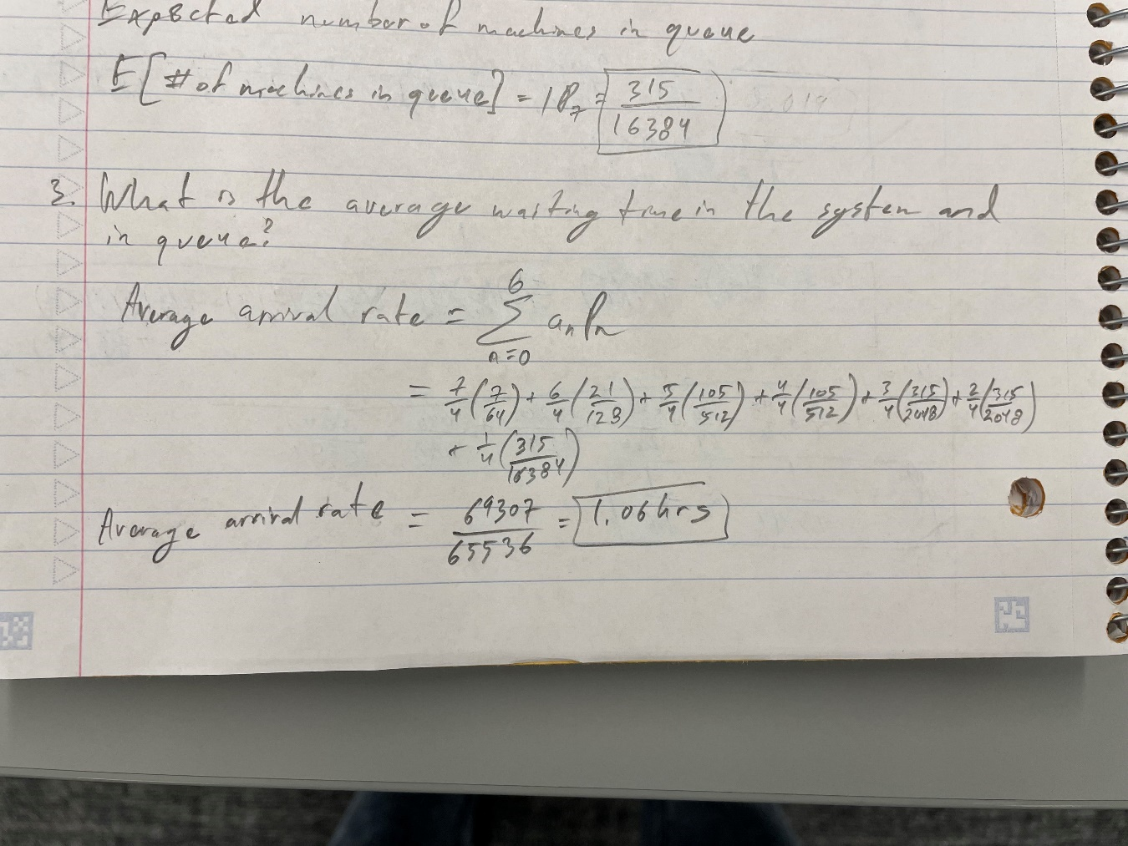

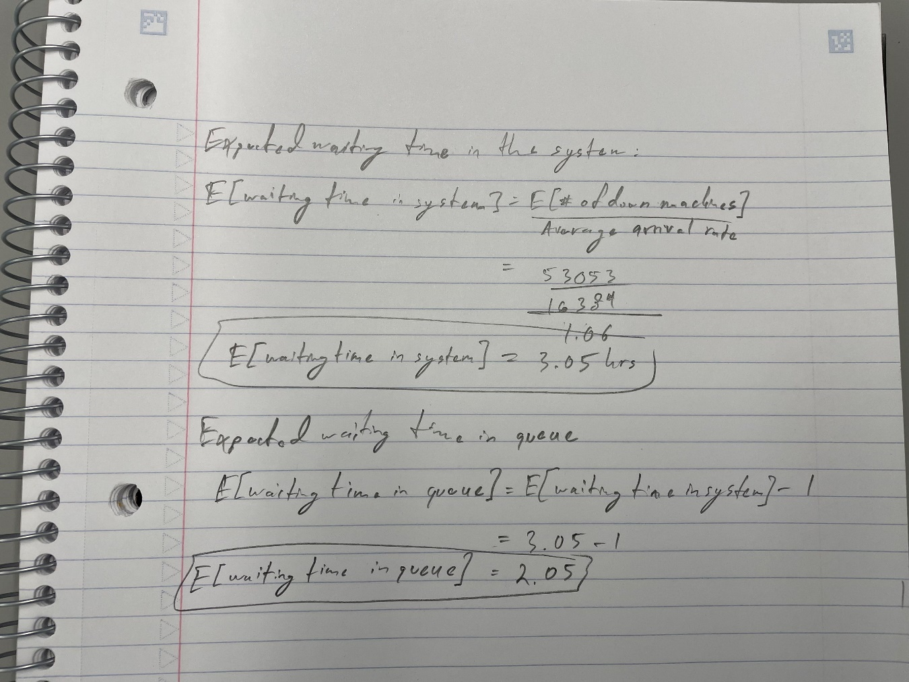

1. What is the server utilization?

The cookie maker utilization is provided below in the far-right column of the process analyzer table below.

1. Construct an ARENA model for the problem and answer questions 2) – 4). Use the process analyzer to determine the **minimum number of cookie makers required** to serve the 7 machines so that the average wait time in queue will reduce by half. Show the screenshot of the result from the process analyzer.

Minimum number of cookie makers required = 2

When the number of cookie makers is 2, the average wait time in queue is reduced from 2.404 to 0.416 (82.7% reduction). For the average wait time to be reduced to exactly half (50% reduction), the cookie maker data type would need to be a real number and not an integer. This, in practice, is not possible as there is no way to have an incomplete human cookie maker working on a machine.

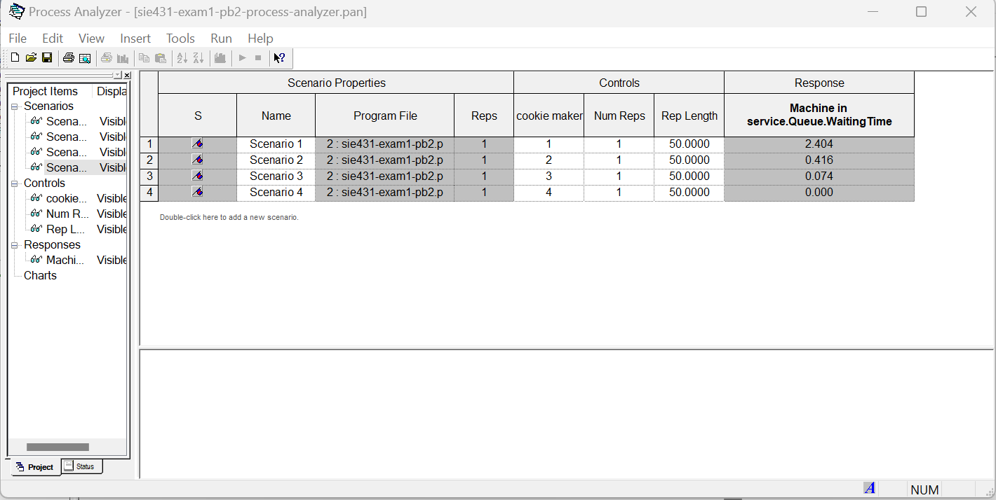

Problem 3 (20 pts): Use Monte Carlo simulation to compute the integral of f(x) = 0.5*sin(x)*cos(x) for x=0 to x=π/4 by modifying book example 4-5. Show the design of your experiment and all the intermediate steps. Show your results by generating 10,000 points, 500,000 points, and 9,000,000 points.

Design

Results

10,000 points:

COUNTERS

Identifier Count Limit

_____________________________________________________________

Non Integral Observations 78513 Infinite

Integral Observations 21487 Infinite

500,000 points:

COUNTERS

Identifier Count Limit

_____________________________________________________________

Non Integral Observations 391917 Infinite

Integral Observations 108083 Infinite

9,000,000 points:

COUNTERS

Identifier Count Limit

_____________________________________________________________

Non Integral Observations 7053543 Infinite

Integral Observations 1946457 Infinite

Problem 4 (30 pts):

Items arrive from an inventory-picking system according to an exponential interarrival distribution with an expected interarrival time of 1.1 (all times are in minutes), with the first arrival at time 0. Upon arrival, the items are packed by one of four identical packers, with a single queue “feeding” all four packers. The packing time is TRIA(2.75, 3.3, 4.0). Packed boxes are then separated by type (each box has an independent probability of 0.2 of being international, and the rest are domestic), and sent to shipping. There is a single shipper for international packages and two shippers for domestic packages with a single queue feeding the two domestic shippers. The international shipping time is TRIA(2.2, 3.3, 4.8), and the domestic shipping time is TRIA(1.7, 2.0, 2.7). This packing system works three 8-hour shifts, 5 days a week. All the packers and shippers are given a 15- minute break 2 hours into their shift, a 30-minute lunch break 4 hours into their shift, and a second 15-minute break 6 hours into their shift; use the Wait Schedule Rule. Run the simulation for 2 weeks (10 replications) to determine the average and the maximum number of items or boxes in each of the three queues.

The average number of items/boxes in the queues for the international and domestic shipping processes were 0, and 0.2042 for the packing process. These values were obtained after setting the item create entity to 100 max arrivals.

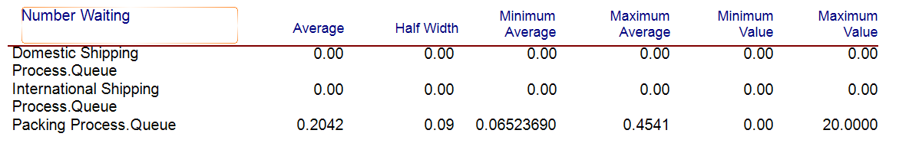

The following is the error message obtained when max arrivals were set to the default infinity value.

