Surveillance Handout Workshop

2024-1-24

### The Relationship between prevalence, confidence, and number of samples

The graph below shows the number of samples required to have a 90%, 95%, or 99% confidence (see colored lines) in detecting at least one case of chronic wasting disease, under various assumed prevalences (x-axis). Prevalence refers to the proportion of the diseased population.

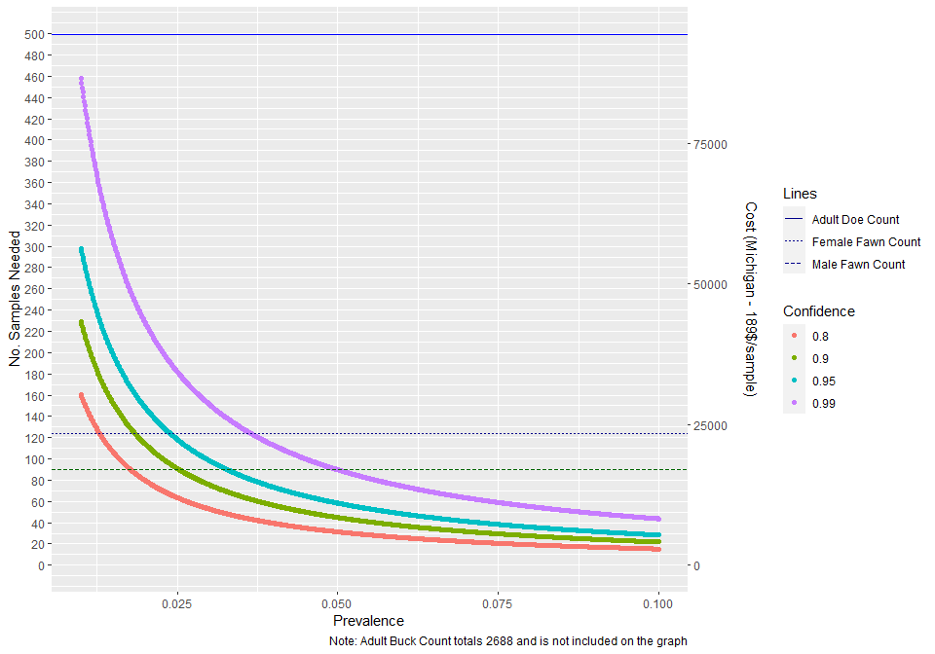

Figure 1. No. Samples Needed under Different Surveillance Designs

### Determine whether current harvest/check station activity allows Vermont to meet surveillance goals when samples are distributed at the county level

*If we get data from Vermont:* We use data from the 2022 harvest for individuals sampled at biological check stations. Each individual is classified into a strata (adult male, adult female, yearling male, and yearling female), season (first weekend of regular or youth hunt), and classified into wildlife management unit (WMU).

*If we don’t get data from Vermont and use simulated data:* We use values from the Vermont 2022 Deer Harvest report to estimate counts of individuals in strata (adult male, adult female, yearling male, and yearling female), harvested in Vermont’s 14 counties, across harvest seasons (archery, youth, novice, October muzzle, regular, and December muzzle). We use an multinomial with probability informed by percentage breakdowns in the deer harvest report to estimate the count of each strata in a county by season. Vermont only collects samples from check stations from the first weekend of the regular season and from the youth hunt. We estimate that checked individuals from the regular season were only 1/3 of the total harvest. Our dataset only includes individuals harvested in the youth hunt and one-third of individuals harvested in the regular season.

With these data, we calculate the number of samples needed to detect CWD at a given prevalence and statistical assurance (alpha). Alpha is the confidence that population-level CWD prevalence is at or below the threshold level.

Under a simplified random sample (SRS), the confidence level heavily influences the number of samples needed and associated costs.

Here, we divide the total number of samples needed for specific combinations of confidence and prevalence proportionally by county and then identify whether the number of samples available at a county level is enough to meet the proportional allocation. The proportional number of samples needed per county is based on the proportion of harvest.

… to see if the number of samples on a per county basis can meet the goal assigned by the proportional amount.

We allocate the number of samples we need to each county based on the proportion of harvest.

We can get the sample size we need for all counties except under one sample design scenario where we are trying to detect a small amount of the disease with high confidence (alpha of .01 and prevalence of .001)

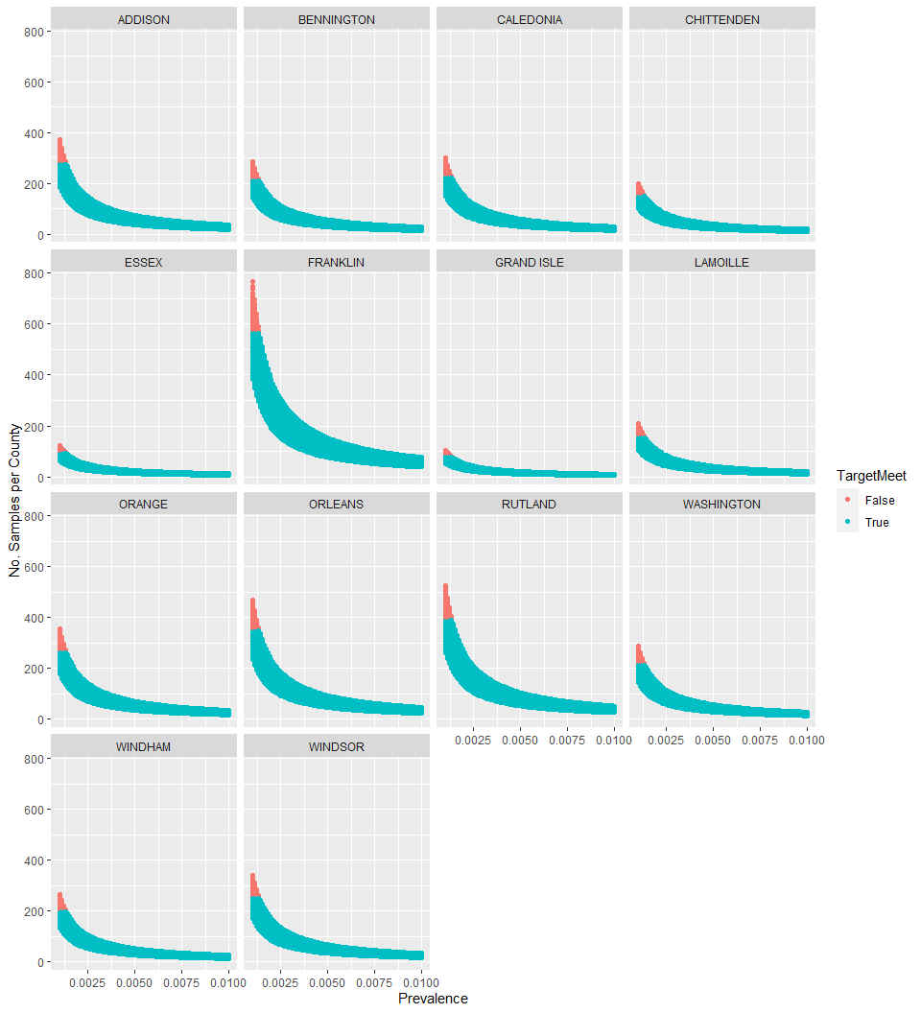

Figure 2. Number of Samples per County

**Is their a risk of anchoring here?**

Graph to add: state wide prevalence (x) vs county level prevalence (y) *Still not sure about this graph so not including it for now*