FWS Partnerships

Annabelle Stanley, Gwen Iacona, Becky Epanchin-Niell

January 21, 2020

# Objective:

Explore the presence and activities of partnerships between players that are engaged in threatened species conservation actions

# Background:

1. Threatened species recovery often relies on the formation of partnerships between agencies. These partnerships contribute to recovery through providing resources, performing actions that they are suited to, and encouraging behavior or learning.
2. Efficient recovery planning needs to be able to consider existing partnerships and know when to strategically develop new ones.
3. This is hard, because we currently do not have a good idea of how common partnerships are, whether they are more or less common across different types of species/recovery initiatives, or who the partners are. In addition, we do not know what the different partners contribute to the recovery effort
4. One situation where partners are explicitly acknowledged is when species are precluded from listing because of proactive conservation measures. This is likely not representative of how partnerships work across the bulk of ESA listed species, but it gives us an opportunity to start to think about how to explore partnerships so they can be better incorporated into conservation planning.
5. In this study we aim to characterize partnerships within precluded species and begin to explore how conservation actions are distributed across partnering agencies. We do so by answering the following questions:

* what are the characteristics of partnership for species that are precluded from listing?
* who are the organizations partnering with FWS?
* what are the roles of different partners?

# Methods

For XXX species that have been precluded from listing due to conservation actions:

We collected data from Federal Register documents, recovery plans, and YYY (need description of data sources) on - How many partners were involved in the recovery - Who the partners were, (subset) - What the partners were doing (subset of subset) ▪ - Categorized to Salafsky action headings + a few categories (?)

We use these data to answer: 1) what are the characteristics of partnership for species that are precluded from listing? a) How many partners are there? - Total number of partners

## [1] 262

* the number of partners working on each species

## # A tibble: 66 x 3  
## `Scientific name` `Common name` TotalPartners  
## <chr> <chr> <dbl>  
## 1 Calochortus persistens SISKIYOU MARIPOSA LILY 2  
## 2 Allium gooddingii GOODING'S ONION 1  
## 3 Astragalus cusickii var. pa~ PACKARDS MILKVETCH 1  
## 4 Thymallus arcticus ARCTIC GRAYLING- UPPER MISSO~ 4  
## 5 Cimicifuga arizonica ARIZONA BUGBANE 2  
## 6 Lupinus aridus ssp. ashland~ ASHLAND LUPINE 2  
## 7 Pseudanophthalmus major BEAVER CAVE BEETLE 7  
## 8 Opuntia X multigeniculata BLUE DIAMOND CHOLLA 1  
## 9 Phacelia stellaris BRAND'S PHACELIA 20  
## 10 Fallicambarus gordoni CAMP SHELBY BURROWING CRAYFI~ 4  
## # ... with 56 more rows

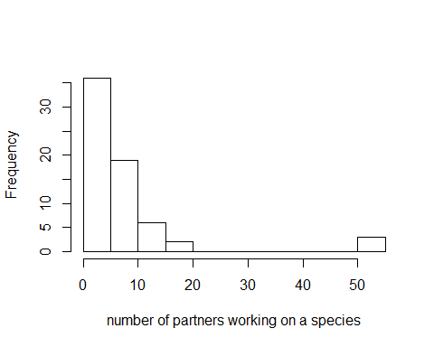

## Min. 1st Qu. Median Mean 3rd Qu. Max.   
## 1.000 3.000 4.500 7.712 7.750 54.000

* Per agreement/species (?)

1. Does number of partners relate to species/recovery programs characteristics? ▪ - taxonomic groups, FWS region, threats, # agreements, form of agreements? ▪ - Test performing regression of form • # of partners = a + B1(species characteristics) + B2(program characteristics) + B3(threats) + u(random effects) + error
2. who are the organizations partnering with FWS?

* List of all the organizations involved
* Which partners are most commonly working with others
* Histogram of partnerships/partner
* Max, min, median, and 1st and 3rd quantiles partners/partner

1. How many species each partner is involved in projects on 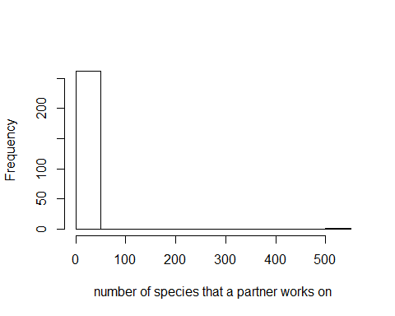

##   
## 1 2 3 4 5 6 7 26 32 48 509   
## 144 100 9 2 1 2 1 1 1 1 1

## Min. 1st Qu. Median Mean 3rd Qu. Max.   
## 1.000 1.000 1.000 3.871 2.000 509.000

1. Network representation of who works with who. Partners as nodes (weighted by number of species they work on), edges between partners weighted by number of species they work on together
2. How are actions distributed across partners?
3. Frequency distribution (histogram) of how many partners are participating in each type of action
4. Look at distribution of actions across partners (e.g., what proportion of recovery is enacted by FWS?)
5. I haven’t figured out how to do this yet? Maybe % of actions performed for a species as a response = partner identity + characteristics of species?….