ESA_Recovery_overview_doc

Annabelle

6/7/2021

##Introduction We are trying to answer the following Qs (which are the same as in the “Overview” doc) 1. What are the conservation initiatives for a species 2. What are the actions specified in the federal register important for the species? 3. Who are the organizations/players involved in doing these conservation initiatives? 4. What are the actions each organization is doing (optional?)

This document has the summary statistics for questions 1 & 2 (added 06/07/2021) and each section is question specific

Notes - Slight issue - missing at least 10 species data from tyler for initial draft of data (10 out of 38 species) … is this data accessible from the drives??

##Set up file structure

##load in different datasets

##Modify datasets

##Modify datasets Tyler Variables needed: # range size –> area c32 # area weighted footprint –> c33 ?have options # total threat count –> c 26 # type of threat –> c27 # employment (all relevant industries) -> 55:59 [avg_employment ???] # percent public and percent federal c66, c68 # diversity of landowners - shannons H (land use complextity) # taxa (plants v animals // vert v invert) taxa c16 # percent public private lands now added (6/27)

missing species (presumming Tyler dropped them..) # Euphilotes pallescens arenamontana # Nysius wekiuicola

Species Name changes/differences accross datasets Chorizanthe parryi var fernandina -> Chorizanthe parryi var. fernandina Moxostoma sp 2 -> Moxostoma sp.

## 1. What are the conservation initiatives for a species

#### 1 - Summary stats

* Number of iniatitves per species

# iniatives per species (mean, median, quartiles)

* Count of efforts, agreements, groups per species

#### 1 - Regression Predictor Modification

* Working group mentioned – logistic regression
* Numbers of efforts or agreements – linear regression or negative binomial or poisson regression (since count data)

### Base model

* Note: percent public variable is still in matrix but was removed from model

VIFS

model summary - variations

Trying stargazer

## 2. What are the actions specified in the federal register important for the species?

#### 1 - Summary stats

Count of outcomes as proactive vs responsive

Count of outcomes on public vs private land

##   
## Pearson's Chi-squared test with Yates' continuity correction  
##   
## data: test_act  
## X-squared = 3.6447, df = 1, p-value = 0.05625

##   
## Pearson's Chi-squared test with Yates' continuity correction  
##   
## data: test_land  
## X-squared = 6.9557, df = 1, p-value = 0.008355

##   
## Fisher's Exact Test for Count Data  
##   
## data: test_act  
## p-value = 0.0551  
## alternative hypothesis: true odds ratio is not equal to 1  
## 95 percent confidence interval:  
## 0.980416 8.939537  
## sample estimates:  
## odds ratio   
## 2.852948

##   
## Fisher's Exact Test for Count Data  
##   
## data: test_land  
## p-value = 0.00795  
## alternative hypothesis: true odds ratio is not equal to 1  
## 95 percent confidence interval:  
## 1.35466 10.13523  
## sample estimates:  
## odds ratio   
## 3.615964

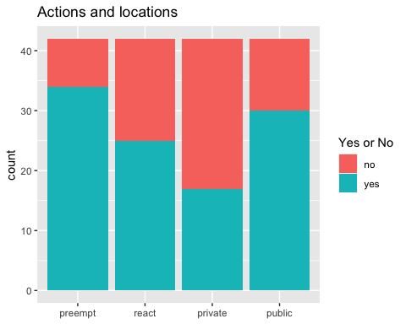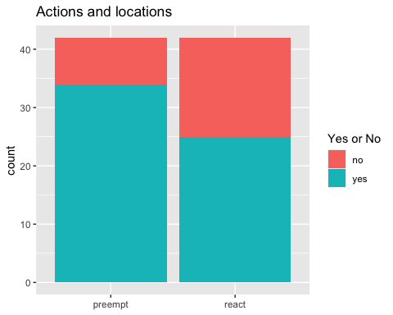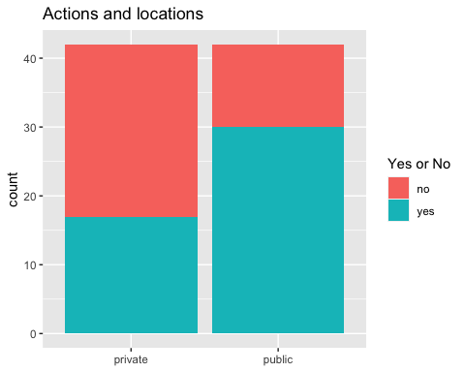

#### Taxa

##   
## Pearson's Chi-squared test  
##   
## data: test_taxa_actions  
## X-squared = 11.871, df = 5, p-value = 0.0366

## # A tibble: 6 x 5  
## group n p p.adj p.adj.signif  
## * <chr> <dbl> <dbl> <dbl> <chr>   
## 1 1 84 0.761 1 ns   
## 2 2 84 0.0575 0.345 ns   
## 3 3 84 0.0289 0.173 ns   
## 4 4 84 0.493 1 ns   
## 5 5 84 0.371 1 ns   
## 6 6 84 0.226 1 ns

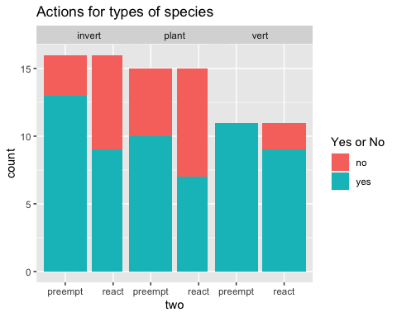

##   
## Pearson's Chi-squared test  
##   
## data: test_taxa_land  
## X-squared = 13.223, df = 5, p-value = 0.02138

## # A tibble: 6 x 5  
## group n p p.adj p.adj.signif  
## * <chr> <dbl> <dbl> <dbl> <chr>   
## 1 1 84 0.404 1 ns   
## 2 2 84 0.00321 0.0193 *   
## 3 3 84 0.748 1 ns   
## 4 4 84 1 1 ns   
## 5 5 84 0.0273 0.164 ns   
## 6 6 84 0.78 1 ns

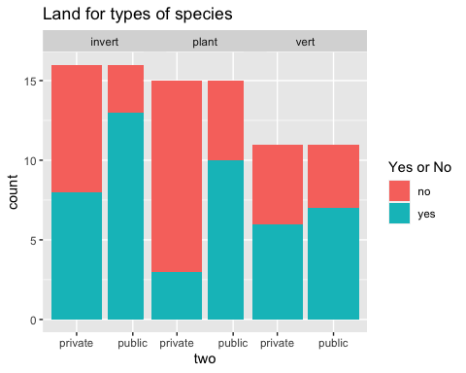

#### Land actions

##   
## Pearson's Chi-squared test  
##   
## data: test_landactions  
## X-squared = 8.1376, df = 3, p-value = 0.04325

## # A tibble: 4 x 5  
## group n p p.adj p.adj.signif  
## * <chr> <dbl> <dbl> <dbl> <chr>   
## 1 1 118 0.153 0.612 ns   
## 2 2 118 0.0959 0.384 ns   
## 3 3 118 0.106 0.424 ns   
## 4 4 118 0.175 0.7 ns

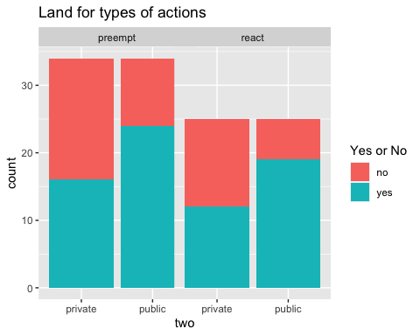

##   
## Pearson's Chi-squared test  
##   
## data: test_landactions  
## X-squared = 6.1418, df = 3, p-value = 0.1049

## # A tibble: 4 x 5  
## group n p p.adj p.adj.signif  
## * <chr> <dbl> <dbl> <dbl> <chr>   
## 1 1 94 0.61 1 ns   
## 2 2 94 0.0622 0.249 ns   
## 3 3 94 0.0742 0.297 ns   
## 4 4 94 0.756 1 ns

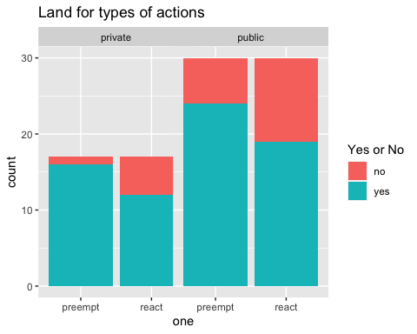

####threat types Note - missing three species because don’t have data

##   
## Pearson's Chi-squared test  
##   
## data: test_threat_actions  
## X-squared = 26.151, df = 11, p-value = 0.006163

## # A tibble: 12 x 5  
## group n p p.adj p.adj.signif  
## * <chr> <dbl> <dbl> <dbl> <chr>   
## 1 1 182 0.263 1 ns   
## 2 2 182 1 1 ns   
## 3 3 182 0.205 1 ns   
## 4 4 182 0.3 1 ns   
## 5 5 182 0.692 1 ns   
## 6 6 182 0.124 1 ns   
## 7 7 182 0.0231 0.277 ns   
## 8 8 182 1 1 ns   
## 9 9 182 0.205 1 ns   
## 10 10 182 0.00551 0.0661 ns   
## 11 11 182 1 1 ns   
## 12 12 182 0.253 1 ns

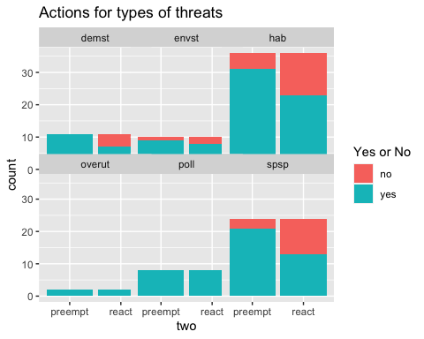

Chi squares

## 3. Who are the organizations/players involved in conserving the conservation of the species (eg in an agreement of effort)?

#### 3 - Data wrangling

o Summary stats… histograms/bar charts… (perhaps stacked bar charts where color code stacks for low, medium, high confidence in having collected most of partners)?

o To account for the uncertainty in number of partners, we put this information into bins and then “then use an ordered probit to look at how well variables predict the rough estimate of numbers of partners.”

o We use logit regression models to predict participation by different “types” of partners

#### Set up model

### Base model

* Note: percent public variable is still in matrix but was removed from model

VIFS

Adding stargazer

## Paper

###Summary stats

* number of unique partners working on all species (note - using the HCP dataset)

Scrap - testing ECOS csv against our list of species

run confidence check

## Joining, by = c("scientific_name", "common_name")  
## Joining, by = c("scientific_name", "common_name")

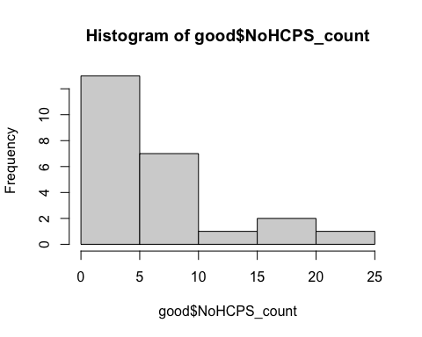

##   
## Call:  
## lm(formula = log(NoHCPS_count) ~ log(range_area) + plant + total_threats +   
## private_land_proportion, data = good)  
##   
## Residuals:  
## Min 1Q Median 3Q Max   
## -1.45667 -0.47158 -0.00002 0.52812 1.24481   
##   
## Coefficients:  
## Estimate Std. Error t value Pr(>|t|)   
## (Intercept) -4.36439 3.10160 -1.407 0.1774   
## log(range_area) 0.23843 0.12509 1.906 0.0737 .  
## plant -0.54846 0.35426 -1.548 0.1400   
## total_threats 0.02466 0.15549 0.159 0.8759   
## private_land_proportion 1.14626 0.67645 1.695 0.1084   
## ---  
## Signif. codes: 0 '***' 0.001 '**' 0.01 '*' 0.05 '.' 0.1 ' ' 1  
##   
## Residual standard error: 0.7652 on 17 degrees of freedom  
## (2 observations deleted due to missingness)  
## Multiple R-squared: 0.3411, Adjusted R-squared: 0.186   
## F-statistic: 2.2 on 4 and 17 DF, p-value: 0.1125

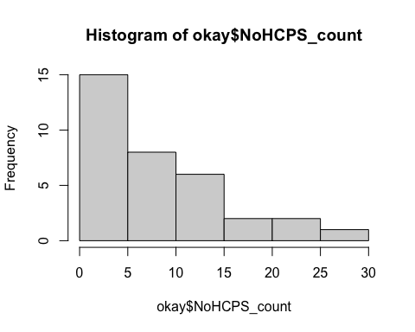

##   
## Call:  
## lm(formula = log(NoHCPS_count) ~ log(range_area) + plant + total_threats +   
## private_land_proportion, data = okay)  
##   
## Residuals:  
## Min 1Q Median 3Q Max   
## -1.49513 -0.38167 0.07007 0.44253 1.23390   
##   
## Coefficients:  
## Estimate Std. Error t value Pr(>|t|)   
## (Intercept) -6.37636 2.25217 -2.831 0.00883 **  
## log(range_area) 0.32167 0.09535 3.373 0.00234 **  
## plant -0.45424 0.27660 -1.642 0.11259   
## total_threats 0.04625 0.12525 0.369 0.71491   
## private_land_proportion 1.40696 0.48794 2.883 0.00779 **  
## ---  
## Signif. codes: 0 '***' 0.001 '**' 0.01 '*' 0.05 '.' 0.1 ' ' 1  
##   
## Residual standard error: 0.7097 on 26 degrees of freedom  
## (3 observations deleted due to missingness)  
## Multiple R-squared: 0.4546, Adjusted R-squared: 0.3707   
## F-statistic: 5.418 on 4 and 26 DF, p-value: 0.002609

test relationship between number of initiatives and number of partners

Q - how many agreement documents are we missing