Population dynamics of a globally rare yet locally abundant endemic monocarpic perennial (Oenoethera coloradensis)
Alice E. Stears$​^{1*}$, Maria Paniw², Roberto Salguero-Gómez³, Daniel C. Laughlin$​^{1}$
$​^{1}$Botany Department and Program in Ecology, University of Wyoming, Laramie, WY
² Estación Biológica de Doñana, Sevilla, Spain
³Department of Zoology, Oxford University, Oxford, England
$​^{*}$Corresponding Author: astears@uwyo.edu
Abstract
The persistence of naturally rare species has long been a motivating question for ecologists. Classical theory implies that community dynamics should be driven by common species, and that natural selection should not allow small populations of rare species to persist over long periods. And yet, a majority of the species found on earth are rare. Rare species contribute to diversity, community stability, and ecosystem function, and several mechanisms have been proposed to explain their persistence. We used size-based integral projection models (IPMs) to examine the population dynamics of Oenothera coloradensis, a rare, endemic, monocarpic perennial forb, and determined whether any of five proposed demographic mechanisms for rare species persistence were acting in populations of this species. We also evaluated the importance of including a discrete seedbank stage in population models of this species, and simulated population growth under different climate scenarios to assess the persistence outlook for O. coloradensis populations. We determined that including a seedbank stage in population models has a significant impact on modeled O. coloradensis population growth rate. IPMs that included a size-based continuous state and discrete seedbank state indicated that negative density-dependence is acting to maintain the positive growth rates we observed in O. coloradensis subpopulations. We did not identify evidence of any other proposed mechanisms of rare species persistence. We propose that high micro-site abundance is the primary factor by which this species persists, which allows it to sidestep the demographic and genetic challenges of small population size that rare species typically face. Simulations indicate that this species is likely to persist in the future, barring the negative impacts of habitat loss.
Introduction
Determining how and why populations of naturally rare species persist in nature has been a question motivating ecologists for a long time (Levins and Culver 1971, Drury 1974). Theoretically, low population size is the last step on a trajectory toward extinction (Stanley 1979, Rosenzweig and Lomolino 1997), and yet stable populations of rare species exist in every ecosystem and across the tree of life. In fact, a large proportion of species globally – as much as 35% of plant species, for example— can be considered naturally rare (Enquist et al. 2019). This implies that there must be both fundamental and realized niches that are available for these species to occupy, and that small population size is not necessarily a harbinger of extinction. A growing body of evidence shows that rare species do in fact contribute to community dynamics. For example, species-specific perturbations of rare species population dynamics have a disproportionate adverse impact on community stability (Arnoldi et al. 2019, Säterberg et al. 2019). The presence and abundance of rare species can also significantly alter community functional composition (Leitão et al. 2016, Burner et al. 2022), which in turn impacts ecosystem function (Lyons et al. 2005). Rare species can also reduce the success of invasive species, and are the primary drivers of global diversity patterns (Lyons and Schwartz 2001). These reasons, as well as the inherent and unquantifiable value of any species, make rare species particularly important for conservation, particularly since their low natural abundances render them especially susceptible to local extirpation or even global extinction.
Effective conservation and management of rare species requires a detailed understanding of both the conditions causing rarity in the first place, and the demographic mechanisms that allow rare species to persist. Causes of rarity can vary from highly-specific habitat requirements (Sgarbi and Melo 2018), to adverse impacts of anthropogenic environmental change. Rarity makes a species or population susceptible to a host of challenges, primarily the negative effects of stochasticity. Demographic, environmental, and genetic stochasticity describe random variation in demographic rates, abiotic environmental conditions, and genetic allele frequencies (May 1973). Random deleterious changes in the environment, in demographic rates or in genotype can easily cause extirpation or even extinction in small populations, since there may not be enough unaffected individuals or subpopulations to “rescue” the affected population from the ill effects of these stochastic events (Nei et al. 1975). Rare species that are able to maintain populations over time typically do so by employing certain demographic strategies that compensate for the adverse effects of small population size. There are five main strategies that allow persistence of rare populations (Fig. 1) (Dibner et al. 2019): negative density-dependence (Rovere and Fox 2019), demographic compensation(Villellas et al. 2015), vital rate buffering (Morris and Doak 2004, Hilde et al. 2020), asynchronous responses between subpopulations (Abbott et al. 2017), and fine-scale source-sink dynamics (Kauffman et al. 2004, Pulliam 2016).
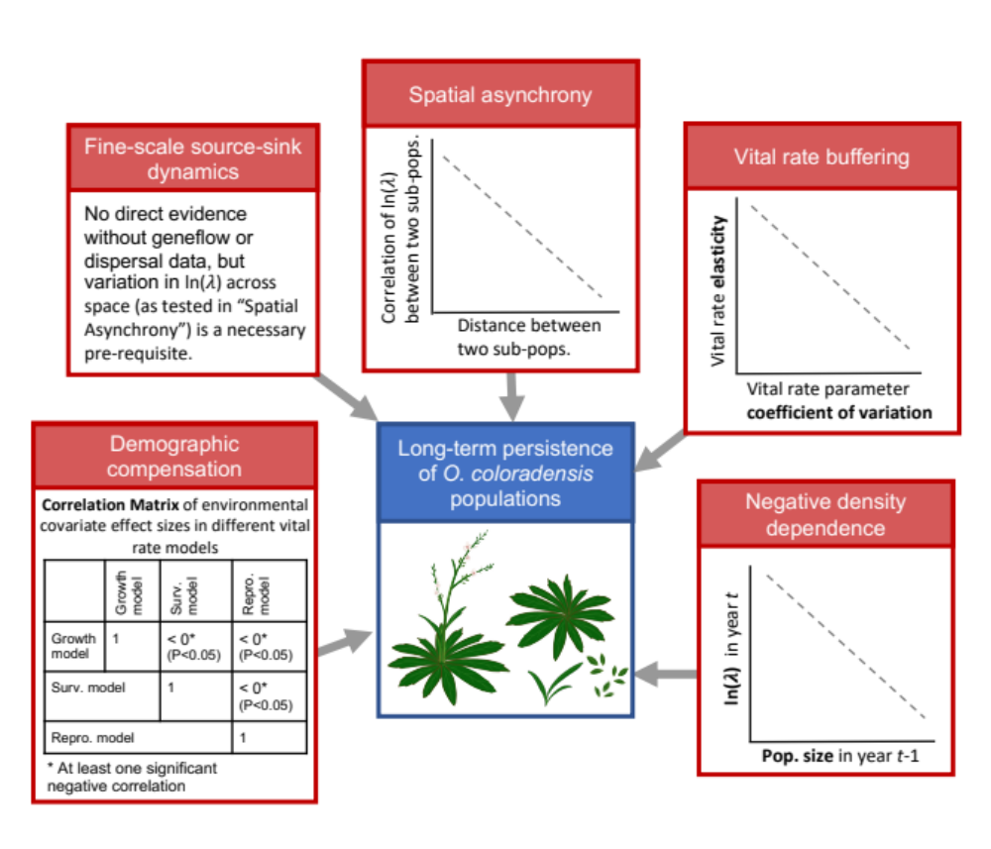
Figure 1: The evidence that would be required to show support for each of the five mechanisms that can act to maintain populations of rare species.

Negative density-dependence occurs when the growth rate (λ) of a population increases with decreasing population size. Demographic compensation occurs when different vital rates, such as growth, survival, or reproduction, are affected in opposing ways by the same perturbation in the environment, which can help maintain a relatively constant population growth rate in response to environmental variation. Vital rate buffering occurs when the variability of vital rates decreases as the vital rate becomes more important (i.e., has a higher elasticity) for determining population growth rate, which prevents λ from fluctuating as the environment changes. Spatial asynchrony occurs when subpopulations close to one another in space have different or even opposing growth rates, stabilizing λ for the entire population. Fine-scale source-sink dynamics occur when there is gene flow between subpopulations, either by migration, pollination, or seed dispersal, that bolsters the size and genetic diversity of very small subpopulations, which stabilizes λ for the population as a whole. Each of these above mechanisms can act independently, but also can interact or overlap with other mechanisms. The most effective conservation and management plans for rare populations will differ according to which of these persistence mechanisms is operating.
We use size-based integral population models (IPMs) (Easterling et al. 2000) that include a discrete seedbank population state to identify which mechanisms are contributing to the persistence and in some cases population growth of a naturally rare, endemic plant species, Oenothera coloradensis (Onagraceae). Oenothera coloradensis is monocarpic perennial forb that occurs in riparian habitats in southeastern Wyoming, northern Colorado, and western Nebraska. It was listed as “threatened” under the Endangered Species Act from 2000 until 2019, when it was delisted due to “recovery” (Jennings 2000, Everson 2019). The largest known populations occur on the FE Warren Airforce Base (FEWAFB) near Cheyenne, WY, and the Soapstone Prairie Natural Area in Larimer County, CO. We conducted a three-year demographic study of O. coloradensis subpopulations at the FEWAFB and Soapstone prairie, and used the resulting vital rate information to parameterize a set of IPMs that account for the effects of density dependence, abiotic variation, and demographic and environmental stochasticity on observed and simulated population growth rates.
Our first objective was to determine if including information about the seedbank significantly altered population models for O. coloradensis. There is evidence that seeds of this species can persist in the soil, and can maintain viability for at least five years in laboratory conditions (Burgess et al. 2005). Seedbanks can serve as important reservoirs of genetic diversity and can buffer populations against collapse (Vitalis et al. 2004, Jongejans et al. 2006). They can be especially critical for monocarpic perennials that only flower once in their lifetime (Rees et al. 2006). If many plants reproduce in a year that initially seems favorable, but then experience conditions later in the season that limit seed production, a seedbank can rescue the population by providing a source of new recruits in the subsequent year. For these reasons, we expected that a soil seedbank is important for O. coloradensis. Seedbanks are often not included in population models because their parameters can be very difficult to estimate, but previous work shows that including them can significantly alter model outcomes (Paniw et al. 2017, Nguyen et al. 2019). We predicted that including a discrete seedbank state in IPMs would increase the projected λ for O. coloradensis populations.
Our second objective was to identify whether any of the five persistence mechanisms was acting to maintain O. coloradensis populations. This species occurs in habitats that naturally experience frequent, highly localized disturbance, which means that some subpopulations of O. coloradensis might be negatively affected by flood, for example, while other nearby populations are simultaneously thriving due to lack of disturbance. Additionally, previous matrix population models constructed for this species in the 1990s found substantial variation in lambda across space and time (Floyd and Ranker 1998). The population-wide pattern of asynchronous disturbance also could make source-sink dynamics important. We also have evidence of large fluctuations in the number of plants within subpopulations (Heidel et al. 2021), which indicate that population growth rate decreases at high population size and increases at low population size. Therefore, we predicted that density dependence, small-scale source-sink dynamics and asynchronous responses between subpopulations would be important mechanisms of persistence for O. coloradensis.
Our final objective was to estimate whether the FEWAFB and Soapstone prairie O. coloradensis populations will persist into the future. We used IPMs for each population to simulate their trajectory 50 years into the future under two different climate scenarios, one based on climate conditions during our demographic study, and another simulating hotter and drier conditions that approximate the predicted effect of climate change at our study location. These simulations all included the effects of density dependence and demographic and environmental stochasticity. The US Fish and Wildlife service delisting of this species was based on a positive viability outlook, and suggests that the rapid decline in population sizes that prompted the initial listing decision was actually the downward portion of a sinusoidal pattern of population growth common in density-dependent species, rather than a true long-term decline in population size (Everson 2019). We expected that simulations of O. coloradensis population growth over time generally would support this conclusion, since observed growth rates during demographic monitoring were positive. We expected that hotter and drier conditions would decrease simulated population growth rate, since this species appears to prefer wet habitats that are more common with higher precipitation and lower evapotranspiration.

Methods
Species description: Oenothera coloradensis, formerly Gaura neomexicana spp. coloradensis (Wagner et al. 2007), is an herbaceous, monocarpic perennial plant in the Onagraceae family. Non-reproductive plants consist of a rosette of basal leaves with a fleshy taproot. Flowering typically occurs around four years of age, when plants send up a stalk between 10 and 30 cm tall that bears flowers and fruits. Plants almost always die after flowering—93% of the time in populations we observed. Seeds are contained within small, woody, indehiscent capsules that contain two to five seeds each (Burgess et al. 2005). A single adult plant can produce more than 500 capsules. This species does not reproduce vegetatively, although seeds typically germinate near the base of the parent plant, which often results in dense clumps of vegetative individuals (Heidel et al. 2021). O. coloradensis has no known specialist pollinators or seed dispersers (Floyd and Ranker 1998, Heidel et al. 2021).
Previous work established that O. coloradensis population growth rate is particularly impacted by recruitment of individuals to the small rosette, or seedling, stage (Floyd and Ranker 1998). Seedling recruitment increases when non-O. coloradensis biomass is removed, indicating that surrounding grasses and forbs outcompete or shade-out seedlings (Munk et al. 2002). Previous work also suggests that seedbanks are important for this species, since years of high seedling density are not necessarily preceded by years of high rates of flowering and seed production (Munk et al. 2002). The O. coloradensis seedbank has not been studied directly, but a greenhouse seed viability and germination study showed that an average of 58% of seeds produced by a parent plant are viable, and that a viable seed has a 20% mean probability of germinating (Burgess et al. 2005). Neither seed viability nor germination rate changed meaningfully over the five years of the study. These results also showed that two-months of cold-moist stratification triggered germination.
This species primarily occurs in open, frequently disturbed habitats with sub-irrigated, alluvial soils (Jennings 2000). Populations typically occur within the floodplain of ephemeral or perennial streams, but also exist in wet meadows, drainage bottoms, and spring-fed wetlands (Munk 1999). O. coloradensis commonly co-occurs with ﻿Agrostis stolonifera, Pascopyrum smithii, Poa pratensis, Glycyrrhiza lepidota, Iris missouriensis, Cirsium flodmanii, and Grindelia squarrosa (Jennings 2000, Munk et al. 2002). Encroachment of woody shrubs such as Salix exigua has been correlated with declining numbers in some populations (Heidel et al. 2021). Relatively frequent disturbance such as flooding that reduces growth of both woody and herbaceous species and removes litter is important for this species, especially for successful seedling recruitment (Jennings 2000, Burgess 2003).
All historical and known extant O. coloradensis populations lie within a ﻿7,000-hectare area that includes southeast Wyoming, northern Colorado, and a small part of southwest Nebraska. Range-wide survey efforts between 1984 and 1986 identified more than 20 populations. The largest population on Federal land occurs on the F. E. Warren Airforce Base near Cheyenne, WY. The Wyoming Natural Diversity Database (WYNDD) began a base-wide census of reproductive individuals in this population in 1986, and has repeated this census annually since 1988 (Heidel et al. 2021). The Soapstone Prairie Natural Area, a public property owned by the city of Fort Collins, CO, has the largest documented number of O. coloradensis individuals, but this population has not been routinely monitored. The first estimate of species size after its full geographic range was identified occurred in 1998, when it was approximated that the entire species consisted of 47,300 to 50,300 reproductive individuals (Jennings 2000). Although an older estimate of total species numbers or geographic range does not exist to serve as a reference, decline in a majority of the known populations between the mid-1980s and 2000 lead the U.S. Fish and Wildlife Service (USFWS) to designate O. coloradensis as a “threatened” species protected under the Endangered Species Act (Jennings 2000). Although this species appears to be naturally rare, mangers were concerned that, without protection, O. coloradensis had the potential for extinction because of habitat loss due to ranching, natural resource extraction, and shrub encroachment resulting from altered disturbance regimes.
Demographic Data Collection: We conducted a three-year demographic study of O. coloradensis across six subpopulations, three at the F.E. Warren Airforce Base (FEWAFB) and three at the Soapstone Prairie Natural Area. In early summer 2018 we established three 2x2 m quadrats in each of these subpopulations, resulting in 18 plots (Table 1). We tagged and mapped every unique individual in each of these plots if their largest leaf was at least 3 cm. We recorded longest leaf length, reproductive status, flowering status and seed production. In 2019 and 2020 censuses, we mapped and tagged new plants if their largest leaf was at least 3 cm, and re-measured all surviving plants from previous years. High densities of small plants (i.e., plants with largest leaf < 3 cm) prevented our ability to map and tag all seedlings each year, so we tallied them in each plot in each year. We will refer to these plants smaller than 3 cm as “seedlings,” and plants larger than 3 cm as “non-seedling plants.” All censuses took place between late May and early July, during the peak of the O. coloradensis growing season.
It was not possible to measure seed production exactly because O. coloradensis seeds are contained in indehiscent capsules. Additionally, buds on the same plant flower and set seed with a time lag, such that mature seed capsules often exist at the tip of a stem while un-opened buds lower down on that same stem have not yet flowered. This makes it difficult to count the total number of capsules produced by a plant. However, seed capsules leave a noticeable scar on the stem, so we used the number of seed capsule scars on reproductive stems as an estimate of capsule production. Counting scars is extremely time-intensive since a single plant can produce several hundred capsules, so we used linear regression to estimate the relationship between the length of stem bearing capsule scars and the number of capsules produced by that stem. Linear regression using stem measurements and capsule counts from 106 individuals in 2018 indicates that number of capsules produced = 2.95 + 2.0*(stem length in cm) (multiple R-squared = 0.67, P = < 0.01, F-statistic = 212.5, df = 104) (Fig. S1). We used this relationship to estimate capsule production for each reproductive individual. Previous work indicated that each capsule contained an average of 1.7 seeds, so we multiplied the estimated number of capsules produced by an adult plant by 1.7 to estimate seed production (Burgess et al. 2005).
Table 1: Permanent Plot Locations. GPS coordinates listed in decimal degrees, map datum and spheroid: WGS 84.
Site | Subpopulation | Plot Name | N Coordinate | W Coordinate
FEWAFB | Unnamed Creek | U3 | 41.13642 | -104.87209
FEWAFB | Unnamed Creek | U4 | 41.13634 | -104.87183
FEWAFB | Unnamed Creek | U6 | 41.13647 | -104.87132
FEWAFB | Diamond Creek | D7 | 41.14340 | -104.88380
FEWAFB | Diamond Creek | D10 | 41.14441 | -104.88303
FEWAFB | Diamond Creek | D11 | 41.14431 | -104.88094
FEWAFB | Crow Creek | C4 | 41.15540 | -104.87497
FEWAFB | Crow Creek | C5 | 41.15477 | -104.87474
FEWAFB | Crow Creek | C8 | 41.15534 | -104.87487
Soapstone | Pasture HQ5 | S1 | 40.99297 | -105.00925
Soapstone | Pasture HQ5 | S2 | 40.99318 | -105.00935
Soapstone | Pasture HQ5 | S3 | 40.99342 | -105.00937
Soapstone | Pasture HQ3 | S4 | 40.98623 | -105.01691
Soapstone | Pasture HQ3 | S5 | 40.98639 | -105.01671
Soapstone | Pasture HQ3 | S6 | 40.98650 | -105.01656
Soapstone | Meadow | S7 | 40.98753 | -105.02148
Soapstone | Meadow | S8 | 40.98747 | -105.02179
Soapstone | Meadow | S9 | 40.98724 | -105.02145

Environmental Measurements: To determine the effect of temporal variation in climate on O. coloradensis populations, we used modeled, site-level temperature and precipitation data from PRISM (PRISM Climate Group, Oregon State University, https://prism.oregonstate.edu, accessed 30 November 2021). We calculated the mean temperature of both the growing season and preceding winter season for each year of demographic data collection at FEWAFB and Soapstone Prairie. We also calculated total precipitation for each water-year, which we defined as the period from October of the previous year to September of the current year. These variables are referred to as “environmental covariates.”
Objective 1: Quantifying the importance of the seedbank stage
Population Models: We used data from the demographic study detailed above in combination with results from greenhouse and field seedbank studies, to parameterize integral projection models (IPMs) for O. coloradensis. We first created a density-independent IPM using data from both populations that had a single continuous, size-based population state, and did not include a seedbank state (Table 2: IPM “OO”). Then, we created a suite of IPMs that included both a discrete seedbank state, and a continuous, size-based stage for above-ground plants (Table 2: IPMs “A” – “NN”) (Ellner and Rees 2006, Rees et al. 2006, Paniw et al. 2017). Each of these IPMs used a different subset of data, and included different covariates in vital rate models. First, the data used to fit vital rate models came either from a single subpopulation, a population (FEWAFB or Soapstone prairie), or from all locations, and included data for both transitions, or only one transition (2018-2019 or 2019-2020). Second, while all vital rate models included size_{t} (or in some cases when the model fitting process indicated, (size_{t})²) as a predictor of vital rates, these models could also include predictor terms for any combination of the following: population size in the previous year (to account for density dependence), environmental variation (water year precipitation, mean annual growing season temperature, and mean annual winter temperature), and a random intercept of subpopulation to approximate effects of demographic stochasticity.
Table 2. A description of the data used to create each IPM, as well as the covariates included in the vital rate models used in that IPM. log(λ) estimates and 95% bootstrap confidence intervals of log(λ) are also shown for each IPM. log(λ) is not given for IPMs that were constructed with random effects or continuous environmental covariates, since those models were implemented stochastically. For those models, log(λ_{s}) is given instead.
IPM name | Data Included |  |  |  |  |  |  |  |  |  |  | Transitions included |  |  | Covariates included |  |  | log(λ) (95% CI) | log(λ_{s)}
IPM name | Continuous state only | Continuous + seedbank states | All subpopulations | Each population |  | Each subpopulation |  |  |  |  |  | All transitions | Each transition |  | Density dependence | Environmental covariates | subpopulation random intercept | log(λ) (95% CI) | log(λ_{s)}
 |  |  |  | Soapstone | FEWAFB | Unnamed Creek | Diamond Creek | Crow Creek | Meadow | HQ3 | HQ5 | All transitions | 2018-2019 | 2019-2020
OO | x |  | x |  |  |  |  |  |  |  |  | x |  |  |  |  |  | 0.41 (0.408, 0.411) | N/A
A |  | x | x |  |  |  |  |  |  |  |  | x |  |  |  |  |  | 0.39 (0.393, 0.395) | N/A
B |  | x | x |  |  |  |  |  |  |  |  | x |  |  | x |  |  | 0.35 | N/A
C |  | x |  |  |  | x |  |  |  |  |  | x |  |  |  |  |  | 0.24 (0.241, 0.244) | N/A
D |  | x |  |  |  |  | x |  |  |  |  | x |  |  |  |  |  | 0.81 (0.814, 0.819) | N/A
E |  | x |  |  |  |  |  | x |  |  |  | x |  |  |  |  |  | 0.46 (0.462, 0.468) | N/A
F |  | x |  |  |  |  |  |  | x |  |  | x |  |  |  |  |  | 0.31 (0.306, 0.310) | N/A
G |  | x |  |  |  |  |  |  |  | x |  | x |  |  |  |  |  | 0.19 (0.184, 0.189) | N/A
H |  | x |  |  |  |  |  |  |  |  | x | x |  |  |  |  |  | 0.29 (0.291, 0.295) | N/A
I |  | x |  |  |  | x |  |  |  |  |  | x |  |  | x |  |  | 0.34 | N/A
J |  | x |  |  |  |  | x |  |  |  |  | x |  |  | x |  |  | 0.53 | N/A
K |  | x |  |  |  |  |  | x |  |  |  | x |  |  | x |  |  | 0.65 | N/A
L |  | x |  |  |  |  |  |  | x |  |  | x |  |  | x |  |  | -0.28 | N/A
M |  | x |  |  |  |  |  |  |  | x |  | x |  |  | x |  |  | -0.24 | N/A
N |  | x |  |  |  |  |  |  |  |  | x | x |  |  | x |  |  | 0.32 | N/A
O |  | x |  | x |  |  |  |  |  |  |  | x |  |  | x | x | x | N/A | 0.044
P (hot+dry) |  | x |  |  | x |  |  |  |  |  |  | x |  |  | x | x | x | N/A | 0.022
Q |  | x |  | x |  |  |  |  |  |  |  | x |  |  | x | x | x | N/A | 0.067
R (hot+ dry) |  | x |  |  | x |  |  |  |  |  |  | x |  |  | x | x | x | N/A | 0.069
S |  | x |  |  |  | x |  |  |  |  |  | x |  |  | x | x |  | 0.33 | N/A
T |  | x |  |  |  |  | x |  |  |  |  | x |  |  | x | x |  | 0.39 | N/A
U |  | x |  |  |  |  |  | x |  |  |  | x |  |  | x | x |  | 0.61 | N/A
V |  | x |  |  |  |  |  |  | x |  |  | x |  |  | x | x |  | -0.27 | N/A
W |  | x |  |  |  |  |  |  |  | x |  | x |  |  | x | x |  | -0.21 | N/A
X |  | x |  |  |  |  |  |  |  |  | x | x |  |  | x | x |  | 0.50 | N/A
Y |  | x | x |  |  |  |  |  |  |  |  |  | x |  |  |  |  | 0.61 | N/A
Z |  | x | x |  |  |  |  |  |  |  |  |  |  | x |  |  |  | 0.15 | N/A
AA |  | x |  | x |  |  |  |  |  |  |  | x |  |  |  |  |  | 0.27 | N/A
BB |  | x |  |  | x |  |  |  |  |  |  | x |  |  |  |  |  | 0.458 (0.457, 0.459) | N/A
CC |  | x |  |  |  | x |  |  |  |  |  |  | x |  |  |  |  | 0.16 | N/A
DD |  | x |  |  |  |  | x |  |  |  |  |  | x |  |  |  |  | 1.21 | N/A
EE |  | x |  |  |  |  |  | x |  |  |  |  | x |  |  |  |  | 0.62 | N/A
FF |  | x |  |  |  |  |  |  | x |  |  |  | x |  |  |  |  | 0.38 | N/A
GG |  | x |  |  |  |  |  |  |  | x |  |  | x |  |  |  |  | 0.51 | N/A
HH |  | x |  |  |  |  |  |  |  |  | x |  | x |  |  |  |  | 0.82 | N/A
II |  | x |  |  |  | x |  |  |  |  |  |  |  | x |  |  |  | 0.26 | N/A
JJ |  | x |  |  |  |  | x |  |  |  |  |  |  | x |  |  |  | 0.48 | N/A
KK |  | x |  |  |  |  |  | x |  |  |  |  |  | x |  |  |  | 0.46 | N/A
LL |  | x |  |  |  |  |  |  | x |  |  |  |  | x |  |  |  | 0.20 | N/A
MM |  | x |  |  |  |  |  |  |  | x |  |  |  | x |  |  |  | -0.10 | N/A
NN |  | x |  |  |  |  |  |  |  |  | x |  |  | x |  |  |  | -0.19 | N/A
The IPM with one state variable corresponding to continuous plant size (IPM “OO”) used a kernel structure where the continuous, above-ground population state ((n(z’, t+1)) at time t+1 was described by the following equation:
$$n\left(z^{'}, t+1\right)=\int_{L}^{U}{\left(1-P_{b}\left(z\right)\right) s\left(z\right) G\left(z^{'},z\right) n\left(z,t\right) dz} + pEstab\int_{L}^{U}{P_{b}\left(z\right) b\left(z\right) c_{o}\left(z^{'}\right) n\left(z,t\right) dz} eqn 1$$
All of the IPMs with two population states used the same kernel structure, where the continuous, above-ground population state (n(z’, t+1)) and the seedbank state (B(t+1)) at time t+1 were described by the following equations:
$$n\left(z^{'}, t+1\right)=\int_{L}^{U}{\left(1-P_{b}\left(z\right)\right) s\left(z\right) G\left(z^{'},z\right) n\left(z,t\right) dz} + goCont\int_{L}^{U}{P_{b}\left(z\right) b\left(z\right) c_{o}\left(z^{'}\right) n\left(z,t\right) dz}+outSB \left(B\left(t\right)c_{o}\left(z^{'}\right)\right) eqn 2$$
$$B\left(t+1\right)=goSB \int_{L}^{U}{P_{b}\left(z\right) b\left(z\right) n\left(z,t\right) dz}+B\left(t\right) staySB eqn 3$$
In both sets of equations, z is the distribution of plant size in the current year (“size_{t}”), z’ is the distribution of plant size in the next year (“size_{t+1}”), and U and L are the upper and lower boundaries of plant size. G(z’, z) is the vital rate function describing size_{t+1} as a function of size_{t}. The vital rate functions s(z), P_{b}(z), and b(z) describe the relationship between size_{t} and survival probability of non-flowering plants, flowering probability, and seed production of flowering plants, respectively. c_{o}(z’) is the distribution of above-ground recruit size_{t+1}. goCont, outSB, goSB, and staySB are discrete parameters that determine seedbank dynamics. goCont is the probability of a seed produced in year t germinating as a seedling in year t+1, outSB is the probability of a seed from the seedbank in year t germinating as a seedling in year t+1, goSB is the probability of a seed produced in year t going into the seedbank in year t+1, and staySB is the probability of a seed from the seedbank in year t persisting in the seedbank in year t+1 (Paniw et al. 2017) (Table 3). pEstab is the probability of a seed produced in year t establishing as a seedling in year t+1.
We used data from the three-year demographic monitoring study to parameterize the vital rates used in the IPMs (vital rates are shown in Fig. 1). Vital rate functions for the continuous, size-based above-ground stage were parameterized using data from “non-seedling plants” as well as seedlings. Although seedlings (above-ground plants < 3 cm in leaf length) were only tallied in each subplot of each quadrat and year instead of tagged and measured, we incorporated them into the dataset for continuous, above-ground plants by assigning them a random size drawn from a continuous, uniform probability distribution (seedling size ~ U(0.1, 3)). Each new recruit to the > 3 cm stage in year t+1 was randomly assigned to a seedling within the same subplot in year t. Seedlings in year t that were assigned a recruit in year t+1 survived, while those without an assigned recruit died. Incorporating seedlings into the continuous dataset in this fashion allowed us to create IPMs using only one discrete stage.
We used data from the demographic study to estimate continuous vital rate functions describing survival, growth, probability of flowering, seed production, and recruit size. For each of these vital rates, we fit subpopulation-level models as well as models using data across all sites. We additionally fit models with and without density dependence, with and without environmental covariates, and using data either from all years or from each unique annual transition. The basic model structure was the same for each vital rate (Table 3). All models included log-transformed leaf size_{t} as a predictor. Log-transformed leaf size_{t} squared was also included as a predictor if it decreased model AIC. Additional covariates indicating population size and environmental conditions were added to these basic models. We modeled survival probability (s(z)) as a function of log-transformed leaf size_{t} using generalized linear models with binomial error distributions. Flowering individuals were excluded from the data used to fit survival models, since O. coloradensis is a monocarpic perennial that nearly always dies after flowering. Probability of flowering (Pb(z)) was also modeled using generalized linear models with binomial error distributions, and was predicted by log-transformed leaf size_{t} plus log-transformed leaf size_{t} squared. We estimated seed production (b(z)) as a function of size_{t} using negative binomial models because the count data was over-dispersed. We only used data from flowering plants in this analysis, and fit these models using the “glm.nb” function from the “MASS” R package (Venables and Ripley 2002). Plant size_{t+1} (G(z’,z)) was described as a series of Normal distributions with mean = μ_{s} and standard deviation = σ_{s}. Mean plant size_{t+1} (μ_{s}) was modeled as a function of size_{t} using linear models with Gaussian error. The standard deviation of plant size_{t+1} (σ_{s}) was the residual standard error of these linear models, which we assumed to be constant. The distributions of recruit size in the next year (c_{o}(z’)) were described by Normal distributions with the mean μ_{r}, and the standard deviation σ_{r}. μ_{r} and σ_{r} were the mean and standard deviation of observed plant size in the next year.
Figure 1. Diagram of the O. coloradensis life-cycle, with transitions labeled with the notation used in IPM equations. Based on model structures and notation from Paniw et al. (2017), Merow et al. (2014), and Ellner and Rees (2016).

Table 3. Description of vital rates used in O. coloradensis IPMs
Vital rate | Description | Model
pEstab | P(seed produced in t establishes as a seedling in t+1) | pEstab = $\frac{Num. new recruits in year t+1 }{Num. seeds produced in year t}$
goCont | P(seed produced in t germinates in t+1) | goCont = viab. rate (germ. rate)
outSB | P(seedbank seed in t germinates in t+1) | outSB = germ. rate (1 - death rate)
goSB | P(seed produced in t goes to the seedbank in t+1) | goSB = viab.rate (1 - germ. rate)
staySB | P(seedbank seed in t stays in the seedbank in t+1) | staySB = (1 - germ. rate) (1 - death rate)
s(z) | P(survival from t to t+1) | logit(survival) ~ β₀ + β₁ (log(size_{t})) + ε
Pb(z) | P(flowering in t) | logit(flowering) ~ β₀ + β₁ (log(size_{t})) + β₂ (log(size_{t})²) + ε
b(z) | Seed production in t | exp(seed number) ~ β₀ + β₁ (log(size_{t}))+ ε
G(z’,z) | Distribution of plant size in year t | G(z’,z) = N (μ_{s}, σ_{s}); μ_{s} ~ β₀ + β₁ (log(size_{t})) + ε ; σ_{s} ~ RSE (β₀ + β₁ (log(size_{t})) + ε)
c_{o}(z’) | Distribution of new recruit size in year t | c_{o}(z’) = N(μ_{r}, σ_{r}); μ_{r} = mean (size of recruits in t) σ_{r} = stnd. dev. (size of recruits in t)

* RSE = residual standard error
We estimated discrete vital rates for seeds using data from both greenhouse and field-based germination and seed viability studies. Previously-published data from a greenhouse experiment using O. coloradensis seed capsules collected from the FEWAFB populations determined that viable seeds had an average germination rate of 20.3% after cold-stratification, and did not identify a consistent decline in germination rate over five years (Burgess et al. 2005). This study also found that a seed capsule contained an average of 1.7 seeds, and that 58.5% of seeds produced were viable. We conducted an additional seed study to determine if overwintering in natural conditions lead to a lower germination rate than was identified in the previous greenhouse study. We buried 60 field-collected seed capsules in mesh bags at 6 locations near our demographic study plots at FEWAFB, and then recovered the seed bags after one winter. An average of 10% of seed capsules were not recoverable, likely because they were non-viable and withered away or were eaten. We planted the recovered capsules in standard greenhouse conditions, and found a mean germination rate of 6.8%. This germination rate was much lower than that identified by Burgess et al., however our seed study had a much smaller sample size, reducing the reliability of our result. However, it is still likely that true germination rates are much lower than those identified in greenhouse conditions, so we reduced the germination rate identified by Burgess et al. by 20%. The following parameters we used to estimate the discrete seed vital rate parameters: viable seed germination rate (germ. rate) = 0.16, viability rate of seeds produced by a parent plant (viab. rate) = 0.58, rate of natural seed death in the seedbank (death rate) = 0.10. We did not have the data required to determine how these rates changed across subpopulations or in response to abiotic variation, so we used the same seed vital rates for all IPM models (Table 3).
We used these vital rate functions and discrete parameters described above to construct discretized IPM kernels. All kernels were numerically implemented using the “midpoint rule” method (Easterling et al. 2000) with 500 bins, an upper size limit corresponding to 120% of the maximum observed plant size and a lower size limit corresponding to 80% of the minimum simulated seedling size of 0.1 cm. We then used eigen analysis of these kernels to estimate the asymptotic population growth rate (λ), damping ratio, stable size distribution, and reproductive value (Caswell 2001, Ellner et al. 2016). We used 1000 iterations of bootstrap resampling to estimate 95% bootstrap confidence intervals (95% CIs) for each continuous vital rate parameter included in each IPM, as well as each estimate of λ (Merow et al. 2014, Fieberg et al. 2020). We were unable to estimate CIs for discrete seedbank parameters because they were from a previous publication. We used perturbation analysis to determine the sensitivity and elasticity of λ to changes in germination rate, viability rate, seed survival rate, and each parameter in each continuous vital rate model (Morris and Doak 2002). We used the IPM with all data and no density dependence or environmental covariates (IPM “A”) for this analysis. All vital rate models and IPMs, as well as the information derived from them, were used to evaluate the importance of negative density dependence, demographic compensation, vital rate buffering, asynchronous responses, and source-sink dynamics for persistence of O. coloradensis populations.
Objective 2: Evaluating Persistence Mechanisms
Negative Density Dependence: In order to determine the importance of density dependence in O. coloradensis populations, we compared subpopulation-level, all-transition IPMs and vital rate functions that did and did not include population size in the current year as a covariate in vital rate models (density-independent IPMs: “C”-“H”; density-dependent IPMs: “I”-“N”). We used AIC to identify significant differences between vital rate models with and without density dependence terms. We also used results from subpopulation-level IPMs (IPMs CC-NN) for each transition to identify relationships between subpopulation size in year t and log(λ) (as shown in Fig. 1), as well as subpopulation size in year t and the ratio of population size in year t+1 and subpopulation size in year t. In addition to population size information and log(λ) values from our IPMs, we also used population sizes and log(λ) values from a previously-published demographic study of O. coloradensis at the three FEWAFB subpopulations that we also monitored (Floyd and Ranker 1998). A negative relationship between population size in year t and either log(λ) or the ratio of population size in year t + 1 to population size in year t would provide evidence for negative density dependence. Additionally, significant differences between models with and without population size predictor terms would constitute evidence for density dependence.
Demographic Compensation: To test for demographic compensation, we calculated the correlation between environmental covariate coefficients in different vital rate models. A negative correlation between coefficients of the same covariate in different vital rate models indicated demographic compensation was taking place (Villellas et al. 2015, Dibner et al. 2019). For example, if soil moisture had a positive effect on growth but a negative effect on survival, this would be evidence for demographic compensation. For this correlation analysis we used vital rate models that were fit using data from each subpopulation and both transitions, and that included covariates for density dependence and all environmental covariates (vital rate models from IPMs “S”-“X”). We tested the significance of negative correlations between environmental covariate coefficients using a randomization procedure similar to that used by Villellas et al. (2015), where we randomly assigned an environmental covariate coefficient drawn from the observed distribution of values for that coefficient to each vital rate function, calculated a correlation matrix between those coefficients in each vital rate function, and counted the number of negative correlations in that matrix. This procedure was repeated 10,000 times to generate a null distribution of the expected number of negative correlations between environmental coefficients that would occur randomly. We compared the observed number of negative correlations between each environmental covariate coefficient to these expected distributions of random correlations to determine statistical significance. We could not test for demographic compensation in discrete seedbank vital rate parameters because we did not know how they varied according to environmental conditions. A significant negative correlation between environmental covariate coefficients in different vital rate models would provide evidence for demographic compensation (Fig. 1).
Vital Rate Buffering: We tested for the presence of vital rate buffering in O. coloradensis populations by comparing the quartile coefficient of variation of each vital rate parameter to the absolute value of its elasticity (Pfister 1998, Morris and Doak 2004). The quartile coefficient of dispersion (QCD) is a metric of relative dispersion that can be used in place of the coefficient of variation when the mean of values is negative (Bonett 2006). We used an IPM that was fit across all subpopulations using data from both transitions (Table 2: IPM “A”) to calculate elasticity values for each discrete vital rate and each parameter in each continuous vital rate function (Morris and Doak 2002). We calculated the QCD for each vital rate function parameter using the equation ﻿QCD = (Q3-Q1)/(Q3+Q1), where Q3 and Q1 are the third and first quartiles of the observed values, respectively. These “observed values” were 12 parameter estimates for each vital rate parameter which were taken from the vital rate functions that were fit uniquely for each subpopulation and each transition (Table 2: IPMs “CC”-“NN”). Because we did not have site-level information about discrete seedbank vital rates, we calculated QCD for these parameters based on the maximum possible variability in each rate. Seed survival, germination rate, and viability rate are all probabilities bounded by 0 and 1, so we calculated QCD using Q1 and Q3 values from a uniform distribution bounded by 0 and 1. We then evaluated the correlation between QCD and the absolute value of elasticity for all vital rate parameters (Pfister 1998). A significant negative correlation would indicate that vital rate buffering was present (Fig. 1).
Asynchronous Responses and Source-Sink Dynamics: To determine whether O. coloradensis subpopulations showed asynchronous responses to environmental variation, we made a correlation matrix to determine how change in log(λ) across each transition was correlated across each subpopulation, using values of log(λ) derived from IPMs for each subpopulation (Table 2: IPMs “C”-“H”). We used the “mantel()” function from the “vegan” R package to perform a Mantel test, which determined if the Spearman correlation of log(λ) across subpopulations was significantly related to the Euclidian distance between each subpopulation (Oksanen et al. 2020). A negative relationship between the distance between subpopulations and degree of correlation of log(λ) would constitute evidence for spatial asynchrony between subpopulations (Fig. 1).
Because we did not have information about gene flow between subpopulations of O. coloradensis via pollination or seed dispersal, it was not possible to directly measure whether fine-scale source-sink dynamics were acting in these populations. However, because variation in population growth rate across space is a pre-requisite for source-sink dynamics, the previously described tests for spatial asynchrony in subpopulations can also provide evidence for the existence of source-sink dynamics. Again, this would be a negative relationship of distance between subpopulations and correlation of subpopulation log(λ) (Fig. 1).
Objective 3: Population viability analysis
To determine the likelihood that each population (Soapstone prairie and FEWAFB) would persist, we used the “ipmr” R package to project each population forward 50 years, incorporating the effects of density dependence and demographic and environmental stochasticity (using IPMs “O”-“R”). Each projection was repeated 1000 times, and stochastic log(λ) (or log(λ_{s})) was calculated with a burn-in of 15 iterations. We did one set of projections using climate values that were randomly drawn from the distribution of observed climate values at each population site. A second set of projections drew climate values from distributions that were 10% warmer and 10% drier than the observed climate, to evaluate how O. coloradensis populations may fare under hotter and drier conditions that are predicted to occur in this region under climate change (Vicente-Serrano et al. 2020).
Results
Vital Rate Models
In vital rate models parameterized for each population using data from both transitions, we found that larger non-reproductive plants are more likely to survive to year t+1 than smaller plants (Fig. 3A). Plants below ~7.5 cm in year t are likely to become larger in year t+1, while plants larger than ~7.5 cm are likely to become smaller in the next year (Fig. 3B). Flowering probability is best approximated as a quadratic polynomial: flowering probability rises when log(size_{t}) approaches 2.5 (12 cm), but plants with the largest leaves exhibit low flowering probability (Fig. 3C). The number of seeds that a reproductive plant produces increases sharply with log(size_{t}) (Fig. 2D). The inclusion of additional covariates did not alter the overall shape or sign of the relationships between log(size_{t}) and vital rates, so models shown in Figure 3 did not include any additional covariates beyond log(size_{t}).
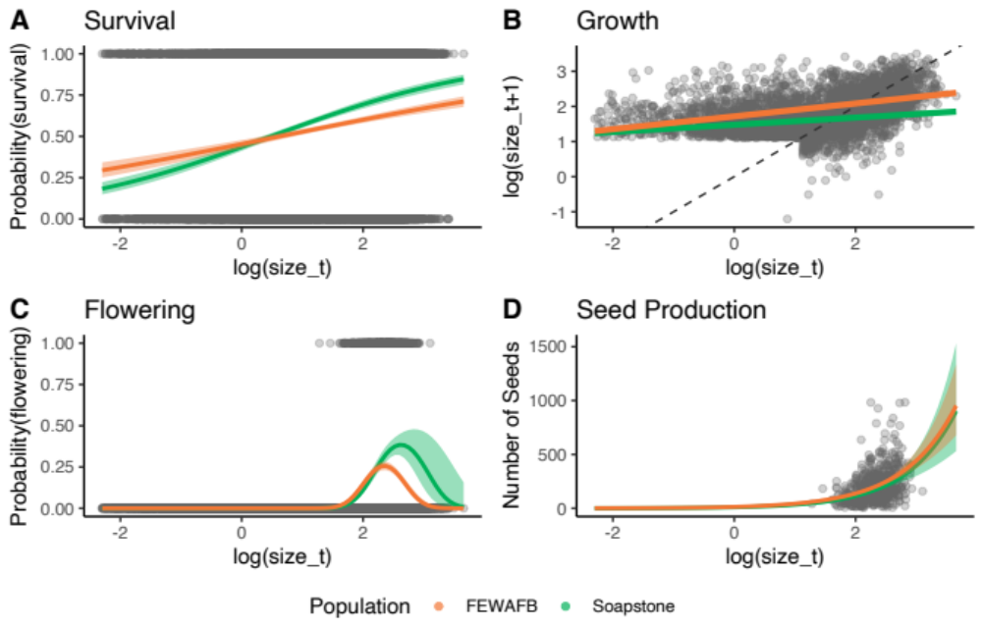
Figure 3. The effect of current year size (log(size_{t})) on vital rates in monitored O. coloradensis populations. Data for from all sites and all transitions is shown. Lines indicate vital rate functions for each population, and include only log(size_{t}) as a predictor, with the exception of flowering models, which include a (log(size_{t}))² term. Bands around each line show 95% confidence intervals. The dashed line in panel B shows a 1:1 line. The sharp cut-off in log(size_{t+1}) in panel B is due to the fact that two year-old plants could not be seedlings, which were classified as any plant less than 3 cm in size.

Integral Projection Models:

Objective 1: Quantifying the importance of the seedbank stage
We found that including a discrete seedbank stage in IPMs for O. coloradensis significantly, yet modestly, lowered the asymptotic population growth rate. The continuous state-only IPM (Table 2: IPM “OO”) predicted an asymptotic log(λ) of 0.41 for all populations (95% CI: 0.408 - 0.411), while the continuous + discrete state IPM (Table 2: IPM “A”) predicted an asymptotic log(λ) of 0.39 (populations (95% CI: 0.393 - 0.395). All subsequent IPM results refer to models that included a discrete seedbank state.
The simplest two-state IPMs that excluded density dependence and environmental variation indicated that both the Soapstone prairie and FEWAFB populations had positive population growth rates (Table 2: Soapstone prairie- IPM “AA”, log(λ) = 0.27; FEWAFB – IPM “BB”, log(λ) = 0.46). The Diamond Creek subpopulation at FEWAFB had the highest population growth rate from 2018 to 2020 (Table 2: IPM “D”, log(λ) = 0.81), while the HQ3 subpopulation at Soapstone prairie had the lowest growth rate (Table 2: IPM “G”, log(λ) = 0.19). We parameterized multiple other sets of IPMs that used different combinations of covariates in their vital rate models, and almost all identified a positive population growth rate (Table 2).
A density-independent, discretized IPM kernel (made using IPM “A”) shows transition probabilities within and between the discrete and continuous stages of the O. coloradensis lifecycle when all populations and transitions are considered together (Fig. 4A). Relative to the rest of the kernel, there is a very high probability that seeds stay in the seedbank, as well as a large contribution of seeds from medium-sized adult plants to the seedbank in the next year. The rates at which seeds are produced by adult plants and stay in the seedbank have the most impact on population growth rate (Fig. 4C). 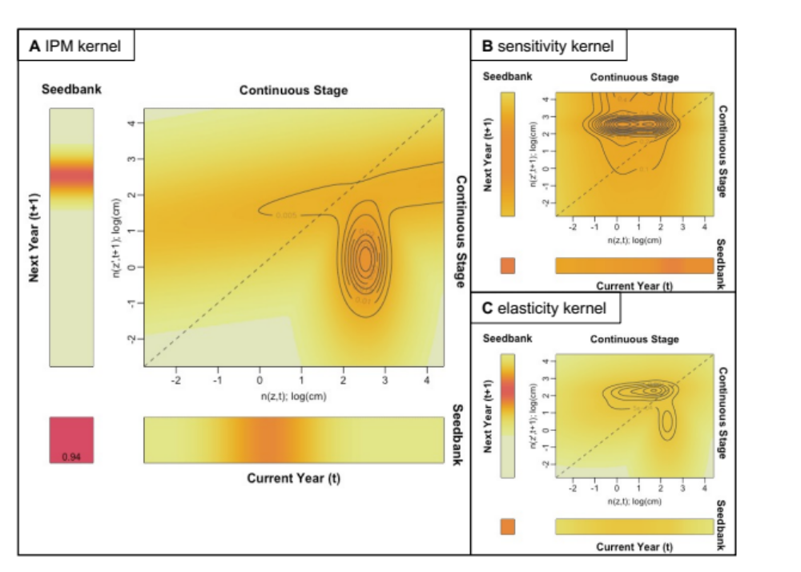
Figure 4. Visualizations of the O. coloradensis IPM kernels. (A) The IPM kernel for O. coloradensis. This kernel shows a density-independent IPM constructed using all data from all transitions (IPM A). (B) Sensitivity of the IPM kernel. (C) Elasticity of the IPM kernel. In all panels, color indicates probability, with darker colors corresponding to higher probability, and lighter colors corresponding to lower probability. The dashed line shows a 1:1 line.

Objective 2: Evaluating Persistence Mechanisms
Negative Density Dependence: There is moderate evidence that negative density-dependence is acting to maintain populations of O. coloradensis. AIC comparison of continuous vital rate models indicate that density-dependent models are better predictors of the majority of vital rates than density-independent models in most subpopulations (Table 4). Models that included population size in the previous year as a covariate were better predictors of growth in five of six subpopulations. Density dependent models were better predictors of survival and seed production than density independent models in four out of six subpopulations, and density dependent models of flowering were better in one subpopulation. Recruit size distribution was not affected by density dependence—AIC model comparison did not indicate substantial differences, either negative or positive, between recruit size models for any subpopulation. The vital rate models for the Meadow population at Soapstone Prairie were least affected by density dependence. Only the growth model was improved by including a density dependence term. Although density dependence is important for O. coloradensis, it appears only to be acting to decrease lambda at high density, but not clearly increasing lambda at low density. We also found that population growth rate is generally higher when population size is smaller, but only when comparing the relationship between log(λ) and population size within a subpopulation (Fig. 5A and C). There is also a negative relationship within each subpopulation between population size in year t and the ratio of subpopulation size in t+1 to subpopulation size in t (Fig. 5B and D). However, when looking across all subpopulations, there is not a clear relationship between subpopulation size in t and either log(λ) or the ratio of subpopulation size in t+1.
Table 4. Comparison of vital rate models that do and do not include density dependence. The “DI” and “DD” rows contain AIC values for each vital rate model in each subpopulation for models that are density-independent (DI) and density-dependent (DD). The difference between the AIC of DI and DD models is shown in the Δ AIC column. Bold text indicates that the |ΔAIC| value is > 3, which means that including a term for density dependence substantially changed that vital rate model. A positive ΔAIC indicates that including density dependence improved the model, while a negative value indicates that including density dependence made model fit worse.
Vital Rate Model |  | Subpopulation
 |  | Crow Creek | Diamond Creek | Unnamed Creek | HQ5 | HQ3 | Meadow
Survival | DI | 776.79 | 1012.69 | 2678.99 | 3247.02 | 716.77 | 164.69
Survival | DD | 757.98 | 905.76 | 2679.41 | 2927.47 | 637.98 | 169.69
Survival | Δ AIC | 18.79 | 106.93 | -0.41 | 319.55 | 78.80 | 0
Growth | DI | 511.97 | 951.59 | 1100.00 | 1570.03 | 291.46 | 113.16
Growth | DD | 508.07 | 935.49 | 1070.15 | 1109.27 | 259.15 | 113.16
Growth | Δ AIC | 3.89 | 16.10 | 29.85 | 460.76 | 32.31 | 0
Flowering | DI | 371.68 | 523.30 | 1087.93 | 538.55 | 191.46 | 104.24
Flowering | DD | 373.31 | 523.73 | 1087.48 | 483.99 | 193.22 | 106.05
Flowering | Δ AIC | -1.63 | -0.44 | 0.45 | 54.52 | -1.76 | -1.81
Seed production | DI | 737.74 | 1397.76 | 2459.80 | 1248.52 | 521.81 | 242.26
Seed production | DD | 731.30 | 1383.77 | 2461.10 | 1244.70 | 517.66 | 243.79
Seed production | Δ AIC | 6.45 | 13.99 | -1.30 | 3.81 | 4.15 | -1.53
Recruit Size | DI | 920.42 | 1015.31 | 3365.29 | 4655.41 | 973.09 | 159.41
Recruit Size | DD | 922.25 | 1016.49 | 3367.29 | 4657.33 | 974.34 | 161.21
Recruit Size | Δ AIC | -1.82 | -1.18 | -1.99 | -1.92 | -1.25 | -1.81
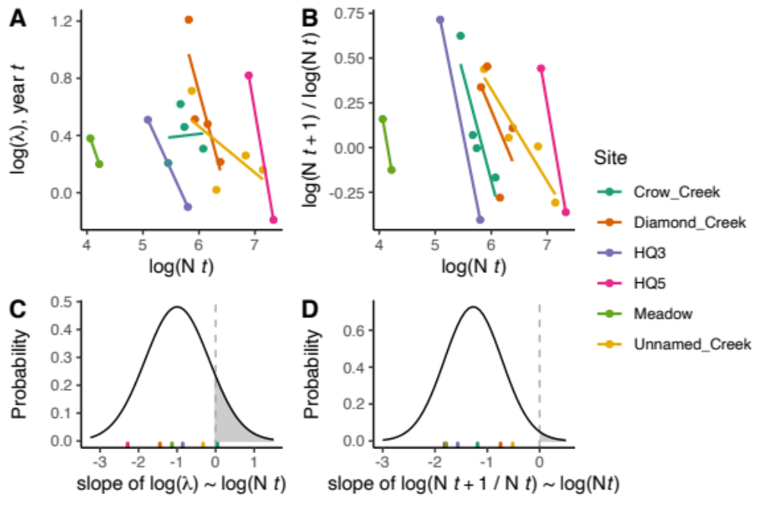
Figure 5. (A) Within the same subpopulation, population growth rate (log(λ)) calculated from IPMs decreases as population size increases. (B) Population growth rate calculated by change in population size from year t to year t+1 also decreases as population size increases in the same subpopulation. In A and B, each point represents values calculated from data from one transition in one subpopulation. Lines show linear regressions of the relationships between log(N t) and the respective response variable in each subpopulation. Rug plots in panels C and D show the slope of each regression line in panels A and B, respectively. The normal distributions in C and D were created using the means and standard deviations of these slopes. According to these distributions of observed slopes, there is an 11% probability that the relationship between log(λ) and log(N t) would be positive, and a 1% probability that the relationship between log(N t) and log(N t+1 / N t) would be positive. In all panels, “N” indicates the number of individuals in a subpopulation.
Demographic Compensation: Our analyses did not identify signatures of demographic compensation in O. coloradensis populations. While there were negative correlations between the effect of mean growing season temperature on vital rates for five combinations of vital rates, none of these correlations were significant (Table 5). Ten thousand correlations of randomly assigned coefficients found that the number of negative correlations in a matrix can be described by a normal distribution with a mean of 5.01 and a standard deviation of 1.58. Using this distribution as a null model, there was a 49.8% probability of observing five negative correlations. Although there is no significant evidence for demographic compensation, it is notable that the effect of mean growing season temperature on distribution of recruit size was negatively correlated with the effect of growing season temperature on all other vital rates. We were only able to compare coefficients across vital rate models for mean growing season temperature, because including precipitation and mean winter temperature as covariates resulted in overfitting in some cases.
Table 5. Pearson correlations between mean growing season temperature coefficients in each continuous vital rate function. Below each correlation value is the P value for that correlation.
 |  | Vital Rate
 |  | Flowering | Survival | Growth | Seeds | Recruit Size
Vital Rate | Flowering | 1.00 (0) | 0.415 (0.413) | 0.163 (0.773) | -0.073 (0.891) | -0.381 (0.456)
Vital Rate | Survival |  | 1.00 (0) | 0.822 (0.045) | 0.708 (0.115) | -0.300 (0.568)
Vital Rate | Growth |  |  | 1.00 (0) | 0.683 (0.135) | -0.091 (0.863)
Vital Rate | Seeds |  |  |  | 1.00 (0) | -0.604 (0.204)
Vital Rate | Recruit Size |  |  |  |  | 1.00 (0)
Vital Rate Buffering: We did not identify strong evidence of vital rate buffering in the O. coloradensis populations we observed. The quartile coefficients of dispersion and elasticities of discrete vital rates and continuous vital rate parameters were not significantly negatively correlated (Fig. 6; correlation with all data: r = -0.32 , P = 0.25; correlation excluding the outlier: r = -0.38 , P = 0.25). As a vital rate became more important for determining population growth rate, it also was not significantly less variable, which does not indicate that vital rate buffering is taking place (Figure 1).
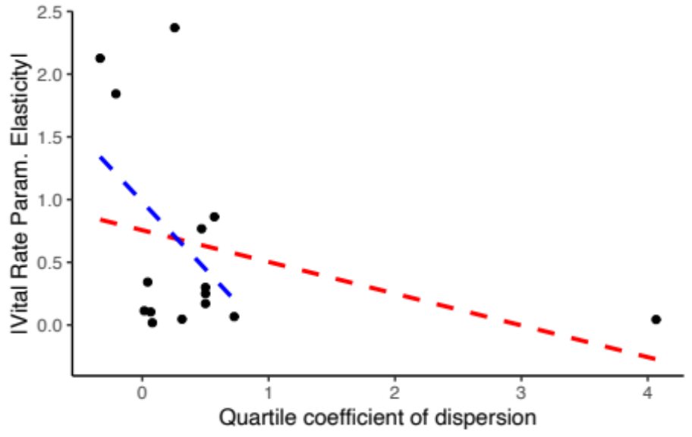
Figure 6. The relationship between the quartile coefficient of dispersion (QCD) of each vital rate parameter and the absolute value of its elasticity. The dashed red line shows the correlation between vital rate elasticity and QCD that was calculated using all vital rates (r = -0.32 , P = 0.25), while the dashed blue line shows the correlation when the outlying vital rate was excluded (r = -0.38 , P = 0.25). The insignificant negative correlation between QCD and elasticity indicates that vital rate buffering is not acting in the O. coloradensis populations we studied.
Asynchronous Responses and Source-Sink Dynamics: We did not identify a signature of asynchronous responses to environmental variation in O. coloradensis populations. There was not a significant relationship between the Spearman correlation of log(λ) between subpopulations and their spatial proximity (Mantel statistic = 0.08, P = 0.37). We also performed Mantel tests using log(λ) correlation and distance matrices calculated uniquely for each population, and while the tests did not identify significant relationships, we did find a positive relationship between correlation of log(λ) and distance between subpopulations at Soapstone prairie, and a negative relationship between correlation of log(λ) and distance between subpopulations at FEWAFB. These insignificant Mantel tests also indicate that fine-scale source-sink dynamics were not important for these O. coloradensis populations.
Objective 3: Population viability analysis: Simulations that incorporate demographic and environmental stochasticity and density dependence indicate that, if the demographic patterns observed during our monitoring study persist, both the Soapstone prairie and FEWAFB populations of O. coloradensis will hover around their current population size for the next decade (Fig. 7A). Over a span of 50 years, however, the simulations suggest that the Soapstone population will grow considerably to reach an equilibrium size that is an order of magnitude larger than it is currently, and the FEWAFB population will grow exponentially and then decline steadily through the end of the simulation period. By the end of the simulations, the population growth rate of the Soapstone population stabilizes slightly above zero, while the growth rate of the FEWAFB population stabilizes slightly below zero (Fig. 7B). Even though the FEWAFB population is in decline at the end of the simulation period, the mean stochastic log(λ) (or log(λ_{s}), which is the mean of the log(λ) values of the 15th through 100th simulated transitions, is positive. This is driven by the very high log(λ) values in the first 30 years of the simulations (Fig. 7C). The mean log(λ_{s}) for the Soapstone population is lower than the FEWAFB log(λ_{s}), but is still positive.
The climate scenario used for the simulation did not substantially affect the outcome for the FEWAFB populations. Mean population size, mean log(λ) and log(λ_{s}) of the FEWAFB population are very similar both in simulations using a scenario based on current observed climate and a scenario with higher mean temperature and lower precipitation. However, climate scenario did affect the outcome of simulations of the Soapstone prairie population. In the hotter and drier scenario, population size grew faster initially, but stabilized at a smaller size than in the current climate scenario (Fig. 7B). Mean log(λ_{s}) was also lower in the hotter and drier climate scenario (Fig. 7C).
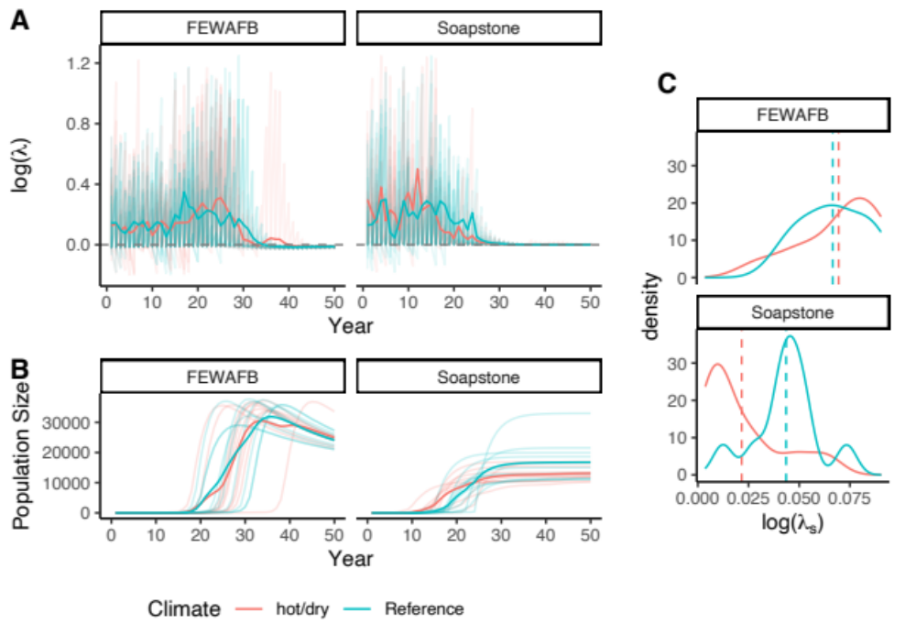
Frequency of observed log(λ_{s})
Figure 7: Simulated growth rates and sizes of each population under two climate scenarios. (A) Simulated log(λ) of the Soapstone prairie population stabilizes just above zero in both climate scenarios after ~30 years. Simulated log(λ) of the FEWAFB population stabilizes just below zero after ~40 years. Solid, dark-colored lines show the mean log(λ) at each simulated transition, while faint lines show log(λ) values for each iteration of the simulation. Horizontal dashed lines indicate log(λ_{s}) = 0. (B) Simulated size of the Soapstone prairie population grows until reaching an equilibrium size, which is smaller in the hotter and drier climate scenario. Simulated size of the FEWAFB population grows initially, but is still in decline at the end of the simulation period. (C) Climate scenario does not have a pronounced effect on the distribution of observed stochastic λ (log(λ_{s})) values in simulations of the FEWAFB population. In simulations of the Soapstone prairie population, mean log(λ_{s}) is lower under the hotter and drier climate scenario. Vertical dashed lines indicate mean log(λ_{s}) under each climate scenario.
Table 6: Coefficients from vital rate models that were used to create projection IPMs
 |  | Coefficient (P-value) |  |  |  |  |  | Variance (std. dev.)
 | Response Variable | Intercept | log(size_{t}) | log(size_{t})² | Plot-level plant density | mean growing season temp. | total water-year precip. | subpop. random-intercept
Soapstone Prairie | P(survival) | -0.21 (0.48) | 0.73 (< 0.01) | - | 0.002 (< 0.01) | 0.82 (< 0.01) | - | 0.24 (0.49)
Soapstone Prairie | log(size_{t+1}) | 1.56 (0.001) | 0.17 (< 0.01) | - | -3.76x10⁻⁵ (0.39) | 0.21 (< 0.01) | - | 0.01 (0.10)
Soapstone Prairie | P(flowering) | -30.77 (< 0.01) | 23.13 (< 0.01) | -4.34 (< 0.01) | 0.0014 (0.007) | 0.50 (< 0.01) | -0.14 (0.47) | 0.24 (0.49)
Soapstone Prairie | Num. seeds | 3.89 (< 0.01) | 0.39 (0.07) | - | 0.0006 (0.0002) | 0.38 (< 0.01) | 0.83 (< 0.01) | -
Soapstone Prairie | recruit size | 0.23 (< 0.01) | - | - | -7.57x10⁻⁶ (0.90) | -4.51x10⁻³ (0.80) | -0.002 (0.45) | -
FEWAFB | P(survival) | -1.07 (0.08) | 0.27 (< 0.01) | - | 0.005 (< 0.01) | 0.20 (< 0.01) | - | 1.07 (1.03)
FEWAFB | log(size_{t+1}) | 1.62 (0.009) | 0.19 (< 0.01) | - | 5.08x10⁻⁴ (< 0.01) | -0.02 (0.14) | - | 0.09 (0.30)
FEWAFB | P(flowering) | -30.12 (< 0.01) | 27.38 (< 0.01) | -5.88 (< 0.01) | 3.95x10⁻⁴ (0.45) | 0.11 (0.09) | 0.22 (0.0001) | 0.07 (0.26)
FEWAFB | Num. seeds | 3.13 (< 0.01) | 0.90 (< 0.01) | - | -0.0001 (0.56) | 0.11 (0.008) | 0.11 (0.0008) | -
FEWAFB | recruit size | 0.19 (< 0.02) | - | - | -1.22x10⁻⁵ (0.89) | 0.03 (0.10) | -0.006 (0.68) | -

Discussion
Our demographic analysis of the two largest known populations of the globally rare Oenothera coloradensis evaluated the importance of seedbanks to population dynamics, identified the demographic mechanisms that allow this rare species to persist, and determined the likelihood of these populations persisting into the future. First, we found that including information about cryptic life stages alters the outcomes of the population model (Paniw et al. 2017, Nguyen et al. 2019). O. coloradensis populations show signs of negative density-dependence at the subpopulation scale (Table 4; Fig. 5). However, these populations do not show substantial evidence of demographic compensation, vital rate buffering, spatial asynchrony, or fine-scale source-sink dynamics. This may indicate that while these mechanisms may be important for the persistence of many small populations of rare plants, they are not strictly necessary in all cases. Third, we found that these populations are likely to persist in the short term, substantiating the 2019 decision to remove this species from the Endangered Species List. However, the potential negative effects of climate warming emphasize the importance of continued habitat protection (Everson 2019).
Including a discrete seedbank state in an IPM decreased the asymptotic population growth rate compared to an IPM with only a continuous, size-based state, although both growth rates were still positive (Table 2: with seedbank: IPM “A”, log(λ) = 0.39; without seedbank: IPM “OO”, log(λ) = 0.41). The importance of the including the seedbank in the model aligned with our expectations, although it was surprising that including the seed bank decreased log(λ) because seedbanks are thought of as buffers against stochastic causes of population decline. This could be related to the fact that seedbank vital rate parameters were inferred from laboratory tests of germination and viability rates, which may not be good representations of in situ rates of viability and germination. The annual rate of seed death (10%) was inferred from an in situ study, but is imprecise because of low sample size. These discrete rates for the probability of persisting and transitioning out of the seedbank have high elasticity, but not the highest elasticity of any vital rate in the IPM (Fig. 4C), which means that imprecision in these vital rate estimates would not drastically impact predictions made from the IPM. The rate at which seeds produced by adult plants in year t go into the seedbank in year t+1 is the vital rate function with highest elasticity, however we have higher confidence in the accuracy of this vital rate because it was based on field-collected data. Previous matrix population models of O. coloradensis without a seedbank state that were constructed in the 1990s identified the emergence rate of new seedlings as the vital rate most important for determining log(λ) (Floyd and Ranker 1998). Our finding that seedbank state transitions are important for this species aligns with this previous result, since rate of seedling emergence is the above-ground plant vital rate that is closest to the seedbank in this plant’s life cycle. The seedbank can be an important element of a perennial plant’s lifecycle, and if possible, should be modeled explicitly based on in situ estimates of the probability of seeds going into, persisting in, and emerging from the seedbank.
We found evidence that, of the five proposed demographic mechanisms of small population persistence, negative density dependence was the only one acting in these O. coloradensis populations. Including population size in the previous year as a covariate in vital rate models typically improved model fit, suggesting that density dependence is an important driver of growth, survival, and reproduction (Table 4). Within a single subpopulation, population growth rate and the ratio of population size in year t+1 to year t was generally higher when population size in year t was smaller (Fig. 5), which indicates that negative density dependence prevents subpopulations from crashing when their population size is very small. However this pattern of higher growth rate at low population sizes did not exist when considering all subpopulations together (Fig. 5). This could indicate that each subpopulation is close to its carrying capacity for O. coloradensis. This may indicate that the number of individuals is close to carrying capacity in each subpopulation, and that growth rate increases when the population size in a given subpopulation is small in comparison to its subpopulation-specific carrying capacity. O. coloradensis vital rates had correlated responses to variation in the abiotic environment (Table 5), which is the inverse of what is expected if demographic buffering is taking place. It is possible that a signal of demographic buffering would appear if we considered different abiotic variables or had more data. Vital rate buffering also was not identified, even when we simulated variation in discrete seedbank vital rate parameters across the entire set of possible values (from 0 to 1). Vital rates with higher QCD did not have a significantly higher or lower impact on log(λ) in comparison to less variable vital rates (Fig. 6), which would prevent vital rate buffering from stabilizing log(λ) after abiotic or demographic perturbation. The evidence for spatial asynchrony and fine-scale source-sink dynamics was also not strong. Mantel tests did not identify a significant relationship between the correlation of log(λ) between subpopulations and their spatial proximity, but did identify non-significant relationships between log(λ) correlation and proximity. However, this relationship was positive in Soapstone prairie subpopulations and negative in FEWAFB subpopulations, which provides inconsistent support for these mechanisms.
It is somewhat surprising that negative density dependence is the only mechanism of small population persistence that has significant support in O. coloradensis populations, since multiple mechanisms have been identified in other rare species (Dibner et al. 2019). It is possible that support for one or more of these persistence mechanisms could emerge if more information about abiotic variation across space and time and data from more annual transitions was available for analysis. One potential explanation is that, while this species is a globally rare endemic with isolated subpopulations, it often grows at high local density. This strategy, which Rabinowitz describes as ﻿“locally abundant in a specific habitat but restricted geographically,” may allow O. coloradensis to bypass the problems that small populations typically face, such as genetic and demographic bottlenecks that make them susceptible to stochastic environmental variation (Rabinowitz 1981). It has also been shown that rare species are more likely than common species to benefit from facilitative interspecific interactions (Calatayud et al. 2020). O. coloradensis may participate in facilitative interactions with other species that increase its probability of persistence, although determining this will require further, community-level analysis. Our results imply that not all rare species can be treated equally. While demographic strategies that help maintain persistence may be effective for some species, other species may employ different strategies. This further emphasizes the importance of carefully considering the specific population and its community dynamics when managing and conserving rare species.
Finally, our simulations of O. coloradensis populations at FEWAFB and Soapstone prairie indicated that these populations are likely to persist, at least in the next few decades. Both populations were predicted to increase in size over the next 20-30 years even with density dependence in the models (Fig. 7A and B). While our simulations predicted that the Soapstone prairie population will stabilize by the end of the 100 year simulation interval, they also predicted that after approximately 30 years, the FEWAFB population will be begin a decline that continues to the end of the simulation interval. However, the rate of decline diminished toward the end of the 100 year period, when log(λ) values started to become less negative (Fig. 7A). Average stochastic growth rate (log(λ_{s})) was smaller for the Soapstone population, even though this population didn’t decrease in size over the course of the simulation while the FEWAFB population did (Fig. 7C). This is explained by very high log(λ) in the initial years of simulated growth in the FEWAFB population, which increases the mean of log(λ) (or log(λ_{s})). While these log(λ_{s}) values are useful in that they indicate persistence rather than extirpation, they should not be used alone as an indicator of population status, since they do not capture the substantial variation in log(λ) and population size that occurs on shorter timescales.
Simulations additionally showed that the FEWAFB and Soapstone prairie populations might respond differently to the warmer and drier climate conditions that are predicted to occur with climate change. Mean simulated log(λ) in the FEWAFB population was not significantly impacted by climate, while hotter and drier climate conditions correspond to a lower mean log(λ_{s}) and a smaller equilibrium population size in the Soapstone prairie population. In this population, log(λ) in hotter and drier conditions is higher in the initial years of the simulation, but declines earlier and faster than log(λ) in reference climate simulations. This difference in response could be driven by the difference in habitat at the FEWAFB and Soapstone prairie locations. At FEWAFB, O. coloradensis is found exclusively along the floodplains of small streams, while O. coloradensis at Soapstone prairie grows in wet meadows far from any running water. A decrease in precipitation and increase in evapotranspiration as a result of higher temperature could certainly decrease flows in the streams at FEWAFB, but would likely cause a drastic decrease in the amount of ephemeral wet meadow habitat at Soapstone prairie. This difference in habitat could explain the different simulated responses of these two populations to simulated climate change. Additionally, the difference in projected impact of the abiotic environment between the two populations could be an artefact of the relatively short duration of demographic monitoring, which meant that we only were able to model the response of these O. coloradensis populations to a relatively small range of abiotic conditions. Additionally, it is important to note that these simulations employ a very coarse estimation of future climate conditions, and do not incorporate the effects of change in disturbance regimes, habitat loss due to anthropogenic disturbance or shrub encroachment, or other potential threats to this species. As such, they should be taken as a single piece of encouraging evidence for the fate of this species, and should not be used to make a definite prognosis for persistence of O. coloradensis.
Our analysis of the population dynamics of Oenothera coloradensis at two distinct locations shows that this species has a lifecycle that is strongly influenced by introduction and persistence of seeds into a seedbank. More broadly, we show that this rare endemic species shows signs of negative density dependence. Populations of O. coloradensis may additionally be maintained via high local abundances that allow them to escape the challenges of small population size that rare species often face (Rabinowitz 1981). These findings reinforce the importance of careful evaluation of the unique population dynamics of rare species to inform successful conservation and management.
References
Abbott, R. E., D. F. Doak, and M. L. Peterson. 2017. Portfolio effects, climate change, and the persistence of small populations: analyses on the rare plant Saussurea weberi. Ecology 98:1071–1081.
Arnoldi, J. F., M. Loreau, and B. Haegeman. 2019. The inherent multidimensionality of temporal variability: how common and rare species shape stability patterns. Ecology Letters 22:1557–1567.
Bonett, D. G. 2006. Confidence interval for a coefficient of quartile variation. Computational Statistics and Data Analysis 50:2953–2957.
Burgess, L. M. 2003. Impacts of Mowing, Burning, and Climate on Germination and Seedling Recruitment of Colorado Butterfly Plant (Gaura neomexicana ssp. coloradensis). University of Wyoming.
Burgess, L. M., A. L. Hild, and N. L. Shaw. 2005. Capsule treatments to enhance seedling emergence of Gaura neomexicana ssp. coloradensis. Restoration Ecology 13:8–14.
Burner, R. C., L. Drag, J. G. Stephan, T. Birkemoe, R. Wetherbee, J. Muller, J. Siitonen, T. Snäll, O. Skarpaas, M. Potterf, I. Doerfler, M. M. Gossner, P. Schall, W. W. Weisser, and A. Sverdrup-Thygeson. 2022. Functional structure of European forest beetle communities is enhanced by rare species. Biological Conservation 267.
Calatayud, J., E. Andivia, A. Escudero, C. J. Melián, R. Bernardo-Madrid, M. Stoffel, C. Aponte, N. G. Medina, R. Molina-Venegas, X. Arnan, M. Rosvall, M. Neuman, J. A. Noriega, F. Alves-Martins, I. Draper, A. Luzuriaga, J. A. Ballesteros-Cánovas, C. Morales-Molino, P. Ferrandis, A. Herrero, L. Pataro, L. Juen, A. Cea, and J. Madrigal-González. 2020. Positive associations among rare species and their persistence in ecological assemblages. Nature Ecology and Evolution 4:40–45.
Caswell, H. 2001. Matrix Population Models: Construction, Analysis, and Interpretation. 2nd edition. Sinauer Associates.
Dibner, R. R., M. L. Peterson, A. M. Louthan, and D. F. Doak. 2019. Multiple mechanisms confer stability to isolated populations of a rare endemic plant. Ecological Monographs 89:1–16.
Drury, W. H. 1974. Rare species. Biological Conservation 6:162–169.
Easterling, M. R., S. P. Ellner, and P. M. Dixon. 2000. Size-Specific Sensitivity: Applying a New Structured Population Model. Ecology 81:694–708.
Ellner, S. P., D. Z. Childs, and M. Rees. 2016. Data-driven Modelling of Structured Populations. Springer International Publishing, Switzerland.
Ellner, S. P., and M. Rees. 2006. Integral projection models for species with complex demography. American Naturalist 167:410–428.
Enquist, B. J., X. Feng, B. Boyle, B. Maitner, E. A. Newman, P. M. Jørgensen, P. R. Roehrdanz, B. M. Thiers, J. R. Burger, R. T. Corlett, T. L. P. Couvreur, G. Dauby, J. C. Donoghue, W. Foden, J. C. Lovett, P. A. Marquet, C. Merow, G. Midgley, N. Morueta-Holme, D. M. Neves, A. T. Oliveira-Filho, N. J. B. Kraft, D. S. Park, R. K. Peet, M. Pillet, J. M. Serra-Diaz, B. Sandel, M. Schildhauer, I. Šímová, C. Violle, J. J. Wieringa, S. K. Wiser, L. Hannah, J. C. Svenning, and B. J. McGill. 2019. The commonness of rarity: Global and future distribution of rarity across land plants. Science Advances 5:1–14.
Everson, M. E. 2019. Endangered and Threatened Wildlife and Plants; Removing Oenothera coloradensis (Colorado Butterfly Plant) From the Federal List of Endangered and Threatened Plants. Federal Register: The Daily Journal of the United States 84:59570–59588.
Fieberg, J. R., K. Vitense, and D. H. Johnson. 2020. Resampling-based methods for biologists. PeerJ 2020.
Floyd, S. K., and T. A. Ranker. 1998. Analysis of a Transition Matrix Model for Gaura neomexicana Ssp . coloradensis (Onagraceae) Reveals Spatial and Temporal Demographic Variability. International Journal of Plant Sciences 159:853–863.
Heidel, B., D. Tuthill, and Z. Wallace. 2021. 33-Year Population Trends of Colorado Butterfly Plant (Oenothera Coloradensis; Onagraceae), a Short-Lived Riparian Species on F. E. Warren Air Force Base, Laramie County, Wyoming. Laramie, WY.
Hilde, C. H., M. Gamelon, B. E. Sæther, J. M. Gaillard, N. G. Yoccoz, and C. Pélabon. 2020. The Demographic Buffering Hypothesis: Evidence and Challenges. Trends in Ecology and Evolution xx.
Jennings, M. 2000. Endangered and Threatened Wildlife and Plants: Threatened Status for the Colorado Butterfly Plant (Gaura neomexicana ssp. coloradensis) From Southeastern Wyoming, Northcentral Colorado, and Extreme Western Nebraska. Federal Register: The Daily Journal of the United States 65:62302–62310.
Jongejans, E., A. W. Sheppard, and K. Shea. 2006. What controls the population dynamics of the invasive thistle Carduus nutans in its native range? Journal of Applied Ecology 43:877–886.
Kauffman, M. J., J. F. Pollock, and B. Walton. 2004. Spatial structure, dispersal, and management of a recovering raptor population. American Naturalist 164:582–597.
Leitão, R. P., J. Zuanon, S. Villéger, S. E. Williams, C. Baraloto, C. Fortune, F. P. Mendonça, and D. Mouillot. 2016. Rare species contribute disproportionately to the functional structure of species assemblages. Proceedings of the Royal Society B: Biological Sciences 283.
Levins, R., and D. Culver. 1971. Regional Coexistence of Species and Competition between Rare Species. Proceedings of the National Academy of Sciences 68:1246–1248.
Lyons, K. G., C. A. Brigham, B. H. Traut, and M. W. Schwartz. 2005. Rare species and ecosystem functioning. Conservation Biology 19:1019–1024.
Lyons, K. G., and M. W. Schwartz. 2001. Rare species loss alters ecosystem function - Invasion resistance. Ecology Letters 4:358–365.
May, R. M. 1973. Stability in Randomly Fluctuating Versus Deterministic Environments. The American Naturalist 107:621–650.
Merow, C., J. P. Dahlgren, C. J. E. Metcalf, D. Z. Childs, M. E. K. Evans, E. Jongejans, S. Record, M. Rees, R. Salguero-Gómez, and S. M. Mcmahon. 2014. Advancing population ecology with integral projection models: A practical guide. Methods in Ecology and Evolution 5:99–110.
Morris, W. F., and D. F. Doak. 2002. Quantitative Conservation Biology: Theory and Practice of Population Viability Analysis. Sinauer Associates, Sunderland, MA.
Morris, W. F., and D. F. Doak. 2004. Buffering of Life Histories against Environmental Stochasticity: Accounting for a Spurious Correlation between the Variabilities of Vital Rates and Their Contributions to Fitness. American Naturalist 163:579–590.
Munk, L. M. 1999. Colorado butterfly plant (Gaura neomexicana spp. coloradensis) regeneration with removal of Canada thistle (Cirsium arvense) or native herbs. University of Wyoming.
Munk, L. M., A. L. Hild, and T. D. Whitson. 2002. Rosette recruitment of a rare endemic forb (Gaura neomexicana subsp. coloradensis) with canopy removal of associated species. Restoration Ecology 10:122–128.
Nei, M., T. Maruyama, and R. Chakraborty. 1975. The Bottleneck Effect and Genetic Variability in Populations. Evolution 29:1–10.
Nguyen, V., Y. M. Buckley, R. Salguero-Gómez, and G. M. Wardle. 2019. Consequences of neglecting cryptic life stages from demographic models. Ecological Modelling 408.
Oksanen, J., F. G. Blanchet, M. Friendly, R. Kindt, P. Legendre, D. McGlinn, P. R. Minchin, R. B. O’Hara, G. L. Simpson, P. Solymos, M. H. H. Stevens, E. Szoecs, and H. Wagner. 2020. vegan: Community Ecology Package. R package version 2.5-7.
Paniw, M., P. F. Quintana-Ascencio, F. Ojeda, and R. Salguero-Gómez. 2017. Accounting for uncertainty in dormant life stages in stochastic demographic models. Oikos 126:900–909.
Pfister, C. A. 1998. Patterns of variance in stage-structured populations : Evolutionary predictions and ecological implications. Proceedings of the National Academy of Sciences 95:213–218.
Pulliam, H. R. 2016. Sources , Sinks , and Population Regulation Author ( s ): H . Ronald Pulliam Published by : The University of Chicago Press for The American Society of Naturalists Stable URL : http://www.jstor.org/stable/2461927 Accessed : 17-03-2016 21 : 27 UTC Your use 132:652–661.
Rabinowitz, D. 1981. Seven forms of rarity. Page in H. Synge, editor. The Biological aspects of rare plant conservation. John WIley & Sons, Ltd.
Rees, M., D. Z. Childs, C. J. E. Metcalf, K. E. Rose, A. W. Sheppard, and P. J. Grubb. 2006. Seed dormancy and delayed flowering in monocarpic plants: selective interactions in a stochastic environment. The American Naturalist 168:E53–E71.
Rosenzweig, M. L., and M. V Lomolino. 1997. The Biology of Rarity. Page in W. E. Kunin and K. J. Gaston, editors. The Biology of Rarity. Chapman & Hall, London.
Rovere, J., and J. W. Fox. 2019. Persistently rare species experience stronger negative frequency dependence than common species: A statistical attractor that is hard to avoid. Global Ecology and Biogeography 28:508–520.
Säterberg, T., T. Jonsson, J. Yearsley, S. Berg, and B. Ebenman. 2019. A potential role for rare species in ecosystem dynamics. Scientific reports 9:11107.
Sgarbi, L. F., and A. S. Melo. 2018. You don’t belong here: explaining the excess of rare species in terms of habitat, space and time. Oikos 127:497–506.
Stanley, S. M. 1979. Macroevolution: Pattern and Process. W. H. Freeman.
Venables, W. N., and B. D. Ripley. 2002. Modern Applied Statistics with S. Fourth. Springer, New York.
Vicente-Serrano, S. M., S. M. Quiring, M. Peña-Gallardo, S. Yuan, and F. Domínguez-Castro. 2020. A review of environmental droughts: Increased risk under global warming? Earth-Science Reviews 201:102953.
Villellas, J., D. F. Doak, M. B. García, and W. F. Morris. 2015. Demographic compensation among populations: What is it, how does it arise and what are its implications? Ecology Letters 18:1139–1152.
Vitalis, R., S. Glémin, and I. Olivieri. 2004. When genes go to sleep: The population genetic consequences of seed dormancy and monocarpic perenniality. American Naturalist 163:295–311.
Wagner, W. L., P. C. Hoch, and P. H. Raven. 2007. Revised Classification of the Onagraceae. Page Systematic Botany Monographs. The American Society of Plant Taxonomists.

** Note To Self: change the Rondeau and Heidel citations to include the ‘Prepared for…” statements ** also maybe change the italicization of the species name, if required **

Appendix 1: Supplementary Figures
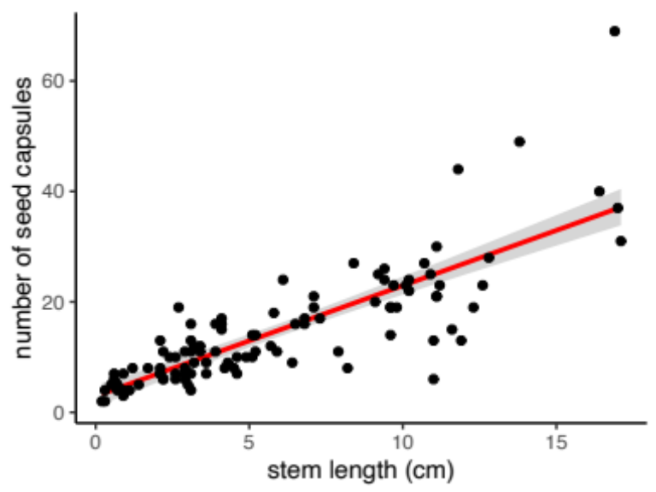
Figure S1: As the stem length of an Oenothera coloradensis flowering individual increases, the number of capsules it produces increases as well (Number of capsules = 2.95 + 2.0*(stem length in cm) (multiple R-squared = 0.67, P = < 0.01, F-statistic = 212.5, df = 104).

