**SOILWAT2**

* PFTs share a single simulation point and “compete” for rain and soil moisture
* Land cover is treated as fractional cover: *SW_VPD_fix_cover()*
  + 1 == sum over kv in {pfts, bareGround} of cover[kv]
* Solar radiation and PET: *SW_Water_Flow()*
  + Albedo = sum over kv in {pfts, bareGround} of cover[kv] * albedo[kv,mono]
* Total live biomass: *SW_Water_Flow()*
  + sum over kv in {pfts} of cover[kv] * biomass[kv,mono]
* Rain interception by vegetation: *veg_intercepted_water()*
  + sum over kv in {pfts} of interceptedStorage[kv]
    - interceptedStorage[kv] = cover[kv] * interception[kv,mono]
* Rain interception by litter: *litter_intercepted_water()*
  + sum over kv in {pfts} of cover[kv] * interception[kv,mono]
* Potential transpiration rate: *pot_transp()*
  + sum over kv in {pfts} of cover[kv] * Tpot[kv,mono]
* Potential bare-soil evaporation rate: *pot_soil_evap()*
  + sum over kv in {pfts} of cover[kv] * Es,pot[kv,mono]
* Hydraulic redistribution: *hydraulic_redistribution()*
  + from layer m to layer n
    - sum over kv in {pfts} of cover[kv] * hydred[[kv,mono]
* Potential evaporation rate from intercepted water: *SW_Water_Flow()*
  + sum over kv in {pfts} of min(cover[kv] * pet, interceptedStorage[kv])
  + *Bug???: peti -= surface_evap_veg_rate[k] / scale_veg[k]*
* AET: *SW_Water_Flow()*
  + Tmp = Esurf,pot + Eint,litter,pot + sum over kv in {pfts} of Tpot[kv] + Esoil,pot[kv] + Eint,veg,pot[kv]
  + Each of these potential rates is scaled by (PET – Esnow) / tmp

**CLM5**

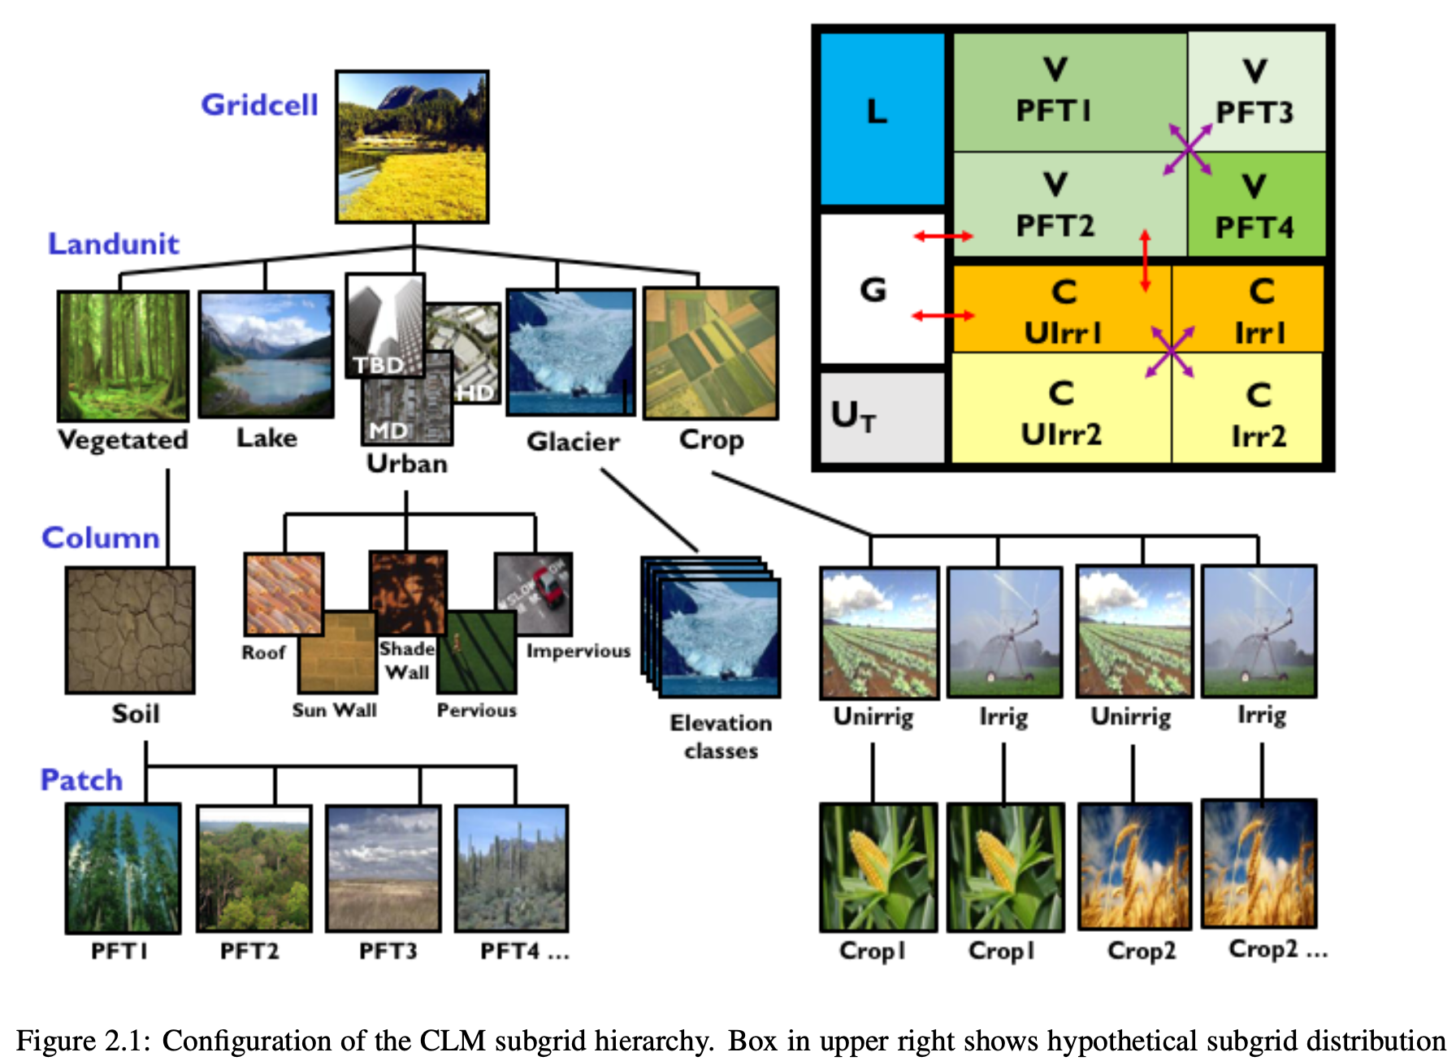

* Ch2.1
  + “Spatial land surface heterogeneity in CLM is represented as a nested subgrid hierarchy in which grid cells are com- posed of multiple land units, snow/soil columns, and PFTs (Figure 2.1). Each grid cell can have a different number of land units, each land unit can have a different number of columns, and each column can have multiple PFTs. The first subgrid level, the land unit, is intended to capture the broadest spatial patterns of subgrid heterogeneity. The current land units are glacier, lake, urban, vegetated, and crop (when the crop model option is turned on).”
  + “The second subgrid level, the column, is intended to capture potential variability in the soil and snow state variables within a single land unit. For example, the vegetated land unit could contain several columns with independently evolving vertical profiles of soil water and temperature. “
  + “The default snow/soil column is represented by 25 layers for ground (with up to 20 of these layers classified as soil layers and the remaining layers classified as bedrock layers) and up to 10 layers for snow, depending on snow depth. The central characteristic of the column subgrid level is that this is where the state variables for water and energy in the soil and snow are defined, as well as the fluxes of these components within the soil and snow. Regardless of the number and type of PFTs occupying space on the column, the column physics operates with a single set of upper boundary fluxes, as well as a single set of transpiration fluxes from multiple soil levels. **These boundary fluxes are weighted averages over all PFTs**.”
  + “The third subgrid level is referred to as the patch level. Patches can be PFTs or bare ground on the vegetated land unit and crop functional types (CFTs) on the crop land unit. The patch level is intended to capture the biogeophysical and biogeochemical differences between broad categories of plants in terms of their functional characteristics. On the vegetated land unit, up to 16 possible PFTs that differ in physiology and structure may coexist on a single column. All fluxes to and from the surface are defined at the PFT level, as are the vegetation state variables (e.g. vegetation temperature and canopy water storage). “
  + “Note that the biogeophysical processes related to soil and snow require PFT level properties to be aggregated to the column level. For example, the net heat flux into the ground is required as a boundary condition for the solution of snow/soil temperatures (Chapter 6). This column level property must be determined by aggregating the net heat flux from all PFTs sharing the column. This is generally accomplished in the model by computing a weighted sum of the desired quantity over all PFTs whose weighting depends on the PFT area relative to all PFTs, unless otherwise noted in the text.”
* Ch2.3
  + “Required surface data for each land grid cell are listed in Table 2.6 … the **fractional cover of each plant functional type (PFT),** …”
  + “**PFTs in the naturally vegetated land unit share one soil column and compete for water** (default CLM setting). PFTs in the human managed land unit do not share soil columns and thus permit for differences in land management between crops“
* Ch27.2
  + **“total land unit area remains 100%”**
* Ch27.4
  + “CLM5 represents the land surface as a hierarchy of sub-grid types: glacier; lake; urban; vegetated land; and crop land. The vegetated land is further divided into a mosaic of Plant Functional Types (PFTs), while the crop land is divided into a mosaic of Crop Functional Types (CFTs).”
  + “The current day land unit descriptions are generated from 1km resolution MODIS, MIRCA2000, ICESAT, AVHRR, SRTM, and CRU climate data products combined with reference year LUH2 land unit data, usually set to 2005. “
  + “Land Use Harmonized version 2 (LUH2) transient datasets for use with Earth System Model simulations. The new data sets are the product of the Land Use Model Intercomparison Project (LUMIP; https://cmip.ucar.edu/lumip) as part of the Coupled Model Intercomparison Project 6 (CMIP6)”
  + “The LULCC information is provided at 0.25 degree grid resolution and includes fractional grid cell coverage by the 12 land units of:
    - Primary Forest, Secondary Forest, Primary Non-Forest, Secondary Non-Forest,
    - Pasture, Rangeland, Urban,
    - C3 Annual Crop, C4 Annual Crop, C3 Perennial Crop, C4 Perennial Crop, and C3 Nitrogen Fixing Crop”

