

Evaluating CARE’s HIV and COVID-19 Interventions in Ecuador

GFP Final Report
Emmanuel Attah Ackah,
Claudia Ortega-Borda,
Yuyan Chen,
Aidan Estes,
Bellanirys (Bella) Garcia,
Sophie Goldenberg,
Carly Griffin,
Amelia Heckman,
Pamela Potempa-Rivers,
Daniel Herrera Rodriguez,
Rhiannan Timmermann



Introduction
CARE Ecuador, in collaboration with the Ministry of Health, introduced two programmatic interventions targeting three key populations, men who have sex with men (MSM), transgender women, and sex workers, to mitigate the transmission of Human Immunodeficiency Virus (HIV) and COVID-19. These programs sought to increase disease awareness and improve referrals to screening and care through kit delivery, screening, epidemiological registry for COVID-19 or HIV, and post-intervention monitoring surveys. The analyses sought to evaluate the relationship between demographic factors, the adoption of the HIV intervention, and subsequent access to care among high-risk populations in the 17 Ecuadorian cantons covered between 2020 and 2022. Regarding the COVID-19 component, the analyses looked for discrepancies in COVID-19 outcomes pertaining to testing, vaccination status, and geographic location.
HIV
HIV continues to be a major global health issue, significantly impacting individuals and healthcare systems worldwide. Left untreated, HIV infection can advance to acquired immunodeficiency syndrome (AIDS), which is marked by severe immune system deterioration and increased susceptibility to opportunistic infections and malignancies (Deeks et al., 2015). HIV is primarily transmitted through unprotected sexual contact or blood exposure, including injection drug use, and perinatal transmission. Despite decades of research and intervention efforts, the disease remains a public health challenge due to persistent transmission, barriers to timely diagnosis, and disparities in access to care (Mody et al., 2024).
Ecuador has an estimated HIV prevalence of 0.4% among adults aged 15 to 49 years, with notable differences between sexes (UNAIDS, 2024). The epidemic remains highly concentrated, with HIV prevalence among MSM, transgender women, and female sex workers of 10.2%, 18.2%, and 1.0%, respectively (UNAIDS, 2024). Geographically, the epidemic is concentrated in the cantons Guayas, Pichincha, Los Ríos, Manabí, and Esmeraldas, which report the highest case burdens (Ministerio de Salud Publica del Ecuador, n.d.). Structural challenges, including stigma, discrimination, and barriers to healthcare access, continue to impede progress toward epidemic control, exacerbating existing disparities in HIV interventions. These structural barriers, coupled with demographic determinants—including age, gender, and education—significantly affect referral pathways and access to the HIV care continuum. Understanding and addressing these disparities is critical to achieving viral suppression and, consequently, reducing HIV transmission at the community level (Mody et al., 2024).
COVID-19
Though many countries experienced high numbers of cases and mortality, the impact of COVID-19 in Ecuador was disproportionate to that of other nearby and socio-economically similar countries (Cuéllar et al., 2021; Flores Sacoto et al., 2022). There was an estimated case fatality rate of 9.4% in Ecuador from COVID-19 in 2020, compared to the estimated global case fatality rate (CFR) of 3.0% during the same period. There were also 64.0% more estimated deaths than expected in 2020. The outbreak of COVID-19 put pressure on Ecuador’s healthcare system, highlighting the continued gaps in the provision and quality of care through the exacerbated negative health outcomes experienced.
Furthermore, the COVID-19 pandemic was not evenly distributed across individuals in Ecuador. Measures of COVID-19 cases and deaths (including CFR and ED) were consistently higher among the male sex and individuals older than 65 (Cuéllar et al., 2021; Flores Sacoto et al., 2022; Lapo-Talledo et al., 2023; Ortiz-Prado et al., 2021). Geographic region was also found to contribute to COVID-19, however, findings regarding rurality were inconsistent across studies (Cuéllar et al., 2021; Flores Sacoto et al., 2022; Lapo-Talledo et al., 2023). Additional socio-demographic variables found to be of influence include ethnicity (Cuéllar et al., 2021; Flores Sacoto et al., 2022) and comorbidities (Ortiz-Prado et al., 2021).
This literature quantifies the morbidity and mortality of COVID-19 in Ecuador during 2020 but does not regard the three key populations. There is a gap in the literature evaluating disproportionate infection rates and severity of COVID-19 among these individuals. Subsequently, it is necessary to determine the impact of underlying health conditions and social determinants of health among these key populations to better respond to the continuation of COVID-19 infections and prepare for an improved response for these individuals in future health emergencies.

Methods
HIV
A cross-sectional survey was conducted between 2020 and 2022 as part of a Global Fund-supported HIV intervention in Ecuador. The interventions were primarily delivered at one point in time, although a few participants received intervention kits up to three times. Participants included individuals from the three key populations. Data was collected across 17 cantons in Ecuador, reaching 46,593 registered individuals.
CARE team representatives collected data through structured surveys administered during mobile health brigades conducted in popular community locations or at designated community centers. Participants received HIV intervention kits, including screening tests, condoms, lubricants (limited in availability), and informational materials about HIV/AIDS, pre-exposure prophylaxis (PrEP), and post-exposure prophylaxis (PEP). Participants with a positive screening test were offered a second confirmatory test and were referred to care provided by the Ecuadorian Ministry of Health network.
Data was cleaned, recoded, managed, and analyzed using R statistical software and Microsoft Excel. Associations between demographic factors and intervention uptake or healthcare access were assessed using Poisson regression calculate the incidence rate ratio (IRR) to estimate prevalence ratios (PR). This analysis aimed to address two research questions. First, what demographic factors (age, gender identity, sexual orientation, and nationality) influenced the receipt of the HIV intervention kits? Secondly, which factors were associated with access to healthcare among participants who screened positive for HIV and how do these associations vary across the key populations?
COVID-19
In total, 7,034 participants were recruited through multiple cluster sampling within three provinces in 2022. Individuals were eligible for inclusion if they identified with one of the three key populations and met the minimum age requirement (16 years). COVID-19 kits and referrals to care were provided for study participants. Recruitment was conducted by CARE and occurred within their offices or through medical van campaigns. Though the recruitment was in Ecuador, participants who relocated to these provinces of alternative nationalities partook in the study.
Geography
The effectiveness of the CARE COVID-19 program in distributing COVID-19 kits to the at-risk populations was evaluated in the three provinces. The study-specific proportions of COVID-19 among these key populations as well as geographical variations in the access to intervention were also quantified. To evaluate these relationships, descriptive analyses and Poisson regressions, controlling for confounders (age, sex and province), were conducted.
Testing
The analysis sought to determine whether there was an association between identified risk factors and receipt of a COVID-19 test (regardless of reported outcome). Thus, the exposure of interest was key population designation, number of risk factors reported, or reporting of a given risk factor. The dataset was merged with the available HIV dataset to also use positive HIV test results as another exposure. The outcome of interest was a reported COVID-19 test result. This variable was re-coded within the dataset to reflect a binary outcome. Subsequently, crude and adjusted analyses were performed using log-binomial regressions. For models that did not converge, a Poisson regression was used to approximate the PR. Adjusted analyses controlled for being over 65 years old, being Indigenous, and reporting COVID-19 symptoms.
Vaccination
We assessed symptom severity using a standardized grading metric based on the total number of symptoms reported by each individual. We included a set of twenty COVID–19–related symptoms, with each symptom given equal weight. The total number of symptoms per individual was summed up. These symptoms were then categorized into three severity groups: mild, moderate, and severe. In addition, vaccination coverage across different provinces and by gender identity, to identify potential disparities in vaccine uptake across geographical and demographic groups, was also explored. We conducted a binary logistic regression analysis to assess whether symptom severity (categorized as "Mild" vs "Moderate/Severe") was associated with the odds of receiving a vaccination. Severity was re-coded into a binary variable, and "Mild" served as the reference category. The model estimated odds ratios (ORs) and 95% confidence intervals (CIs).

Results
HIV
Table 1a: Demographics Stratified by HIV First Test Result
 |  | HIV First Test Result
Characteristic | Overall  N = 36,870¹ | Negative  N = 35,277¹ | Positive  N = 458¹ | Not Done  N = 1,135¹
Nationality²
Ecuadorian | 33,106 (90%) | 31,842 (90%) | 342 (75%) | 922 (81%)
Foreign National | 3,764 (10%) | 3,435 (9.7%) | 116 (25%) | 213 (19%)
Age (years) | 31 (11) | 31 (11) | 30 (9) | 31 (10)
Gender Identity
Male | 24,122 (65%) | 23,316 (66%) | 340 (74%) | 466 (41%)
Female | 5,927 (16%) | 5,301 (15%) | 12 (2.6%) | 614 (54%)
Trans Woman | 6,713 (18%) | 6,552 (19%) | 106 (23%) | 55 (4.8%)
Prefer Not to Answer | 108 (0.3%) | 108 (0.3%) | 0 (0.0%) | 0 (0.0%)
Population Group
MSM | 24,230 (66%) | 23,424 (66%) | 340 (74%) | 466 (41%)
Sex Worker | 5,927 (16%) | 5,301 (15%) | 12 (2.6%) | 614 (54%)
Trans | 6,713 (18%) | 6,552 (19%) | 106 (23%) | 55 (4.8%)
¹ n (%); Mean (SD)
² Venezuelan, Colombian, and other nationalities were grouped under “Foreign National” for simplicity
While most participants were Ecuadorian nationals (90%), foreign nationals were more frequently represented among HIV-positive participants (25%). MSM represented the largest proportion (66%) and among those testing positive (74%). Female sex workers were underrepresented among HIV-positive participants (2.6%) but made up over half of those who did not undergo testing (54%) (Table 1a).
Table 2: Intervention-Related Variables Stratified by Risk Population
 | Risk Population Group
Characteristic | Overall  N = 46,588¹ | MSM  N = 30,306¹ | Sex Worker  N = 7,877¹ | Trans  N = 8,405¹
Received Condoms
No | 600 (1.3%) | 25 (0.0%) | 565 (7.2%) | 10 (0.1%)
Yes | 45,988 (99%) | 30,281 (100%) | 7,312 (93%) | 8,395 (100%)
Received Lubricants
No | 14,840 (32%) | 11,696 (39%) | 569 (7.2%) | 2,575 (31%)
Yes | 31,748 (68%) | 18,610 (61%) | 7,308 (93%) | 5,830 (69%)
First HIV Test Result
Negative | 35,277 (96%) | 23,424 (97%) | 5,301 (89%) | 6,552 (98%)
Positive | 458 (1.2%) | 340 (1.4%) | 12 (0.2%) | 106 (1.6%)
Not Done | 1,135 (3.1%) | 466 (1.9%) | 614 (10%) | 55 (0.8%)
Missing | 9,718 | 6,076 | 1,950 | 1,692
¹n (%)
Almost all participants received condoms (99%), with the lowest distribution among sex workers (93%). Lubricants were distributed to approximately two-thirds of participants (68%), with notable differences between groups, being highest among female sex workers (93%). Within the initial HIV screening, many of the participants tested negative (96%), with positive results most frequently observed among transgender women (1.6%) and MSM (1.4%).
Following confirmatory testing, 85% received a positive result. Of note, about 10% of MSM and Transgender women decided not to take the second HIV test, whereas all female sex workers took it. The proportion of participants accessing care after a positive screening result was 73% overall, slightly higher among female sex workers (80%) than other key populations. Treatment initiation was high among those who accessed care (89%), with female sex workers showing the highest initiation frequency (100%).
Table 3: Regression Indicator Variables for Receiving Intervention (N= 46,588)
 |  | Condoms Received |  |  |  | Lubricant Received
Characteristic |  | IRR |  | 95% CI |  | IRR |  | 95% CI
Age |  | 1 |  | 1.00, 1.00 |  | 1 |  | 1.00, 1.00
Identity
Female (vs. Male) |  | 0.93 |  | 0.89, 0.97 |  | 1.81 |  | 1.71, 1.91
Trans Female (vs. Male) |  | 1 |  | 0.98,1.02 |  | 1.14 |  | 1.11, 1.17
Nationality  (Foreign (vs. Ecuadorian) |  | 0.98 |  | 0.95, 1.01 |  | 0.93 |  | 0.89, 0.96
Sexual Orientation  (Other (vs. Heterosexual) |  | 1 |  | 0.96, 1.04 |  | 1.21 |  | 1.15, 1.27

Age did not seem to be an influencing factor on either condom received or lubricant received (IRR: 1, 95% CI: 1-1; IRR: 1, 95% CI: 1-1). We used women’s and men’s identity instead of sex assigned at birth. There is a correlation between identity and receiving the intervention, with females being slightly less likely to get condoms (IRR: 0.93, 95% CI: 0.89-0.97), while both females and transgender females were more likely to obtain lubricant (IRR: 1.81, 95% CI: 1.71-1.91). Nationality and sexual orientation were influential for lubricants (IRR: 0.93, 95% CI: 0.89-0.96; IRR: 1.21, 95% CI: 1.15-1.27).
Table 4: Care Access among HIV+ only (N = 435)
Characteristic | IRR | 95% CI
Age | 1.00 | 0.99, 1.02
Identity
Female (vs. Males) | 1.00 | 0.41, 2.21
Trans Female (vs. Males) | 1.07 | 0.82, 1.38
Nationality  Foreign (vs. Ecuadorian) | 1.07 | 0.83, 1.36
Sexual Orientation  Other (vs. Heterosexual) | 0.89 | 0.56, 1.52

Transgender women had a higher incidence rate of access to care than men. Nationality had some influence regarding access to care (IRR: 1.07, 95% CI: 0.83-1.36). Sexual orientation remained the most influential factor in access to care, with those being less likely to obtain care if they are straight (IRR: 0.89, 95% CI: 0.56-1.52).
COVID-19
Table 1b: Demographic Characteristics of COVID-19 CARE Program
 | Key Population Designation
Characteristic | MSM  N = 2005 | Sex Workers  N = 4264 | Transgender Women  N = 762 | Total¹  N = 7031
Province
El Oro | 763 (38.1%) | 1304 (30.6%) | 344 (45.1%) | 2411 (34.3%)
Loja | 439 (21.9%) | 500 (11.7%) | 62 (8.1%) | 1001 (14.2%)
Manabi | 803 (40.0%) | 2460 (57.7%) | 356 (46.7%) | 3619 (51.5%)
Sex Assigned at Birth
Male | 2005 (100%) | 0 (0.0%) | 762 (100%) | 2767 (39.4%)
Female | 0 (0.0%) | 4264 (100%) | 0 (0.0%) | 4264 (60.6%)
Gender
Masculine | 2003 (99.9%) | 0 (0.0%) | 0 (0.0%) | 2003 (28.5%)
Feminine | 0 (0.0%) | 4264 (100%) | 0 (0.0%) | 4264 (60.6%)
Transgender Woman | 0 (0.0%) | 0 (0.0%) | 762 (100%) | 762 (10.8%)
No Response | 2 (0.1%) | 0 (0.0%) | 0 (0.0%) | 2 (0.0%)
Age (Years)
Mean (SD) | 31.3 (10.7) | 32.9 (10.7) | 34.3 (11.1) | 32.6 (10.8)
Median [Min, Max] | 29.0 [16.0, 79.0] | 30.5 [15.0, 80.0] | 32.0 [17.0, 68.0] | 30.0 [15.0, 80.0]
Sexual Orientation
Bisexual | 914 (45.6%) | 44 (1.0%) | 6 (0.8%) | 964 (13.7%)
Gay | 854 (42.6%) | 6 (0.1%) | 443 (58.1%) | 1303 (18.5%)
Heterosexual | 207 (10.3%) | 4189 (98.2%) | 16 (2.1%) | 4412 (62.8%)
Lesbian | 0 (0.0%) | 16 (0.4%) | 1 (0.1%) | 17 (0.2%)
No Response | 30 (1.5%) | 9 (0.2%) | 296 (38.8%) | 335 (4.8%)
Nationality
Colombian | 10 (0.5%) | 90 (2.1%) | 3 (0.4%) | 103 (1.5%)
Ecuadorian | 1901 (94.8%) | 3701 (86.8%) | 738 (96.9%) | 6340 (90.2%)
Venezuelan | 88 (4.4%) | 462 (10.8%) | 21 (2.8%) | 571 (8.1%)
Other | 6 (0.3%) | 11 (0.3%) | 0 (0.0%) | 17 (0.2%)
Ethnicity
Afro-descendant | 13 (0.6%) | 40 (0.9%) | 10 (1.3%) | 63 (0.9%)
Mestizo | 1908 (95.2%) | 4027 (94.4%) | 653 (85.7%) | 6588 (93.7%)
Montubio | 56 (2.8%) | 13 (0.3%) | 10 (1.3%) | 79 (1.1%)
White | 27 (1.3%) | 152 (3.6%) | 89 (11.7%) | 268 (3.8%)
Indigenous | 0 (0.0%) | 31 (0.7%) | 0 (0.0%) | 31 (0.4%)
Other | 1 (0.0%) | 1 (0.0% | 0 (0.0%) | 2 (0.0%)
COVID-19 Test
Yes | 913 (45.5%) | 2796 (65.6%) | 434 (57.0%) | 4143 (58.9%)
No | 1092 (54.5%) | 1468 (34.4%) | 328 (43.0%) | 2888 (41.1%)
¹In this table, contacts of COVID-19 cases were excluded in the count, but was included in the COVID-19 testing and vaccination analyses
The study population was 7,031, over half of which were sex workers. Over 30% of the study population identified as queer, while much of the study population identified as heterosexual (63%). Ecuadorians comprised most of the study population, however, individuals who identified as immigrant from neighboring countries (Colombian and Venezuelan) are also present in this sample (Table 1b).
Geography
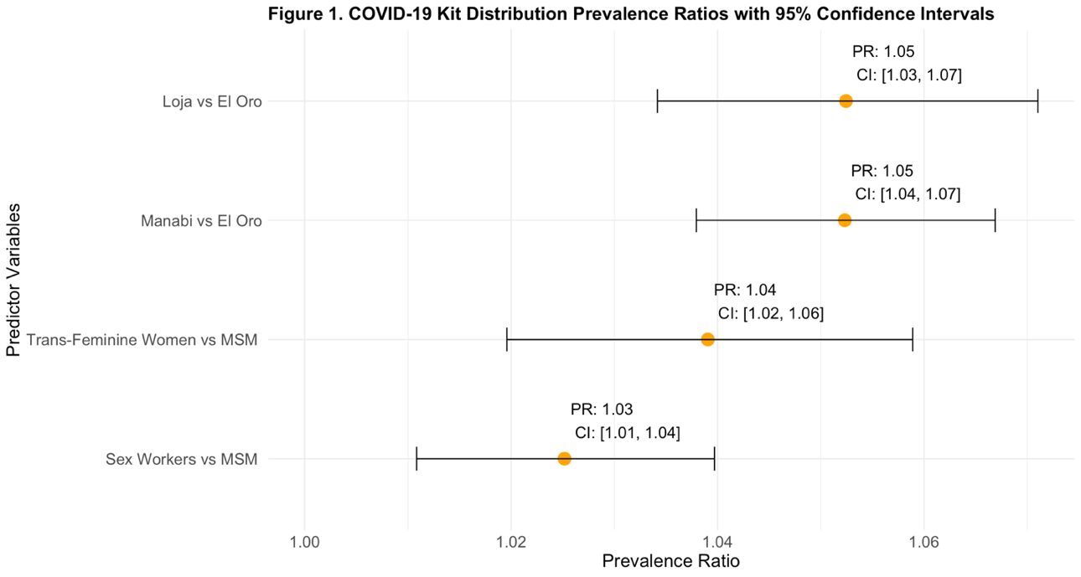 Adjusted models revealed both sex workers and transgender women to have a higher uptake of COVID-19 kits than MS (aPR: 1.03, 95% CI: 1.01-1.04; aPR: 1.04, 95% CI: 1.02-3.1.06). Similarly, individuals in Loja and Manabi were 5% more likely to receive a COVID-19 kit than those in El Oro. (aPR: 1.05, 95% CI: 1.03-1.07; aPR: 1.05, 95% CI: 1.04-1.07) (Figure 1).
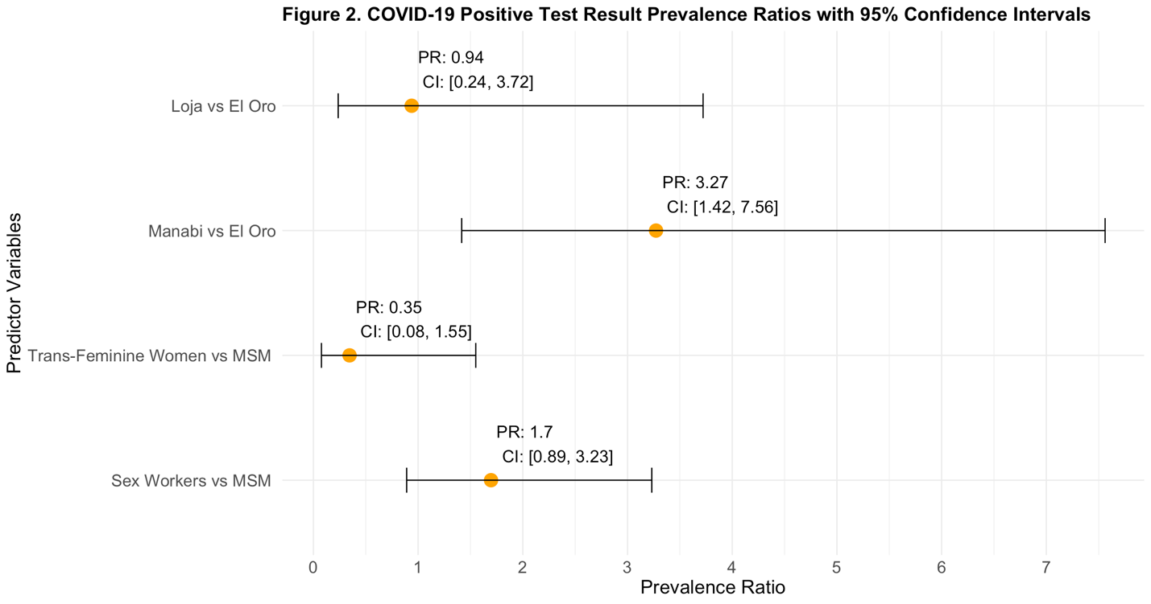 Sex workers were 70% more likely to have a positive test compared to MSM (aPR: 1.7, 95% CI: 0.89-3.23) whereas trans-feminine women were 65% less likely to have a positive test when compared to MSM (aPR: 0.35, 95% CI: 0.08-1.55). When examining positive test by province, individuals in Manabi had a higher likelihood of testing positive for COVID-19 when compared to those in El Oro (aPR: 3.27, 95% CI: 1.42-7.56). Individuals in Loja were slightly less likely to test positive for COVID-19 than those in El Oro (aPR: 0.94, 95% CI: 0.24,3.72) (Figure 2).
Testing
COVID-19 test results were available for 4,146 of the study respondents. This group was prominently comprised of natal sex females (67.5%). The most prominent gender identity and sexual orientation were feminine (67.5%) and heterosexual (68.6%), respectively. Most individuals included in the cohort were sex workers (67.4%).
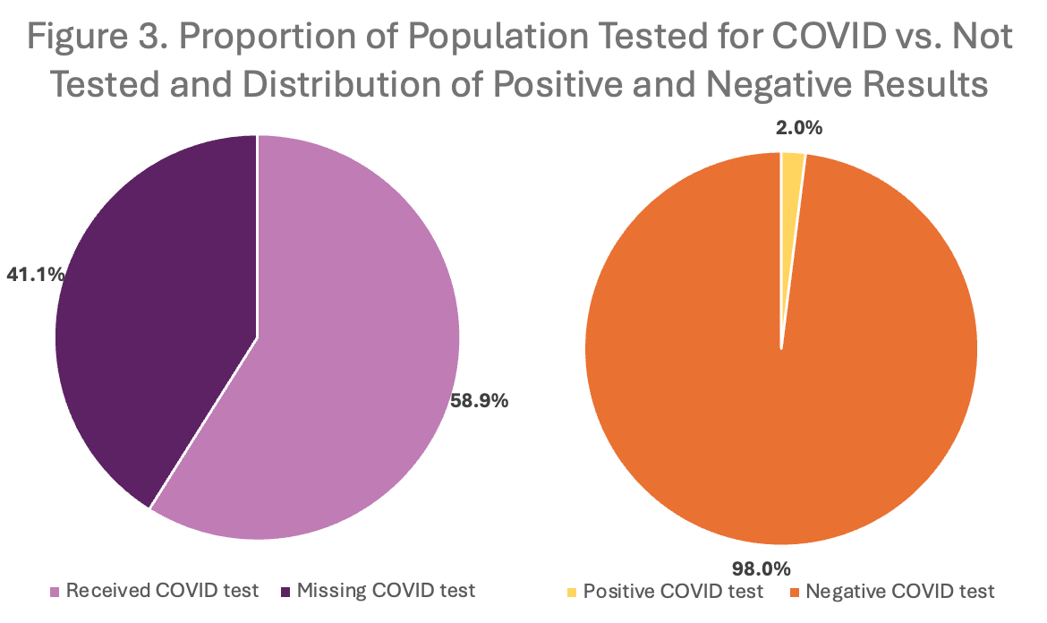
Of the 7,034 individuals included in the study, 41.1% were missing test results and 58.9% had reported test results. Among those with test results, 2.0% reported positive COVID-19 test results and 98.0% (4,064) reported negative COVID-19 test results (Figure 3).
Table 4: Association Between Risk Factors and COVID-19 Testing
 | Adjusted³ (IRR[95% CI])
Risk Factors¹
Number of Risk Factors
2 (vs 1) | 1.22 (1.11-1.34)
3 (vs 1) | 1.24 (1.03-1.49)
Diabetes | 1.39 (1.29-1.50)
Obese | 1.33 (1.24-1.42)
Indigenous² | 1.60 (1.50-1.71)
Male | 1.01 (0.94-1.09)
Positive HIV Test | 0.48 (0.28-0.82)
Key Population⁴
Transgender Woman vs MSM | 1.16 (1.04-1.30)
Sex Workers vs MSM | 1.05 (0.96-1.15)
¹ Models regarding renal disease, liver cirrhosis, cancer, transplant, and moderate immunodeficiency did not converge or did not yield feasible associations and therefore were not included
² Exposure was not included as a control
³ Gold standard model controlled for age older than 65, being indigenous, and having COVID-19 symptoms
⁴ COVID-19 contacts were not included as a key population in analyses given the small sample size (n=3)

Individuals with two or three risk factors (compared with those who only had one) were 1.24 and 1.22 times as likely to test for COVID-19. Specific risk factors of diabetes, obesity, and identifying as indigenous had positive associations with testing for COVID-19 (IRR: 1.39, 95% CI: 1.29-1.50; IRR: 1.33, 95% CI: 1.24-1.42; IRR: 1.60 95% CI: 1.50-1.71). Regarding the key populations, transgender women were more likely to test for COVID-19 compared with their MSM counterparts (IRR: 1.16, 95% CI: 1.04-1.30). Individuals who were HIV Positive were less likely to test for COVID-19 compared with their HIV Negative counterparts (IRR: 0.48, 95% CI: 0.28-0.82) (Table 4).
Vaccination
Table 5: Symptomology and Geographic Descriptions by Vaccination Status
 | Vaccinated  N = 6852 | Unvaccinated  N = 182
Severity
Mild | 6244 (91.1%) | 174 (95.6%)
Moderate | 604 (8.8%) | 8 (4.4%)
Severe | 4 (0.1%) | 0 (0.0%)
Province
El Oro | 2324 (33.9%) | 87 (47.8%)
Loja | 949 (13.8%) | 52 (28.6%)
Manabi | 3579 (52.2%) | 43 (23.6%)

Table 6: Association Between Vaccination Status and Symptom Severity
 | OR | 95% CI
Symptom Severity
Mild | 1.0 (ref) | -
Moderate/Severe | 2.1 | (1.0, 4.3)
Most individuals reported mild symptom severity, regardless of vaccination status (91% for vaccinated and 96% for unvaccinated). The percentage of vaccinated individuals with moderate symptom severity was double that of unvaccinated individuals (9% and 4%, respectively). Severe symptom categorization was only reported among vaccinated individuals. Among vaccinated individuals, the majority lived in Manabí province (52%), while the largest proportion of unvaccinated individuals resided in El Oro province (48%). The odds of vaccination among those with moderate to severe symptoms was 2.1 times (95% CI: 1.0, 4.3) the odds of vaccination among those with mild symptoms. This association was borderline statistically significant, suggesting that symptom severity may influence vaccination decisions.

Discussion
HIV
While mobile outreach effectively delivered HIV education and condoms, lubricant distribution was uneven among the three high-risk groups. Transgender women, despite the highest HIV positivity prevalence, had unremarkable access to care and treatment uptake. Demographic differences appeared to influence intervention reach but not post-screening access to care.
Table 3 displays the results of the variables’ influence on the adoption of HIV interventions. The splitting of the HIV intervention by lubricant and condom led to a difference in sample participants between these groups. Additionally, there was a coding error where those who did not receive lubricant may have been incorrectly coded as not received a condom. Including only positive tests dramatically reduced the sample size for the Poisson regression displayed in Table 4 which may have impacted the power and statistical significance.
This study highlights the strengths of mobile outreach strategies and the ongoing need for equitable resource distribution and community engagement. It contributes to the existing literature by highlighting both progress and persistent gaps in HIV prevention and care access among marginalized groups.
COVID
Geography
To evaluate programmatic effort, an 80% threshold was used to determine effective program dissemination of COVID-19 kit uptake, which originated from prior literature as an industry gold standard (Yang et al., 2024). Among the key populations, MSM had the lowest uptake of the COVID-19 kits (92.9%), still far above the 80% desired achievement. After examining geographically by canton, it was seen that the lowest proportions were among MSM in Pasaje (84.5%), transgender women in Pasaje (85.9%), and sex workers in Sucre (82.4%). The Pasaje canton (translating to “passage”) a coastal city that borders Peru may encompass greater participants as it is at the intersection of multiple major highways. As there are not readily available numbers that estimate numbers of people in key populations in the general Ecuadorian public, the representation of this coverage may not be generalizable.
When looking at study-specific COVID-19 proportions, there were very low proportions of COVID-19 infection among those who were tested, which is observable at the canton level. Portoviejo canton had the highest overall proportions of tests positive for COVID-19 among all key populations. Sex workers in the Manta canton had elevated sub-strata-specific measures with COVID-19 proportions of 4.4%. These proportions may not be representative of the full rates within these key populations.
Testing
This analysis provides important insights into COVID-19 testing behaviors among key populations, showing disparities based on health conditions and demographics. We found that individuals with multiple risk factors were more likely to get tested for COVID-19, suggesting that awareness of health vulnerabilities may encourage testing, as well as this intervention targeting this group of people well. This aligns with existing research indicating that individuals with chronic conditions are more proactive about seeking medical care; however, our findings also reveal concerning gaps -- older adults, unvaccinated individuals, immunosuppressed individuals, and those living with HIV were less likely to get tested, despite being at higher risk for severe disease. These patterns highlight potential barriers such as stigma, healthcare access issues, or misinformation, which have been observed in other studies on testing behaviors.
This analysis contributes to the understanding of how COVID-19 testing efforts reached vulnerable populations during this intervention in Ecuador. The associations between testing and conditions such as diabetes, obesity, and identifying as indigenous suggest that the program’s efforts successfully encouraged testing among some high-risk groups but fell short in others. These findings show the need for targeted interventions to ensure that those at the greatest risk – especially those who are immunocompromised in some way – have equitable access to testing and care.
Vaccination
Evaluating symptom categorization, most of both vaccination statuses reported mild symptoms. However, a larger proportion of vaccinated individuals reported moderate and severe symptoms.
Limitations
This study has some limitations that need to be considered within the design, implementation and analyses phases. As the project was terminated two years ago after beginning in 2022, there was staff discontinuity and variables being unclearly coded. Due to a variety of factors many assumptions were made to move forward with the analysis.
As this was a cross-sectional study design, this study is limited in its ability to make causal inference. These findings are also limited by the timing of the data collection, which occurred in 2022; data collection was after peak COVID-19 incidence leading to lower cell counts, higher prevalence of missings and unknowns, and lower statistical power.
Subsequently, findings cannot be generalized to testing patterns from early in the pandemic, during which testing patterns were largely captured within clinical settings or through mandated reporting. Later stages of the pandemic were classified by relaxed COVID-19 testing protocol and increased at-home testing reducing the generalizability.

Recommendations
In the short term, improving the consistency of intervention kit delivery is important to enhance HIV and COVID-19 prevention and care access among high-risk populations in Ecuador. Disparities in lubricant distribution, caused by supply limitations, highlight the need to ensure stable supply chains. Implementing longitudinal follow-up is critical to better understand long-term impacts and patterns in care access and treatment uptake, addressing the limitations of the current cross-sectional design. Establishing a robust monitoring and evaluation framework in the design phase with clear standards and measurable indicators will support ongoing assessment of program effectiveness. Strengthening partnerships with local communities will help build trust and ensure that interventions remain responsive to population needs. Tailoring program components by gender identity and sexual orientation can further reduce disparities in resource access and promote more equitable, sustainable HIV prevention and care.
Moving forward, public health programs in these regions of Ecuador should focus on improving access to COVID-19 and HIV testing, particularly for high-risk populations such as older adults, unvaccinated individuals, immunosuppressed individuals, and those living with comorbid conditions. Expanding free and accessible testing through mobile units, community health centers, and targeted outreach can help address existing gaps. Continued surveillance not just for COVID-19 and HIV but for other infectious diseases as well among key populations is important to ensure that future public health responses are data-driven and equitable. Given the limited information available among these populations in the context of COVID-19 and HIV, future interventions in Ecuador and beyond should explicitly incorporate sex workers, transgender individuals, MSM, and other vulnerable groups into public health planning. Addressing structural barriers, such as stigma, healthcare access, inequities, and socioeconomic challenges, will be critical in ensuring that those most at risk are reached effectively. By tailoring outreach efforts and integrating these populations into broader public health strategies, we can work toward a more inclusive and effective approach to infectious disease prevention and response.

Works Cited
Cuéllar, L., Torres, I., Romero-Severson, E., Mahesh, R., Ortega, N., Pungitore, S., Ke, R., & Hengartner, N. (2021). Excess deaths reveal unequal impact of COVID-19 in Ecuador. BMJ Global Health, 6(9), e006446. https://doi.org/10.1136/bmjgh-2021-006446
Deeks, S. G., Overbaugh, J., Phillips, A., & Buchbinder, S. (2015). HIV infection. Nature Reviews Disease Primers, 1(1), 1–22. https://doi.org/10.1038/nrdp.2015.35
Flores Sacoto, K. M., Sanchez Del Hierro, G. A., Moreno-Piedrahita Hernández, F. G., & Jarrin Estupiñan, J. X. (2022). Case Fatality Rate of COVID-19 and its Relationship to Sociodemographic Characteristics in Ecuador, 2020. International Journal of Public Health, 67, 1604768. https://doi.org/10.3389/ijph.2022.1604768
Lapo-Talledo, G. J., Talledo-Delgado, J. A., & Fernández-Aballí, L. S. (2023). A competing risk survival analysis of the sociodemographic factors of COVID-19 in-hospital mortality in Ecuador. Cadernos de Saúde Pública, 39(1), e00294721. https://doi.org/10.1590/0102-311xen294721
Ministerio de Salud Publica del Ecuador. (n.d.). Informe Anual del VIH 2022. Retrieved April 3, 2025, from https://www.salud.gob.ec/wp-content/uploads/2024/04/INFORME-ANUAL-DE-VIH-2022_MSP.pdf
Mody, A., Sohn, A. H., Iwuji, C., Tan, R. K. J., Venter, F., & Geng, E. H. (2024). HIV epidemiology, prevention, treatment, and implementation strategies for public health. Lancet (London, England), 403(10425), 471–492. https://doi.org/10.1016/S0140-6736(23)01381-8
Ortiz-Prado, E., Simbaña-Rivera, K., Barreno, L. G., Diaz, A. M., Barreto, A., Moyano, C., Arcos, V., Vásconez-González, E., Paz, C., Simbaña-Guaycha, F., Molestina-Luzuriaga, M., Fernández-Naranjo, R., Feijoo, J., Henriquez-Trujillo, A. R., Adana, L., López-Cortés, A., Fletcher, I., & Lowe, R. (2021). Epidemiological, socio-demographic and clinical features of the early phase of the COVID-19 epidemic in Ecuador. PLOS Neglected Tropical Diseases, 15(1), e0008958. https://doi.org/10.1371/journal.pntd.0008958
UNAIDS. (2024, March 15). Ecuador. https://www.unaids.org/en/regionscountries/countries/ecuador
Yang, J., Lo, N. C., Dankwa, E. A., Donnelly, C. A., Gupta, R., Montgomery, M. P., Weng, M. K., & Martin, N. K. (2024). Determining Herd Immunity Thresholds for Hepatitis A Virus Transmission to Inform Vaccination Strategies Among People Who Inject Drugs in 16 US States. Clinical infectious diseases : an official publication of the Infectious Diseases Society of America, 78(4), 976–982. https://doi.org/10.1093/cid/ciad552

