Simple and Mixed Model Analysis

Alexis Swanson

3/3/2021

#Histograms of the 3 Approaches for tc

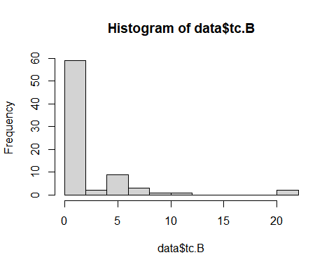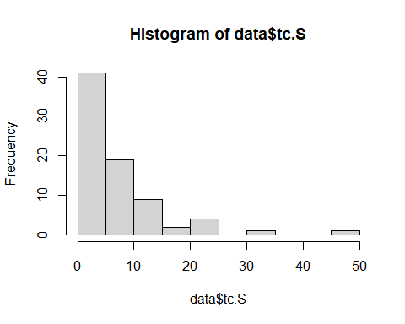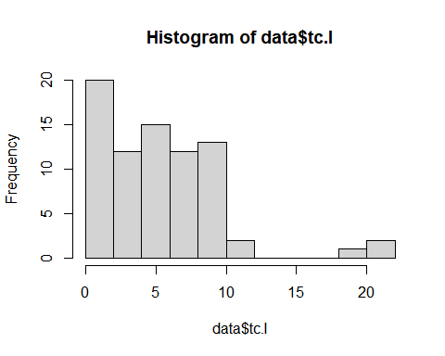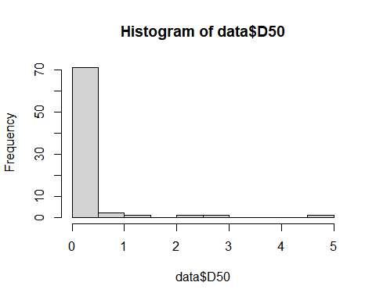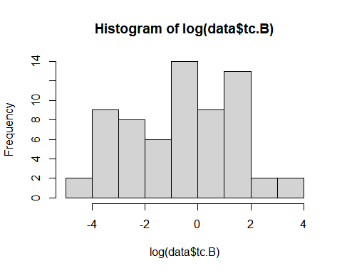

## [1] 0.00 20.41

## [1] 0.00 45.69

## [1] 0.00 21.63

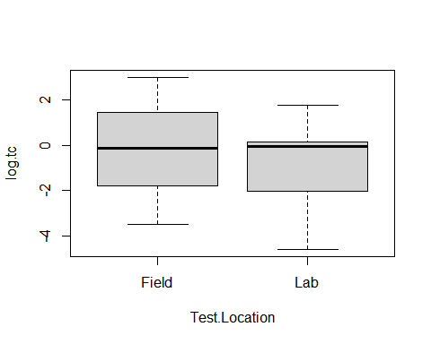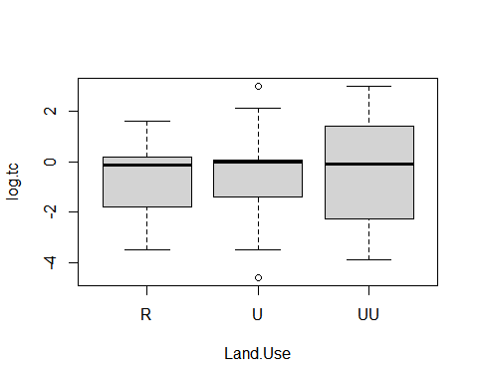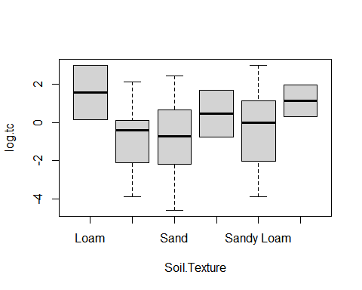

The ranges are for Blaisdell, Scour Depth and the Iterative solutions respectively.

After our discussion on 2/18 the concensus was to move forward using the Blaisdell solution.

# First Linear Model

# All Predictors

##   
## Call:  
## lm(formula = tc.B ~ Temp + EC + Cor.Moist + D50 + Cu + Cc + GSD +   
## Pass200, data = data)  
##   
## Residuals:  
## Min 1Q Median 3Q Max   
## -4.344 -2.003 -0.904 0.174 15.635   
##   
## Coefficients:  
## Estimate Std. Error t value Pr(>|t|)   
## (Intercept) -3.049088 2.826870 -1.079 0.2846   
## Temp 0.120007 0.107898 1.112 0.2700   
## EC -8.467148 4.792000 -1.767 0.0817 .  
## Cor.Moist 3.932084 5.568399 0.706 0.4825   
## D50 -5.956643 3.699243 -1.610 0.1120   
## Cu 0.158814 0.089062 1.783 0.0790 .  
## Cc 1.793598 1.253990 1.430 0.1572   
## GSD 0.143669 0.233921 0.614 0.5411   
## Pass200 -0.009086 0.051057 -0.178 0.8593   
## ---  
## Signif. codes: 0 '***' 0.001 '**' 0.01 '*' 0.05 '.' 0.1 ' ' 1  
##   
## Residual standard error: 3.746 on 68 degrees of freedom  
## Multiple R-squared: 0.1623, Adjusted R-squared: 0.06373   
## F-statistic: 1.647 on 8 and 68 DF, p-value: 0.128

## Warning in sqrt(crit * p * (1 - hh)/hh): NaNs produced  
  
## Warning in sqrt(crit * p * (1 - hh)/hh): NaNs produced

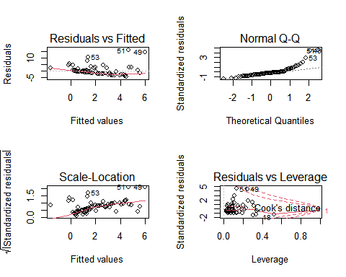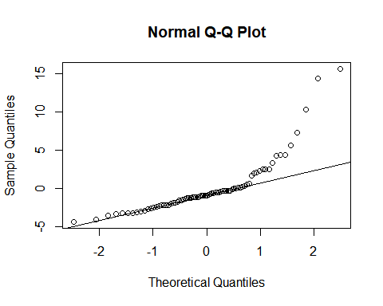

## Warning: Removed 3 rows containing missing values (geom_point).

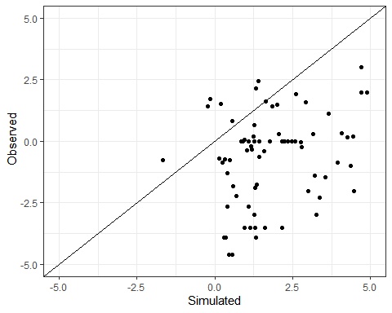

Here I also plotted box plots to see if there was a significant difference in the categorical variables. The field and lab almost show a statistical difference but are still overlapping slightly. The rural, urban and ultra urban are not showing much of a difference. The soil texture however seems to have something going on where the critical shear stress could be statiscially different for each soil texture.

# Mixed Model with 3 Random Factors

# Test Location and Land Use

## Linear mixed model fit by REML ['lmerMod']  
## Formula: log.tc ~ (1 | Test.Location) + (1 | Land.Use) + (1 | Soil.Texture) +   
## Temp + EC + Cor.Moist + D50 + Cu + Cc + GSD + Pass200  
## Data: data  
##   
## REML criterion at convergence: 315.3  
##   
## Scaled residuals:   
## Min 1Q Median 3Q Max   
## -1.8567 -0.8675 0.1761 0.6341 1.7345   
##   
## Random effects:  
## Groups Name Variance Std.Dev.   
## Soil.Texture (Intercept) 0.000e+00 0.000e+00  
## Land.Use (Intercept) 2.485e-09 4.985e-05  
## Test.Location (Intercept) 1.706e-01 4.131e-01  
## Residual 3.282e+00 1.812e+00  
## Number of obs: 77, groups: Soil.Texture, 6; Land.Use, 3; Test.Location, 2  
##   
## Fixed effects:  
## Estimate Std. Error t value  
## (Intercept) -1.6835127 1.4169589 -1.188  
## Temp -0.0009589 0.0527033 -0.018  
## EC -2.9817891 2.3407696 -1.274  
## Cor.Moist -0.2805212 2.6992557 -0.104  
## D50 -1.7869984 1.7942177 -0.996  
## Cu 0.0639025 0.0431257 1.482  
## Cc 0.5652295 0.6072596 0.931  
## GSD 0.0420957 0.1131518 0.372  
## Pass200 0.0238488 0.0246938 0.966  
##   
## Correlation of Fixed Effects:  
## (Intr) Temp EC Cr.Mst D50 Cu Cc GSD   
## Temp -0.743   
## EC -0.246 0.292   
## Cor.Moist -0.333 -0.003 -0.409   
## D50 0.143 0.065 0.331 -0.023   
## Cu -0.086 -0.074 -0.367 0.021 -0.947   
## Cc -0.243 -0.031 -0.257 0.004 -0.932 0.846   
## GSD -0.271 -0.083 0.056 -0.002 -0.324 0.119 0.412   
## Pass200 0.160 -0.085 0.354 -0.378 0.670 -0.601 -0.635 -0.294  
## optimizer (nloptwrap) convergence code: 0 (OK)  
## boundary (singular) fit: see ?isSingular

## Analysis of Variance Table  
## npar Sum Sq Mean Sq F value  
## Temp 1 4.1903 4.1903 1.2767  
## EC 1 3.6076 3.6076 1.0992  
## Cor.Moist 1 3.6527 3.6527 1.1129  
## D50 1 4.5270 4.5270 1.3793  
## Cu 1 12.0308 12.0308 3.6655  
## Cc 1 11.5880 11.5880 3.5306  
## GSD 1 1.5475 1.5475 0.4715  
## Pass200 1 3.0614 3.0614 0.9327

## $Soil.Texture  
## (Intercept)  
## Loam 0  
## Loamy Sand 0  
## Sand 0  
## Sandy Clay Loam 0  
## Sandy Loam 0  
## Silt Loam 0  
##   
## $Land.Use  
## (Intercept)  
## R -2.333255e-09  
## U -1.618449e-09  
## UU 3.951704e-09  
##   
## $Test.Location  
## (Intercept)  
## Field 0.2337003  
## Lab -0.2337003  
##   
## with conditional variances for "Soil.Texture" "Land.Use" "Test.Location"

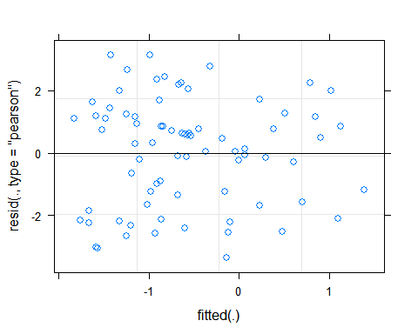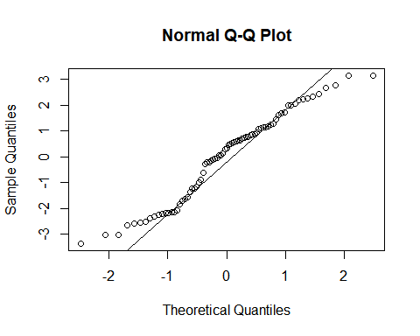

# Mixed Model with only Test Location as Random Factor

## Linear mixed model fit by REML ['lmerMod']  
## Formula: log.tc ~ (1 | Test.Location) + Temp + EC + Cor.Moist + D50 +   
## Cu + Cc + GSD + Pass200  
## Data: data  
##   
## REML criterion at convergence: 315.3  
##   
## Scaled residuals:   
## Min 1Q Median 3Q Max   
## -1.8567 -0.8675 0.1761 0.6341 1.7345   
##   
## Random effects:  
## Groups Name Variance Std.Dev.  
## Test.Location (Intercept) 0.1706 0.4131   
## Residual 3.2821 1.8117   
## Number of obs: 77, groups: Test.Location, 2  
##   
## Fixed effects:  
## Estimate Std. Error t value  
## (Intercept) -1.6835144 1.4169594 -1.188  
## Temp -0.0009589 0.0527033 -0.018  
## EC -2.9817867 2.3407696 -1.274  
## Cor.Moist -0.2805199 2.6992555 -0.104  
## D50 -1.7869974 1.7942176 -0.996  
## Cu 0.0639025 0.0431257 1.482  
## Cc 0.5652293 0.6072596 0.931  
## GSD 0.0420957 0.1131518 0.372  
## Pass200 0.0238488 0.0246938 0.966  
##   
## Correlation of Fixed Effects:  
## (Intr) Temp EC Cr.Mst D50 Cu Cc GSD   
## Temp -0.743   
## EC -0.246 0.292   
## Cor.Moist -0.333 -0.003 -0.409   
## D50 0.143 0.065 0.331 -0.023   
## Cu -0.086 -0.074 -0.367 0.021 -0.947   
## Cc -0.243 -0.031 -0.257 0.004 -0.932 0.846   
## GSD -0.271 -0.083 0.056 -0.002 -0.324 0.119 0.412   
## Pass200 0.160 -0.085 0.354 -0.378 0.670 -0.601 -0.635 -0.294

## Analysis of Variance Table  
## npar Sum Sq Mean Sq F value  
## Temp 1 4.1903 4.1903 1.2767  
## EC 1 3.6076 3.6076 1.0992  
## Cor.Moist 1 3.6527 3.6527 1.1129  
## D50 1 4.5270 4.5270 1.3793  
## Cu 1 12.0308 12.0308 3.6655  
## Cc 1 11.5880 11.5880 3.5306  
## GSD 1 1.5475 1.5475 0.4715  
## Pass200 1 3.0614 3.0614 0.9327

## $Test.Location  
## (Intercept)  
## Field 0.2337016  
## Lab -0.2337016  
##   
## with conditional variances for "Test.Location"



# Mixed Model with only Land Use as Random Factor

## Linear mixed model fit by REML ['lmerMod']  
## Formula: tc.I ~ (1 | Land.Use) + Temp + EC + Cor.Moist + D50 + Cu + Cc +   
## GSD + Pass200  
## Data: data  
##   
## REML criterion at convergence: 416.3  
##   
## Scaled residuals:   
## Min 1Q Median 3Q Max   
## -1.3363 -0.5957 -0.1293 0.3853 3.7220   
##   
## Random effects:  
## Groups Name Variance Std.Dev.  
## Land.Use (Intercept) 0.5291 0.7274   
## Residual 14.5122 3.8095   
## Number of obs: 77, groups: Land.Use, 3  
##   
## Fixed effects:  
## Estimate Std. Error t value  
## (Intercept) 4.04742 2.91115 1.390  
## Temp -0.16467 0.10985 -1.499  
## EC -10.01961 4.98360 -2.011  
## Cor.Moist 8.51366 5.75384 1.480  
## D50 -5.44487 3.81696 -1.426  
## Cu 0.18260 0.09169 1.991  
## Cc 1.08070 1.28978 0.838  
## GSD 0.19346 0.24760 0.781  
## Pass200 0.02960 0.05223 0.567  
##   
## Correlation of Fixed Effects:  
## (Intr) Temp EC Cr.Mst D50 Cu Cc GSD   
## Temp -0.746   
## EC -0.221 0.266   
## Cor.Moist -0.328 -0.008 -0.445   
## D50 0.161 0.053 0.288 -0.005   
## Cu -0.103 -0.062 -0.344 0.015 -0.945   
## Cc -0.256 -0.024 -0.217 -0.017 -0.932 0.841   
## GSD -0.260 -0.088 0.109 -0.052 -0.346 0.128 0.431   
## Pass200 0.169 -0.089 0.345 -0.368 0.673 -0.608 -0.634 -0.287

## Analysis of Variance Table  
## npar Sum Sq Mean Sq F value  
## Temp 1 0.210 0.210 0.0145  
## EC 1 12.106 12.106 0.8342  
## Cor.Moist 1 111.966 111.966 7.7153  
## D50 1 8.891 8.891 0.6126  
## Cu 1 162.864 162.864 11.2226  
## Cc 1 24.260 24.260 1.6717  
## GSD 1 14.101 14.101 0.9717  
## Pass200 1 4.661 4.661 0.3212

## $Land.Use  
## (Intercept)  
## R -0.44358634  
## U 0.02410128  
## UU 0.41948506  
##   
## with conditional variances for "Land.Use"

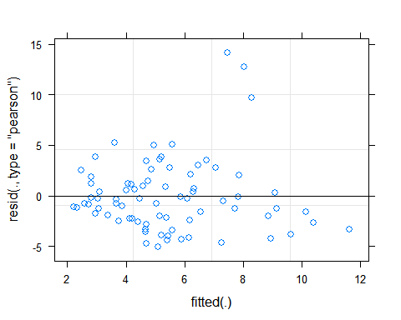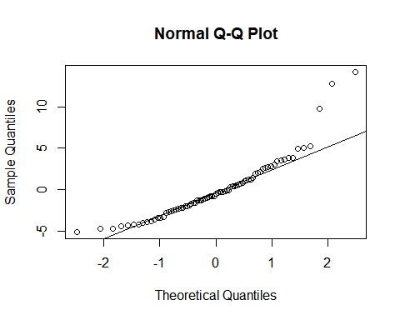

# Mixed Model with only Soil Texture as Random Factor

## Linear mixed model fit by REML ['lmerMod']  
## Formula: tc.I ~ (1 | Soil.Texture) + Temp + EC + Cor.Moist + D50 + Cu +   
## Cc + GSD + Pass200  
## Data: data  
##   
## REML criterion at convergence: 415.1  
##   
## Scaled residuals:   
## Min 1Q Median 3Q Max   
## -1.3638 -0.7080 -0.1229 0.5148 3.5684   
##   
## Random effects:  
## Groups Name Variance Std.Dev.  
## Soil.Texture (Intercept) 3.579 1.892   
## Residual 13.651 3.695   
## Number of obs: 77, groups: Soil.Texture, 6  
##   
## Fixed effects:  
## Estimate Std. Error t value  
## (Intercept) 3.31583 3.25082 1.020  
## Temp -0.14205 0.10784 -1.317  
## EC -10.52209 5.00237 -2.103  
## Cor.Moist 6.91197 5.72903 1.206  
## D50 -10.07830 4.24291 -2.375  
## Cu 0.28304 0.10123 2.796  
## Cc 2.63290 1.43130 1.840  
## GSD 0.26325 0.23648 1.113  
## Pass200 0.02059 0.06100 0.338  
##   
## Correlation of Fixed Effects:  
## (Intr) Temp EC Cr.Mst D50 Cu Cc GSD   
## Temp -0.651   
## EC -0.203 0.224   
## Cor.Moist -0.244 0.005 -0.439   
## D50 0.249 0.007 0.306 0.008   
## Cu -0.198 -0.014 -0.344 0.000 -0.959   
## Cc -0.326 0.012 -0.239 -0.039 -0.947 0.878   
## GSD -0.215 -0.099 0.049 -0.036 -0.293 0.110 0.377   
## Pass200 -0.101 -0.093 0.361 -0.380 0.434 -0.399 -0.392 -0.240

## Analysis of Variance Table  
## npar Sum Sq Mean Sq F value  
## Temp 1 0.994 0.994 0.0728  
## EC 1 11.714 11.714 0.8581  
## Cor.Moist 1 60.310 60.310 4.4181  
## D50 1 8.873 8.873 0.6500  
## Cu 1 160.610 160.610 11.7657  
## Cc 1 46.694 46.694 3.4206  
## GSD 1 20.654 20.654 1.5130  
## Pass200 1 1.555 1.555 0.1139

## $Soil.Texture  
## (Intercept)  
## Loam 1.1136833  
## Loamy Sand -0.9465199  
## Sand 0.8158503  
## Sandy Clay Loam 1.3762088  
## Sandy Loam -1.7133819  
## Silt Loam -0.6458405  
##   
## with conditional variances for "Soil.Texture"

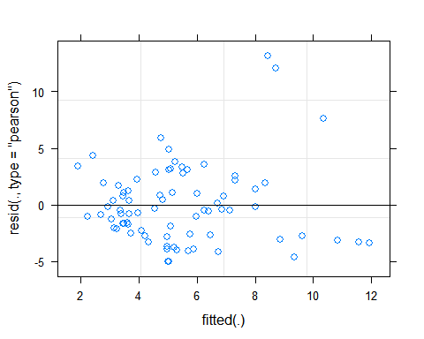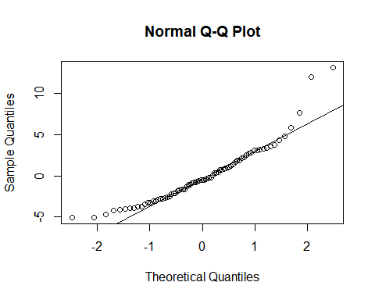

# Mixed Model with Soil Texture and Land Use as Random Factors

## Linear mixed model fit by REML ['lmerMod']  
## Formula: tc.B ~ (1 | Soil.Texture) + (1 | Land.Use) + Temp + EC + Cor.Moist +   
## D50 + Cu + Cc + GSD + Pass200  
## Data: data  
##   
## REML criterion at convergence: 409.4  
##   
## Scaled residuals:   
## Min 1Q Median 3Q Max   
## -1.9916 -0.4381 -0.2167 0.1319 3.5753   
##   
## Random effects:  
## Groups Name Variance Std.Dev.  
## Soil.Texture (Intercept) 9.1952 3.0324   
## Land.Use (Intercept) 0.3155 0.5617   
## Residual 11.9045 3.4503   
## Number of obs: 77, groups: Soil.Texture, 6; Land.Use, 3  
##   
## Fixed effects:  
## Estimate Std. Error t value  
## (Intercept) -2.38214 3.52246 -0.676  
## Temp 0.16263 0.10154 1.602  
## EC -11.03044 4.98702 -2.212  
## Cor.Moist 2.94662 5.56808 0.529  
## D50 -11.21582 4.16122 -2.695  
## Cu 0.28792 0.09857 2.921  
## Cc 3.47259 1.40507 2.471  
## GSD 0.13964 0.23069 0.605  
## Pass200 -0.06539 0.06701 -0.976  
##   
## Correlation of Fixed Effects:  
## (Intr) Temp EC Cr.Mst D50 Cu Cc GSD   
## Temp -0.565   
## EC -0.192 0.174   
## Cor.Moist -0.172 0.017 -0.473   
## D50 0.265 -0.007 0.270 0.039   
## Cu -0.221 0.005 -0.322 -0.018 -0.960   
## Cc -0.333 0.023 -0.201 -0.076 -0.951 0.883   
## GSD -0.151 -0.105 0.085 -0.076 -0.301 0.117 0.379   
## Pass200 -0.274 -0.086 0.367 -0.373 0.309 -0.291 -0.262 -0.231

## Analysis of Variance Table  
## npar Sum Sq Mean Sq F value  
## Temp 1 54.883 54.883 4.6103  
## EC 1 18.852 18.852 1.5836  
## Cor.Moist 1 4.463 4.463 0.3749  
## D50 1 4.564 4.564 0.3834  
## Cu 1 28.989 28.989 2.4352  
## Cc 1 62.973 62.973 5.2899  
## GSD 1 1.818 1.818 0.1527  
## Pass200 1 11.335 11.335 0.9522

## $Soil.Texture  
## (Intercept)  
## Loam 3.5674943  
## Loamy Sand -2.2440142  
## Sand -0.4120727  
## Sandy Clay Loam 2.2817054  
## Sandy Loam -2.3944976  
## Silt Loam -0.7986153  
##   
## $Land.Use  
## (Intercept)  
## R -0.2184917  
## U -0.1092026  
## UU 0.3276942  
##   
## with conditional variances for "Soil.Texture" "Land.Use"

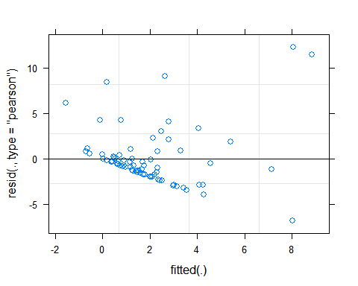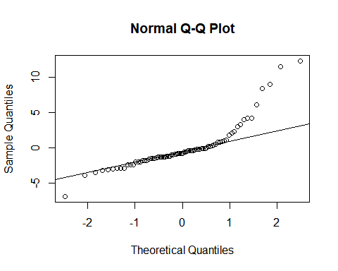

## Warning: Removed 6 rows containing missing values (geom_point).

## Warning: Removed 5 rows containing missing values (geom_point).

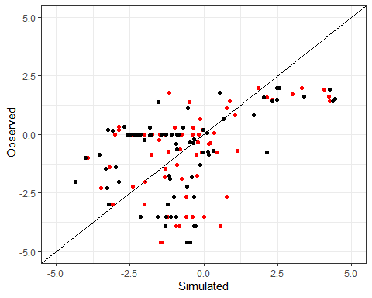

## Warning: Removed 11 rows containing missing values (geom_point).

## Warning: Removed 11 rows containing missing values (geom_point).

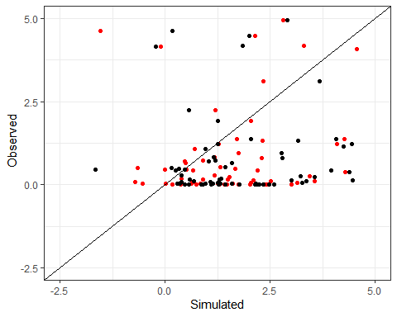

# Conclusion

# Load new data that includes bulk density and water temperature (59 observations)

# Simple Linear Model using limited data with all predictors

##   
## Call:  
## lm(formula = log.tc ~ Temp + EC + Cor.Moist + WTemp + BD + D50 +   
## Cu + Cc + GSD + Pass200, data = data_limited)  
##   
## Residuals:  
## Min 1Q Median 3Q Max   
## -3.095 -1.223 0.005 1.153 3.813   
##   
## Coefficients:  
## Estimate Std. Error t value Pr(>|t|)   
## (Intercept) 2.090230 3.230000 0.647 0.5206   
## Temp 0.173012 0.106550 1.624 0.1110   
## EC -2.245861 3.390571 -0.662 0.5109   
## Cor.Moist 1.589103 3.532915 0.450 0.6549   
## WTemp -0.259776 0.101120 -2.569 0.0134 *  
## BD -0.001571 1.101535 -0.001 0.9989   
## D50 -9.794177 5.005380 -1.957 0.0562 .  
## Cu 0.200558 0.103269 1.942 0.0580 .  
## Cc -0.822989 1.329151 -0.619 0.5387   
## GSD 0.016787 0.198942 0.084 0.9331   
## Pass200 -0.012436 0.059730 -0.208 0.8359   
## ---  
## Signif. codes: 0 '***' 0.001 '**' 0.01 '*' 0.05 '.' 0.1 ' ' 1  
##   
## Residual standard error: 1.726 on 48 degrees of freedom  
## Multiple R-squared: 0.2582, Adjusted R-squared: 0.1037   
## F-statistic: 1.671 on 10 and 48 DF, p-value: 0.1155

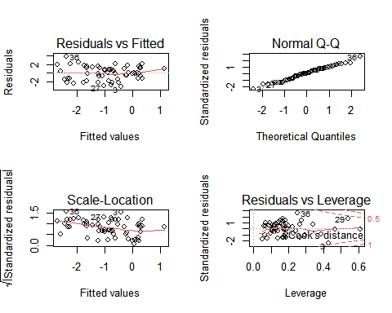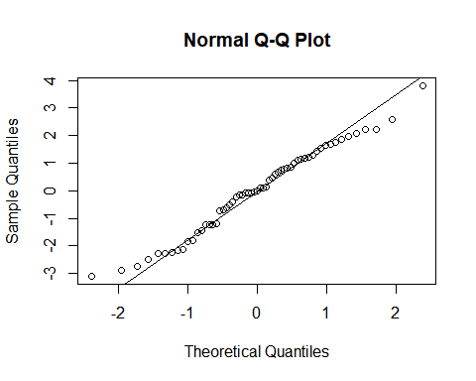

#Simple linear model using limited data and only signifcant predictors

##   
## Call:  
## lm(formula = log.tc ~ WTemp + D50 + Cu, data = data_limited)  
##   
## Residuals:  
## Min 1Q Median 3Q Max   
## -3.3131 -1.4771 0.1893 1.0976 3.0168   
##   
## Coefficients:  
## Estimate Std. Error t value Pr(>|t|)   
## (Intercept) 1.47420 1.01999 1.445 0.1540   
## WTemp -0.12040 0.05550 -2.169 0.0344 *  
## D50 -5.67428 2.90782 -1.951 0.0561 .  
## Cu 0.12843 0.05769 2.226 0.0301 *  
## ---  
## Signif. codes: 0 '***' 0.001 '**' 0.01 '*' 0.05 '.' 0.1 ' ' 1  
##   
## Residual standard error: 1.705 on 55 degrees of freedom  
## Multiple R-squared: 0.1715, Adjusted R-squared: 0.1263   
## F-statistic: 3.795 on 3 and 55 DF, p-value: 0.01517

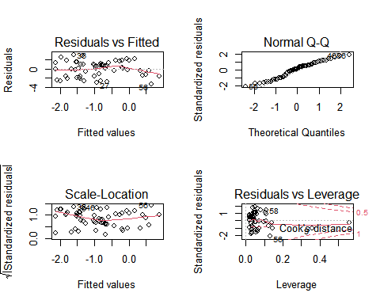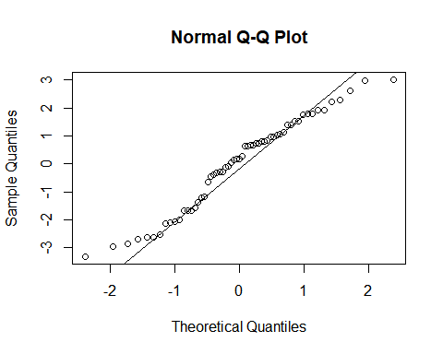

# Mixed Model with limited data and only Land Use as a random factor

## Linear mixed model fit by REML ['lmerMod']  
## Formula: tc.I ~ (1 | Land.Use) + Temp + EC + Cor.Moist + WTemp + BD +   
## D50 + Cu + Cc + GSD + Pass200  
## Data: data_limited  
##   
## REML criterion at convergence: 266.5  
##   
## Scaled residuals:   
## Min 1Q Median 3Q Max   
## -1.3921 -0.6191 -0.0573 0.4014 3.6967   
##   
## Random effects:  
## Groups Name Variance Std.Dev.  
## Land.Use (Intercept) 0.000 0.000   
## Residual 6.939 2.634   
## Number of obs: 59, groups: Land.Use, 3  
##   
## Fixed effects:  
## Estimate Std. Error t value  
## (Intercept) 20.168649 4.928084 4.093  
## Temp -0.008649 0.162566 -0.053  
## EC 5.539330 5.173071 1.071  
## Cor.Moist 5.593705 5.390249 1.038  
## WTemp -0.530138 0.154282 -3.436  
## BD -1.027770 1.680638 -0.612  
## D50 -18.647143 7.636821 -2.442  
## Cu 0.399117 0.157560 2.533  
## Cc -2.316402 2.027915 -1.142  
## GSD -0.090237 0.303530 -0.297  
## Pass200 -0.154064 0.091131 -1.691  
##   
## Correlation of Fixed Effects:  
## (Intr) Temp EC Cr.Mst WTemp BD D50 Cu Cc GSD   
## Temp -0.132   
## EC 0.293 0.226   
## Cor.Moist -0.430 -0.034 -0.595   
## WTemp -0.048 -0.806 -0.235 -0.015   
## BD -0.734 -0.008 -0.226 0.259 -0.042   
## D50 -0.318 -0.078 -0.042 0.161 0.111 0.027   
## Cu 0.287 0.026 -0.008 -0.139 -0.070 0.020 -0.985   
## Cc -0.454 -0.201 -0.178 0.115 0.084 0.325 -0.241 0.292   
## GSD -0.494 0.107 -0.059 0.087 -0.167 0.177 0.074 -0.130 0.573   
## Pass200 -0.165 0.064 -0.162 0.034 0.098 -0.008 0.691 -0.704 -0.625 -0.167  
## optimizer (nloptwrap) convergence code: 0 (OK)  
## boundary (singular) fit: see ?isSingular

## Analysis of Variance Table  
## npar Sum Sq Mean Sq F value  
## Temp 1 168.605 168.605 24.2992  
## EC 1 16.506 16.506 2.3788  
## Cor.Moist 1 15.959 15.959 2.3000  
## WTemp 1 33.076 33.076 4.7669  
## BD 1 0.044 0.044 0.0063  
## D50 1 82.347 82.347 11.8677  
## Cu 1 17.426 17.426 2.5114  
## Cc 1 66.750 66.750 9.6199  
## GSD 1 2.401 2.401 0.3460  
## Pass200 1 19.831 19.831 2.8580

## $Land.Use  
## (Intercept)  
## R 0  
## U 0  
## UU 0  
##   
## with conditional variances for "Land.Use"

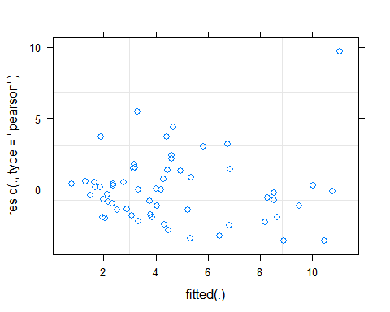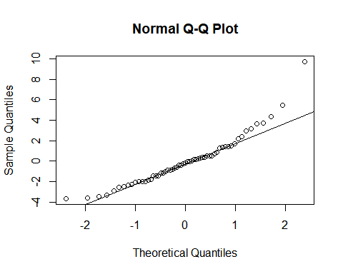

# Mixed Model with limited data and only Soil Texture as a random factor

## Linear mixed model fit by REML ['lmerMod']  
## Formula: tc.I ~ (1 | Soil.Texture) + Temp + EC + Cor.Moist + WTemp + BD +   
## D50 + Cu + Cc + GSD + Pass200  
## Data: data_limited  
##   
## REML criterion at convergence: 266.5  
##   
## Scaled residuals:   
## Min 1Q Median 3Q Max   
## -1.3921 -0.6191 -0.0573 0.4014 3.6967   
##   
## Random effects:  
## Groups Name Variance Std.Dev.  
## Soil.Texture (Intercept) 0.000 0.000   
## Residual 6.939 2.634   
## Number of obs: 59, groups: Soil.Texture, 4  
##   
## Fixed effects:  
## Estimate Std. Error t value  
## (Intercept) 20.168649 4.928084 4.093  
## Temp -0.008649 0.162566 -0.053  
## EC 5.539330 5.173071 1.071  
## Cor.Moist 5.593705 5.390249 1.038  
## WTemp -0.530138 0.154282 -3.436  
## BD -1.027770 1.680638 -0.612  
## D50 -18.647143 7.636821 -2.442  
## Cu 0.399117 0.157560 2.533  
## Cc -2.316402 2.027915 -1.142  
## GSD -0.090237 0.303530 -0.297  
## Pass200 -0.154064 0.091131 -1.691  
##   
## Correlation of Fixed Effects:  
## (Intr) Temp EC Cr.Mst WTemp BD D50 Cu Cc GSD   
## Temp -0.132   
## EC 0.293 0.226   
## Cor.Moist -0.430 -0.034 -0.595   
## WTemp -0.048 -0.806 -0.235 -0.015   
## BD -0.734 -0.008 -0.226 0.259 -0.042   
## D50 -0.318 -0.078 -0.042 0.161 0.111 0.027   
## Cu 0.287 0.026 -0.008 -0.139 -0.070 0.020 -0.985   
## Cc -0.454 -0.201 -0.178 0.115 0.084 0.325 -0.241 0.292   
## GSD -0.494 0.107 -0.059 0.087 -0.167 0.177 0.074 -0.130 0.573   
## Pass200 -0.165 0.064 -0.162 0.034 0.098 -0.008 0.691 -0.704 -0.625 -0.167  
## optimizer (nloptwrap) convergence code: 0 (OK)  
## boundary (singular) fit: see ?isSingular

## Analysis of Variance Table  
## npar Sum Sq Mean Sq F value  
## Temp 1 168.605 168.605 24.2992  
## EC 1 16.506 16.506 2.3788  
## Cor.Moist 1 15.959 15.959 2.3000  
## WTemp 1 33.076 33.076 4.7669  
## BD 1 0.044 0.044 0.0063  
## D50 1 82.347 82.347 11.8677  
## Cu 1 17.426 17.426 2.5114  
## Cc 1 66.750 66.750 9.6199  
## GSD 1 2.401 2.401 0.3460  
## Pass200 1 19.831 19.831 2.8580

## $Soil.Texture  
## (Intercept)  
## Loamy Sand 0  
## Sand 0  
## Sandy Clay Loam 0  
## Sandy Loam 0  
##   
## with conditional variances for "Soil.Texture"



# Mixed Model with limited data and both Land Use and Soil Texture as random factors

## Linear mixed model fit by REML ['lmerMod']  
## Formula: tc.I ~ (1 | Soil.Texture) + (1 | Land.Use) + Temp + EC + Cor.Moist +   
## WTemp + BD + D50 + Cu + Cc + GSD + Pass200  
## Data: data_limited  
##   
## REML criterion at convergence: 266.5  
##   
## Scaled residuals:   
## Min 1Q Median 3Q Max   
## -1.3921 -0.6191 -0.0573 0.4014 3.6967   
##   
## Random effects:  
## Groups Name Variance Std.Dev.  
## Soil.Texture (Intercept) 0.000 0.000   
## Land.Use (Intercept) 0.000 0.000   
## Residual 6.939 2.634   
## Number of obs: 59, groups: Soil.Texture, 4; Land.Use, 3  
##   
## Fixed effects:  
## Estimate Std. Error t value  
## (Intercept) 20.168649 4.928084 4.093  
## Temp -0.008649 0.162566 -0.053  
## EC 5.539330 5.173071 1.071  
## Cor.Moist 5.593705 5.390249 1.038  
## WTemp -0.530138 0.154282 -3.436  
## BD -1.027770 1.680638 -0.612  
## D50 -18.647143 7.636821 -2.442  
## Cu 0.399117 0.157560 2.533  
## Cc -2.316402 2.027915 -1.142  
## GSD -0.090237 0.303530 -0.297  
## Pass200 -0.154064 0.091131 -1.691  
##   
## Correlation of Fixed Effects:  
## (Intr) Temp EC Cr.Mst WTemp BD D50 Cu Cc GSD   
## Temp -0.132   
## EC 0.293 0.226   
## Cor.Moist -0.430 -0.034 -0.595   
## WTemp -0.048 -0.806 -0.235 -0.015   
## BD -0.734 -0.008 -0.226 0.259 -0.042   
## D50 -0.318 -0.078 -0.042 0.161 0.111 0.027   
## Cu 0.287 0.026 -0.008 -0.139 -0.070 0.020 -0.985   
## Cc -0.454 -0.201 -0.178 0.115 0.084 0.325 -0.241 0.292   
## GSD -0.494 0.107 -0.059 0.087 -0.167 0.177 0.074 -0.130 0.573   
## Pass200 -0.165 0.064 -0.162 0.034 0.098 -0.008 0.691 -0.704 -0.625 -0.167  
## optimizer (nloptwrap) convergence code: 0 (OK)  
## boundary (singular) fit: see ?isSingular

## Analysis of Variance Table  
## npar Sum Sq Mean Sq F value  
## Temp 1 168.605 168.605 24.2992  
## EC 1 16.506 16.506 2.3788  
## Cor.Moist 1 15.959 15.959 2.3000  
## WTemp 1 33.076 33.076 4.7669  
## BD 1 0.044 0.044 0.0063  
## D50 1 82.347 82.347 11.8677  
## Cu 1 17.426 17.426 2.5114  
## Cc 1 66.750 66.750 9.6199  
## GSD 1 2.401 2.401 0.3460  
## Pass200 1 19.831 19.831 2.8580

## $Soil.Texture  
## (Intercept)  
## Loamy Sand 0  
## Sand 0  
## Sandy Clay Loam 0  
## Sandy Loam 0  
##   
## $Land.Use  
## (Intercept)  
## R 0  
## U 0  
## UU 0  
##   
## with conditional variances for "Soil.Texture" "Land.Use"



# Mixed Model with limited data, Soil Texture and only sig variables from simple linear model

## Linear mixed model fit by REML ['lmerMod']  
## Formula: tc.I ~ (1 | Soil.Texture) + WTemp + D50 + Cu  
## Data: data_limited  
##   
## REML criterion at convergence: 286.8  
##   
## Scaled residuals:   
## Min 1Q Median 3Q Max   
## -1.3526 -0.6118 -0.2115 0.4791 4.2027   
##   
## Random effects:  
## Groups Name Variance Std.Dev.  
## Soil.Texture (Intercept) 2.835 1.684   
## Residual 6.907 2.628   
## Number of obs: 59, groups: Soil.Texture, 4  
##   
## Fixed effects:  
## Estimate Std. Error t value  
## (Intercept) 13.38429 1.80953 7.397  
## WTemp -0.45506 0.08715 -5.221  
## D50 -17.51294 5.45946 -3.208  
## Cu 0.40368 0.10688 3.777  
##   
## Correlation of Fixed Effects:  
## (Intr) WTemp D50   
## WTemp -0.828   
## D50 -0.138 -0.023   
## Cu 0.137 0.004 -0.987

## Analysis of Variance Table  
## npar Sum Sq Mean Sq F value  
## WTemp 1 165.441 165.441 23.953  
## D50 1 70.951 70.951 10.273  
## Cu 1 98.536 98.536 14.266

## $Soil.Texture  
## (Intercept)  
## Loamy Sand -0.0874248  
## Sand 1.6235503  
## Sandy Clay Loam 0.3047554  
## Sandy Loam -1.8408809  
##   
## with conditional variances for "Soil.Texture"

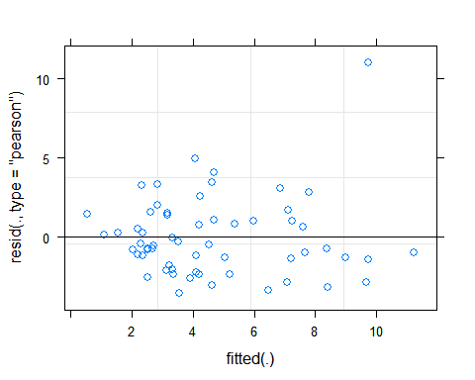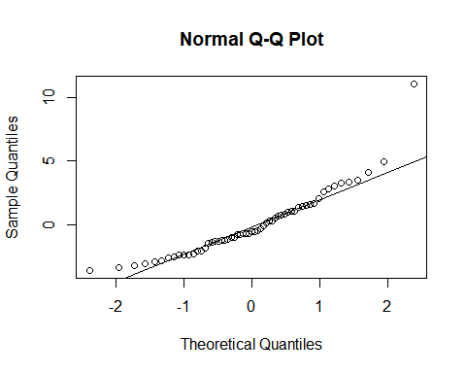

# Load limited data based on water temp, this dataset does not include BD (69 observations)

# Simple Linear Model using limited data based on watertemp with all predictors

##   
## Call:  
## lm(formula = tc.B ~ Temp + EC + Cor.Moist + WTemp + D50 + Cu +   
## Cc + GSD + Pass200, data = data_wtemp)  
##   
## Residuals:  
## Min 1Q Median 3Q Max   
## -3.0079 -1.0909 -0.6300 0.2578 9.2916   
##   
## Coefficients:  
## Estimate Std. Error t value Pr(>|t|)  
## (Intercept) 2.57827 2.03526 1.267 0.210  
## Temp 0.06182 0.13321 0.464 0.644  
## EC -2.55597 3.13574 -0.815 0.418  
## Cor.Moist 4.40552 3.67063 1.200 0.235  
## WTemp -0.19473 0.12723 -1.530 0.131  
## D50 -1.07526 2.70244 -0.398 0.692  
## Cu 0.03843 0.06399 0.601 0.550  
## Cc 0.20546 0.92290 0.223 0.825  
## GSD 0.15864 0.17711 0.896 0.374  
## Pass200 -0.03533 0.03890 -0.908 0.367  
##   
## Residual standard error: 2.332 on 59 degrees of freedom  
## Multiple R-squared: 0.1165, Adjusted R-squared: -0.01833   
## F-statistic: 0.864 on 9 and 59 DF, p-value: 0.5618

## Warning in sqrt(crit * p * (1 - hh)/hh): NaNs produced  
  
## Warning in sqrt(crit * p * (1 - hh)/hh): NaNs produced

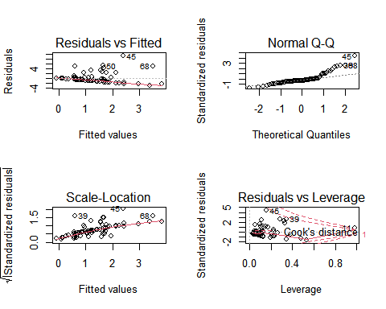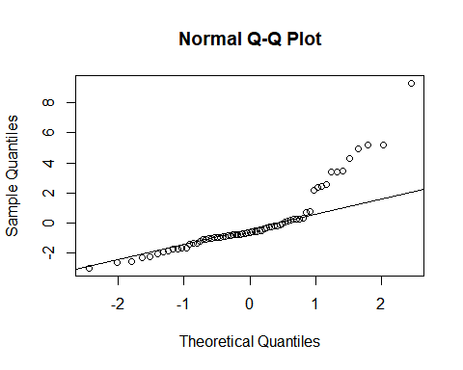

## Warning: Removed 6 rows containing missing values (geom_point).

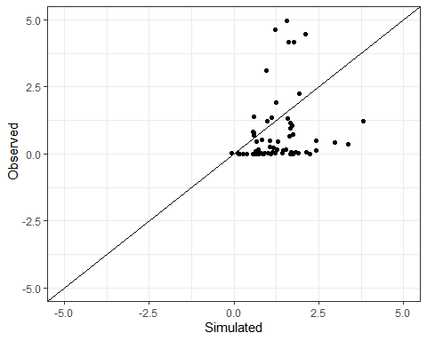

## Warning: Removed 11 rows containing missing values (geom_point).

## Warning: Removed 11 rows containing missing values (geom_point).

## Warning: Removed 6 rows containing missing values (geom_point).

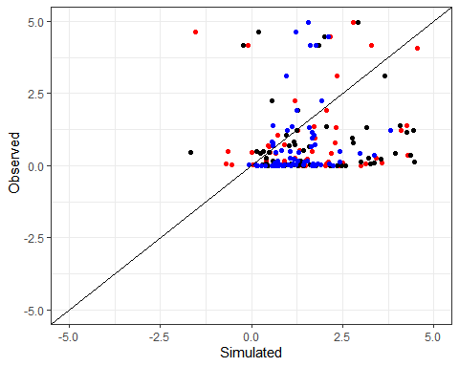

# Mixed Model with limited data and only Land Use as a random factor

## Linear mixed model fit by REML ['lmerMod']  
## Formula: tc.I ~ (1 | Land.Use) + Temp + EC + Cor.Moist + WTemp + D50 +   
## Cu + Cc + GSD + Pass200  
## Data: data_wtemp  
##   
## REML criterion at convergence: 330.4  
##   
## Scaled residuals:   
## Min 1Q Median 3Q Max   
## -1.3470 -0.6254 -0.1151 0.4919 4.5223   
##   
## Random effects:  
## Groups Name Variance Std.Dev.  
## Land.Use (Intercept) 0.04833 0.2198   
## Residual 7.40799 2.7218   
## Number of obs: 69, groups: Land.Use, 3  
##   
## Fixed effects:  
## Estimate Std. Error t value  
## (Intercept) 11.113942 2.381163 4.667  
## Temp -0.152749 0.155720 -0.981  
## EC -3.022431 3.684201 -0.820  
## Cor.Moist 11.588771 4.296795 2.697  
## WTemp -0.366859 0.148572 -2.469  
## D50 0.918525 3.162099 0.290  
## Cu 0.030505 0.074846 0.408  
## Cc -0.946866 1.079158 -0.877  
## GSD 0.151141 0.208556 0.725  
## Pass200 0.009574 0.045436 0.211  
##   
## Correlation of Fixed Effects:  
## (Intr) Temp EC Cr.Mst WTemp D50 Cu Cc GSD   
## Temp -0.505   
## EC -0.161 0.194   
## Cor.Moist -0.228 0.104 -0.384   
## WTemp 0.027 -0.796 -0.113 -0.187   
## D50 0.137 0.146 0.347 0.028 -0.142   
## Cu -0.065 -0.174 -0.397 -0.025 0.160 -0.954   
## Cc -0.221 -0.075 -0.274 -0.041 0.072 -0.947 0.868   
## GSD -0.337 0.179 0.097 0.000 -0.222 -0.329 0.122 0.427   
## Pass200 0.005 0.068 0.320 -0.323 0.003 0.705 -0.645 -0.683 -0.301

## Analysis of Variance Table  
## npar Sum Sq Mean Sq F value  
## Temp 1 155.029 155.029 20.9273  
## EC 1 1.188 1.188 0.1604  
## Cor.Moist 1 46.129 46.129 6.2269  
## WTemp 1 27.438 27.438 3.7039  
## D50 1 29.353 29.353 3.9623  
## Cu 1 96.841 96.841 13.0726  
## Cc 1 13.233 13.233 1.7864  
## GSD 1 5.061 5.061 0.6831  
## Pass200 1 0.329 0.329 0.0444

## $Land.Use  
## (Intercept)  
## R -0.05295917  
## U -0.01729741  
## UU 0.07025659  
##   
## with conditional variances for "Land.Use"

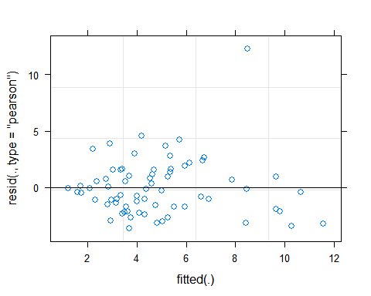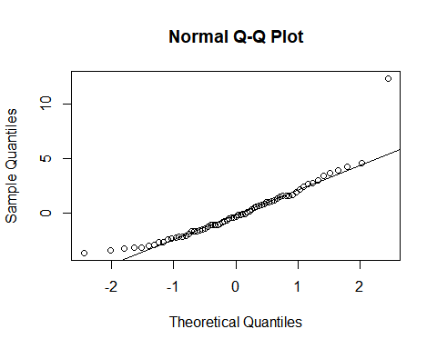

# Mixed Model with limited data and only Soil Texture as a random factor

## Linear mixed model fit by REML ['lmerMod']  
## Formula: tc.B ~ (1 | Soil.Texture) + Temp + EC + Cor.Moist + WTemp + D50 +   
## Cu + Cc + GSD + Pass200  
## Data: data_wtemp  
##   
## REML criterion at convergence: 312  
##   
## Scaled residuals:   
## Min 1Q Median 3Q Max   
## -1.2899 -0.4678 -0.2702 0.1105 3.9846   
##   
## Random effects:  
## Groups Name Variance Std.Dev.  
## Soil.Texture (Intercept) 0.000 0.000   
## Residual 5.438 2.332   
## Number of obs: 69, groups: Soil.Texture, 5  
##   
## Fixed effects:  
## Estimate Std. Error t value  
## (Intercept) 2.57827 2.03526 1.267  
## Temp 0.06182 0.13321 0.464  
## EC -2.55597 3.13574 -0.815  
## Cor.Moist 4.40552 3.67063 1.200  
## WTemp -0.19473 0.12723 -1.530  
## D50 -1.07526 2.70244 -0.398  
## Cu 0.03843 0.06399 0.601  
## Cc 0.20546 0.92290 0.223  
## GSD 0.15864 0.17711 0.896  
## Pass200 -0.03533 0.03890 -0.908  
##   
## Correlation of Fixed Effects:  
## (Intr) Temp EC Cr.Mst WTemp D50 Cu Cc GSD   
## Temp -0.505   
## EC -0.165 0.201   
## Cor.Moist -0.228 0.100 -0.378   
## WTemp 0.026 -0.796 -0.117 -0.185   
## D50 0.138 0.146 0.356 0.025 -0.142   
## Cu -0.063 -0.176 -0.402 -0.024 0.161 -0.955   
## Cc -0.222 -0.073 -0.282 -0.037 0.071 -0.947 0.869   
## GSD -0.344 0.188 0.083 0.010 -0.228 -0.325 0.121 0.424   
## Pass200 0.004 0.068 0.324 -0.325 0.003 0.704 -0.645 -0.683 -0.302  
## optimizer (nloptwrap) convergence code: 0 (OK)  
## boundary (singular) fit: see ?isSingular

## Analysis of Variance Table  
## npar Sum Sq Mean Sq F value  
## Temp 1 4.4065 4.4065 0.8104  
## EC 1 0.8048 0.8048 0.1480  
## Cor.Moist 1 2.0182 2.0182 0.3711  
## WTemp 1 7.0369 7.0369 1.2941  
## D50 1 6.9112 6.9112 1.2710  
## Cu 1 10.9232 10.9232 2.0088  
## Cc 1 3.3851 3.3851 0.6225  
## GSD 1 2.3117 2.3117 0.4251  
## Pass200 1 4.4872 4.4872 0.8252

## $Soil.Texture  
## (Intercept)  
## Loamy Sand 0  
## Sand 0  
## Sandy Clay Loam 0  
## Sandy Loam 0  
## Silt Loam 0  
##   
## with conditional variances for "Soil.Texture"

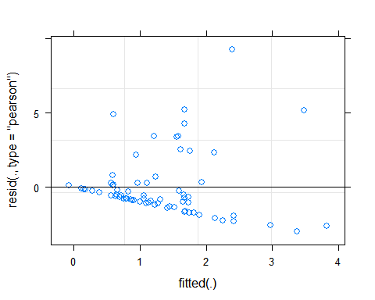

# Mixed Model with limited data and both Land Use and Soil Texture as random factors

## Linear mixed model fit by REML ['lmerMod']  
## Formula: tc.B ~ (1 | Soil.Texture) + (1 | Land.Use) + Temp + EC + Cor.Moist +   
## WTemp + D50 + Cu + Cc + GSD + Pass200  
## Data: data_wtemp  
##   
## REML criterion at convergence: 311.6  
##   
## Scaled residuals:   
## Min 1Q Median 3Q Max   
## -1.2194 -0.4704 -0.2062 0.1099 3.9932   
##   
## Random effects:  
## Groups Name Variance Std.Dev.  
## Soil.Texture (Intercept) 0.0000 0.0000   
## Land.Use (Intercept) 0.2605 0.5104   
## Residual 5.3106 2.3045   
## Number of obs: 69, groups: Soil.Texture, 5; Land.Use, 3  
##   
## Fixed effects:  
## Estimate Std. Error t value  
## (Intercept) 2.40471 2.04280 1.177  
## Temp 0.08028 0.13264 0.605  
## EC -3.45751 3.19132 -1.083  
## Cor.Moist 5.09842 3.67512 1.387  
## WTemp -0.20438 0.12601 -1.622  
## D50 -0.83114 2.70130 -0.308  
## Cu 0.03953 0.06394 0.618  
## Cc 0.10546 0.91943 0.115  
## GSD 0.10253 0.18187 0.564  
## Pass200 -0.03505 0.03859 -0.908  
##   
## Correlation of Fixed Effects:  
## (Intr) Temp EC Cr.Mst WTemp D50 Cu Cc GSD   
## Temp -0.504   
## EC -0.143 0.167   
## Cor.Moist -0.231 0.116 -0.401   
## WTemp 0.031 -0.797 -0.099 -0.192   
## D50 0.137 0.147 0.320 0.039 -0.142   
## Cu -0.073 -0.166 -0.386 -0.025 0.156 -0.952   
## Cc -0.217 -0.080 -0.248 -0.053 0.075 -0.947 0.864   
## GSD -0.313 0.152 0.142 -0.034 -0.203 -0.339 0.123 0.436   
## Pass200 0.009 0.065 0.309 -0.316 0.004 0.706 -0.648 -0.683 -0.298  
## optimizer (nloptwrap) convergence code: 0 (OK)  
## boundary (singular) fit: see ?isSingular

## Analysis of Variance Table  
## npar Sum Sq Mean Sq F value  
## Temp 1 3.3934 3.3934 0.6390  
## EC 1 1.6738 1.6738 0.3152  
## Cor.Moist 1 2.8213 2.8213 0.5313  
## WTemp 1 8.0045 8.0045 1.5073  
## D50 1 9.4005 9.4005 1.7701  
## Cu 1 11.0613 11.0613 2.0829  
## Cc 1 3.7760 3.7760 0.7110  
## GSD 1 0.5007 0.5007 0.0943  
## Pass200 1 4.3792 4.3792 0.8246

## $Soil.Texture  
## (Intercept)  
## Loamy Sand 0  
## Sand 0  
## Sandy Clay Loam 0  
## Sandy Loam 0  
## Silt Loam 0  
##   
## $Land.Use  
## (Intercept)  
## R -0.2354658  
## U -0.1312584  
## UU 0.3667242  
##   
## with conditional variances for "Soil.Texture" "Land.Use"

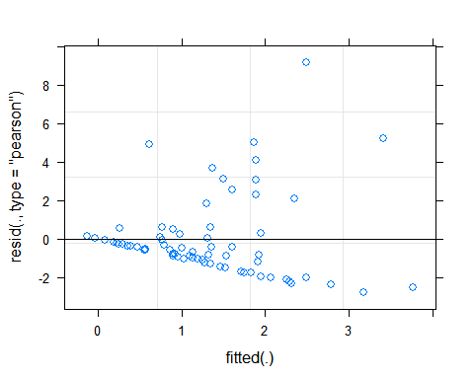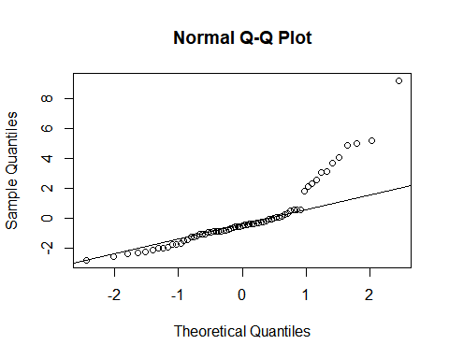

# Calculate Model Statistics for the Four Models and Compare

# Create a plot showing a one to one of the simulated and observed tc values for the four models  
ggplot() +   
 geom_point(data = data,   
 aes(x = Fitted_Mixed, y = tc.B),  
 color = "red") +  
 geom_point(data = data,  
 aes(x = Fitted, y = tc.B),  
 color = "black") +  
 geom_point(data = data_wtemp,  
 aes(x = Fitted, y = tc.B),  
 color = "blue") +  
 geom_point(data = data_wtemp,  
 aes(x = Fitted_Mixed, y = tc.B),  
 color = "green") +  
 geom_abline(intercept=0, slope=1) +  
 theme_bw() + xlim(0,5) + ylim(0,5) +  
 labs(x = expression("Simulated"),  
 y = expression(" Observed"))

## Warning: Removed 16 rows containing missing values (geom_point).

## Warning: Removed 13 rows containing missing values (geom_point).

## Warning: Removed 7 rows containing missing values (geom_point).

## Warning: Removed 8 rows containing missing values (geom_point).

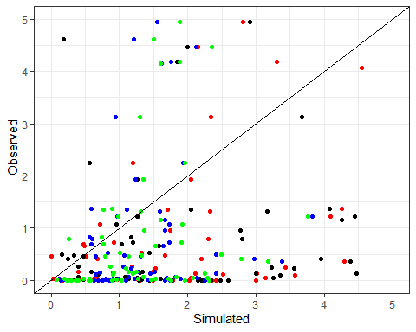

# Set up an empty data frame to compile results of the four models  
model_statistics <- data.frame(matrix(ncol = 5, nrow = 4))  
x <- c("Model", "RMSE", "EF", "r", "Bias")  
colnames(model_statistics) <- x  
  
model_statistics$Model <- c("Simple Model", "Mixed Model", "Simple with WTemp", "Mixed with WTemp")  
  
#Calculate the RMSE  
RMSE_Simple <- sqrt(mean((data$tc.B - data$Fitted)^2))  
RMSE_Mixed <- sqrt(mean((data$tc.B - data$Fitted_Mixed)^2))  
RMSE_WTemp_Simple <- sqrt(mean((data$tc.B - data_wtemp$Fitted)^2))

## Warning in data$tc.B - data_wtemp$Fitted: longer object length is not a multiple  
## of shorter object length

RMSE_WTemp_Mixed <- sqrt(mean((data$tc.B - data_wtemp$Fitted_Mixed)^2))

## Warning in data$tc.B - data_wtemp$Fitted_Mixed: longer object length is not a  
## multiple of shorter object length

model_statistics$RMSE <- c(RMSE_Simple, RMSE_Mixed, RMSE_WTemp_Simple, RMSE_WTemp_Mixed)  
  
#Calculate EF  
EF_Simple <- 1 - (sum((data$tc.B-data$Fitted)^2)/sum((data$tc.B-mean(data$Fitted))^2))  
EF_Mixed <- 1 - (sum((data$tc.B-data$Fitted_Mixed)^2)/sum((data$tc.B-mean(data$Fitted_Mixed))^2))  
EF_WTemp_Simple <- 1 - (sum((data_wtemp$tc.B-data_wtemp$Fitted)^2)/sum((data_wtemp$tc.B-mean(data_wtemp$Fitted))^2))  
EF_WTemp_Mixed <- 1 - (sum((data_wtemp$tc.B-data_wtemp$Fitted_Mixed)^2)/sum((data_wtemp$tc.B-mean(data_wtemp$Fitted_Mixed))^2))  
  
model_statistics$EF <- c(EF_Simple, EF_Mixed, EF_WTemp_Simple, EF_WTemp_Mixed)  
  
#Calculate r  
r_Simple <- cor(data$tc.B,data$Fitted)  
r_Mixed <- cor(data$tc.B,data$Fitted_Mixed)  
r_WTemp_Simple <- cor(data_wtemp$tc.B,data_wtemp$Fitted)  
r_WTemp_Mixed <- cor(data_wtemp$tc.B,data_wtemp$Fitted_Mixed)  
  
model_statistics$r <- c(r_Simple,r_Mixed, r_WTemp_Simple, r_WTemp_Mixed)  
  
#Calculate bias  
Bias_Simple <- mean(data$tc.B-data$Fitted)  
Bias_Mixed <- mean(data$tc.B-data$Fitted_Mixed)  
Bias_WTemp_Simple <- mean(data_wtemp$tc.B-data_wtemp$Fitted)  
Bias_WTemp_Mixed <- mean(data_wtemp$tc.B-data_wtemp$Fitted_Mixed)  
  
model_statistics$Bias <- c(Bias_Simple, Bias_Mixed, Bias_WTemp_Simple, Bias_WTemp_Mixed)  
  
model_statistics

## Model RMSE EF r Bias  
## 1 Simple Model 3.520068 0.1622804 0.4028404 3.659376e-17  
## 2 Mixed Model 3.151996 0.3283115 0.5782873 -2.706482e-15  
## 3 Simple with WTemp 3.995297 0.1164516 0.3412501 3.562468e-17  
## 4 Mixed with WTemp 3.979491 0.1487318 0.3870532 -2.424842e-16

*This is only for my reference when writing the code in R*  
Note that the echo = FALSE parameter was added to the code chunk to prevent printing of the R code that generated the plot.