Assignment 3
due September 11 before class
1 page (typed, double-spaced)
Upload to Box.

This assignment asks you to compare and contrast three sculpted images of the ancient Egyptian royals. These images are to be found in the textbook.

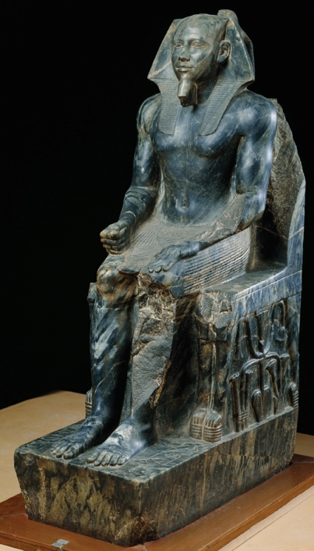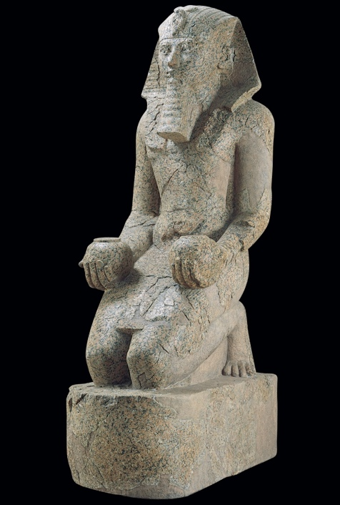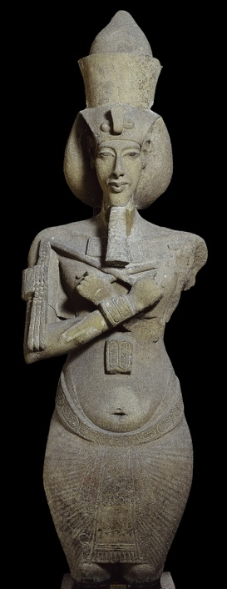

From left to right: Khafre enthroned, from Gizeh, Egypt (fig. 3-12); Hatshepsut with offering jars (fig. 3-21); Akhenaton (fig. 3-30).

The assignment asks you to analyze the relationship between gender and power in ancient Egypt. The big issue is the gender expectations in the royal images of Ancient Egypt. First analyze the sculpture of pharaoh Khafre. Write a brief analysis of the image of the pharaoh (focus on how authority of the individual is conveyed in his image and the role that gender plays in it). Then analyze the sculpture of queen Hatshepsut. Write a brief analysis of the image of the queen (in particular consider what features are highlighted in her image). Then study the sculpture of the pharaoh Akhenaton. How does his representation compare to the previous two images (that of the male king and the female queen)? How would you explain the similarities and differences?

