Critical Thinking   
Test Answer Sheet

I always hated how untrustworthy multiple-choice tests were. How many students just guessed at the right answer? How many of them narrowed it down to 2 choices and just made the wrong one? I wanted better data on how much my students were learning, but as you know short answer and essay tests can be too much to grade. Then I discovered Critical Thinking Multiple Choice. This is a great tool for better understanding your students’ learning!

Directions

1. Students use the answer sheet as they would for any multiple-choice test and put the letter of their answer on the first line.
2. If they are unsure about any answers, have them narrow their choices down to their top 2 and put those 2 letters on the 2 lines for that answer.
3. For each question that they left 2 answers for, they must put that number down and explain their reasoning.
4. I award half credit or more depending on how students explain their answer. Sometimes you will find that students really do know the material, they just were mixed up by the wording of the question.
5. I will limit the number of 2nd choices students are allowed so that they do not overthink every question and run out of time. I generally allow 5 on a 25-question test or 10 for 50 questions.

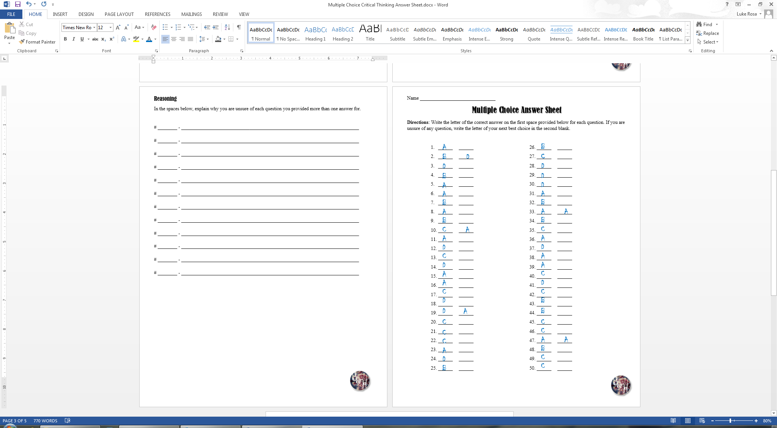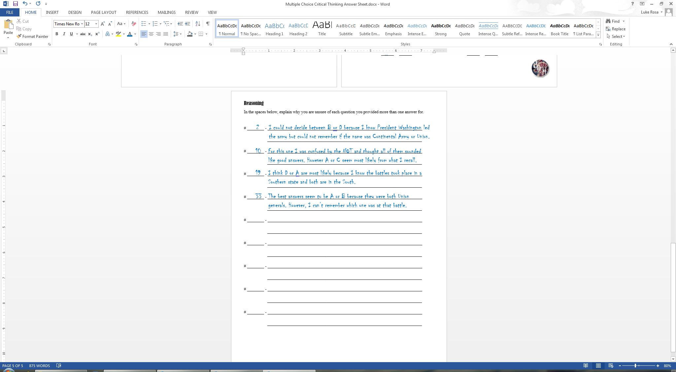

Name _______________________________

Multiple Choice Answer Sheet

**Directions**: Write the letter of the correct answer on the first space provided below for each question. If you are unsure of any question, write the letter of your next best choice in the second blank.

1. ______ ______
2. ______ ______
3. ______ ______
4. ______ ______
5. ______ ______
6. ______ ______
7. ______ ______
8. ______ ______
9. ______ ______
10. ______ ______
11. ______ ______
12. ______ ______
13. ______ ______
14. ______ ______
15. ______ ______
16. ______ ______
17. ______ ______
18. ______ ______
19. ______ ______
20. ______ ______
21. ______ ______
22. ______ ______
23. ______ ______
24. ______ ______
25. ______ ______
26. ______ ______
27. ______ ______
28. ______ ______
29. ______ ______
30. ______ ______
31. ______ ______
32. ______ ______
33. ______ ______
34. ______ ______
35. ______ ______
36. ______ ______
37. ______ ______
38. ______ ______
39. ______ ______
40. ______ ______
41. ______ ______
42. ______ ______
43. ______ ______
44. ______ ______
45. ______ ______
46. ______ ______
47. ______ ______
48. ______ ______
49. ______ ______
50. ______ ______

Reasoning

In the spaces below, explain why you are unsure of each question you provided more than one answer for.

# ________ - _________________________________________________________________________

_________________________________________________________________________

# ________ - _________________________________________________________________________

_________________________________________________________________________

# ________ - _________________________________________________________________________

_________________________________________________________________________

# ________ - _________________________________________________________________________

_________________________________________________________________________

# ________ - _________________________________________________________________________

_________________________________________________________________________

# ________ - _________________________________________________________________________

_________________________________________________________________________

# ________ - _________________________________________________________________________

_________________________________________________________________________

# ________ - _________________________________________________________________________

_________________________________________________________________________

# ________ - _________________________________________________________________________

_________________________________________________________________________

# ________ - _________________________________________________________________________

_________________________________________________________________________

[](http://www.teacherspayteachers.com/Store/Students-Of-History/)