Table countries

CREATE TABLE countries(country STRING, population INT, area INT, currency STRING)
ROW FORMAT DELIMITED
FIELDS TERMINATED BY '\;'
tblproperties("skip.header.line.count"="1");

Loading statement

LOAD DATA LOCAL INPATH '/home/bigdata/hive/apache-hive-1.2.1-bin/examples/files/countries.csv'
OVERWRITE INTO TABLE countries;

Table covid-19

CREATE TABLE covid(isocode STRING, continent STRING, location STRING, dateInput STRING, newcases INT, newdeaths INT, icupatients INT, hospitalpatients INT, newvaccinations int)
ROW FORMAT DELIMITED
FIELDS TERMINATED BY ','
tblproperties("skip.header.line.count"="1");

Loading statement

LOAD DATA LOCAL INPATH '/home/bigdata/hive/apache-hive-1.2.1-bin/examples/files/covid19-detail.csv'
OVERWRITE INTO TABLE covid;

Q4.1)
QUERY
SELECT continent, SUM(newcases)-SUM(newdeaths)
FROM covid
where continent = "North America"
GROUP BY continent;

OUTPUT
North America 32596920



Q4.2)
QUERY
SELECT location, SUM(newcases)
from covid
GROUP BY location
HAVING SUM(newcases) > 1000000;

OUTPUT
Argentina 2149636
Brazil 11019344
Colombia 2276656
Czechia 1321331
France 3964078
Germany 2508655
India 11229398
Indonesia 1379662
Iran 1689692
Italy 3067486
Mexico 2128600
Netherlands 1135258
Peru 1364964
Poland 1794914
Russia 4274263
South Africa 1521068
Spain 3149012
Turkey 1957192
Ukraine 1449741
United Kingdom 4231166
United States 28993309

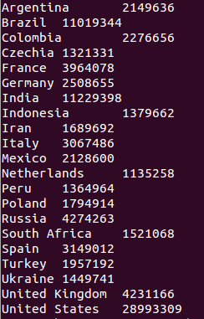

Q4.3)
QUERY

SELECT location, SUM(icupatients) as sum
from covid
GROUP BY location
SORT BY sum DESC
LIMIT 10;

OUTPUT
United States 3723610
France 825686
Germany 605784
Italy 545207
United Kingdom 439600
Spain 282835
Romania 206302
Belgium 153875
Netherlands 144893
Czechia 142089
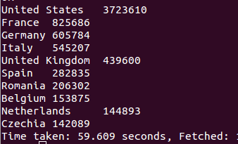

Q4.4)
QUERY

SELECT location, SUM(newdeaths)/100000 AS mortalityrate
FROM covid
GROUP BY location
SORT BY mortalityrate DESC
LIMIT 10;

OUTPUT
United States 5.25031
Brazil 2.65411
Mexico 1.90604
India 1.57853
United Kingdom 1.24736
Italy 0.99785
France 0.88727
Russia 0.87614
Germany 0.71984
Spain 0.71138

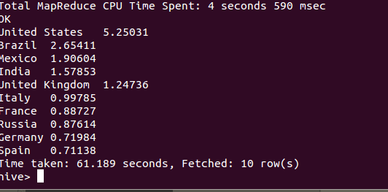

Q4.5)
QUERY

SELECT cov.location, (SUM(cov.newvaccinations)/country.population)*100 AS vacinationrate, country.population
from covid cov JOIN countries country ON (cov.location = country.country)
WHERE country.population > 1000000
GROUP BY cov.location, country.population
SORT BY vacinationrate DESC
LIMIT 3;

OUTPUT

Israel 108.69809526625498 8049314
United Arab Emirates 84.94468628455161 5779760
United Kingdom 32.23297878352749 64088222
