Q1)

Screen shot with inputs 101

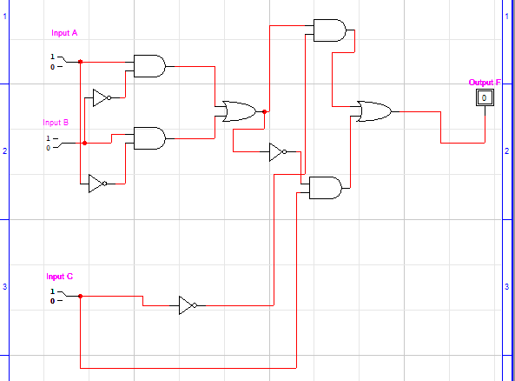

Q2)

