Q1)

0-ADDRESS

PUSH A; PUSH A ONTO THE STACK

PUSH B; PUSH B ONTO THE STACK

PUSH C; PUSH C ONTO THE STACK

MUL; MULTIPLYT B AND C

ADD; ADD A TO CURRENT RESULT

PUSH D; PUSH D ONTO THE STACK

PUSH E; PUSH E ONTO THE STACK

PUSH F; PUSH F ONTO THE STACK

MUL; MULTIPYT E AND F

SUB; SUBTRACT E AND F FROM D

DIV; DIVIDE THE RESULTS

POP X; RETURN X

1-ADDRESS

LOAD E; LOAD THE VALUE OF E

MULT F; MULTIPLY E AND F

STORE Y; STORE THE MULTIPLICATIVE IN Y

LOAD D; LOAD CALUE D

SUB Y; SUBTRACT COMPUTED Y BY D

STORE Y; STORE (D-E*F)

LOAD B; LOAD VALUE B

MUL C; MULTIPLY B*C

ADD A; ADD TO B*C

DIV Y; DIVIDE A+B*C/Y

STORE X; TORE COMPUTED VALUES IN X

2- ADDRESS

MOVE R1, E; MOVE THE VALUE OF E INTO FRIST REGISTER

MULT R1, F; MULTIPLY THE VALUE IN THE REGISTER BY F

MOVE R2, D; MOVE VALUE D IN ANOTHER REGISTER 2

SUB R2, R1; BUBTRACT R1 FROM R2 AND STORE IN R2

MOVE R1, B; MOVE B INTO REG 1

MUL R1, C; MOUTIPLY VALUE B*C AND STORE IN R1

ADD R1, A; ADD A TO R1

DIV R1, R2; DIVIDE R1 BY R2 AND STORE VALUE IN R1

MOVE X, R1; MOVE VALUES OF R1 TO X

3- ADDREESS

MULT R1, E, F; MULTIPLY E*F AND STORE IN R1

SUB R1, D, R1; SUBTRACT R1 FROM D AND STORE IN R1

MULT R2, B, C; MULTIPLY B*C AND STORE IN R2

ADD R2, A, R2; ADD A TO R2 AND STORE IN R2

DIV X, R1, R2; DIVIDE R1 AND R2 AND STORE IN X

Q2)

20 – 40

30 – 50

40 – 60

50 – 70

A) 20

B) 40

C) 60

D) 30

E) 50

F) 70

Q3)

A)

AS11M 01.05 Thu Apr 01, 2021 23:36 reversingArray.lst

0001 0000 ORG $0000; start data at 0000

0002 0000 05 N FCB 5; array size

0003 0001 01 02 03 04 05 ARR FCB 1,2,3,4,5; array values

0004 0006 00 NEW FCB;

0005 e000 ORG $E000; continue with program at E000

0006 e000 ce 00 01 LDX #ARR; load the address of the arrayS END

0007 e003 18 ce 00 06 LDY #NEW;

0008 e007 96 00 LDAA N; load the size of the array

0009

0010 e009 bd e0 0d JSR LOAD; call the subroutine

0011 e00c 01 NOP; this is where your program ends

0012 ; (you may need to set a

0013 ; breakpoint here)

0014 ;

0015 e00d e6 00 LOAD LDAB 0,X;

0016 e00f 18 e7 00 STAB 0,Y;

0017 e012 18 08 INY;

0018 e014 08 INX;

0019 e015 4a DECA;

0020 e016 26 f5 BNE LOAD;

0021 e018 18 ce 00 0a LDY #NEW+4;

0022 e01c ce 00 01 LDX #ARR;

0023 e01f 96 00 LDAA N;

0024 e021 bd e0 24 JSR REVERSE1;

0025

0026 e024 18 e6 00 REVERSE1 LDAB 0,Y;

0027 e027 e7 00 STAB 0,X;

0028 e029 08 INX;

0029 e02a 18 09 DEY;

0030 e02c 4a DECA;

0031 e02d 26 f5 BNE REVERSE1;

0032 e02f 39 RTS;

0033

Number of errors 0

Number of warnings 0

B)

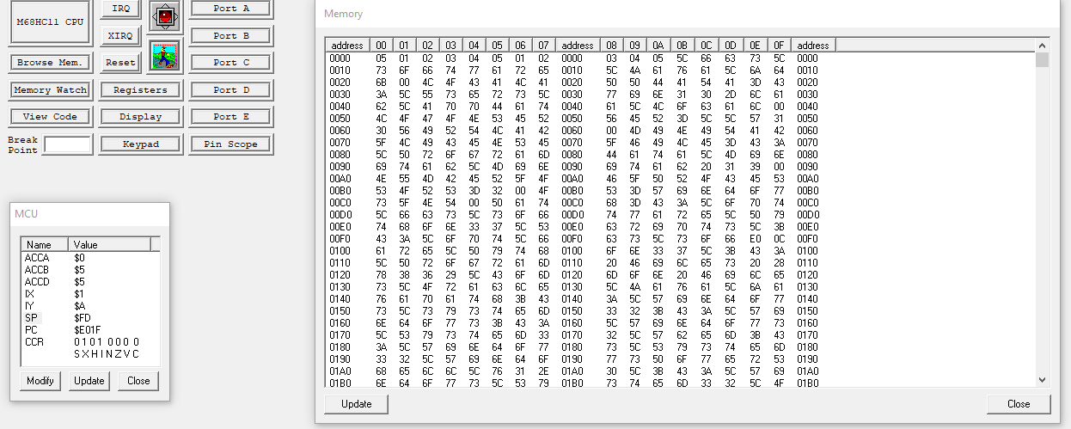

C)

00FE – E0

00FF – 0C

D)

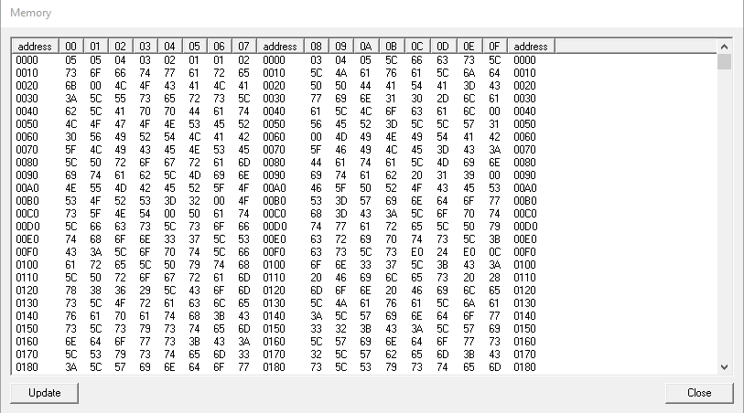

E)

|  |  |  |  |  |
| --- | --- | --- | --- | --- |
| ARR | NEW | ARR | NEW | RETURN |
| 5 | 5 | 1 | 5 |  |
| 4 | 4 | 2 | 4 |  |
| 3 | 3 | 3 | 3 |  |
| 2 | 2 | 4 | 2 |  |
| 1 | 1 | 5 | 1 |  |
| * | * | * | * | * |