
Capital University of Science & Technology
Term Project Proposal
Department of Electrical and Computer Engineering
Project Title |  | Smart Grocery Budgeting & Price Prediction Tool
Course Title |  | Programming fundamentals
S# | Student Name |  | Registration Number
1 | Aetisaam ul Hassan |  | BCY253051
2 | Aman Sajid |  | BCY253084
3 | Naqi Raza |  | BCY253010

Introduction: Smart Grocery Budgeting & Price Prediction Tool
With rising living costs, students often struggle to manage their monthly grocery budgets effectively. Prices change frequently due to inflation, and without proper planning, it becomes difficult to estimate future expenses. This project aims to create a Smart Grocery Budgeting & Price Prediction Tool using C++, enabling users to calculate their current grocery costs, predict next month’s expenses based on expected inflation, and receive suggestions for cheaper alternatives.
Literature Review:
Studies show that simple budgeting tools help individuals manage spending and make better financial decisions. Research also suggests that basic inflation calculations are useful for predicting costs and planning ahead. While most grocery budgeting apps depend on online data, an offline and lightweight tool can be more suitable for programming students. Previous literature further stresses the importance of user-friendly systems that support daily financial decisions, especially for low-budget users.
Problem Statement:

Students often struggle with grocery budgeting due to inconsistent pricing and lack of forecasting tools. They have no simple means to:
- Estimate how their grocery expenses may change next month
- Understand the impact of inflation on their daily spending
- Recognize which items are particularly expensive
- Compare predicted spending with their existing budget
This creates financial uncertainty and difficulty in effective planning. A simple, efficient tool is needed to help students manage their grocery expenses with clarity and confidence.
Objectives:
The objective of this project is to develop a C++ console application that helps users track grocery spending, calculate the current total cost, and predict next month’s expenses using a simple inflation model. It also aims to identify items priced above average, show a basic inflation trend, and assist users in comparing predicted costs with their monthly budget for better planning.
Methodology:
The methodology involves identifying necessary inputs and outputs, designing the program using pseudo-code, arrays, and modular functions, and implementing it in C++ with basic programming constructs. The program is tested for accuracy and error handling, and finally documented with commented code and a brief project report.
FLOWCHART:

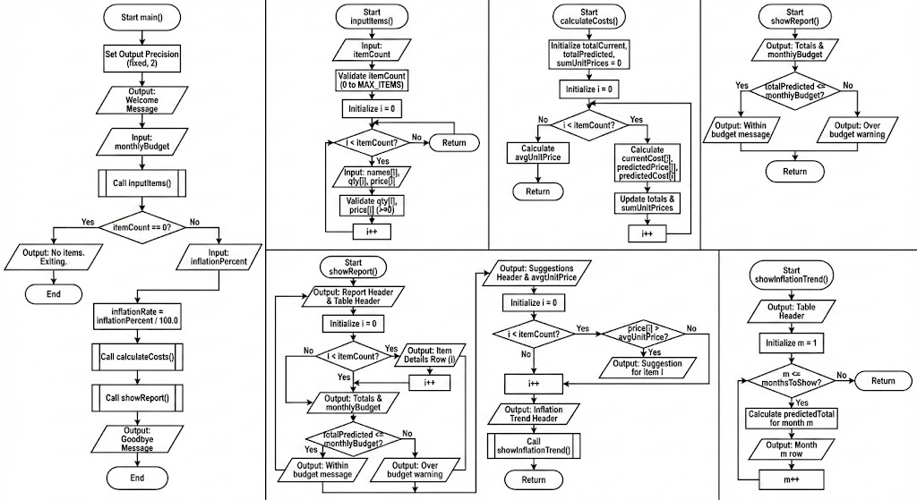
References:
- Pressman, R. S. (2014). Software engineering: A practitioner’s approach (8th ed.). McGraw-Hill Education.
- Deitel, P., & Deitel, H. (2017). C++ how to program (10th ed.). Pearson Education.
- Garman, E. T., & Forgue, R. (2018). Personal finance. Cengage Learning.
- Mankiw, N. G. (2020). Principles of economics (9th ed.). Cengage Learning.
- Organisation for Economic Co-operation and Development. (2019). Consumer policy and budgeting behavior. OECD Publishing.
- Kernighan, B. W., & Ritchie, D. M. (2013). The C programming language (2nd ed.). Pearson Education.

Student 1 Sig.  Student 2 Sig. |  |  |  |  | Instructor Sig:
Student 3 Sig.

