BSCY SMART GROCERY BUDGETING & PRICE PREDICTION TOOL
SMART GROCERY BUDGETING & PRICE PREDICTION TOOL



by

Aetisaam ul Hassan
BCY253051

A Project Report submitted to the
DEPARTMENT OF ELECTRICAL ENGINEERING
in partial fulfillment of the requirements for the degree of
BACHELORS OF SCIENCE IN CYBER SECURITY

Faculty of Engineering
Capital University of Science & Technology,
Islamabad
January, 2026

SMART GROCERY BUDGETING & PRICE PREDICTION TOOL



by

Aman Sajid
BCY253084

A Project Report submitted to the
DEPARTMENT OF ELECTRICAL ENGINEERING
in partial fulfillment of the requirements for the degree of
BACHELORS OF SCIENCE IN CYBER SECURITY

Faculty of Engineering
Capital University of Science & Technology,
Islamabad
January, 2026

SMART GROCERY BUDGETING & PRICE PREDICTION TOOL



by

Naqi Raza
BCY253010

A Project Report submitted to the
DEPARTMENT OF ELECTRICAL ENGINEERING
in partial fulfillment of the requirements for the degree of
BACHELORS OF SCIENCE IN CYBER SECURITY

Faculty of Engineering
Capital University of Science & Technology,
Islamabad
January, 2026

Copyright © 2026 by CUST Student

All rights reserved. Reproduction in whole or in part in any form requires the prior written permission of Aetisaam ul hassan or designated representative.

DECLARATION

It is declared that this is an original piece of my own work, except where otherwise acknowledged in text and references. This work has not been submitted in any form for another degree or diploma at any university or other institution for tertiary education and shall not be submitted by me in future for obtaining any degree from this or any other University or Institution.

Aetisaam ul Hassan

BCY253051

Aman Sajid

BCY253084

Naqi Raza

BCY253010

January, 2026

CERTIFICATE OF APPROVAL
It is certified that the project titled “Smart Grocery Budgeting And Price Prediction Tool” carried out by Aetisaam Ul Hassan, Reg. No. BCY253051, Aman Sajid, Reg. No. BCY253084 and Naqi Raza, Reg. No. BCY253010, under the supervision of Yasir Hussain, Capital University of Science & Technology, Islamabad, is fully adequate, in scope and in quality, as a semester project for the degree of BS CYBER SECURITY.

Supervisor: --------------------------------------
Yasir Hussain
Assistant Professor
Department of Electrical Engineering
Faculty of Engineering
Capital University of Science & Technology, Islamabad

HoD: --------------------------------------
Dr. Noor Mohammad Khan
Professor
Department of Electrical Engineering
Faculty of Engineering
Capital University of Science & Technology, Islamabad

ACKNOWLEDGMENT
Firstly, I would like to thank Allah Almighty for allowing me to accomplish this project by providing me with strength, patience, and knowledge.

I would like to express my sincerest gratitude to our respected course instructor for Programming Fundamentals, without whom this project would never have been possible. The instructor's valuable suggestions and contributions throughout the development stages of the project have been highly beneficial.

I would also like to thank the Department of Electrical and Computer Engineering, Capital University of Science & Technology, which has provided a conducive academic atmosphere as well as the facilities required to complete this work.
I would like to extend my especial thanks to project collaborators Aman Sajid and Naqi Raza for their cooperation, input, and efforts towards the successful completion of the Smart Grocery Budgeting & Price Prediction Tool.

ABSTRACT
Many students struggle to keep up with their grocery expenses as prices keep changing and inflation continues to rise. Without a plan, it's nearly impossible to estimate how much to spend monthly or to be able to predict future costs in advance. This project solves the everyday problem of grocery expenses by offering a straightforward and handy budgeting tool that empowers users to both understand and regulate their grocery expenses. As part of this project, a C++ console, based application named Smart Grocery Budgeting & Price Prediction Tool was created.

The software receives various inputs such as monthly budget, grocery items, quantities, prices, and inflation rate. By applying simple programming techniques such as arrays, functions, loops, and calculations, the software estimates grocery costs of the following month and identifies the user's spending habits. The implemented system not only figures out the total cost of the current grocery list, but also predicts prices for the coming months based on inflation, points out products that have become more expensive than usual, and suggests users to consider buying cheaper alternatives. Additionally, it provides an easy, to, understand inflation trend for the following months, so that users have a better idea of how prices may gradually increase. In summary, this project demonstrates that even a basic programming solution can go a long way in helping students manage their finances better. It bridges programming fundamentals with real, life scenarios and thus, motivates users to develop good budgeting and planning habits.

TABLE OF CONTENTS

DECLARATION vi
CERTIFICATE OF APPROVAL vii
ACKNOWLEDGMENT viii
ABSTRACT ix
TABLE OF CONTENTS x
LIST OF FIGURES xiii
LIST OF TABLES xiv
INTRODUCTION 1
Chapter 1 2
INTRODUCTION 2
1.1 Overview 2
1.2 Project Idea 2
1.3 Purpose of the Project 3
1.4 Project Specifications 3
Table 1.1: Project Specifications 4
1.5 Applications of the Project 4
1.5.1 Personal Budget Management 4
1.5.2 Educational Application 4
1.5.3 Financial Awareness 5
1.6 Project Plan 5
Table 1.2: Proposed Project Plan 5
1.6.1 Project Milestones 5
1.6.2 Targeted Sustainable Development Goals 6
Table 1.3: Targeted SDGs 6
1.6.3 Project Timeline 6
1.7 Report Organization 6
Chapter 2 7
LITERATURE REVIEW 7
2.1 Background Theory 7
2.2 Related Technologies 7
2.2.1 Console-Based Applications 7
2.2.2 Inflation Prediction Techniques 7
2.3 Related Projects 7
2.4 Related Studies and Research 7
2.5 Limitations and Bottlenecks of Existing Work 8
2.6 Problem Statement 8
2.7 Summary 8
Chapter 3 8
PROJECT DESIGN AND IMPLEMENTATION 8
3.1 Proposed Design Methodology 8
3.2 Analysis Procedure 9
3.3 Software Design 9
3.4 Algorithm Design 9
3.5 Implementation Procedure 10
3.6 Mathematical Modeling 10
3.7 Final Working Prototype 10
3.8 Summary 11
Chapter 4 12
TOOLS AND TECHNIQUES 12
4.1 Hardware Tools 12
4.2 Software Tools 12
4.3 Summary 12
Chapter 5 13
PROJECT RESULTS AND EVALUATION 13
5.1 Presentation of Findings 13
5.1.1 Software Results 13
5.2 Verification of Design Functionalities 13
5.3 Discussion on Findings 13
5.3.1 Comparison with Specifications 13
5.3.2 Reasoning for Shortcomings 13
5.4 Limitations of the Prototype 14
5.5 Attainment of SDGs 14
5.6 Summary 14
Chapter 6 15
CONCLUSION AND FUTURE WORK 15
6.1 Conclusion 15
6.2 Future Work 15
REFERENCES 16
APPENDICES 17
Appendix – A 17
Appendix-B 18
Appendix-C 19
Appendix-D 20
Appendix-E 21
Appendix-F 22
Appendix-H 22

LIST OF FIGURES

Figure 1:Block Diagram of Hardware Design 9
Figure 2:Block diagram of software algorithm 10
Figure 3:Appendix-A 17
Figure 4:Appendix-B 18
Figure 5:Appendix-C 19
Figure 6:Appendix-D 20
Figure 7:Appendix-E 21
Figure 8:Appendix-G 22
Figure 9:Appendix-H 22

LIST OF TABLES

Table 1 :Project Specification 4
Table 2 :Proposed Project Plan 5
Table 3 :Targeted SDGs 6
Table 4 :References 15

INTRODUCTION
Managing personal finances has become an essential skill in modern society, particularly for students who must manage their expenses within limited financial resources. Among various daily expenses, grocery shopping remains one of the most frequent and unavoidable activities. Small variations in grocery prices, when accumulated over time, can significantly affect a student’s monthly budget. Inflation, market instability, and lack of financial awareness further increase the difficulty of accurate expense planning. As a result, students often face financial stress due to poor estimation of future grocery costs.
In the digital age, numerous financial management tools are available; however, most of these applications are designed for commercial users and depend heavily on internet connectivity. Such tools may be overwhelming for students and beginners who seek simplicity and clarity. Additionally, these applications do not always support educational objectives related to programming fundamentals. Therefore, there is a strong need for a basic, offline, and educational budgeting system that not only helps in expense calculation but also strengthens problem-solving and programming skills.
The Smart Grocery Budgeting & Price Prediction Tool is a console-based software application developed using the C++ programming language. The system allows users to enter grocery items and their prices, calculate total expenses, predict next month’s costs using a simple inflation model, and compare predicted expenses with a predefined budget. This project integrates real-world financial concepts with basic programming constructs, making it both practically useful and academically valuable.

The introduction chapter provides background information, defines the scope of the project, and outlines the methodology used throughout the report. It establishes the relevance of the project in the real world and prepares the reader for the detailed discussion presented in subsequent chapters.

Chapter 1

INTRODUCTION

1.1 Overview
The primary goal of this project is to design and implement a C++ based application that assists users in calculating grocery expenses and predicting future costs using basic inflation principles. With rising living costs and limited student income, managing grocery expenses has become increasingly challenging. This project addresses that challenge by offering a simple yet effective solution.
The Smart Grocery Budgeting & Price Prediction Tool provides a structured way to analyze current grocery spending and estimate future costs. By doing so, it promotes financial awareness and responsible spending behavior. From an academic perspective, the project allows students to apply programming fundamentals such as arrays, loops, functions, conditional statements, and basic mathematical modeling in a meaningful way.
The system is designed to be offline, lightweight, and easy to understand, making it suitable for educational environments. The overall objective is not only to provide accurate calculations but also to demonstrate how programming techniques can be applied to solve everyday problems.

1.2 Project Idea
The idea of this project is based on the hypothesis that simple budgeting combined with basic price prediction can significantly improve financial planning for students. Since grocery prices tend to increase gradually due to inflation, estimating future costs using a percentage-based model can help users prepare their budgets more effectively.
The project assumes that users can benefit from understanding how inflation affects daily expenses. The hypothesis is tested by developing a functional program that calculates current expenses and predicts future costs. If the predicted values closely reflect realistic spending patterns, the hypothesis is considered valid.
Several issues such as inaccurate input, unrealistic inflation rates, and misunderstanding of results were considered during the design phase. To address these issues, the system includes clear prompts, logical constraints, and understandable output messages. The research process focuses on iterative testing and validation to ensure reliable results.

1.3 Purpose of the Project

The purpose of this project is to provide a practical tool that helps students manage grocery expenses while enhancing their understanding of basic financial concepts. It also serves as an academic exercise that reinforces programming fundamentals through real-world application.
Budgeting systems have evolved significantly over time, from manual bookkeeping to advanced financial software. Despite these advancements, there remains a need for simple educational tools that focus on logic development rather than feature complexity. This project fits within that historical context by offering a minimalistic yet functional solution tailored to student needs.
The project also aims to promote financial responsibility by helping users recognize expensive items, evaluate spending patterns, and plan budgets more effectively.

1.4 Project Specifications

This section outlines the functional and non-functional specifications of the proposed system.

Table 1.1: Project Specifications

Category | Specification
Platform | Console-based
Programming Language | C++
Input | Item names, prices, inflation rate, monthly budget
Processing | Total calculation, average price analysis, inflation prediction
Output | Total cost, predicted cost, budget comparison
Operation Mode | Offline
Target Users | Students and beginners
Table 1:Project Specification

The specifications ensure that the system remains simple, efficient, and educational.

1.5 Applications of the Project

1.5.1 Personal Budget Management
The system helps students track grocery expenses and plan monthly budgets effectively.

1.5.2 Educational Application
The project can be used as a learning tool for programming fundamentals and problem-solving techniques.

1.5.3 Financial Awareness

By visualizing current and future expenses, the system improves understanding of inflation and responsible spending.

1.6 Project Plan
The project was divided into two main parts: Part I focused on research, analysis, and design, while Part II covered implementation, testing, and documentation. Tasks were distributed evenly among team members to ensure timely completion.

Table 1.2: Proposed Project Plan

Sr. No. | Task | Duration | Resource Person
1 | Literature Review | 1 Week | Aetisaam
2 | Requirement Analysis | 1 Week | Aetisaam
3 | Program Design | 1 Week | Aman
4 | Implementation | 4 Days | Aman
5 | Testing and Debugging | 3 Days | Naqi
6 | Documentation | 1 Week | Naqi
Table 2:Proposed Project Plan

1.6.1 Project Milestones
Key milestones include completion of system design, successful program execution, verified results, and final report submission.

1.6.2 Targeted Sustainable Development Goals

Table 1.3: Targeted SDGs

Sr. No. | Targeted SDG | SDG No. | Implementation Detail
1 | Good Health and well being | SDG # 3 | Reduces financial stress
2 | Climate Action | SDG # 13 | Encourages planned consumption and reduced waste
Table 3:Targeted SDGs

1.6.3 Project Timeline
A detailed project timeline was developed using Microsoft Project, showing task distribution and deadlines for Part I and Part II.

1.7 Report Organization
This report is organized into six chapters. Chapter 1 introduces the project. Chapter 2 reviews existing literature. Chapter 3 discusses design and implementation. Chapter 4 describes tools and techniques. Chapter 5 presents results and evaluation. Chapter 6 concludes the report and outlines future work.

Chapter 2

LITERATURE REVIEW

2.1 Background Theory
Budgeting and expense management are fundamental aspects of personal finance. Research indicates that individuals who track expenses are more likely to stay within budget. Inflation prediction models, even simple ones, are widely used for short-term cost estimation. In programming education, financial applications are commonly used to demonstrate logical thinking and algorithmic design.

2.2 Related Technologies

2.2.1 Console-Based Applications
Console-based applications are efficient, lightweight, and ideal for beginners. They allow focus on logic rather than graphical complexity.

2.2.2 Inflation Prediction Techniques
Simple mathematical models using percentage increases are effective for short-term price forecasting.

2.3 Related Projects
Various mobile budgeting apps exist, but they rely on internet connectivity and complex interfaces. Educational console-based tools remain limited.

2.4 Related Studies and Research
Recent studies emphasize the importance of financial literacy among students and the role of software tools in supporting budgeting decisions.

2.5 Limitations and Bottlenecks of Existing Work

Existing systems are often complex, internet-dependent, and unsuitable for beginners.

2.6 Problem Statement
Students lack a simple, offline tool to calculate grocery expenses, predict future costs, and compare spending with budget constraints.

2.7 Summary
This chapter highlighted gaps in existing work and justified the need for the proposed system.

Chapter 3

PROJECT DESIGN AND IMPLEMENTATION

3.1 Proposed Design Methodology
A structured programming methodology was adopted, dividing the system into input, processing, and output modules.
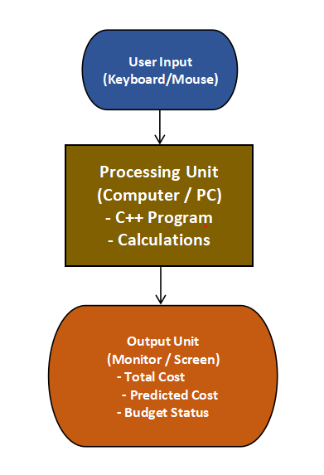
Figure 1:Block Diagram of Hardware Design

3.2 Analysis Procedure
Different approaches were evaluated before selecting a simple and efficient algorithm.

3.3 Software Design

Arrays store data, while functions handle calculations to maintain modularity.

3.4 Algorithm Design

The algorithm follows a step-by-step process from input collection to output display.

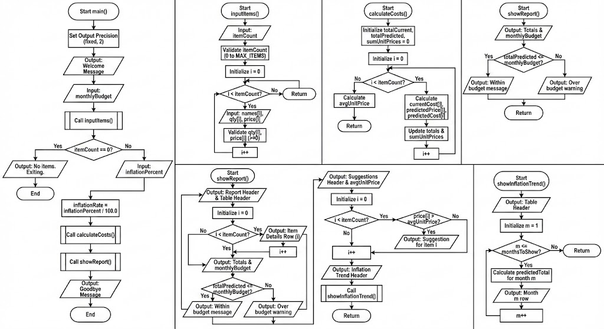
Figure 2:Block diagram of software algorithm

3.5 Implementation Procedure

The program was implemented using C++ constructs and tested iteratively.

3.6 Mathematical Modeling

Predicted Cost = Current Cost × (1 + Inflation Rate)

3.7 Final Working Prototype

The final prototype produces accurate results under different test conditions.

3.8 Summary

This chapter detailed the system development process.

Chapter 4

TOOLS AND TECHNIQUES

4.1 Hardware Tools

Standard personal computer with keyboard and display.

4.2 Software Tools

C++ compiler and IDE such as Code::Blocks.

4.3 Summary

The selected tools ensured simplicity and efficiency.

Chapter 5

PROJECT RESULTS AND EVALUATION

5.1 Presentation of Findings

The system successfully calculated expenses and predicted future costs.

5.1.1 Software Results

All test cases produced accurate outputs.

5.2 Verification of Design Functionalities

All functional requirements were verified successfully.

5.3 Discussion on Findings

Results aligned with project objectives.

5.3.1 Comparison with Specifications

Most specifications were achieved.

5.3.2 Reasoning for Shortcomings

Advanced features were excluded due to time constraints.

5.4 Limitations of the Prototype

No graphical interface or data storage.

5.5 Attainment of SDGs

The project supports SDG #3 and SDG #13 by promoting financial awareness.

5.6 Summary

The project achieved reliable and meaningful results.

Chapter 6

CONCLUSION AND FUTURE WORK

6.1 Conclusion
This project set out to design and implement a simple, effective, and educational software solution to address the problem of grocery budgeting and price prediction for students. Through the development of the Smart Grocery Budgeting & Price Prediction Tool, it has been demonstrated that basic programming concepts, when applied correctly, can solve real-life financial problems in a meaningful way.

The system successfully allows users to enter grocery items and prices, calculate total expenses, predict future costs using an inflation-based mathematical model, and compare predicted expenses with a predefined budget. The results obtained from testing confirm that the program performs accurate calculations and provides clear, understandable outputs. This validates the initial hypothesis that a lightweight, offline budgeting tool can significantly improve financial awareness among students.

From an academic perspective, the project reinforces key programming fundamentals such as arrays, loops, conditional statements, functions, and modular program design. The project also enhances analytical thinking by requiring careful planning, logical flow, and error handling. Overall, the objectives of the project were achieved successfully, and the system meets the defined functional and non-functional requirements.

6.2 Future Work
Although the current version of the Smart Grocery Budgeting & Price Prediction Tool fulfills its intended purpose, there are several areas where the system can be further improved. Future enhancements may include the addition of file handling to store grocery data for long-term analysis. A graphical user interface (GUI) can also be developed to improve usability and user interaction.
Another potential improvement is the integration of real-time price data through online sources, allowing more accurate and dynamic predictions. Advanced prediction models, such as trend analysis or machine learning-based forecasting, can also be explored. These enhancements would make the system more robust, scalable, and suitable for broader use beyond academic purposes.

REFERENCES

1 | Pressman, R. S., Software Engineering: A Practitioner’s Approach, McGraw-Hill.
2 | Deitel, P., and Deitel, H., C++ How to Program, Pearson Education.
3 | Garman, E. T., and Forgue, R., Personal Finance, Cengage Learning.
4 | Mankiw, N. G., Principles of Economics, Cengage Learning.
5 | OECD, Consumer Policy and Budgeting Behavior, OECD Publishing.
Table 4:References

APPENDICES

Appendix – A
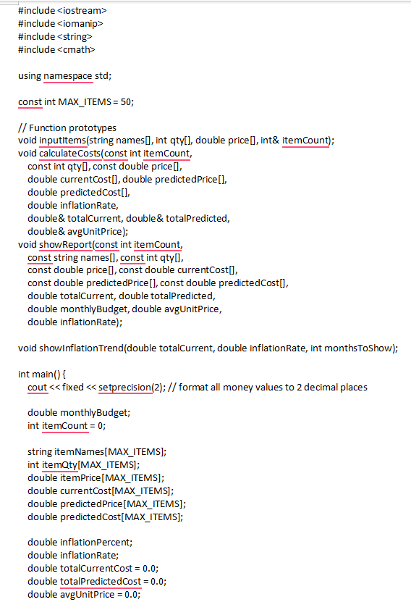
Figure 3:Appendix-A

Appendix-B
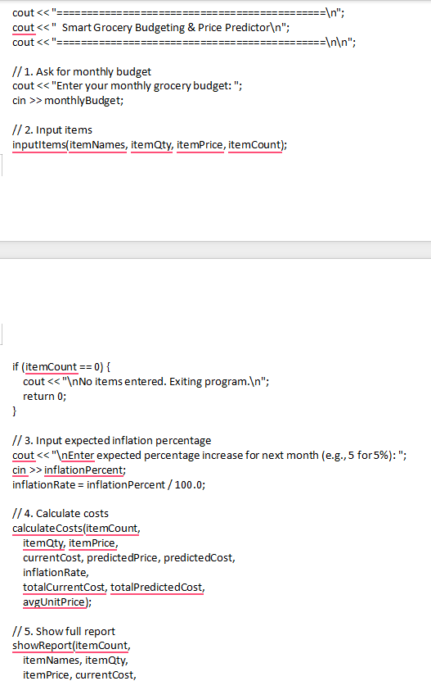
Figure 4:Appendix-B

Appendix-C
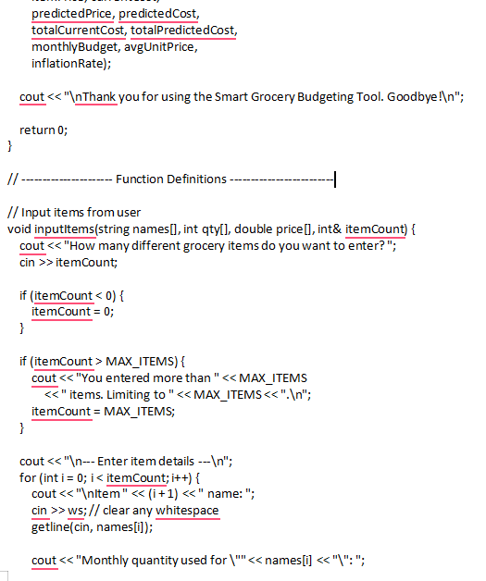
Figure 5:Appendix-C

Appendix-D
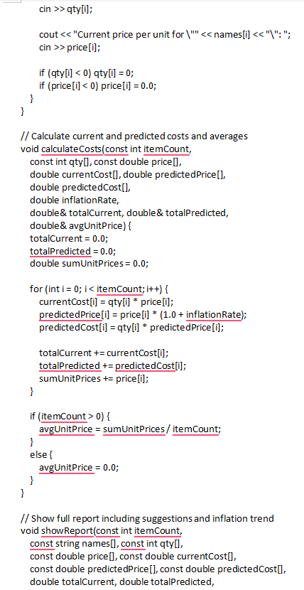
Figure 6:Appendix-D

Appendix-E
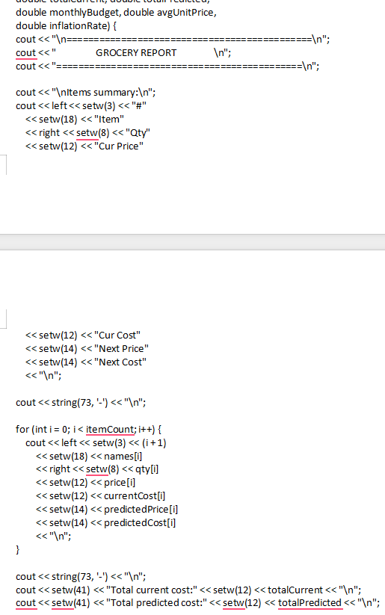
Figure 7:Appendix-E

Appendix-F
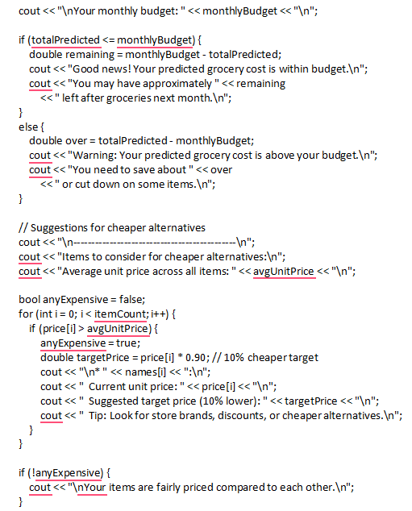
Figure 8:Appendix-G

Appendix-H
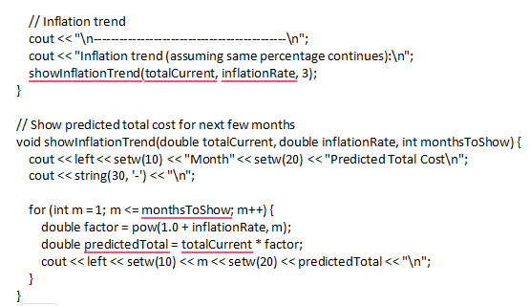
Figure 9:Appendix-H

