
Capital University of Science & Technology
Term Project Proposal
Department of Electrical and Computer Engineering
Project Title |  | University Admission & Enrollment system
Course Title |  | Applications of Information and Computer Technologies
S# | Student Name |  | Registration Number
1 | Aetisaam ul Hassan |  | BCY253051
2 | Aman Sajid |  | BCY253084

Project Idea: University Admission & Enrollment system
The project idea is to design and implement a console-based University Admission & Enrollment Decision System using C++ programming language.The program will collect student information such as age, academic percentages, entry test score, stream, domicile, family income, and desired program. Based on predefined admission rules, the system will automatically determine the student’s eligibility, selection status, merit category, scholarship/fee plan, hostel eligibility, and required documents.
The project focuses on decision-making using conditional statements, demonstrating how ICT systems automate real-life institutional processes like university admissions.
Project Objective:
The main objective of this project is to develop a simple ICT-based admission decision system using C++. The project applies conditional statements to check eligibility and selection criteria and helps users understand their admission status. It also classifies students into merit categories based on performance and demonstrates the practical use of programming in educational systems.
Terminologies Used:

- Conditional Statements (if, else if, else)
Used to make decisions based on user input and predefined rules.
- Relational Operators (<, >, >=, <=)
Used to compare values such as age, marks, and test scores.
- Input/Output (cin, cout)
Used to take user data and display results.
- Merit Category
Classification of applicants based on academic performance (Open Merit, 2nd Merit List, Self Finance).
- Decision Support System
A computer-based system that assists in decision-making using logical rules.

METHODOLOGY:
The proposed methodology for this project begins with taking user input such as age, academic percentages, test score, stream, domicile, family income, and the desired program. The system first checks basic eligibility criteria, including minimum age and intermediate marks. It then evaluates program-specific requirements to determine selection status. After that, a simple merit percentage is calculated and a merit category is assigned. Based on merit and income, the system decides the scholarship or fee plan. Finally, hostel eligibility and the list of required documents are displayed. This step-by-step approach ensures clarity and ease of understanding.
FLOWCHART:

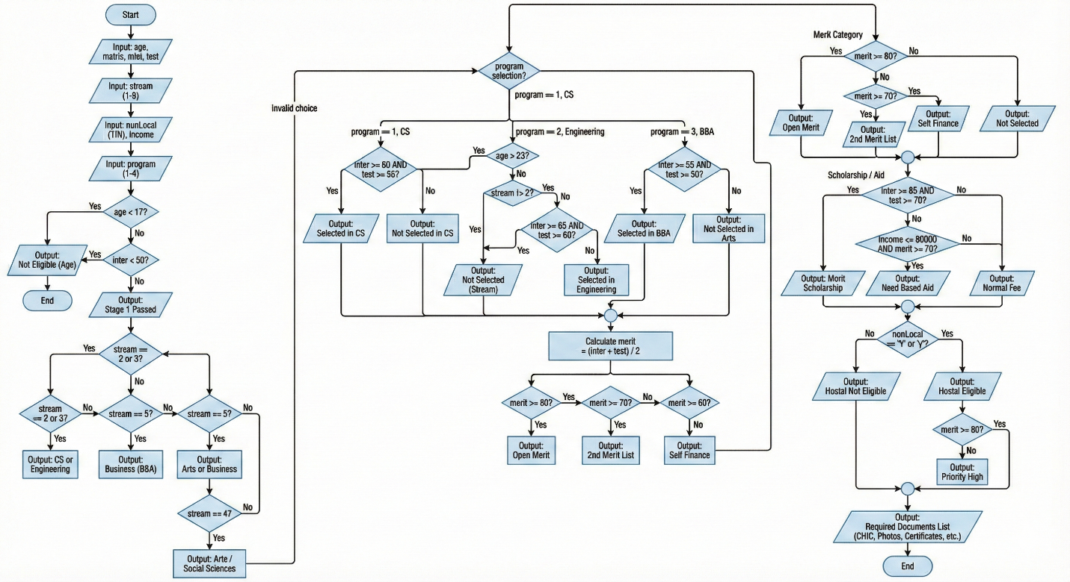

Application of the Project:
- This project demonstrates how ICT is used to automate admission decisions in educational institutions.
- It helps students understand real-life applications of programming using simple logic.
- The system reduces manual effort and chances of error in admission processing.
- The project can be extended in the future by adding databases, graphical interfaces, or online forms.
- It serves as an educational tool to practice basic C++ programming and problem-solving skills.

Student 1 Sig. |  |  |  |  | Instructor Sig:
Student 2 Sig.

