Name: Muhammad Awais P20-0107

Section: A

Answer :

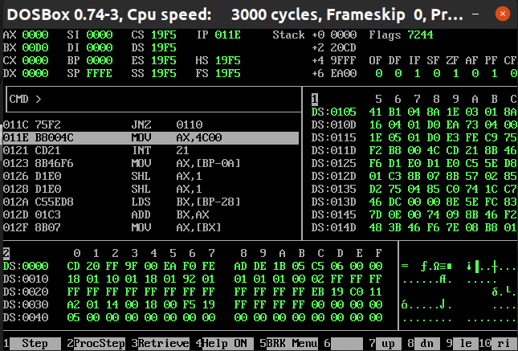**Explanation**:

Firstly we initialized multiplicand by 13 in db in 8 bit as we have to multiply by 4 bit number. Hence our result will be in 8 bits and we will also initialized multiplier by 5, Now we have to run this loop 4 times to move cl to 4, after that we will move multiplicand value to bl and multiplier to dl .Then iteration will start and shr dl ,mean will start the revolution so that right bit will move to carry flag if the carry flag is not set then shift to next bit and if it is set then add to result after the iteration is done then decrement cl and jump to loop again so that it will execute it again. At the end, of the execution, required result will be stored at the address of result label.