**Name:** Muhammad Awais

**Roll No:** 20P – 0107

**Section:** 3A

**Explanation:**

“Inc” increments by 1 and takes one operand;

“Dec” decrements by 1and takes one operand;

“Mul” takes one operand and multiplies it with Ax and stores it in Ax;

Ex: Mul bx ; ax = ax * bx

“Div” takes one operand and divides it with Ax and stores it in Ax;

Ex: Div bx ; ax = ax / bx

**(1)**

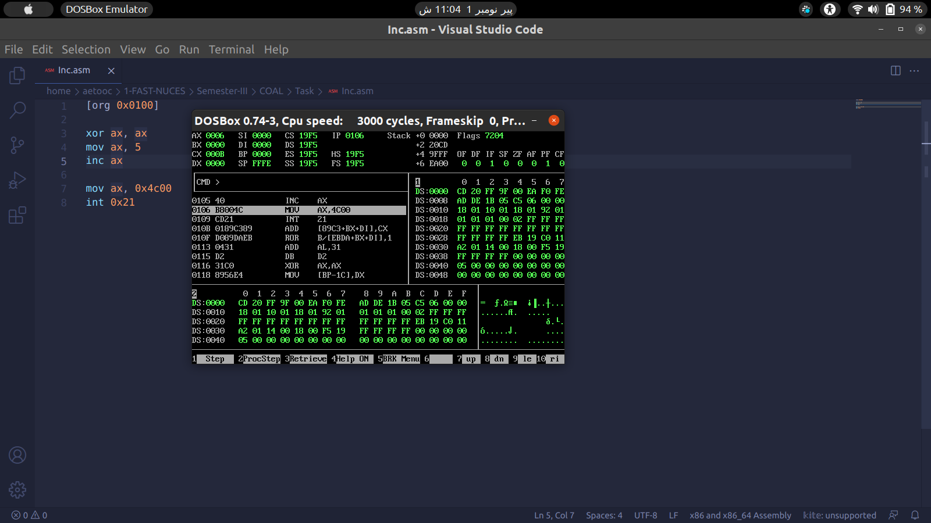**(2)**

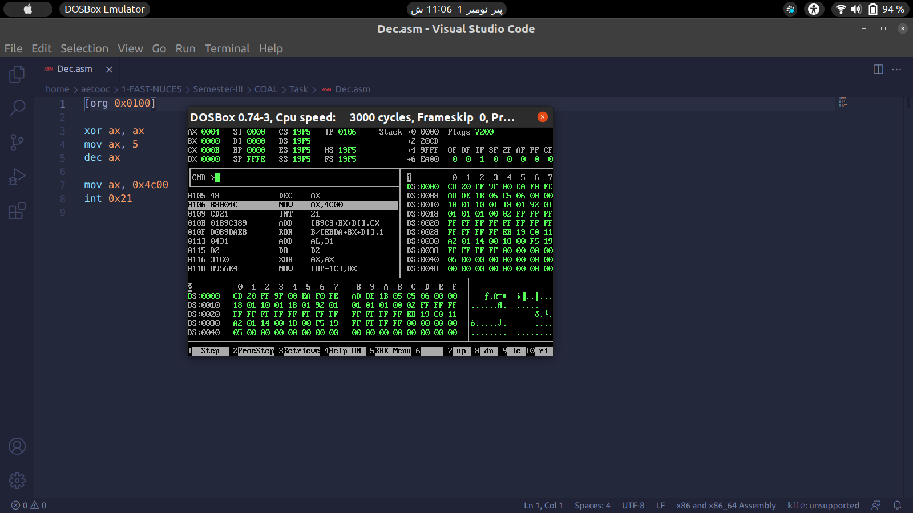**(3)**

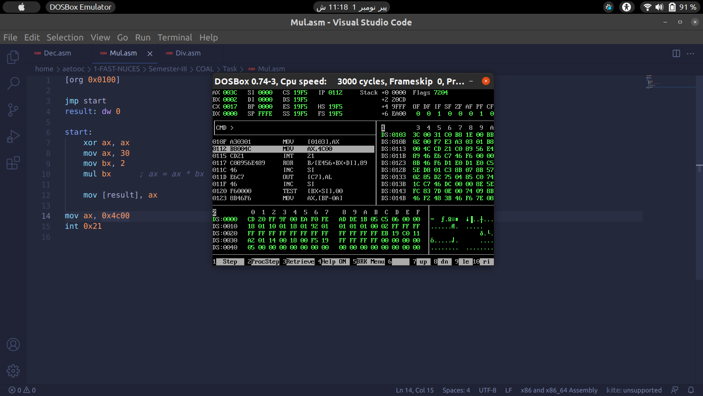**(4)**

