MSSQL

Central Backup

Installation Guide

# Solution Overview

The MSSQLBackupSolution will be installed on one place : the Bastion/Central Backup Server that will be in charge to send backup command to remote MSSQL Instances and Robocopy remote backup results into the central backup repository.

# Required elements

The MSSQLBackupSolution can be found and download as a zip archive on github <https://github.com/aetperf/MSSQLBackupSolution/releases/>

You will need to install the solution on a Windows 2016+ server.

To use the solution you will need also several software :

* **MSSQL Server Instance DB Engine 2019+** that will be use as a CMS (Central Management Server) and that will home a database MSSQLBackupSolutionDB that will store a log table
* **SSMS 19+** : that is not mandatory but we strongly advice to install it to facilitate the CMS Update and follow the backups jobs
* **Git 2+** : could be useful to track gap between source and some customization

Put the SQL and Cumulative Update in the D:\_Sources\SQL Directory

You will also need a **security service account** and some **privileges** given directly or indirectly to the mssqlbackup service account. We advise you to add this service account into the

* BUILTIN\Administrators on the machine where you install the CMS and the MSSQLBackupSolution as well
* BUILTIN\Administrators on all the machines that home the targets MSSQL Instances to backups

A Check Script is available to check requirements. In order to check AD group members the ActiveDirectory powershell module is mandatory. You will need to add a windows feature to obtain this powershell module

# Installation

## **Download** Sources

Source : <https://github.com/aetperf/MSSQLBackupSolution/releases/> take the latest release

You can download and store the MSSQLBackupSolution-<release>.zip into a source folder :

## **Unzip** the content into D:\MSSQLBackupSolution

You can run the following command using a powershell console to decompress and replace an eventual content :

|  |
| --- |
| Expand-Archive -LiteralPath "D:\_Sources\MSSQLBackupSolution\MSSQLBackupSolution-0.6.0.zip" -DestinationPath "D:\" -Force  Move-Item D:\MSSQLBackupSolution-0.6.0\ D:\MSSQLBackupSolution\ -Force |

* Adapt the version regarding the latest released you have downloaded

## Fullfill the configuration file with the target MSSQL instances you want to backup

Move to the Install directory and edit the configuration file

## Activate Proxy



## Run Prechecks

Move to the MSSQLBackupSolution\Install directory and run pre-check.

It will :

* Check Internet Access
* Check if Powershell Module **Logging** is present and install it if not present.
* Check if Powershell Module **dbatools** is present and install it if not present.
* Check if the given service account is member of the local BUILTIN\Administrators group on the CMS Central Backup Server.
* For each target server in the config file it will check if the given service account is member of the remote BUILTIN\Administrators group

1. Edit the MSSQL_BackupSolution.config file and list all the MSSQL target instances in the file. One line per MSSQL Instance

1. Run the Prechecks and adapt the service account to your environment :

|  |
| --- |
| .\MSSQL_Backup_Check_Config.ps1 -serviceAccount "srv_vcic_frk_bck_p" -configFilePath ".\MSSQL_BackupSolution.config" -LogDirectory ".\Logs" |

1. Check results

## Edit the Installer script

Adapt the variable (the first 3 should be enough) : $serviceAccount, $proxyServer, $proxyBypass

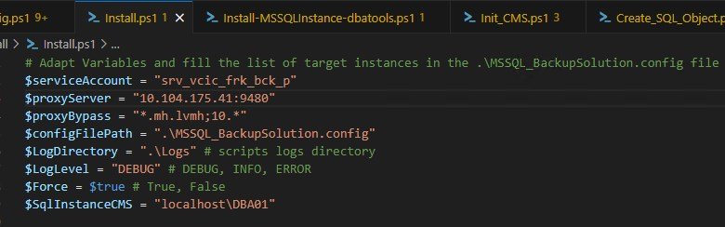

## Run the Installer script

Run the .\Install.ps1 file in the Install Directory.

You will need to provide the password of the service account twice.

Depending on you already have the target instance or not you can choose to ignore MSSQL Instance installation

Read the log file after the installation :

