  
  
  
 **CS 319 - Object-Oriented Software Engineering  
Analysis Report**  
  
**Instructor: ErayTüzün**  
**Project Name: The Wall**

Group 3E

**Erdem Ege Maraşlı - 21602156**

**Ayça Begüm Taşcıoğlu - 21600907**

**Alperen Koca - 21502810**

**Hammad Malik - 21600468**

**Ensar Kaya - 21502089**

Contents

1 Introduction 4

2 Overview 4

2.1 Game Play 5

2.2 Controls 5

2.3 Maps 5

2.4 Objects 6

3 Functional Requirements 7

3.1 Start-Menu 7

3.2 Play Game-Menu 7

3.3 Classical Mode 7

3.4 Campaign Mode 8

3.5 Challenge Mode 8

3.6 Developer Mode 8

3.7 Settings 9

3.8 How To Play 9

3.9 Credits 9

4 Non-functional Requirements 9

4.1 User-Friendly Interface 9

4.2 Perfromance 10

4.3 Extensibility 10

4.4 Pseudo Requirements 10

5 System Models 11

5.1 Use Case Model 11

5.1.1 Use Case Descriptions 12

5.2 Dynamic Models 19

5.2.1 Sequence Diagrams 19

5.2.1.1 Classic Mode 19

5.2.1.2 Campaign Mode 20

5.2.1.3 Challenge Mode 21

5.3 Activity Diagram 23

5.4 Object and Class Models 26

6 User Interface  27

6.1 Start-Menu 27

6.2 Settings Screen 28

6.3 Credits Screen 28

6.4 Play Screen 29

6.5 Classical Mode 29

6.5.1 Classical Mode Game-Play 30

6.6 Campaign Mode 31

6.6.1 Campaign Mode Game-Play 32

6.7 Developer Mode 32

6.7.1 Create Map 32

6.7.2 Play Map 33

7 Conclusion 33

8 References 34

**1. Introduction**

Our aim is to develop a 2D strategy game named “The Wall”, which is inspired of the board game “Walls & Warriors”. The main objective of the game is splitting friendly and enemy units by using the designated walls. The units will mostly be regular knights. However, there will also be some additional units with additional features. The designated walls are same as the walls in “Walls & Warriors” and players are expected to use mouse to drag these walls to the game board and split the enemy and friendly units.

The game will be a desktop application and can be played by using mouse merely.

This report consists of an overview of “The Wall”, description of gameplay and game objects. Then, the report specifies functional and non-functional requirements. The system models namely use case, dynamic, object class and sequential diagrams will also be presented. In addition, there will be some example screen mock-ups.

**2. Overview:**

The Wall will be a single player 2-D game, with its own login database for developer mode and with many different challenges and modes for the player. It is primarily based on the board-game as mentioned above; however, there will be many new additions which will be specified later on in this report. After launching the game, players encounters the login page where they will be required to enter their user-name and password. An option for “Forgot Password.” will also be available to the user. After completing the login process, the Start-Menu will be displayed to the user, which has the following 5 options: “Play Game”,“Credits”, “Settings”, “How to Play” and “Exit”. Upon choosing the “Play Game” option, another menu is displayed which allows users to select the mode they want to play. The game consists of 4 modes: “Classical Mode”, “Campaign Mode”, “Challenge Mode” and “Developer Mode”. Apart from these modes, a “Back” button will also be present on the same screen which will help to return to the previous menu i.e the “Start Menu”. The “How to Play” option will guide the user about the differences between the modes and give a brief description about the different modes and how to play them.

**2.1 Game-play**

As the game is based on a board-game, the game-play will essentially be the same in classical and challenge modes; the only difference between the two is that in challenge mode, the user will be given a specific time to complete the task. The goal of the player will be to place all blue knights (or icons chosen to replace them) inside the walls and all the red knights (or icons chosen to replace them) outside the walls and to make sure that the walls are closed on all sides. Thus, the task of the player is to move these objects (walls and knights) to their defined places.

**2.2 Controls**

The controls for the game are very simple as only the mouse/touchpad will be used. The user will select an object such as a knight or a wall piece with the left-click and drag it to place on the map. Right-click will be used to tilt the objects inside the map by 90 degrees.

**2.3 Maps**

There will be pre-defined maps for the classic, campaign and challenge modes. However, each user will have the option to create and edit his/her own map. These maps will be saved on the database for reusability. The user will also have the option to play maps created by other users in the “Play Designed Maps” option. Upon playing a particular map, the user will be asked to rate the map using the 5-stars system. The maps will be categorized by their ratings and number of times they have been rated by different users. Each map will contain a board-like structure at the middle with visible tiles to place the knights on and places between the tiles to place the wall pieces on. The most basic component of the map will be the tiles or blocks which will be used to create a board-like structure inside the map such as the one in the board game “Walls and Warriors.” On each side of this in-game “board” will be a decorated area such as grass, forests, lakes, mountains etc, depending on the mode selected by the user. In the user-designed maps, this area can be essentially anything the user wants it to look like.

**2.4 Objects**

There will be 4 main types of objects for each mode other than the decorations inside the map. These objects are already defined in the board-game “Walls and Warriors” and are as follows:

* High-Tower piece: There is only one of this, which can be either pre-placed in a given challenge or the user has to place it. This piece has to be placed on the tiles.
* Walls: There are 4 wall pieces, each with its own orientation, length and design. These pieces have to be placed in the space between the tiles.
* Blue Knights: These are the friendly knights of the castle, which must be kept inside the walls, in order to complete any challenge. These pieces have to be placed on the tiles. In total, there will be 4 of these but not all of them might be needed for a particular level/challenge.
* Red Knights: They are the enemies, the ones which must be kept outside the walls of the castle in order to complete any challenge. These pieces have to be placed on the tiles. In total, there will be 3 of these but not all of them might be needed for a particular level/challenge.

However, it is important to understand that these objects can be made to look like something else using the “Change Icons” option in the Start-Menu. So, for example, the Red Knights can be changed to Barbarians. The design and outlook of the high-tower piece and the wall pieces can also be changed; however, the orientation cannot be changed since they are designed in such a way so as to fit at specific parts of the board in order to complete a particular challenge.

**3) Functional Requirements**

**3.1 Start-Menu**

This is basic user screen which will be displayed to each user upon successful completion of the login process. This menu will contain the following 6 buttons: “Play Game”, “Change Icons”, “Settings”, “How to Play”, “Credits” and “Exit”. The exit button will help the user to quit and close the game.

**3.2 Play Game Menu**

This menu is displayed when the user clicks on the “Play Game” button in the “Start-Menu”. This menu essentially contains the different modes of the game. As mentioned above the game consists of 4 modes – “Classical Mode”, “Campaign Mode”, “Challenge Mode”, “Developer Mode”.

**3.3 Classical Mode**

The Wall is a strategy game that is inspired by the board game “Walls & Warriors”. The game offers the classical concept of the board game with and without changes. In the classical mode, players will choose the difficulty level that they desire. Players will be given a map according to the difficulty level and they will start playing “The Wall”. The players can drag the pre-shaped walls to the game board using the mouse. In order to win the game, the player has to create a closed structure using the predefined walls such that all the friendly knight objects will be placed inside while none of the enemy knight objects are inside of the structure. By holding the left click, the walls will be selected and moving the cursor while holding the left-click will mean moving the wall. The players can rotate the wall by using the right click. Every right click will rotate the wall by 90 degrees. Releasing the left-click will place the wall at the location of cursor. In order to put the wall on the board, the tiles coincide with the desired location of the wall should be empty. If the player struggles to find the appropriate position for a wall, he/she can use a hint, which will reveal an accurate location of one wall. If the players thinks that the solution is reached, check button will be pressed and the game will inform whether it is true or not. When the victory condition is reached, player will be asked whether he/she wants to continue playing or not. In the classical mode, there are no additional units. Therefore, the victory condition for this mode is the same as in the board game “Walls & Warriors”.

**3.4 Campaign Mode**

In the campaign mode, the game play will be nearly similar to classic mode. The player will be given a story that consists of several maps. These maps will be different from the ones in the classic mode and challenge mode. There will be pop up messages to inform the story to the players and there will be additional units with additional features. The player will be able to save/load their game in this mode.

**3.5 Challenge Mode**

The only difference between this mode and the Classical Mode is that the map will be set randomly and there will be a limited amount of time. Thus, there will be an additional time counter on the screen and the player has to complete the task within this time limit.

**3.6 Developer Mode**

In this mode, players will be able to develop their own maps by using the same walls as in the classic mode. Similar to the classic mode, there will be a catalog on the right of the screen consisting of units (knights and additional units). The players will drag these units onto the board and will create a pattern according to the rules of the game. The players are also expected to give the accurate solution of the map and save this solution. The players can play their own created maps while they can also play maps created by other players. There will be a database of maps, which will include only the created maps. Players can rate maps created by other users and in order to play these maps, they will be able to download them.

**3.7 Settings**

This option will give opportunity to player to change the volume, background of the game, and will contain a button named “Change Icons” which can be used to change the icons/pictures of the game-objects.

**3.8 How To Play**

This option will give information about game and teach the basic elements of the game to the player.

**3.9 Credits**

When this option is selected, the names of the developers will be shown.

**4. Non-Functional Requirements**

**4.1 User-Friendly Interface**

The User-Interface will be designed and implemented in such a manner that the game can be understood and played easily as well as stimulate interest in the user. The mechanics will be general, similar to those seen in many online board-games.

**4.2 Game Performance**

Since there will be many different users, modes and maps, and we are also planning to add animations in “Campaign Mode”; we will make sure these implementations don’t cause any performance issues for the user. The game-play should be smooth with a higher FPS rate than the monitor refresh rate (which on average is around 60~). Also, the game shouldn’t strain or add extra load on the computer and thus affect the performance of the computer.

**4.3 Extensibility**

When creating any software, extendibility and reusability are always important considerations. As it is often observed that there are continuous updates to all famous applications. Thus, “The Wall” will also be implemented such that it can be extended and updated with time according to the needs and feedback received by the users.

**4.4 Pseudo Requirements**

The game will be implemented in Java; graphics will be implemented using Java’s AWT and swing libraries. Also, since it will be an online game, the online login process will be implemented using PHP.

**5. System Models**

**5.1 Use Case Model**

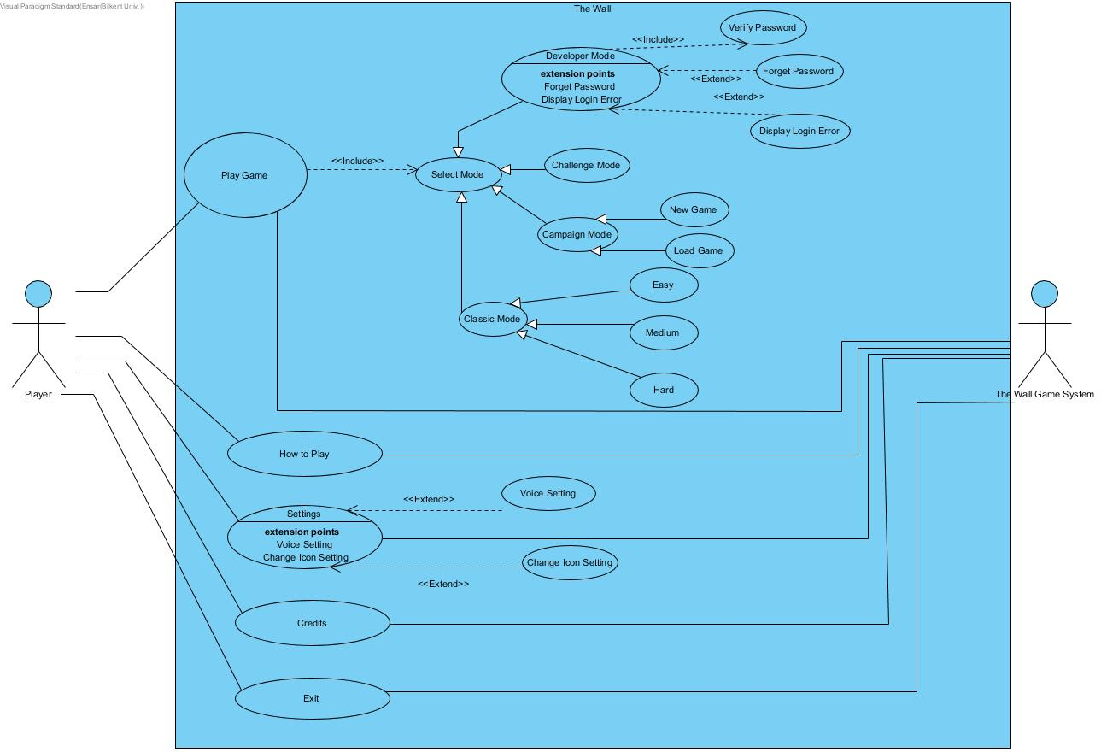

**5.1.1 Use Case Descriptions**

**Use Case #1**

**Use Case name**: Play Classic Mode

**Participating actors**: Player

**Entry Condition:** The player opens the game; he first clicks Play Game and secondly Classic Mode button.

**Exit Conditions:**

1-Player completes all the provided levels in selected difficulty (Easy, medium, hard)

2-Player wants to exit game, first player returns main menu and then clicks Exit button.

**Main Flow:**

1. Player opens the game

2. Player clicks Play Game button

3. Modes screen appears.

4. Player clicks Classic button

5. Difficulties screen appears.

6. Player clicks Medium button

7. System prepares levels and allows player to play any unlocked map

8. Player clicks one of the map buttons

9. Player completes all the levels provided

10. Player returns opening page

11. Player clicks Exit button

**Alternative Flow:**

1. Player selects another difficulty level
2. Player completes all the provided levels
3. Player clicks Exit button

**Use Case #2**

**Use Case name:** Play Campaign Mode

**Participating actors:** Player

**Entry Condition**: The player opens the game; he first clicks Play Game and secondly Campaign Mode button.

**Exit Conditions:**

1-Player finishes story which mean player completes all the provided levels in Campaign

2-Player wants to exit game, first player returns main menu and then clicks Exit button.

**Main Flow:**

1. Player opens the game

2. Player clicks Play Game button

3. Modes screen appears.

4. Player clicks Campaign button

5. New game or load game screen appears.

6. Player clicks New Game button

7. System prepares levels and allows player to play first map

8. Player completes the level provided

10. Game provides option for continue story or close game

11. Player clicks continue story button

12. Player completes all the maps in the story

13. The system displays congratulation message and returns main menu

**Alternative Flow:**

1. Player clicks Continue Game Button
2. Player continues play from his/her last map
3. Player completes all the remaining maps
4. The system displays congratulation message and returns main menu

**Use Case #3**

**Use Case name:** Play Challenge Mode

**Participating actors:** Player

**Entry Condition**: The player opens the game; he first clicks Play Game and secondly Challenge Mode button.

**Exit Conditions:**

1-Player completes all the challenges provided from system

2- Player cannot succeed to complete the challenge in given time

3-Player wants to exit game, first player returns main menu and then clicks Exit button.

**Main Flow:**

1. Player opens the game

2. Player clicks Play Game button

3. Modes screen appears.

4. Player clicks Challenge button

5. System prepares a challenge

6. Player completes the challenge

10. New Challenge or close game option screen appears

11. Player clicks close game button

**Use Case #4**

**Use Case name**: Play Developer Mode (Create a map)

**Participating actors**: Player

**Entry Condition:** The player opens the game; he first clicks Play Game, secondly Developer Mode button and thirdly Create Map button.

**Exit Conditions:**

1-Player creates a map and uploads it to the system

2-Player wants to exit game, first player returns main menu and then clicks Exit button.

**Main Flow:**

1. Player opens the game

2. Player clicks Play Game button

3. Modes screen appears.

4. Player clicks Developer button

5. Player clicks Create Map button

6. System provides an empty game board and game units

7. Player creates his/her own map

8. Player clicks Save Map button

9. System checks if it is a valid map

10. Player clicks upload map button

11. System uploads map to the server

12. Player clicks Exit button

**Alternative Flow:**

1. Player clicks Save Map button

2. System check if it is valid map

3. System displays error message

**Use Case #5**

**Use Case name**: Play Developer Mode (Play a map)

**Participating actors**: Player

**Entry Condition:** The player opens the game; he first clicks Play Game, secondly Developer Mode button thirdly Play Map button.

**Exit Conditions:**

1-Player plays a map completes it

2-Player wants to exit game, first player returns main menu and then clicks Exit button.

**Main Flow:**

1. Player opens the game

2. Player clicks Play Game button

3. Modes screen appears.

4. Player clicks Developer button

5. Player clicks Play Map button

6. System provides an screen which contains shared maps

7. Player selects a map

8. Player completes selected map

9. Player clicks return main menu button

10. Player clicks Exit button

**Alternative Flow:**

1. Player selects a map

2. Player completes the map

3. Player vote for the completed map

**Use Case #6**

**Use Case name**: How to Play

**Participating actors**: Player

**Entry Condition:** The player opens the game; he clicks How to Play button

**Exit Conditions:**

1-Player wants to exit game, first player returns main menu and then clicks Exit button.

**Main Flow:**

1. Player opens the game

2. Player clicks How to Play button

3. How to Play screen appears.

4. Player clicks return main menu button

5. Player clicks Exit button

**Use Case #7**

**Use Case name**: Settings

**Participating actors**: Player

**Entry Condition:** The player opens the game; he clicks Settings button

**Exit Conditions:**

1-Player wants to exit game, first player returns main menu and then clicks Exit button.

**Main Flow:**

1. Player opens the game

2. Player clicks Settings button

3. Settings screen appears.

4. Player clicks voice button for closing voice of game

5. Player clicks Change Icons button

6. Icons page appears

7. Player clicks one of the icons for blue knights

8. Player clicks one of the icons for red knights

9. Player clicks return main menu button

10. Player clicks Exit button

**Use Case #8**

**Use Case name**: Credits

**Participating actors**: Player

**Entry Condition:** The player opens the game; he clicks Credits button

**Exit Conditions:**

1-Player wants to exit game, first player returns main menu and then clicks Exit button.

**Main Flow:**

1. Player opens the game

2. Player clicks Credits button

3. Credits screen appears.

4. Player clicks return main menu button

5. Player clicks Exit button

**Use Case #9**

**Use Case name**: Exit Game

**Participating actors**: Player

**Entry Condition:** The player opens the game; he clicks Exit button

**Exit Conditions:**

1-Player wants to exit game, player clicks Exit button.

**Main Flow:**

1. Player opens the game

2. Player clicks Exit button

3. System asks player if s/he is sure or not

4. Player clicks “Yes” if s/he wants to close the game

**5.2 Dynamic Models**

**5.2.1 Sequence Diagrams**

**5.2.1.1 Classic Mode**

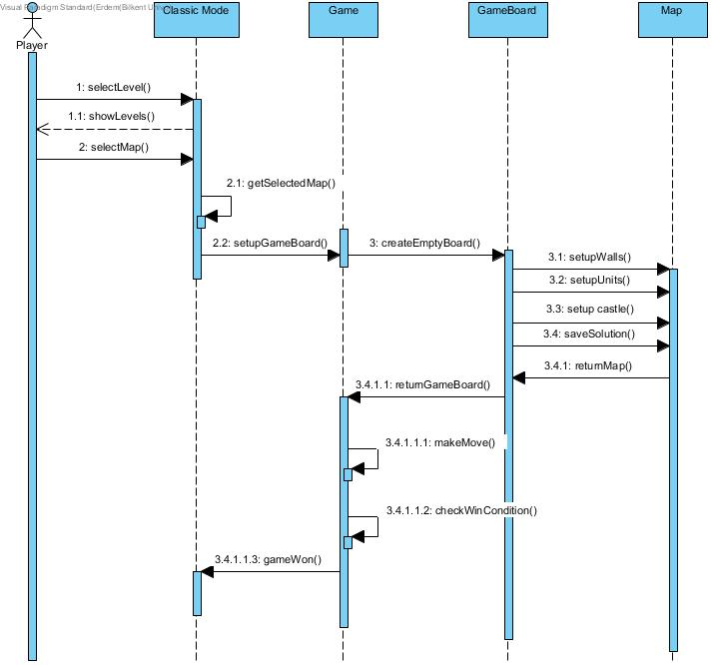

Scenario: In this scenario, the player selects the classic mode. After his selection, available maps are shown to the player. The player selects the level and game board setups according to that level. After the game board setup done, the player can start to make moves. After every move of player; game controls if the player wins the game or not. If all win conditions satisfied player passes the level and message shown to the player.

**5.2.1.2 Campaign Mode**

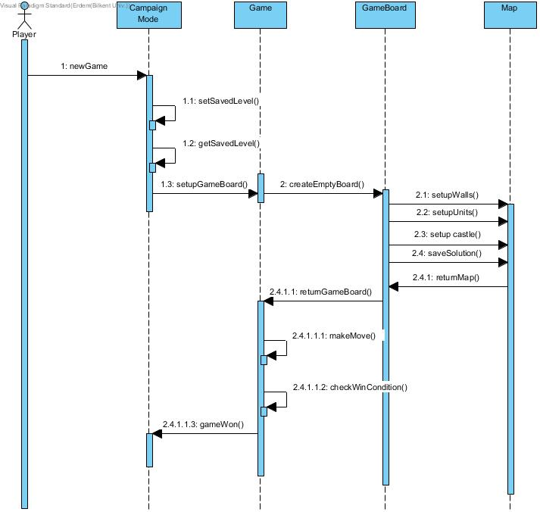

Scenario: In this scenario, the player selects campaign mode and starts a new game. New game record saved to the memory and first map loads by system. The system creates a board according to the first map of Campaign Mode. After the game board setup is done, the player can start to make moves. After every move of player; game controls if the player wins the game or not. If all win conditions are satisfied, player passes the level. The system displays a congratulations screen to the player and the story information saves by the system.

**5.2.1.3 Challenge Mode**

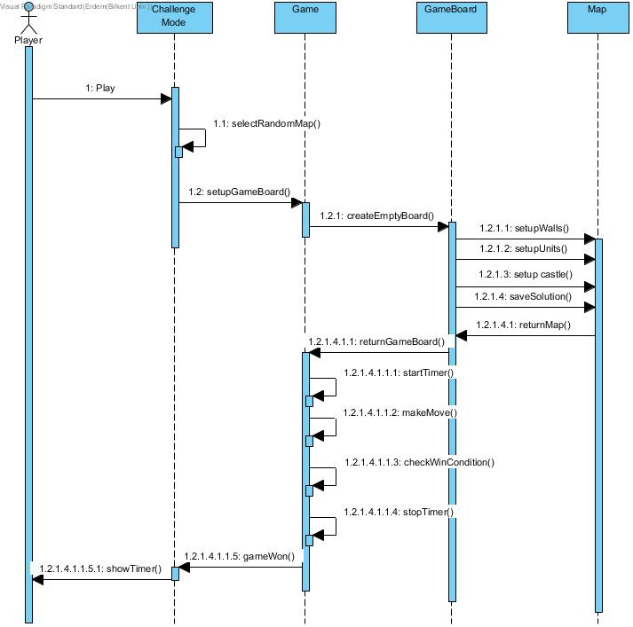

Scenario: In this scenario, the player selects challenge mode to play. After his selection, random maps selected from each difficulty and game board setups according to that maps. After the game board setup done, the timer starts to count the time and player can start his moves. After win condition satisfied, the timer stops and passed time shown to the player.

**5.3 Activity Diagram**

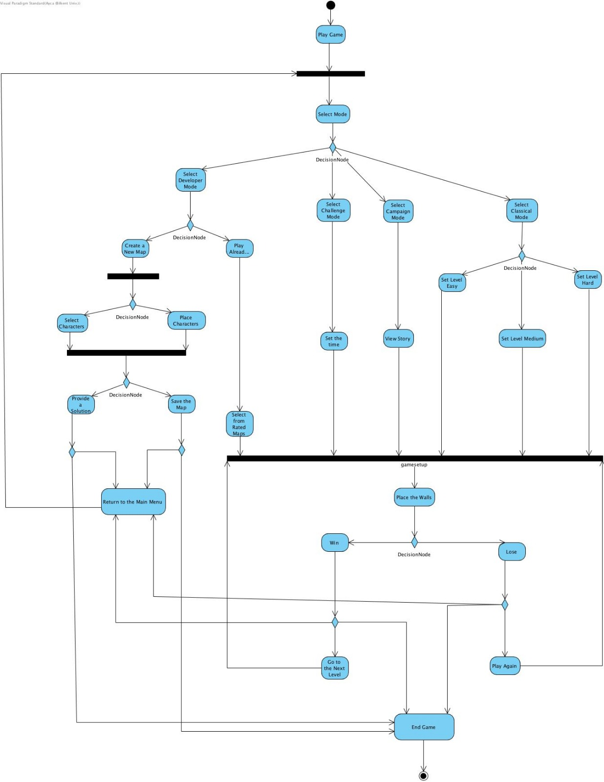

Initially, if the user clicks “Play Game” button, there will be options such as game modes will be displayed. The user is able to choose “Classic Mode”, “Campaign Mode”, “Challenge Mode” or “Developer Mode”.

If the user clicks “Classical Mode”, the system requests the user to provide level choice “Easy”, “Medium” or “Hard”. After this, the user should pick a map to play. The system initializes the game board, places of the game objects regarding these choices. In the next step, the user should pick a wall, rotate it and place it to the game board to keep all his/her knights and the castle inside the walls. If the user succeeds, the system controls the win condition and outputs if the game is won or not. If the game is won, the user can either play the next level, return the main menu or exit the game.

If the user clicks “Campaign Mode”, the system will show the user the stories with pop-ups. then the user can play the game, moving with the events of flow of the given story. The user will place the walls to continue the campaign. The system checks if the win condition satisfied and outputs if the game is won or not. If the game is won, the user can either play the next part of the story, return the main menu or exit the game.

If the user clicks “Challenge Mode”, he/she should set the time (duration) which he/ she wants to challenge himself/herself. After that decision, he/she should place the walls and keep her/his castle and knights inside in given time. If the user can finish the part in a given duration, he/she can pass the new challenge or return to the main menu or exit the game.

If the user selects “Developer Mode” the user can either play with already designed maps or “Create a New Map”. If the user clicks the “Create a New Map”, the system will provide the user an empty game board. The user can select various characters and place them. However, the user should provide an appropriate solution for his/her own designed map if he/she wants to make her/his game is played by other users. If the user selects “Play Already Designed Maps” then the user will be redirected to the rated maps and selects a map to play. The user will place the walls to win just as classical games. The system controls the win condition and outputs if the user solved the map or not. The user can either exit the game or return the menu after this.

**5.4 Object and Class Diagram**

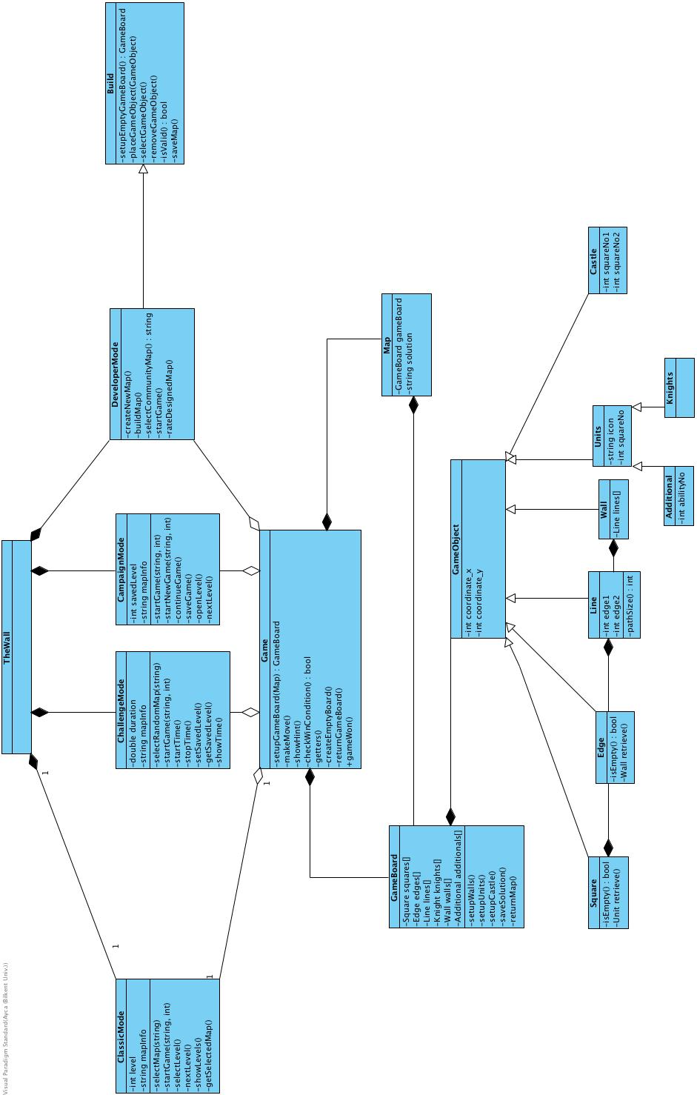

**6. User Interface**

**6.1 Start Menu**

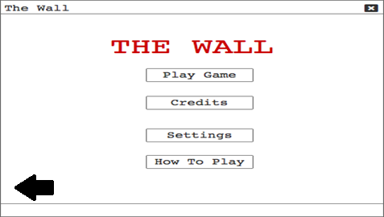

In starting screen there will be 4 options for player: Play Game button which is for start the game, Credits for developers and references, Settings for changing volume, changing background color and changing icons for game units. And How to Play button informs player about the game.

**6.2 Setting Screen**

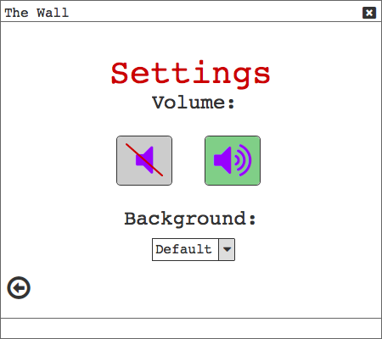

**6.3 Credits Screen**

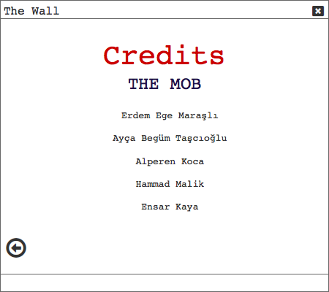

**6.4 Play Screen**

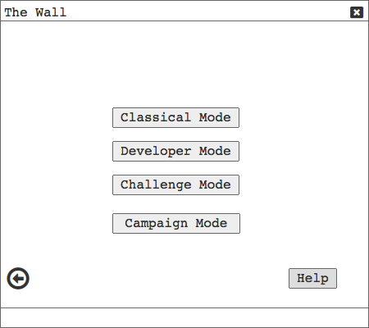

When user clicks Play Game button, this screen will be displayed by the system. In this screen player has 4 options such as Classical mode, Developer mode, Challenge mode and Campaign mode.

**6.5 Classical Mode**

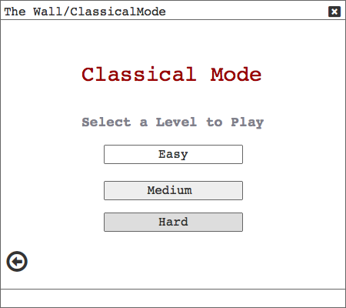

If the player selects classical mode this screen will be display. There are 3 options for difficulty levels.

**6.5.1 Classical Mode Game Play**

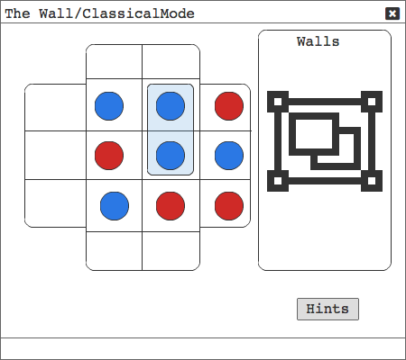

The game board will setup by system according to player choose. Walls will be stand on the right hand side and game board will be stand on the left hand side.

**6.6 Campaign Mode**

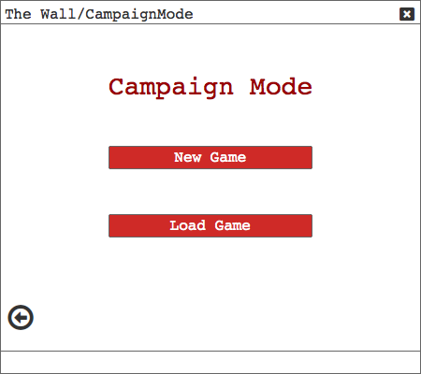

If the player clicks on the Campaign button, this screen will be display. Player can start a new game or continue his/her old game.

**6.6.1 Campaign Mode Play Screen**

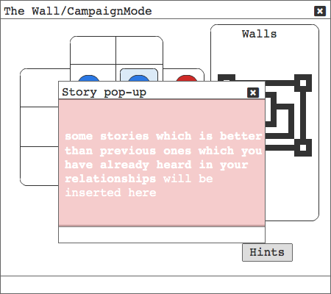

**6.7 Developer Mode**

**6.7.1 Create Map**

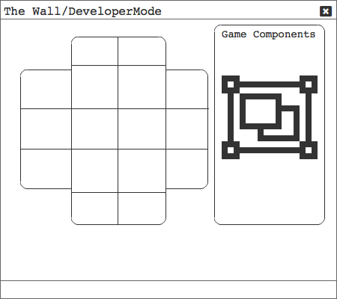

If the player selects Developer button there will 2 options for player: Create Map and Play Map. In create map case, this screen will be display. The player will have the full access to walls and game units to place unless the whole map is invalid.

**6.7.2 Play Map**

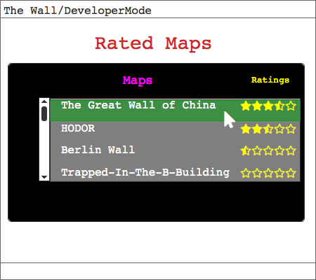

The player can choose also playing maps which are created by other users. They can also see the rating of the map and if a player completes a map, s/he can vote the map, too.

**7. Conclusion**

In order to implement our project, we have prepared an analysis report. The report consists of 5 subtitles; introduction, overview, requirement specifications, system model and user interface. We tried to describe these subtitles elaborately and explanatory.

In the Introduction and overview section, the project has been summarized and described.

During the requirement specification section, functional and non-functional requirements have been determined.

In the system model section, there are 4 diagrams:

Use case Diagram

Sequence Diagram

Activity Diagram

Class Diagram

In use case diagram, we designate use cases for the main actions of the game.

In the sequence diagram, we have shown some scenarios with UML sequence diagram

In the activity diagram, we have shown all possible actions of the game.

In the class diagram, we showed the associations between classes which will be used during the implementation process.

During this analysis report, we tried to be brief and comprehensive while not neglecting the significant details. We also tried to specify our objectives and diagrams in order to accurately and effectively implement the game. Our aim is to use this analysis report as a guideline for the implementation process.

**8. References**

Inspired by the board-game Walls and Warriors:  
 <https://www.smartgames.eu/uk/one-player-games/walls-warriors>