

**Bilkent University**

**CS353**

**DATABASE SYSTEMS**

**Project Proposal**

**Company Interview and Employment Review Platform Database System**

**GROUP 5**

Mehmet Sanisoğlu

Mehmet Selim Özcan

Ayça Begüm Taşçıoğlu

Erdem Ege Maraşlı

Table of Contents

1.Introduction 2

2. Project Description 3

2.1 Need for a Database in the Platform 4

2.2 Integrating the Database inside the Project 4

3. Requirements 5

3.1 Functional Requirements 5

3.1.1 Employee 5

3.1.2 Company 5

3.1.3 Admin 6

3.2 Non-functional Requirements 6

3.2.1 Security 6

3.2.2 User-Friendliness 6

3.2.3 Quick Response Time 7

3.2.4 Reliability 7

3.2.5 Capacity 7

3.3 Pseudo Requirements 7

4. Entity-Relationship Diagram 8

5. Limitations 9

6. Conclusion 9

# 1.Introduction

This is a project proposal about an employment review platform and the constructed database relationships between its entities. In this report, we discuss the basic structure, relationships between the entities as well as limitations and restrictions within the aimed design.

In the first part of the proposal details relevant to the Project Description are shared. The demands of the project and the aim of the platform are explained in detail with regards to each other. The role of the database implementation along with the need for such a platform is also discussed.

Next part of the report continues with the requirements of the platform. In this section, we explore the functional and nonfunctional requirements. In functional requirements part, we explain the allowed functionalities and desired interactions between the users of the platform. System bounds will be declared in this section according to the allowed actions of each user. In nonfunctional requirements, we discuss the technical requirements expected from the platform including user-friendliness, scalability of the platform, reliability aspect of the platform as well as quick response time. Limitations related to the design expectations will provide information about the reasons behind the chosen path of implementation.

After discussing requirements and limitations report goes along with the proposed ER(Entity Relationship) Model to provide further explanations related to the entity relationships inside the model.

# 2. Project Description

Company Interview and Employment Review Platform is a proposed platform form users to give reviews related to companies, jobs, and interview processes. In the platform, users can share information regarding their employment status, qualifications, resume, and their desired job. The desired job specification can include fundamental information about the salary, job title, position, job location, benefits provided by the job.

Companies can post about the currently available job offerings within their ranks with the pre-requirements they are looking for. The platform, in turn, provides the employees and employment seekers with possible job suggestions.

# 2.1 Need for a Database in the Platform

Implementing such a platform where each individual has the ability to store, edit and remove their own information while at the same time being able to see detailed information provided by the companies requires a vast amount of data to be interchanged in this online system. The users are presented with the many aspects of the jobs and companies when they are making their reviews such as the salary, difficulty, work environment and location the job takes place in. Differentiating different types of platform actors such as admins, employers, employees, and companies from each other while regulating their interactions in the desired manner presents a great complication in the management of this grand data flow. Therefore, by implementing a database we help ease the control of the data in the dedicated solution pattern for the case.

# 2.2 Integrating the Database inside the Project

The database will serve as a means of organizing and controlling the flow of data in between the entities. By using the database design inside our project, we will provide the platform with the means to implement the desired reviewing, listing and applying operations.

# 3. Requirements

Our requirements for database system will be divided in three main parts.

# 3.1 Functional Requirements

Our database system will have 3 end user: Employee, Company and Admin. Every user should have to be authorized in order to use the system.

# 3.1.1 Employee

* Employees should be able to create a review about interviews, salaries, benefits and companies itself
* Employees should be able to upload their resume
* Employees should be able to provide their personal information such as gender, age, location
* Employees should be able to subscribe to companies
* Employees should be able to get notifications about job offerings from subscribed companies
* Employees should be able to apply a job
* Employees should be able to change their anonymity when they write reviews

# 3.1.2 Company

* Company should be able to provide their information about itself such as location, website, type of company etc.
* Company should be able to create jobs
* Company should be able to see employees that applied created jobs
* Company should be able to see their subscribers
* Company should be able to see different kind of reviews(interview, benefits, general) about itself from employees
* Company should be able to state its employers
* Company should be able to manage its employees status
* Company should be able to send a request to admin for removing the review about itself
* Company should be able to upload photos
* Company should be able to create projects
* Company should be able to see its rating from employees
* Company should be able to present its awards that given according to its rating

# 3.1.3 Admin

* Admin should be able to manage users’ authentication
* Admin should be able to remove a requested reviews from companies

# 

# 3.2 Non-functional Requirements

In our system, we have 5 main non-functional requirements that we will consider.

# 3.2.1 Security

* Users will have password with certain length and qualifications in order to access the system and their mail will be used for authentication
* Only admins can manage the access level of users

# 3.2.2 User-Friendliness

* System will have clean instructions for starters
* System will have tips and explanations for users

# 3.2.3 Quick Response Time

* System will work in real-time as possible.
* Storing and retrieval operations of informations will be fast enough in order to create a practical working environment
* Loading and refresh time will be at most 0.5 second

# 3.2.4 Reliability

* System should have backup storage if it encounters with any problems
* There will be conditions for each operation that user wants to make
* System should perform simultaneously for every user
* System should minimize the data loss

# 3.2.5 Capacity

* System will manage large amount of data
* System’s storage will be

# 3.3 Pseudo Requirements

* MySQL will be main program for our database implementation
* CSS, HTML, JavaScript, JQuery, Bootstrap, Google Material Design Lite will be used for the front-end implementation of the website.
* PHP will be used for the back-end implementation of the website

# 4. Entity-Relationship Diagram

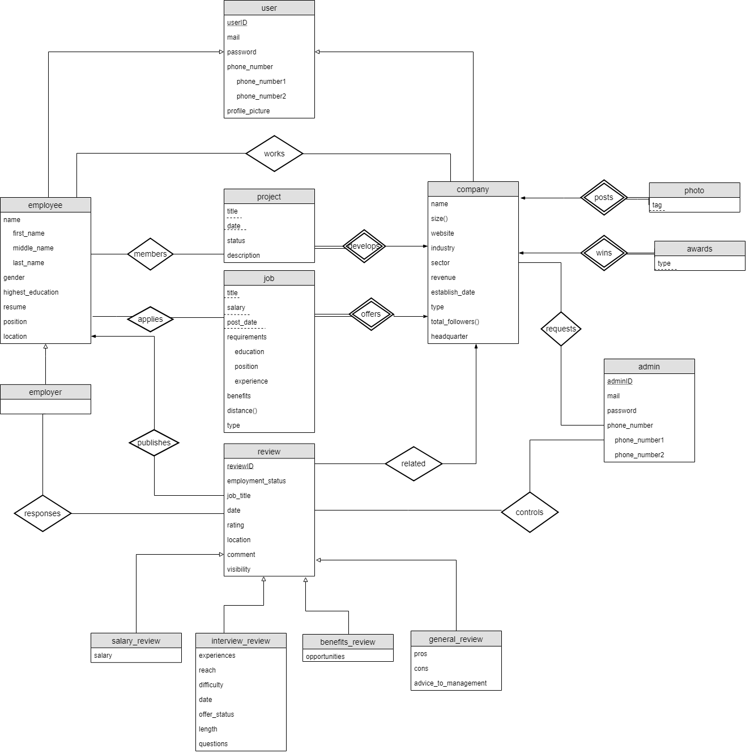

*Figure 1 - ER Diagram*

# 5. Limitations

* Each employee can evaluate an interview only once
* Each review can be associated with only one company
* Each review can be written by only one employee
* Each job can be offered by only one company
* Each project can be developed by only one company
* Each job can be applied once by the same user

# 6. Conclusion

The Company Interview and Employment Review Platform Database System is a web-based application for providing its users to review companies based on their employment and interview experiences.

In this report, we stated the goal, the brief information about the project and importance of designing and implementing a database management system for a real life problem. After the description of the project we divided the requirements into 2 subgroups: Functional Requirements, Non-functional Requirements. We tried to clarify the requirements for each user. Then before finalizing the report, we provided the limitations of the system.

At the last part of the project, we provided an Entity Relation Diagram to visualize and explain our database design.

# Website

<https://github.com/aeyc/Company-Interview-and-Employment-Review-Platform-Database-System.git>