End-to-End MLOps for Heart Disease Risk Prediction
Machine Learning Operations (AIMLCZG523) - Assignment 01
Field | Detail
Student | Abdullah Farhan Safwi
Student ID | 2025AE05836
Course | MLOps (AIMLCZG523), BITS Pilani WILP
Date | 18 October 2026
Code repository | https://github.com/aezakmi007/heart-disease-mlops-assignment
Demo video | [TODO: paste video link or file name]

1. Introduction and Problem Statement
Heart disease is a leading cause of death, and early risk screening from routine clinical measurements can help prioritise patients for further tests. This project builds a binary classifier on the UCI Heart Disease (Cleveland) dataset that predicts whether a patient has heart disease, and delivers it the way a production ML system would be delivered: reproducible, tested, tracked, containerised, deployed and monitored.
Objectives
- Acquire, clean and explore the data with a scripted, repeatable process.
- Train and tune two classifiers (Logistic Regression and Random Forest) with cross-validation.
- Track every experiment in MLflow and package the best model with its preprocessing pipeline.
- Automate linting, testing and training with GitHub Actions.
- Serve the model through a FastAPI service in Docker and deploy it on Kubernetes.
- Monitor the running service with structured logs, Prometheus metrics and a Grafana dashboard.

2. Setup and Installation
Prerequisites: Python 3.11 (pinned in .tool-versions), Git, Docker, and a local Kubernetes cluster (Rancher Desktop was used). All commands run from the repository root.
git clone https://github.com/aezakmi007/heart-disease-mlops-assignment
cd heart-disease-mlops
python -m venv .venv && source .venv/bin/activate
pip install -r requirements-dev.txt

python src/download_data.py # fetch UCI data -> data/raw/heart_raw.csv
python src/preprocess.py # clean data -> data/processed/heart_clean.csv
python src/train.py # tune, track in MLflow, save models/model.joblib
python src/package_model.py # metadata + MLflow-format copy + round-trip check
python src/predict.py # inference on data/sample_input.json
pytest && flake8 src tests # tests and lint
mlflow ui --backend-store-uri ./mlruns --port 5001

Table 1. Dependency files
File | Purpose
requirements.txt | Pinned packages for training, tracking and the pipeline
requirements-dev.txt | Adds pytest, flake8, Jupyter and httpx for development and CI
requirements-api.txt | Minimal pinned packages for the serving container
.tool-versions | Pins the Python version used

Reproducibility was verified by running the whole pipeline, from dataset download to prediction, in a brand-new virtual environment created only from requirements.txt.
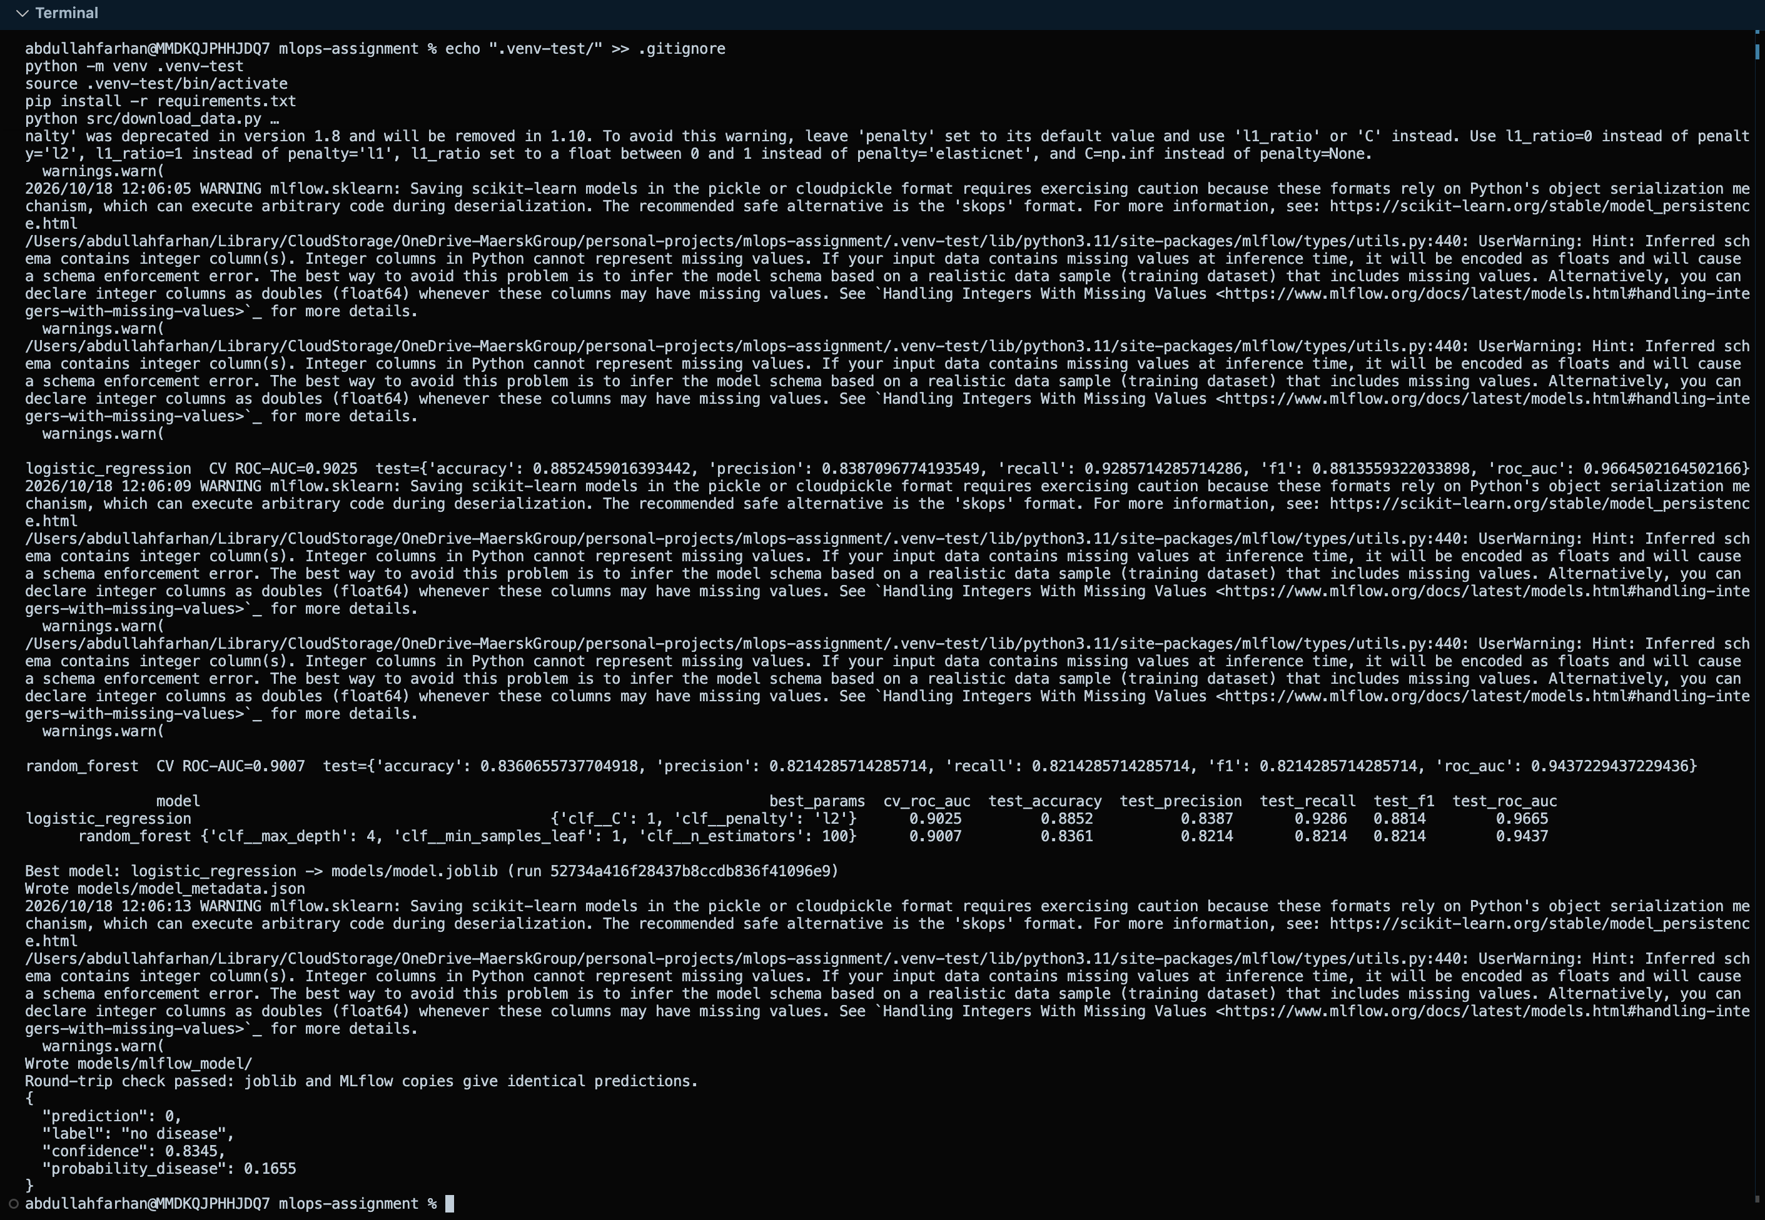
Figure 1. Full pipeline executed in a clean virtual environment

3. Data Acquisition and Exploratory Data Analysis

3.1 Dataset and cleaning
The Cleveland subset of the UCI Heart Disease dataset has 303 patient records and 13 predictors plus a binary target. After binarising the original 0-4 diagnosis column (0 = no disease, 1-4 = disease), there are 164 patients without disease (54.1%) and 139 with disease (45.9%).
The data is downloaded by src/download_data.py, which assigns the column names (the source file has no header) and treats '?' as missing.
Table 2. Cleaning decisions
Issue | Columns | Action | Reason
Missing values | ca, thal | Filled with the most frequent value | Categorical codes, only a handful of rows affected
Multi-class target | num | Binarised into target (0 / 1) | The task is risk prediction (disease present or not)
Duplicates | all | Dropped if present | Avoid leakage between train and test
Scaling / encoding | numeric / categorical | Done inside the model pipeline, not here | Same transformation at training and serving time

3.2 Exploratory analysis
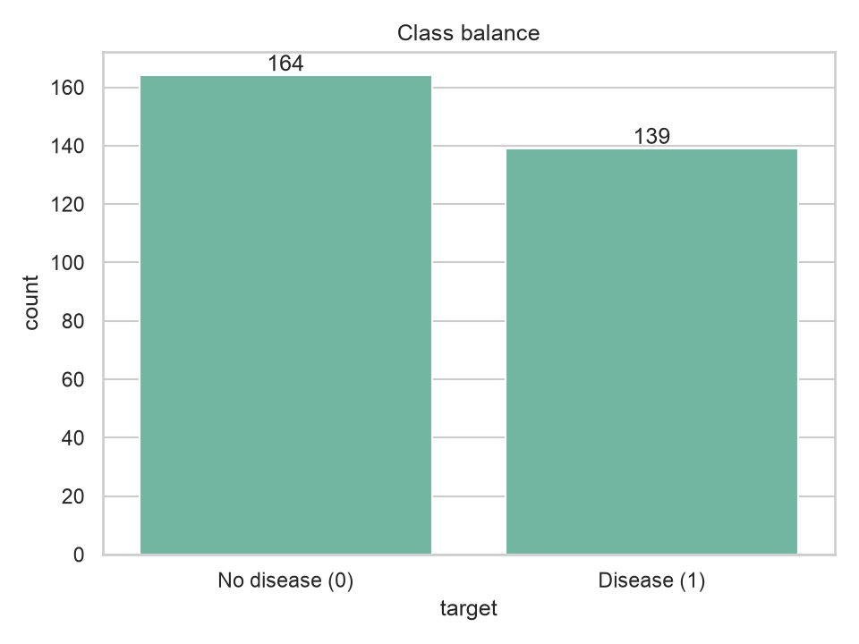 | 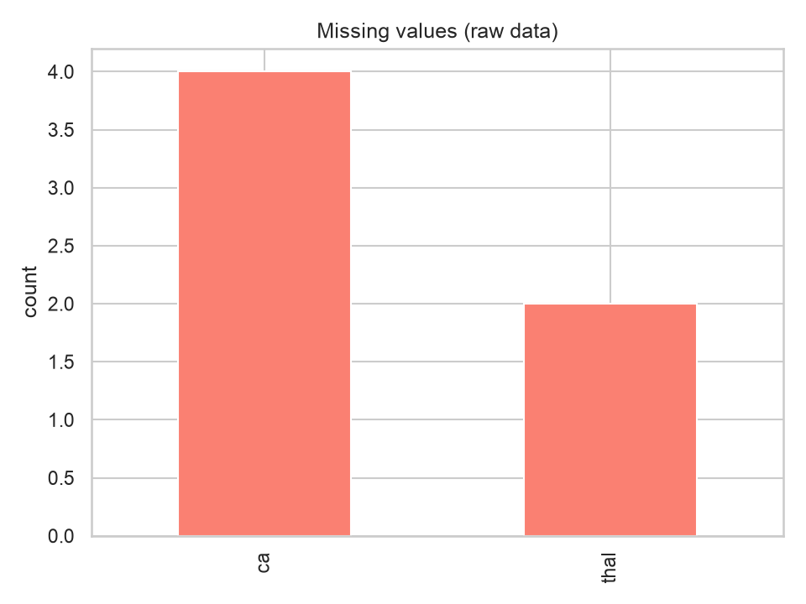
Figure 2. Class balance (left) and missing values in the raw data (right)
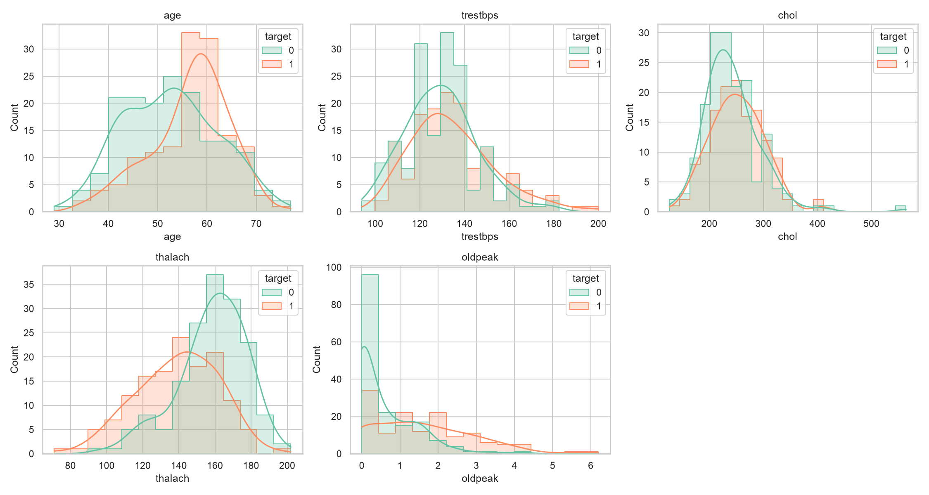
Figure 3. Numeric feature distributions split by target
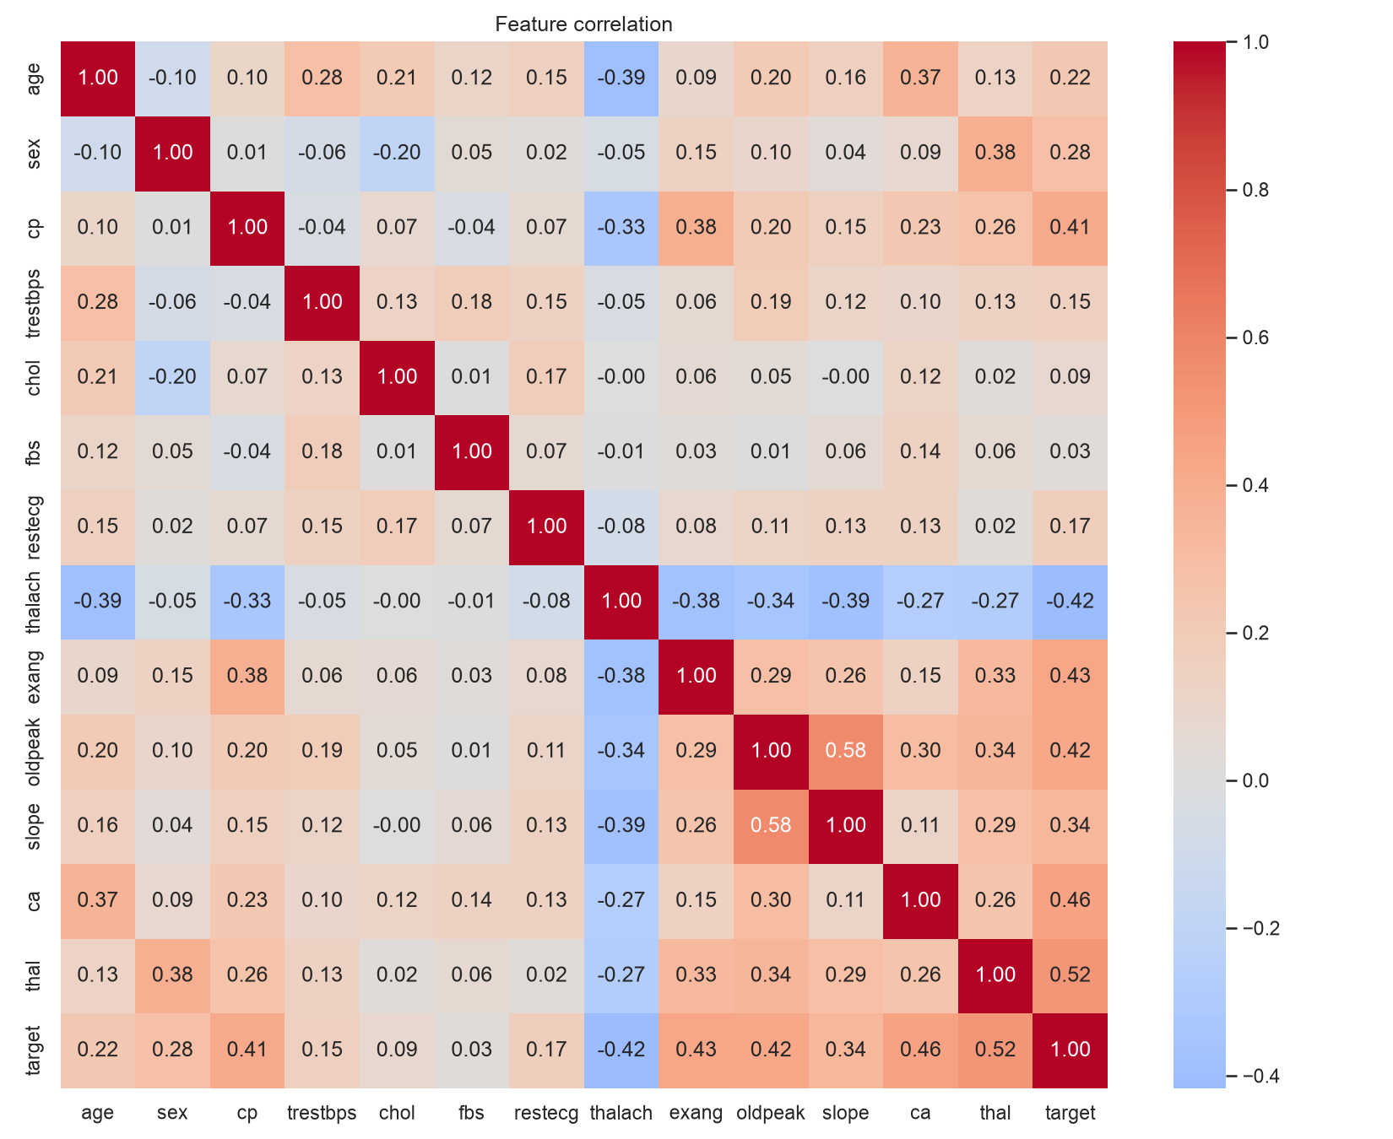
Figure 4. Correlation heatmap of all features
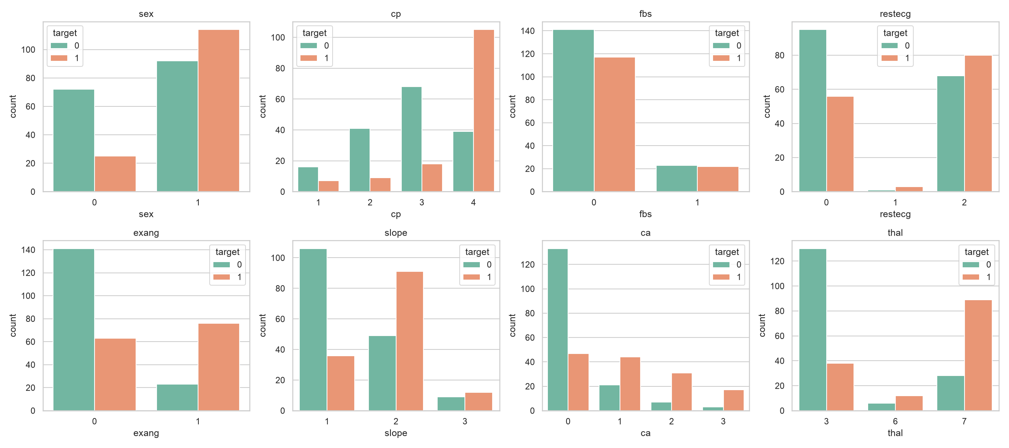
Figure 5. Categorical features against the target
Table 3. Six strongest correlations with the target
Feature | Correlation with target
thal | +0.522
ca | +0.460
exang | +0.432
oldpeak | +0.425
thalach | -0.417
cp | +0.414

Key observations
- [TODO: write 3-4 observations in your own words, e.g. class balance and what that means for the choice of metrics]
- [TODO: which numeric features separate the two classes best in the histograms/boxplots]
- [TODO: which categorical features (cp, thal, ca, exang) show the clearest pattern]
- [TODO: any outliers (e.g. chol) and whether you kept them, and why]

4. Feature Engineering and Model Development

4.1 Feature pipeline
All transformations live in one scikit-learn ColumnTransformer so the exact same steps run in training, tests and the API:
- Numeric (age, trestbps, chol, thalach, oldpeak): median imputation, then standard scaling.
- Categorical (sex, cp, fbs, restecg, exang, slope, ca, thal): most-frequent imputation, then one-hot encoding with handle_unknown='ignore'.
- Scaling matters for Logistic Regression because features such as chol and oldpeak sit on very different scales. Codes such as cp and thal are labels, not quantities, so they are one-hot encoded.

4.2 Models, tuning and evaluation
The data was split 80/20 with stratification (random_state = 42). Each model was tuned with GridSearchCV using 5-fold stratified cross-validation on the training portion, optimising ROC-AUC. The winner was chosen on its cross-validation score, so the held-out test set never influenced model selection.
Table 4. Search space
Model | Hyperparameter grid
Logistic Regression | C in {0.01, 0.1, 1, 10}; penalty = l2
Random Forest | n_estimators in {100, 200}; max_depth in {None, 4, 8}; min_samples_leaf in {1, 3}

Table 5. Cross-validation and held-out test results
Model | CV ROC-AUC | Accuracy | Precision | Recall | F1 | Test ROC-AUC
Logistic Regression | 0.902 | 0.885 | 0.839 | 0.929 | 0.881 | 0.967
Random Forest | 0.901 | 0.836 | 0.821 | 0.821 | 0.821 | 0.944

Selected model: Logistic Regression with best parameters {'clf__C': 1, 'clf__penalty': 'l2'}, CV ROC-AUC 0.902 and test recall 0.929.
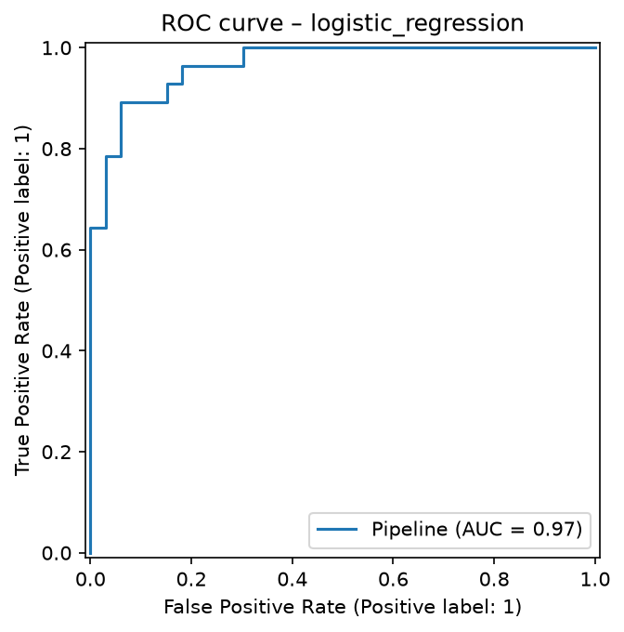 | 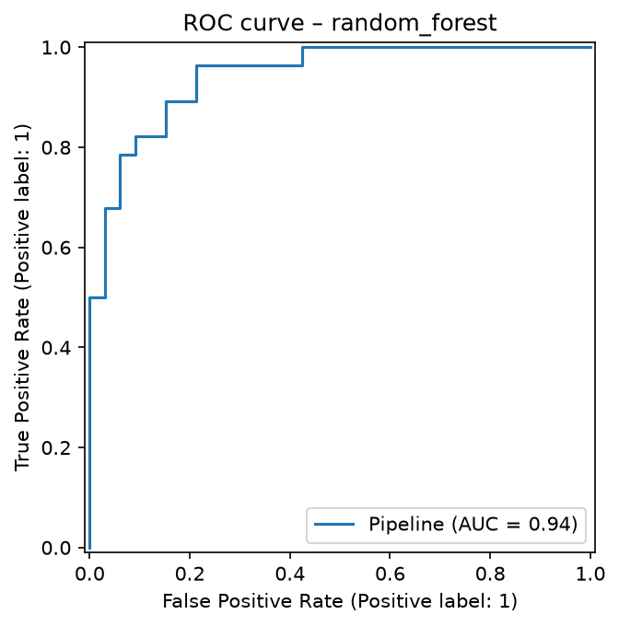
Figure 6. ROC curves on the test set: Logistic Regression (left), Random Forest (right)
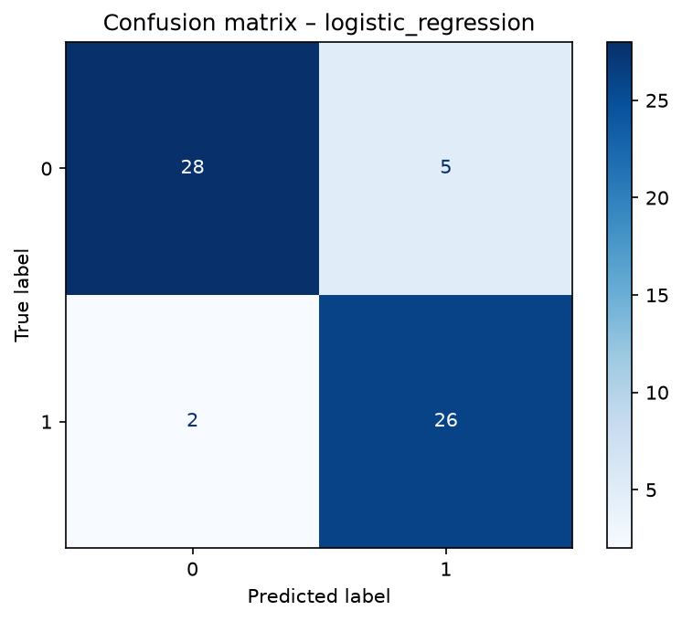 | 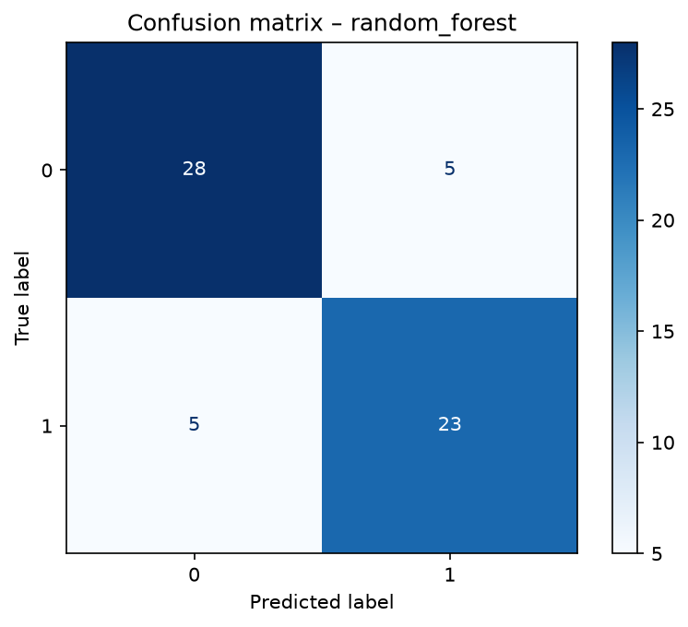
Figure 7. Confusion matrices on the test set
[TODO: 3-4 sentences on why you picked this model: compare CV score vs test score, recall (missed disease cases are costly), interpretability, and any overfitting you saw]

5. Experiment Tracking
MLflow records every training run so results can be compared, audited and reproduced. Each model gets a parent run, and every hyperparameter combination tried by the grid search is logged as a nested child run.
Table 6. What is logged to MLflow
Logged item | Details
Parameters | model name, split size, CV folds, random state, row counts, search grid, best parameters
Metrics | per-candidate CV ROC-AUC mean and std; best CV ROC-AUC; test accuracy, precision, recall, F1, ROC-AUC
Artifacts | confusion matrix and ROC curve (plots/), full pipeline (model/), model_comparison.csv
Tags | model_type, stage, selected_as_best on the winning run

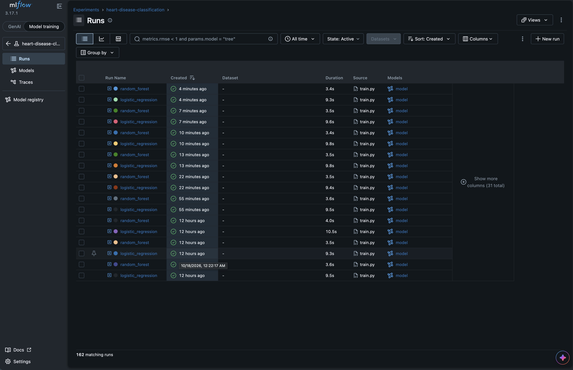
Figure 8. MLflow experiment with parent runs and nested candidate runs
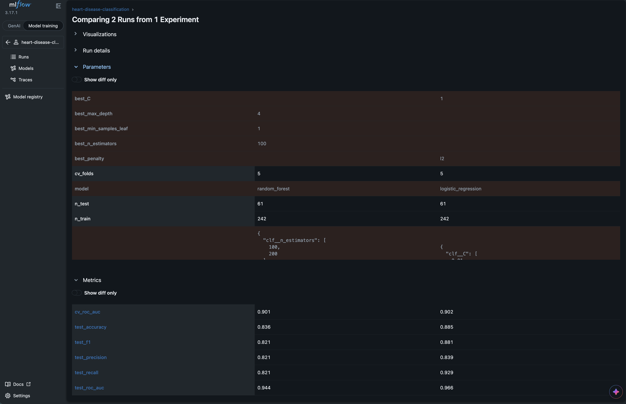
Figure 9. MLflow run comparison of the two models
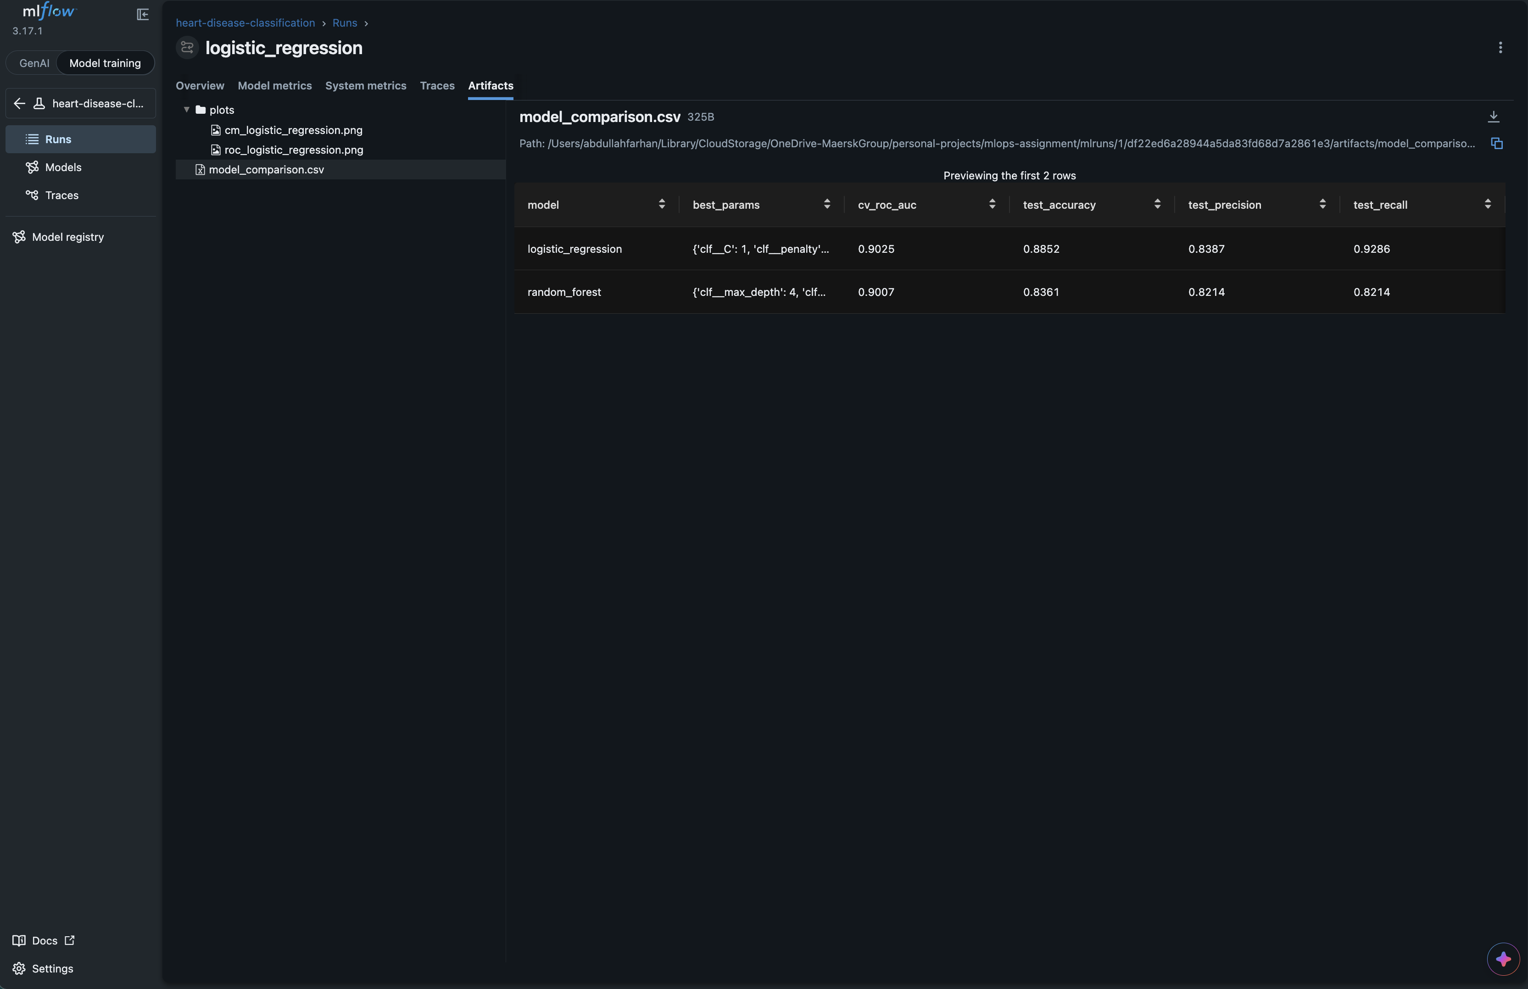
Figure 10. MLflow artifacts: plots/ and model/
[TODO: 2-3 sentences on what the candidate runs showed, e.g. how much C or max_depth changed the CV ROC-AUC]

6. Model Packaging and Reproducibility
The final artefact is a single scikit-learn Pipeline (imputers, scaler, one-hot encoder and classifier) saved as models/model.joblib, plus an MLflow-format copy in models/mlflow_model that carries its own environment files. Because preprocessing is part of the saved object, the API receives raw feature values and cannot drift from the training-time transformations. joblib was chosen over ONNX because it keeps the complete pipeline, including one-hot encoding, without conversion tooling.
Table 7. Model metadata (models/model_metadata.json)
Metadata field | Value
Model | Logistic Regression
Trained at (UTC) | 2026-10-18T06:36:13+00:00
Python / scikit-learn | 3.11.9 / 1.9.1
Training data hash (SHA-256, truncated) | d0021ed770110715
Model file hash (SHA-256, truncated) | d4d0b7f5cb8ec4ca
Random state | 42

Reproducibility measures
- Fixed random_state = 42 for the split, cross-validation and models; training twice produced an identical comparison table.
- Pinned requirements files and a pinned Python version.
- package_model.py checks that the joblib and MLflow copies give identical predictions.
- The pipeline was run end-to-end in a clean virtual environment (Figure 1).
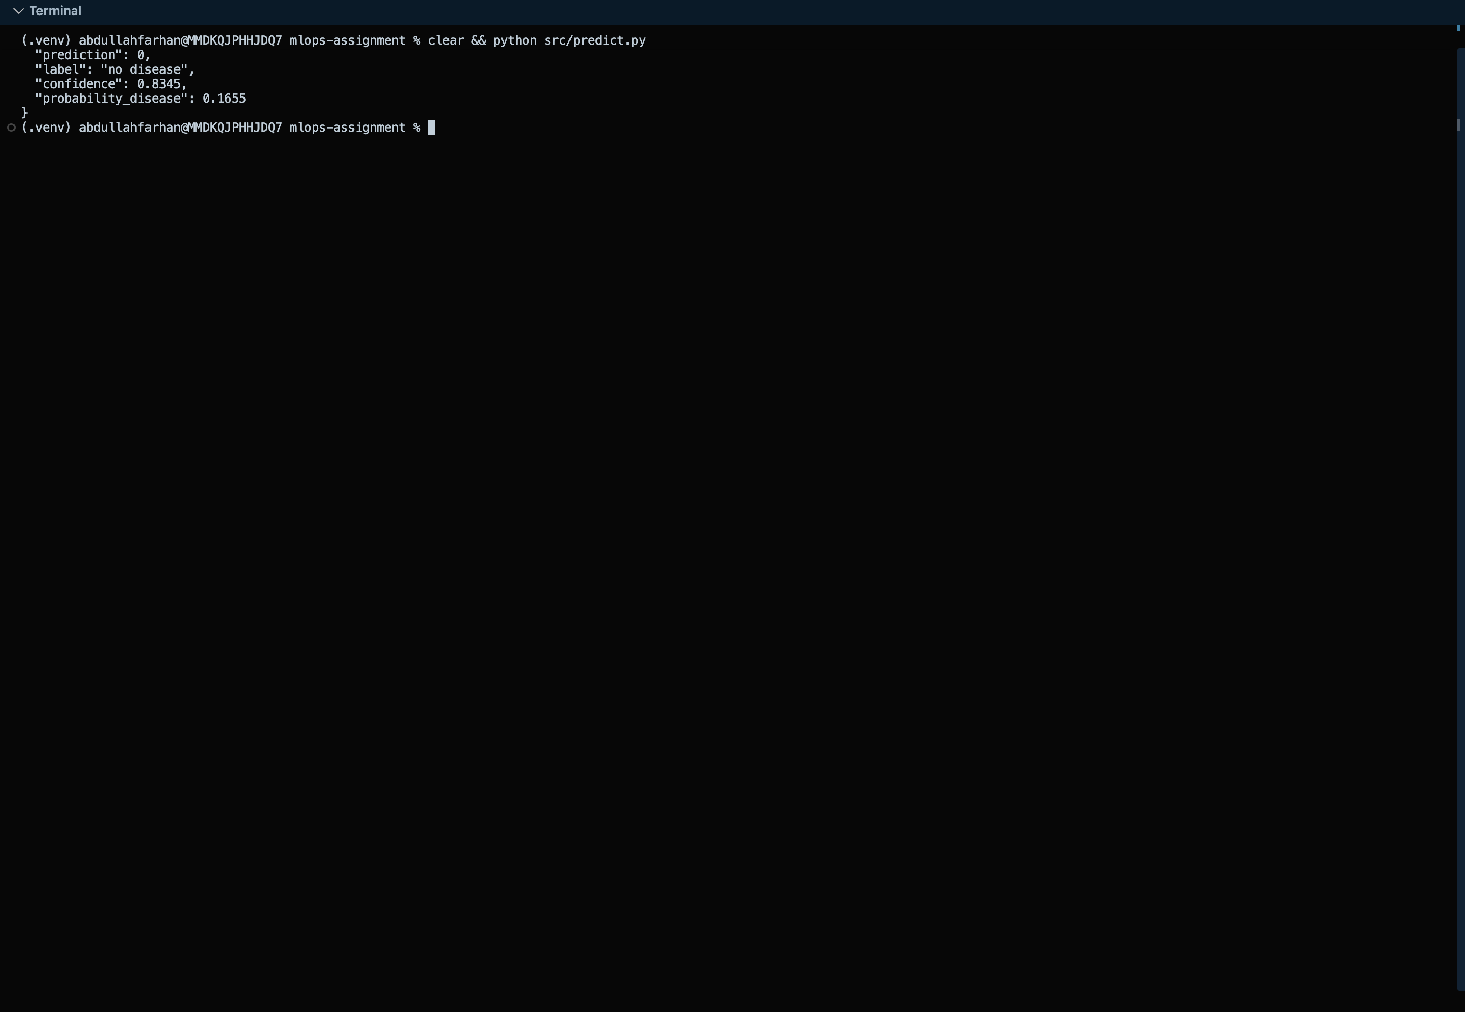
Figure 11. Command-line inference with src/predict.py

7. CI/CD Pipeline and Automated Testing
Table 8. Unit-test suite (pytest)
Test file | What it covers | Tests
test_api.py | Health, /predict, validation errors (422), /metrics endpoint | 6
test_features.py | Scaling, one-hot encoding, unseen categories, imputation | 5
test_model.py | Metric ranges, probability validity, training reproducibility | 3
test_predict.py | Output format, confidence range, missing-feature error, saved model | 3
test_preprocess.py | Target binarisation, missing-value handling, duplicates, no input mutation | 6
Total |  | 23

The tests use small synthetic datasets so they run in seconds and do not depend on local files. The GitHub Actions workflow (.github/workflows/ci.yml) has three chained jobs:
Table 9. CI/CD workflow
Job | Steps | Artifacts
lint | flake8 on src/ and tests/ | flake8-report.txt
test | pytest (needs lint) | pytest-report.xml
train | preprocess, train with MLflow, package model, smoke-test inference (needs test) | models/, reports/, mlruns/

A failure in lint or test stops the pipeline and skips later jobs, so broken code never reaches the training stage. Logs for every step are retained by GitHub.
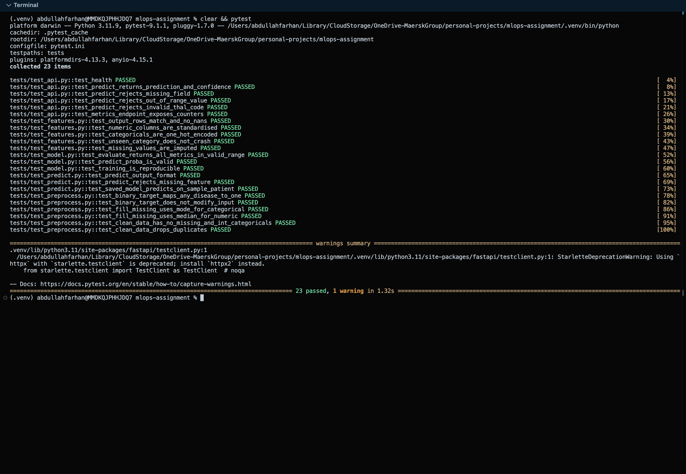
Figure 12. Local pytest run
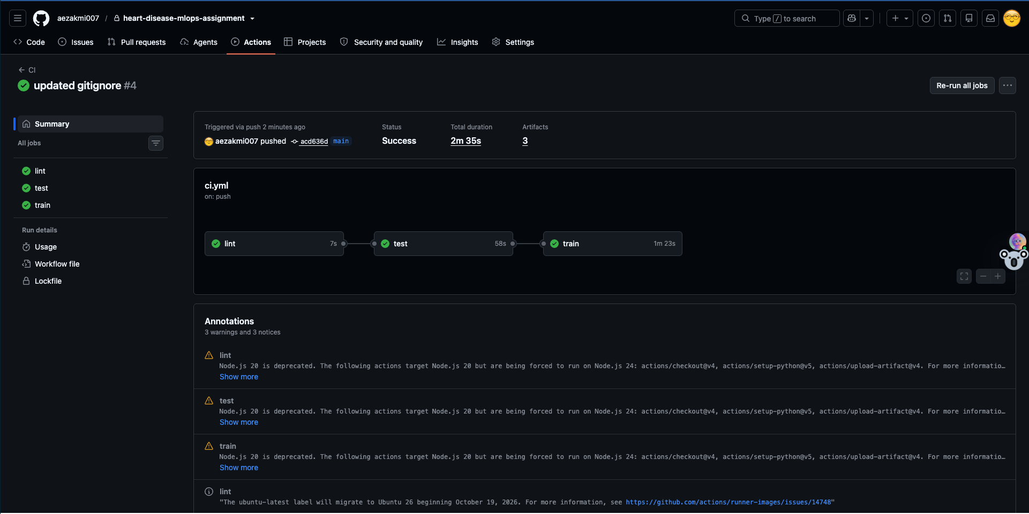
Figure 13. GitHub Actions run: lint, test and train jobs all passing
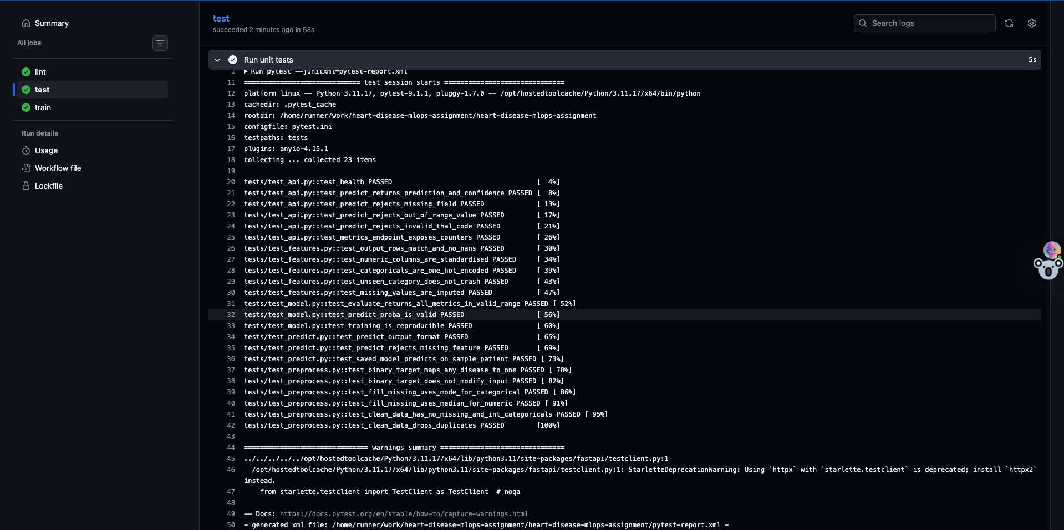
Figure 14. Expanded pytest step logs in GitHub Actions
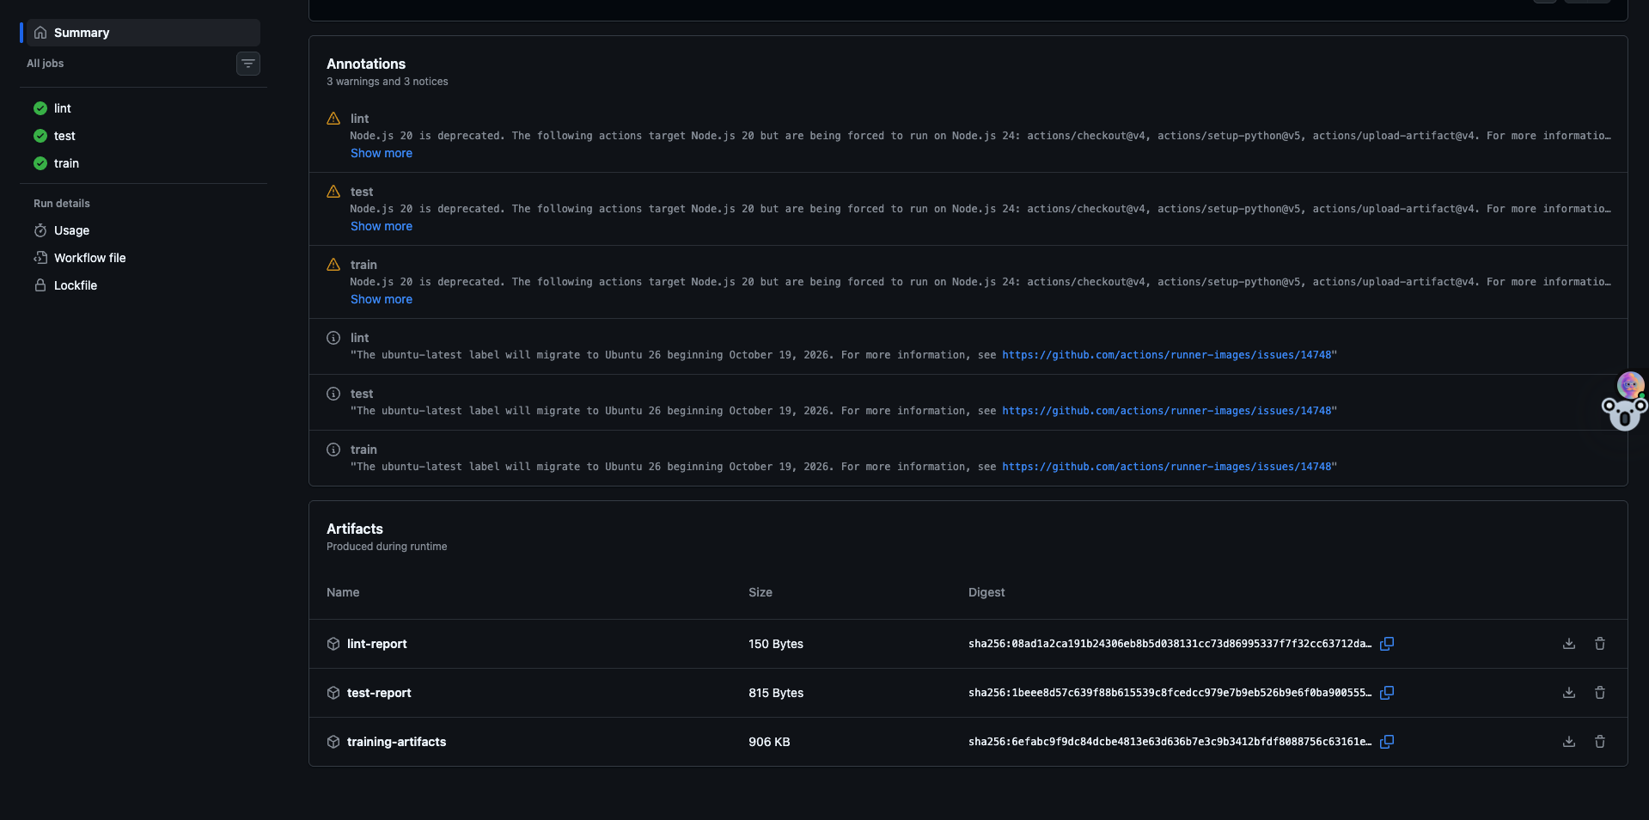
Figure 15. Artifacts uploaded by a workflow run

8. Containerisation and Deployment

8.1 Serving API
The service is built with FastAPI. POST /predict accepts the 13 patient features as JSON and returns the prediction and a confidence value. Pydantic validates every field (type and range), so invalid input is rejected with HTTP 422 before it reaches the model. GET /health supports Kubernetes probes and GET /metrics exposes Prometheus metrics.
Request POST /predict
{"age": 63, "sex": 1, "cp": 1, "trestbps": 145, "chol": 233, "fbs": 1, "restecg": 2,
"thalach": 150, "exang": 0, "oldpeak": 2.3, "slope": 3, "ca": 0, "thal": 6}

Response 200
{"prediction": 1, "label": "disease", "confidence": 0.87, "probability_disease": 0.87}

[TODO: replace the response above with the real output from your container]
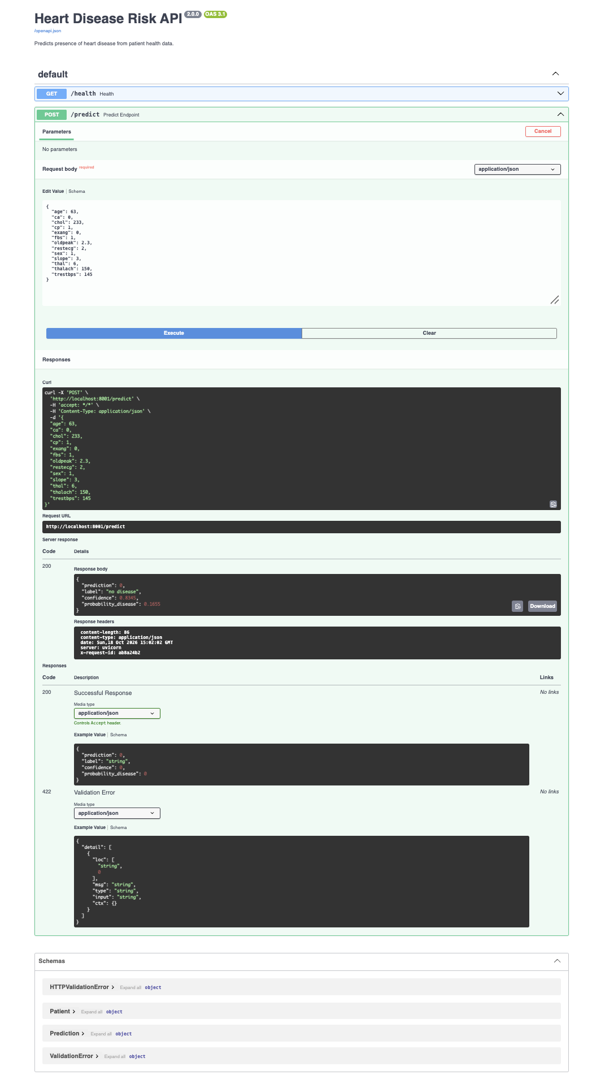
Figure 16. Swagger UI calling POST /predict

8.2 Docker image
- Slim Python 3.11 base image; dependencies installed before the code so Docker caches that layer.
- A separate requirements-api.txt keeps MLflow, Matplotlib and Jupyter out of the image.
- Runs as a non-root user and includes a HEALTHCHECK.
- .dockerignore keeps the virtual environment, data, notebooks and tests out of the build context.

8.3 Kubernetes deployment
The image was deployed on a local Kubernetes cluster (Rancher Desktop) using manifests in k8s/ and exposed through a LoadBalancer service:
Table 10. Kubernetes manifests
Manifest | Defines
00-namespace.yaml | heart-api namespace
10-deployment.yaml | 2 replicas, rolling update (maxUnavailable 0), readiness and liveness probes on /health, CPU/memory requests and limits, non-root security context
20-service.yaml | LoadBalancer service on port 8081 forwarding to container port 8000
30-service-headless.yaml | Headless service so Prometheus scrapes each pod separately

Access: kubectl apply -f k8s/, then open http://localhost:8081/docs. The following were demonstrated: traffic shared across both pods, automatic replacement of a deleted pod, scaling, and a rolling update with rollback.
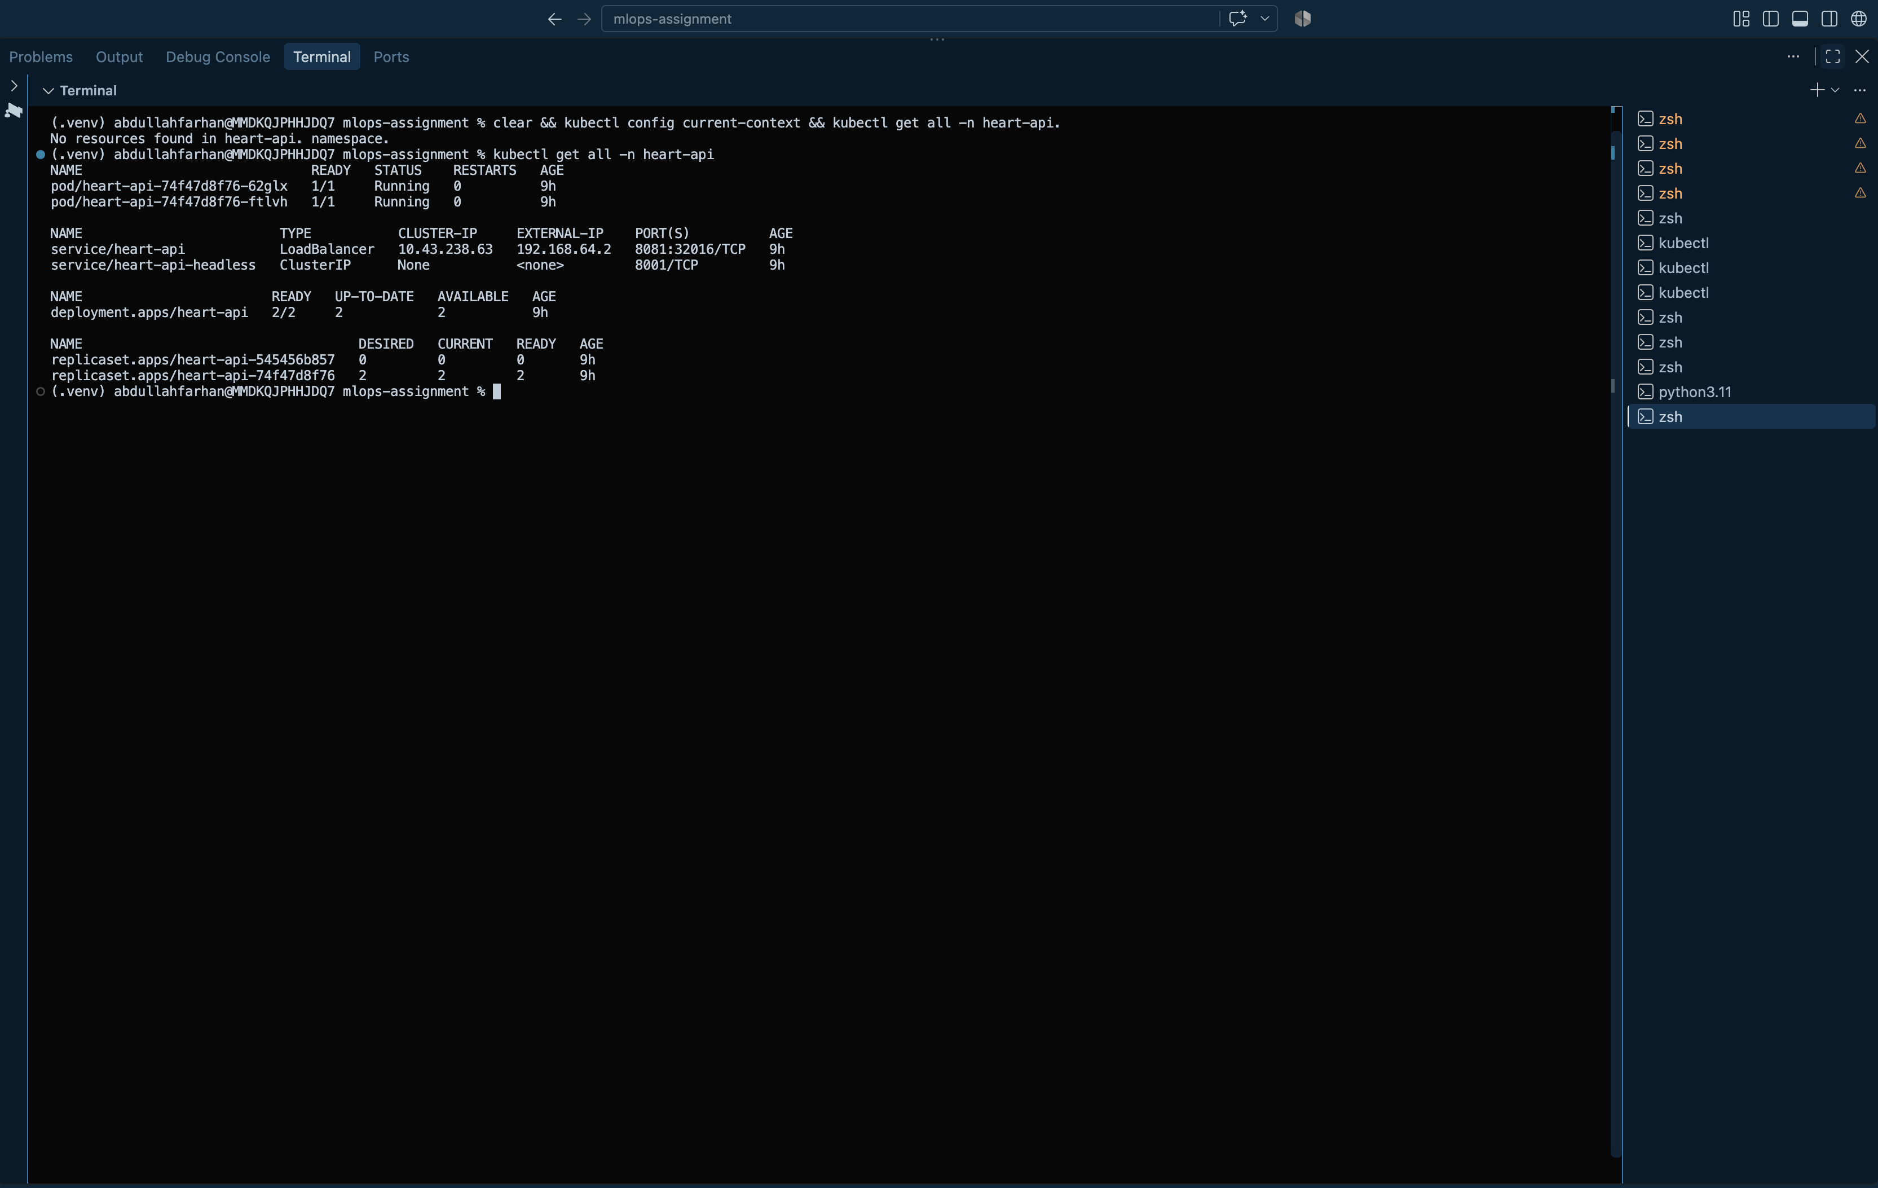
Figure 17. kubectl get all -n heart-api
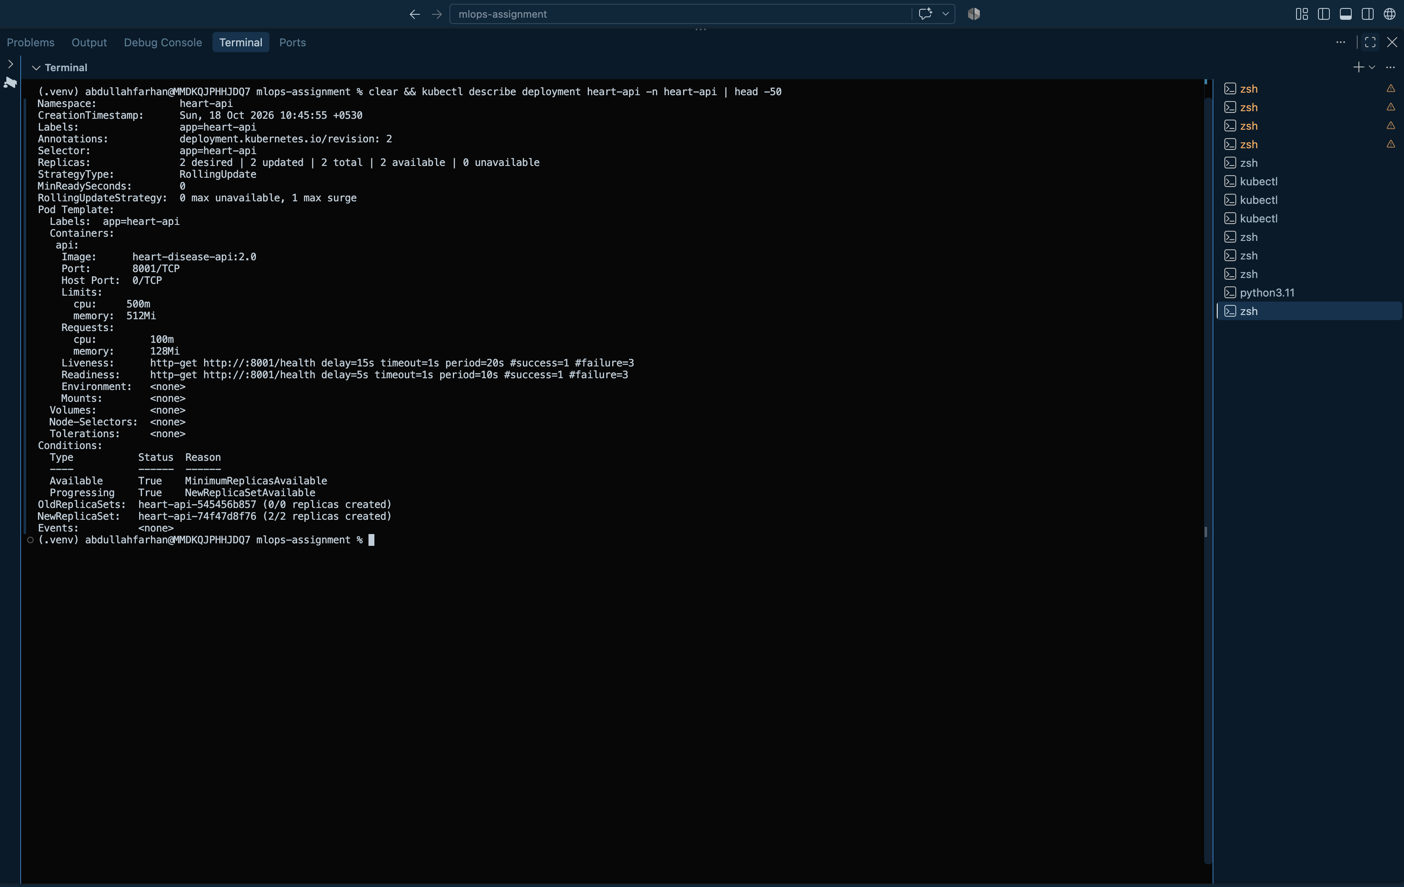
Figure 18. kubectl describe deployment

9. Monitoring and Logging
Every request passes through a middleware that writes one structured JSON log line (request ID, method, path, status, duration) and updates Prometheus metrics. Patient input values are deliberately not logged, to avoid writing health data to logs. Health and metrics calls are excluded so probes do not flood the logs.
{"event": "request", "request_id": "3f9a1c2e", "method": "POST", "path": "/predict", "status": 200, "duration_ms": 6.41}

Table 11. Exported metrics
Metric | Type | Purpose
api_requests_total{method,path,status} | Counter | Traffic and error rates
api_request_duration_seconds{path} | Histogram | Latency percentiles (p95)
api_predictions_total{label} | Counter | Predicted class mix, a simple drift signal
api_prediction_confidence | Histogram | Model confidence over time

Prometheus discovers both API pods through the headless service and scrapes them every 10 seconds. The Grafana dashboard shows request rate, p95 latency, pods up, 5xx error rate, average confidence and predictions by class. It was tested with 300 generated requests, about 10% of them deliberately invalid.
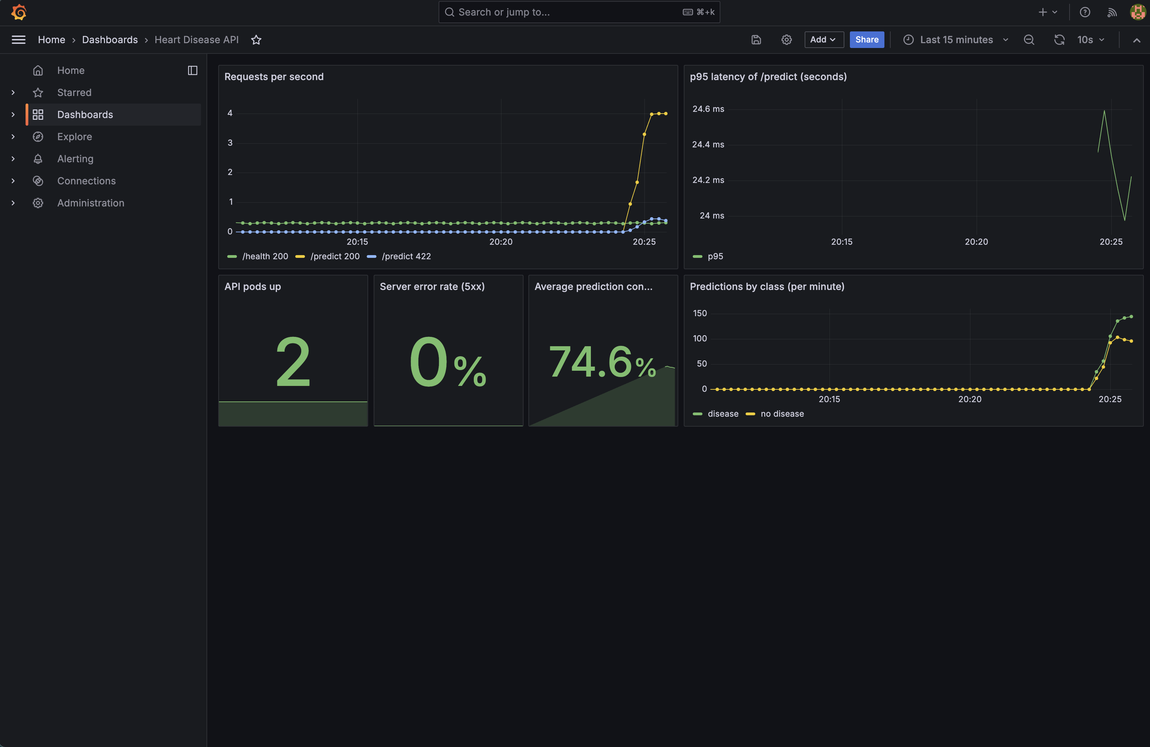
Figure 19. Grafana dashboard under generated traffic
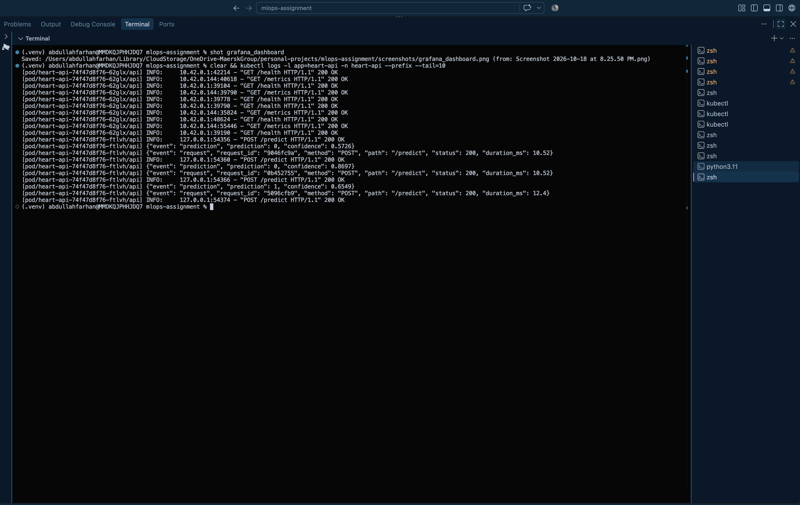
Figure 20. Structured JSON request logs from both pods
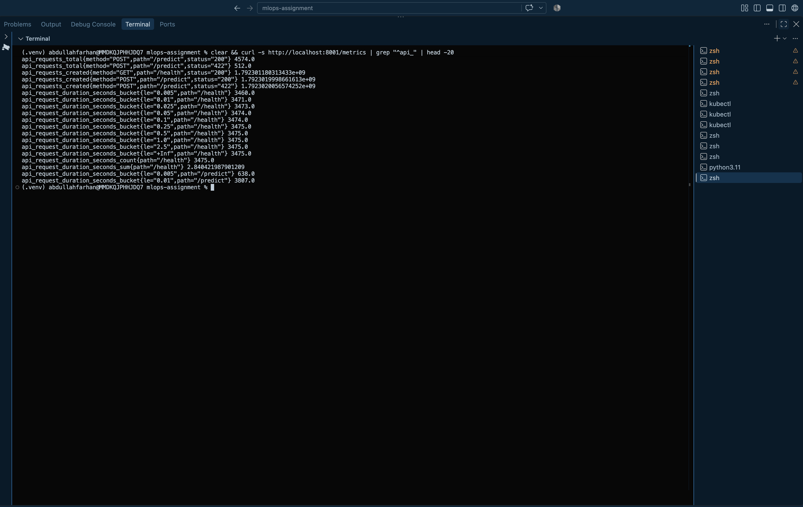
Figure 21. Raw /metrics output
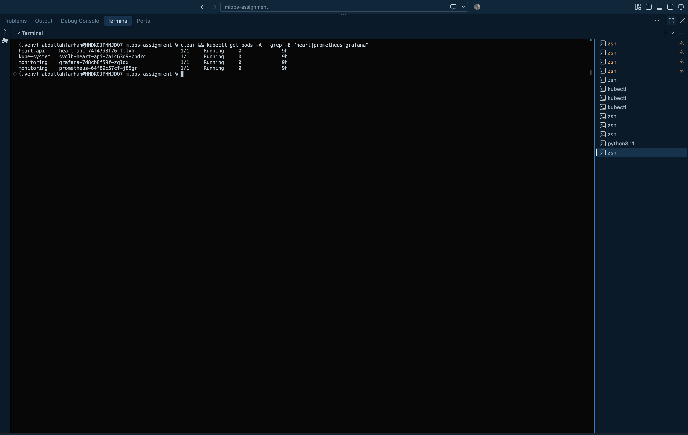
Figure 22. All pods across the heart-api and monitoring namespaces

10. Architecture, Repository and Conclusion
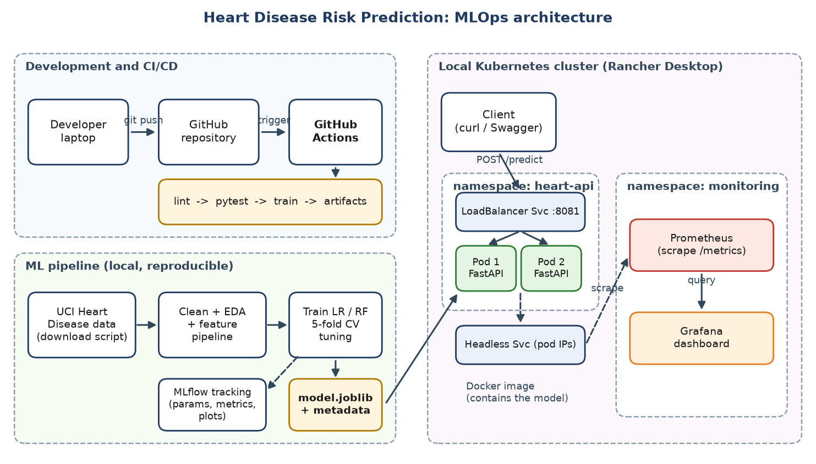
Figure 23. End-to-end architecture

10.1 Repository structure
heart-disease-mlops/
.github/workflows/ci.yml CI/CD pipeline
data/ raw + cleaned dataset, sample input
notebooks/01_eda.ipynb exploratory analysis
src/ download, preprocess, features, train, package, predict, app
tests/ pytest unit tests
models/ model.joblib, metadata, MLflow-format copy
k8s/ monitoring/ Kubernetes and Prometheus/Grafana manifests
scripts/ traffic generator, report builder
screenshots/ reports/ evidence and figures
Dockerfile requirements*.txt

Repository: https://github.com/aezakmi007/heart-disease-mlops-assignment
Access: the API runs locally at http://localhost:8081/docs after kubectl apply -f k8s/. No public URL is exposed.

10.2 Conclusion and limitations
The project delivers a complete, automated path from raw data to a monitored, containerised prediction service.
- The dataset is small (303 rows), so metrics have wide uncertainty and the model is a learning exercise, not a clinical tool.
- The model is a static artefact; there is no automated retraining or drift alerting yet.
- Deployment is local; moving to a cloud cluster would need a container registry and Ingress.

