**1.Initialization**

Use R's kmeans function with several random starts to build a preliminary clustering. Set γik= 1 if observation i is assigned to cluster k and γik=0 otherwise. By running the K-means algorithm 10 times, each with a maximum iteration number of 20, finally we get 10 clusters. And the clusters size show in below table

|  |  |  |  |  |  |  |  |  |  |  |
| --- | --- | --- | --- | --- | --- | --- | --- | --- | --- | --- |
| Cluster | 1 | 2 | 3 | 4 | 5 | 6 | 7 | 8 | 9 | 10 |
| Number | 157 | 225 | 131 | 110 | 88 | 168 | 254 | 132 | 166 | 162 |

**2.Convergence:**

The log-likelihood vs. iteration number plots are shown as follows. We generate a plot of the observed data log-likelihood vs. iteration number (4 plots, 1 for each q, q= # principle components).

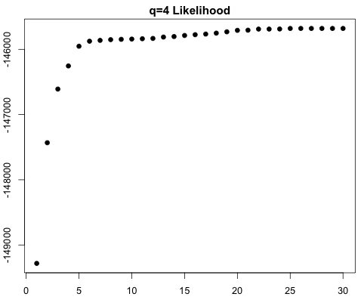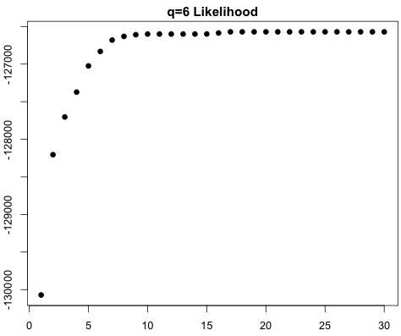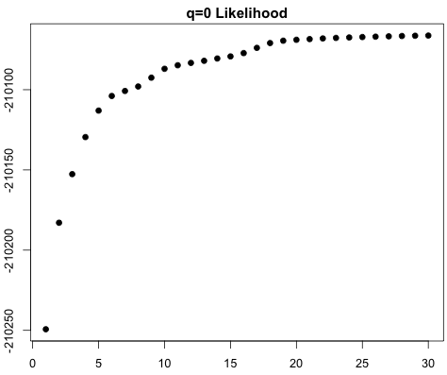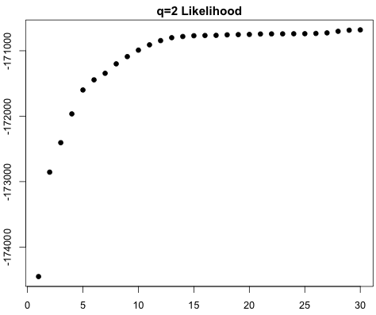

The final log-likelihood values are listed as follows:

|  |  |
| --- | --- |
| q value | Likelihood |
| q=0 | -210662.2 |
| q=2 | -170680.7 |
| q=4 | -145721.1 |
| q=6 | -125926.6 |

We can see from the table above, the log likelihood increase as the q value increase.

**3.Choice of Number of Principle Component, q:**

The Akaike information criterion (AIC) is a measure of the relative quality of statistical models for a given set of data. It offers a relative estimate of the information lost when a given model is used to represent the process that generates the data. Given a set of candidate models for the data, the preferred model is the one with the minimum AIC value.

|  |  |
| --- | --- |
| q value | AIC |
| q=0 | 420134.5 |
| q=2 | 342385.3 |
| q=4 | 293480.0 |
| q=6 | 254897.3 |

We can see from the table above, when q=6 the AIC value is the minimum. Thus we choose 6 principle component.

**4.Visualization of Clusters:**

We visualized the cluster mean and drew 5 samples from each cluster-specific distribution, where q is set to be 6. As we can see from this visualization, the digits 4, 3, 6 and 0 work pretty good for this algorithms. However, it doesn’t work well for other digits. Like digits 8, it’s barely recognizable from the visualization results.

**5.Accuracy Assessment:**



Mis-categorization rate (For q=6)

|  |  |  |  |  |  |  |  |  |  |  |
| --- | --- | --- | --- | --- | --- | --- | --- | --- | --- | --- |
| Cluster | 1 | 2 | 3 | 4 | 5 | 6 | 7 | 8 | 9 | 10 |
| Rate | **0.0311** | **0.4259** | **0.3270** | **0.2579** | **0.1242** | **0.3962** | **0.2112** | **0.1646** | **0.3355** | **0.3861** |

Overall mis-catagorization rate

|  |  |  |  |  |
| --- | --- | --- | --- | --- |
| q | 0 | 2 | 4 | 6 |
| Rate | 0.39485 | 0.28813 | 0.30138 | 0.26554 |

R Code

# ISyE 6740 Take Home Exam #1

library(mvtnorm)

# Read handwritten digits data

myData=read.csv("semeion.csv",header=FALSE)

myX=data.matrix(myData[,1:256])

myLabel=apply(myData[,257:266],1,function(xx){

return(which(xx=="1")-1)

})

# Number of rows

NR=dim(myX)[1]

# Number of columns

NC=dim(myX)[2]

# Number of clusters

Nclu=10

# Number of principal component

q=6

#Cluster data by using kmeans method, K=10

myCluster=kmeans(myX,10,iter.max=20,nstart=10)

#Initialization: assignments of data

gamma=matrix(0,nrow=NR,ncol=Nclu)

for(i in 1:NR) {

Clc=myCluster$cluster[i]

gamma[i, Clc]=1

}

#For likelihood

likeli=rep(0,30)

#Iterations

for(it in 1:30){

N=matrix(0,1,10)

for(i in 1:10) {

N[i]=sum(gamma[,i])

}

Mu=matrix(0,nrow=Nclu,ncol=NC)

pi=matrix(0,10,1)

#Initialization of covariance matrices

sigma=array(dim=c(256,256,10))

px=matrix(0,NR,Nclu)

#------------------------M-Step------------------------

for(k in 1:Nclu){

mu_k=rep(0,256)

for(n in 1:NR){

mu_k=mu_k+gamma[n,k]*myX[n, ]

}

Mu[k,]=mu_k/N[k]

}

pi=colSums(gamma)/NR

for (k in 1:Nclu){

Covar_k=matrix(0,256,256)

for(n in 1:NR){

Xi_Bar=myX[n, ]-Mu[k, ]

Covk_temp=(Xi_Bar %*% t(Xi_Bar))*gamma[n,k]

Covar_k=Covar_k+Covk_temp

}

Covar_k=Covar_k/N[k]

myeigen=eigen(Covar_k,symmetric=TRUE)

Vq=myeigen$vectors[,1:q]

sigma_2=sum(myeigen$values[q+1:NC],na.rm=TRUE)/(NC-q)

diag_q=diag(q)

for(nq in 1:q){

diag_q[nq,nq]=sqrt(myeigen$values[nq]-sigma_2)

}

Wq=Vq %*% diag_q

sigma[ , ,k]=Wq %*% t(Wq)+(sigma_2*diag(NC))

}

#------------------------E-Step----------------------

for (k in 1:Nclu){

px[ ,k]=pi[k]*dmvnorm(myX,Mu[k, ],sigma[ , ,k],log=FALSE)

}

for (i in 1:NR){

for(k in 1:Nclu){

gamma[i,k]=px[i,k]/sum(px[i, ])

}

}

#------------------------Likelihood------------------------

likeli[it]=sum(log(rowSums(px)))

print(c(it,likeli[it]))

}

#------------------------Computer AIC----------------------

AIC= -2*likeli[30]+2*(NC*q+1-q*(q-1)/2)

likeli

AIC

# Plot likelihood VS. iter

dev.new(width=6,height=4)

par(mai=c(0.5,0.45,0.35,0.05),cex=0.8)

plot(1:30,likeli, pch=19,axes=TRUE)

title("q=6 Likelihood")

# Visulazation pictures

dev.new(width=6,height=10)

par(mai=c(0,0,0,0),cex=0.8,mfrow=c(10,6))

for(k in 1:Nclu){

image(t(matrix(Mu[k, ],byrow=TRUE,16,16)[16:1, ]),col=gray(0:256/256),axes=FALSE)

box( )

for(j in 1:5){

temp=rmvnorm(1,mean=Mu[k, ],sigma[ , ,k])

image(t(matrix(temp,byrow=TRUE,16,16)[16:1, ]),col=gray(0:256/256),axes=FALSE)

box ( )

}

}

# Accuracy Assessment

# calculate new Labels

EMLabel = matrix(0,NR,Nclu)

for(i in 1:NR){

EMLabel[i,which.max(gamma[i,])]=1

}

# Accuracy Assessment

misRate=matrix(1,Nclu,1)

temp1=0

for(i in 1:Nclu){

temp=apply(EMLabel[myLabel==(i-1),],2,function(xx){

return(sum(xx))

})

misRate[i,] =1-max(temp)/sum(temp)

temp1=temp1+max(temp)

}

OverAllMisRate=1-temp1/NR

#For q=0 There is a little difference for M-step

for(k in 1:Nclu){

mu_k=rep(0,256)

for(n in 1:NR){

mu_k=mu_k+gamma[n,k]*myX[n, ]

}

Mu[k,]=mu_k/N[k]

}

pi=colSums(gamma)/NR

for (k in 1:Nclu){

Covar_k=matrix(0,256,256)

for(n in 1:NR){

Xi_Bar=myX[n, ]-Mu[k, ]

Covk_temp=(Xi_Bar %*% t(Xi_Bar))*gamma[n,k]

Covar_k=Covar_k+Covk_temp

}

Covar_k=Covar_k/N[k]

myeigen=eigen(Covar_k,symmetric=TRUE)

sigma_2=sum(myeigen$values[q+1:NC],na.rm=TRUE)/(NC-q)

sigma[ , ,k]=(sigma_2*diag(NC))

}