* Extract file ppob_saipay
* Create table pobb_saipay
* Import file pobb_saipay.sql to your database
* Run php artisan serve

# Halaman Login

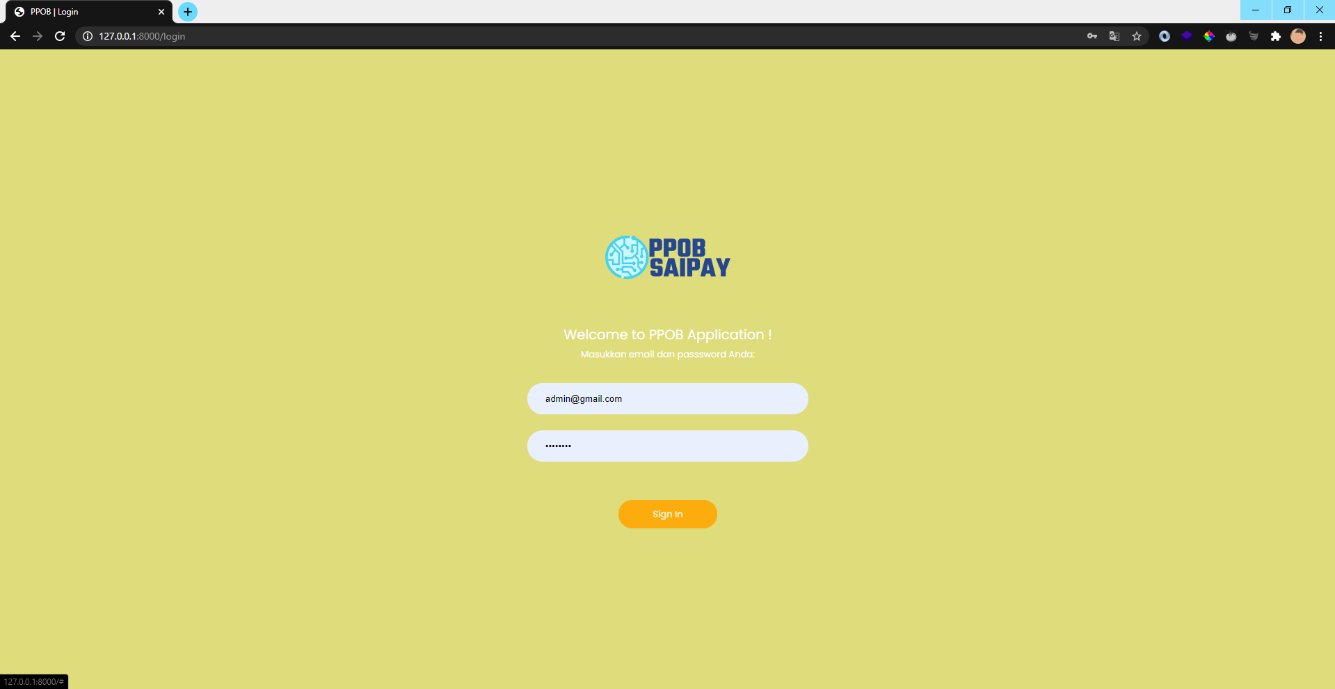

1. Username/ email = [user@gmail.com](mailto:user@gmail.com)
2. Password = user123

# Halaman Dahsboard

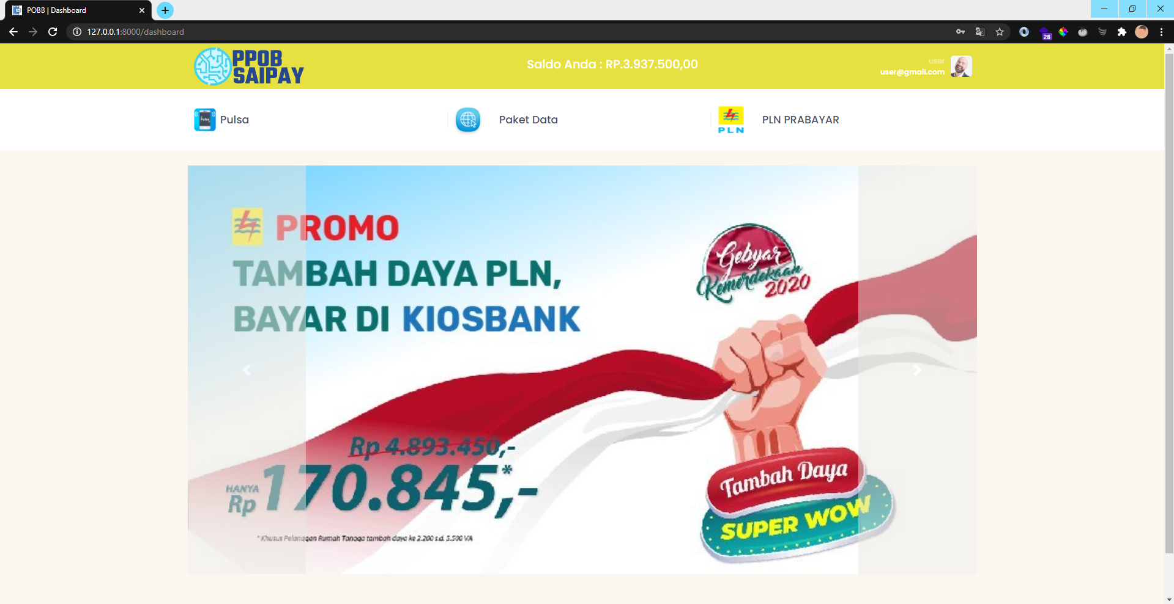

# Halaman Pulsa

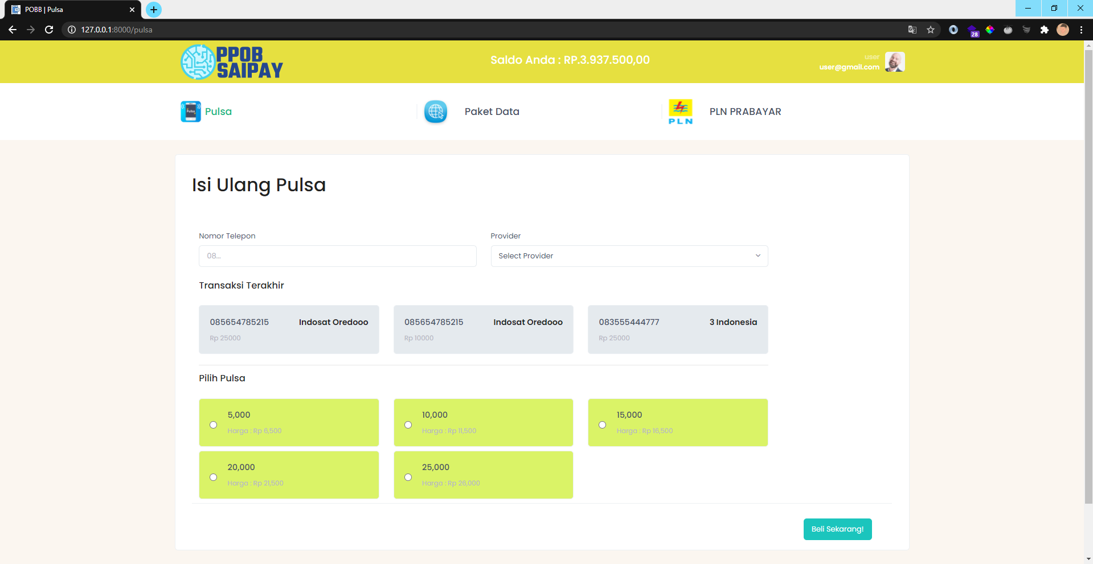

# Halaman Paket Data

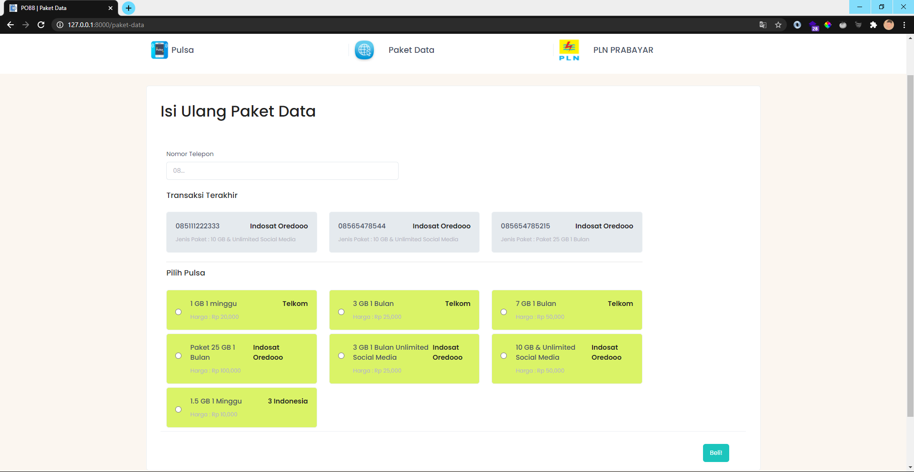

# Halaman PLN Prabayar

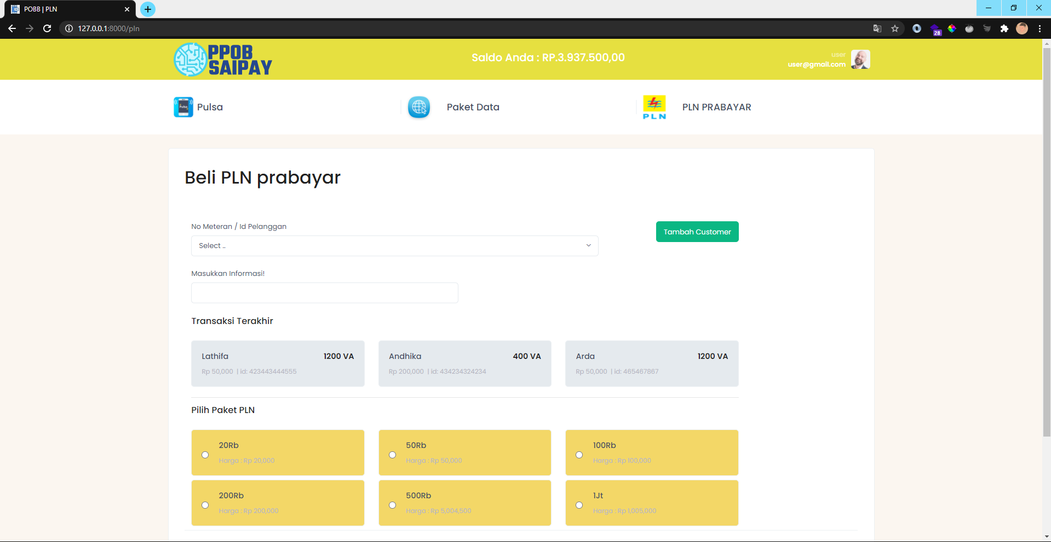

# Halaman Insert Customer PLN

