CS 112: Computer Programming for CS
Week 1 Deliverable Package
Preliminary Requirements, UML Diagrams, Framework Decisions,
Coding & Documentation Standards, Initial Test Plan,
and Ethical/Security Boundaries
Components: National Electricity Grid Network Analysis | GridCare-Lite | ClinicCare-Lite

1. Purpose of This Document
This document satisfies the Week 1 deliverable for the CS 112 Final Course Project: preliminary application requirements, UML diagrams (use case, class, architecture, and entity-relationship) for GridCare-Lite and ClinicCare-Lite, the team's development framework decisions, coding and documentation standards, an initial test plan, and the ethical/security boundaries specific to ClinicCare-Lite. Requirements here are preliminary and expected to be refined as implementation reveals edge cases in Weeks 2 to 5.

2. Preliminary Application Requirements — GridCare-Lite

2.1 Functional Requirements
ID | Requirement | Priority
FR-1 | Users must log in with a username/ID and password before accessing any screen. | High
FR-2 | The system must support four roles: Administrator, Engineer, Technician, and Customer-Service Rep, each restricted to its own permitted actions. | High
FR-3 | Engineers can log a new outage against a valid, existing substation (validated against the imported grid data). | High
FR-4 | Administrators can create a work order from a logged outage and assign it to an available technician. | High
FR-5 | Technicians can view only the work orders assigned to them and update status (Assigned → In Progress → Resolved). | High
FR-6 | Customer-Service Reps can log a complaint and link it to an existing outage. | Medium
FR-7 | The system must display an operational dashboard summarising open outages, average resolution time, and outages by region. | Medium
FR-8 | The system must reject an outage/work order referencing a substation ID that does not exist in the imported dataset. | High
FR-9 | Every work-order status change must be recorded in a status-history log with a timestamp and the user who made the change. | Medium

2.2 Non-Functional Requirements
ID | Requirement | Priority
NFR-1 | The GUI must not crash on invalid input (empty fields, non-numeric IDs, bad dates) — errors are caught and shown to the user. | High
NFR-2 | Passwords are never stored or displayed in plain text. | High
NFR-3 | Common operations (login, opening the dashboard) should complete in under 2 seconds on a typical student laptop. | Low
NFR-4 | The database schema and data dictionary must be documented well enough for a new teammate to understand it without asking. | Medium

3. Preliminary Application Requirements — ClinicCare-Lite

3.1 Functional Requirements
ID | Requirement | Priority
FR-1 | Users register/log in with an 8-digit ID (clinician IDs end 0000; patient IDs end in a 2022-2028 year) and a bcrypt-hashed password meeting complexity rules. | High
FR-2 | Clinicians can create a health task assigned to one or more patients, with a title, description, due date, and optional attachment. | High
FR-3 | Patients can view their assigned tasks and submit a response file restricted to .txt, .csv, or .pdf. | High
FR-4 | Submitted files are renamed systematically (e.g. patientID_taskID.ext) and stored in a per-patient folder with a timestamp. | High
FR-5 | The system automatically checks a submission for completeness (missing fields, wrong file type) without interpreting medical meaning. | High
FR-6 | Clinicians record a categorical review outcome only: Pending, Reviewed-Normal, Needs Follow-up, or Escalated — never a numeric health score. | High
FR-7 | Clinicians and patients can exchange secure messages; every message thread displays a persistent “not for emergencies” notice. | High
FR-8 | Clinicians can post clinic-wide announcements visible to their patients. | Medium
FR-9 | Patients have a private wellness-engagement view visible only to themselves — never a shared leaderboard or cross-patient comparison. | Medium
FR-10 | Clinicians see aggregated, clinic-level analytics (no-show rate, completion rate, turnaround time); patients see only their own history. | Medium

3.2 Non-Functional Requirements
ID | Requirement | Priority
NFR-1 | A patient must never be able to view another patient's tasks, submissions, messages, or files, under any navigation path. | High
NFR-2 | All routes are session-protected; an unauthenticated request to any patient/clinician page redirects to login. | High
NFR-3 | The app must never present diagnostic, risk-scoring, or treatment-recommendation content, in any screen or message. | High
NFR-4 | File uploads are validated by type and size before being written to disk. | High
NFR-5 | The UI should be usable on both desktop and mobile browser widths (Flask + responsive CSS). | Medium

4. UML Diagrams

4.1 Use Case Diagrams
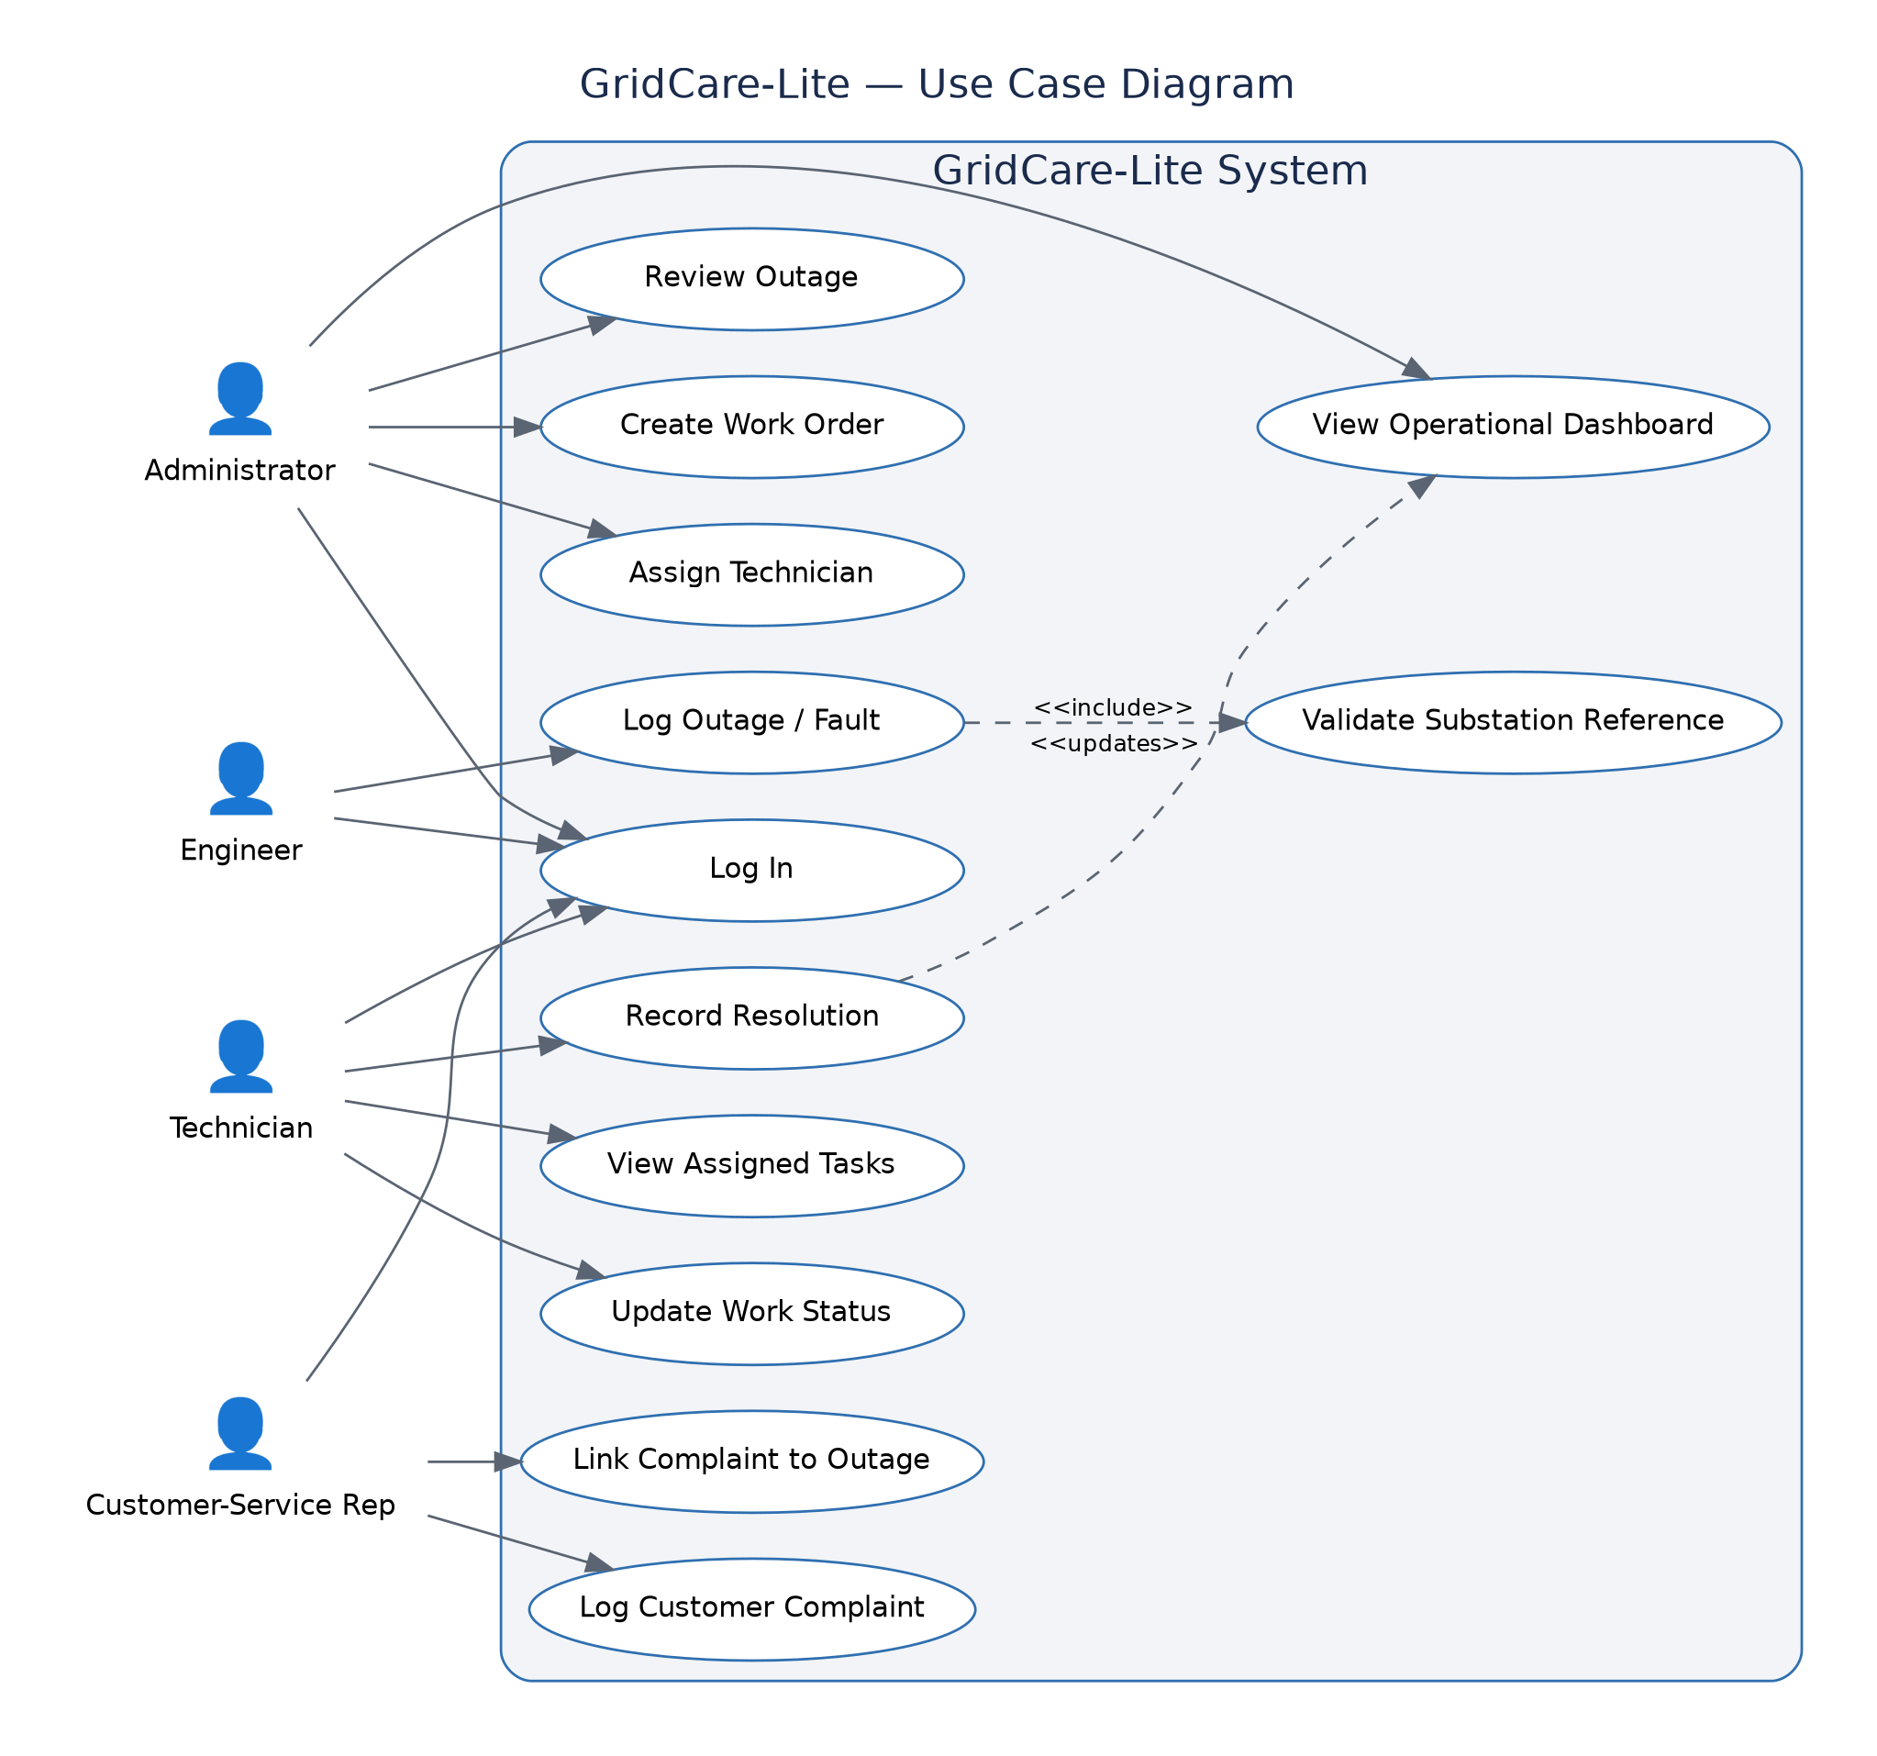
Figure 1. GridCare-Lite use case diagram — four actors (Administrator, Engineer, Technician, Customer-Service Rep).
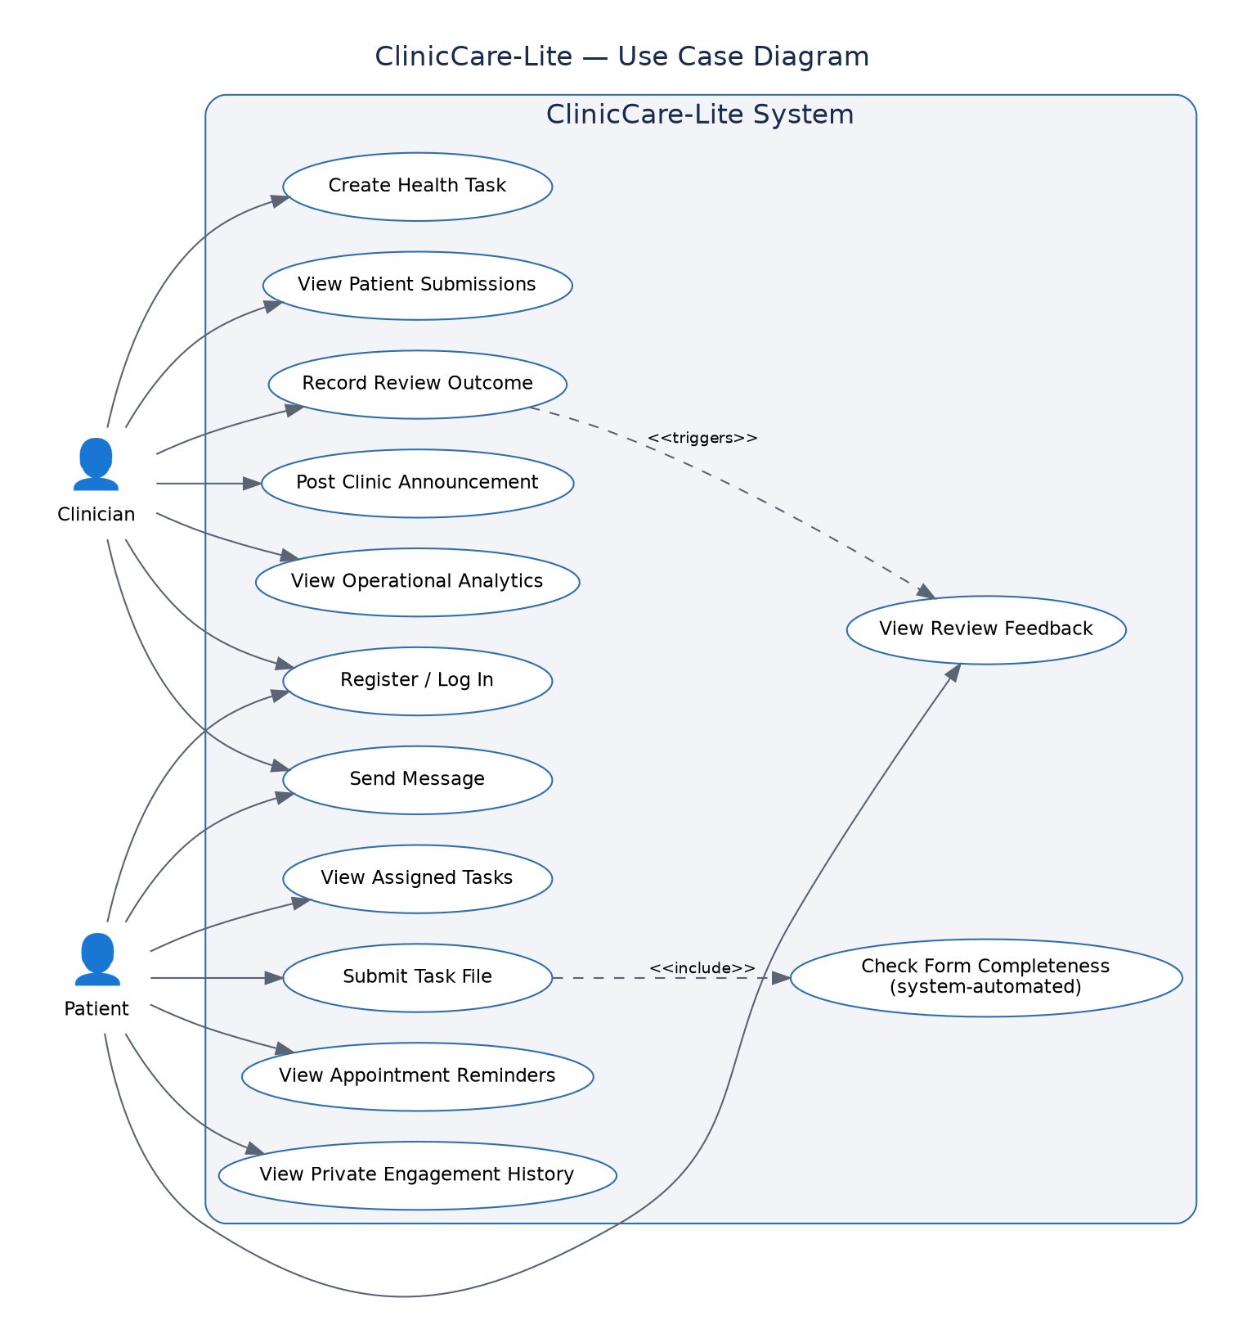
Figure 2. ClinicCare-Lite use case diagram — Clinician and Patient actors.

4.2 Class Diagrams
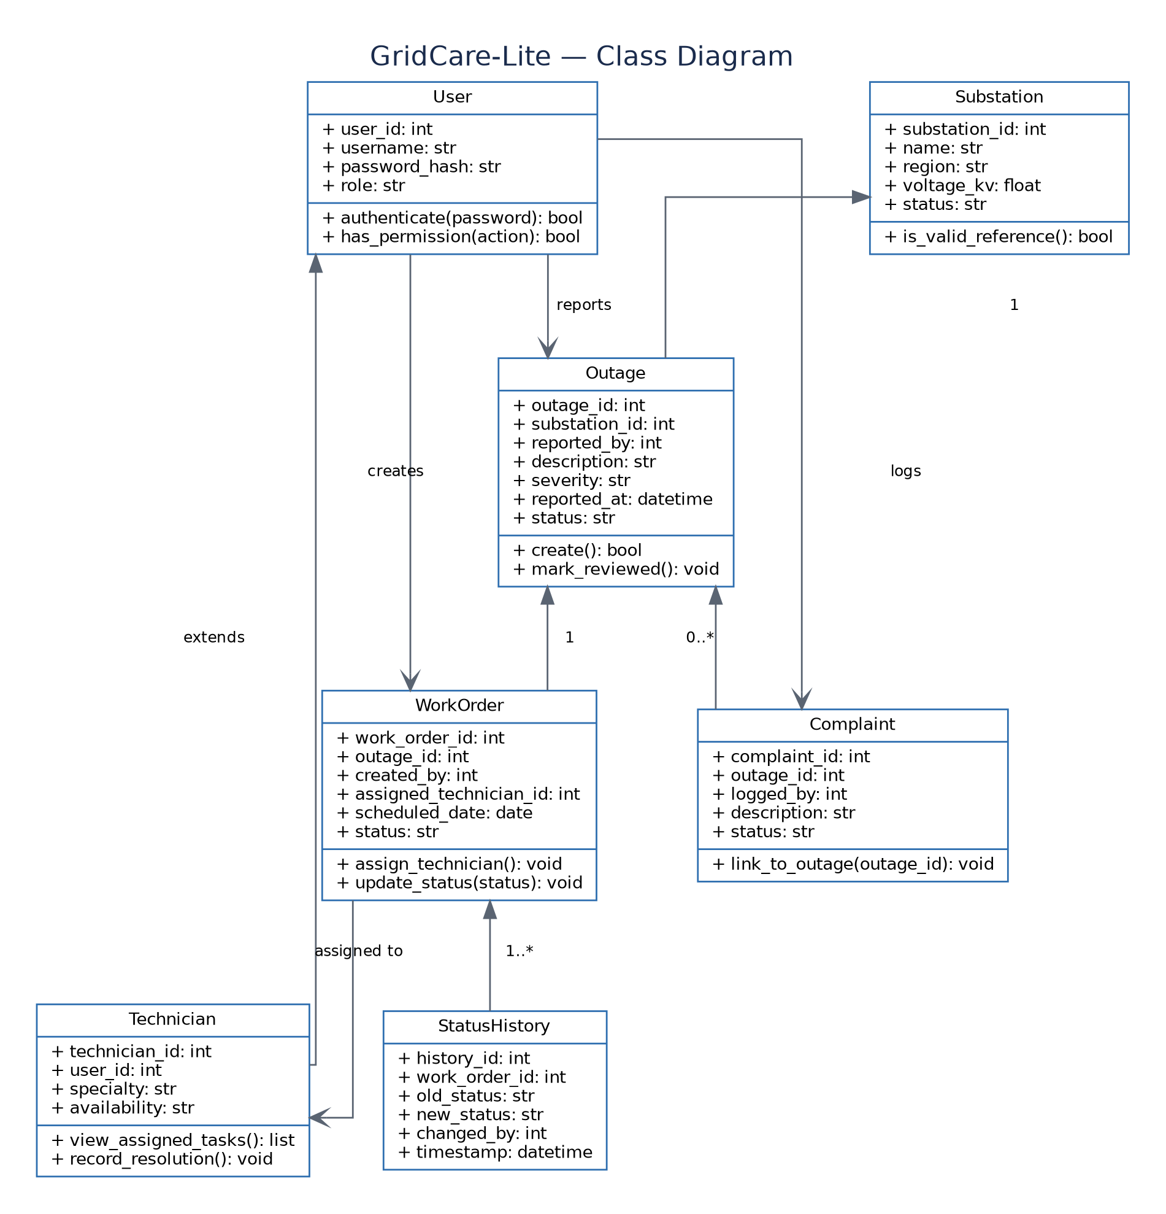
Figure 3. GridCare-Lite class diagram.
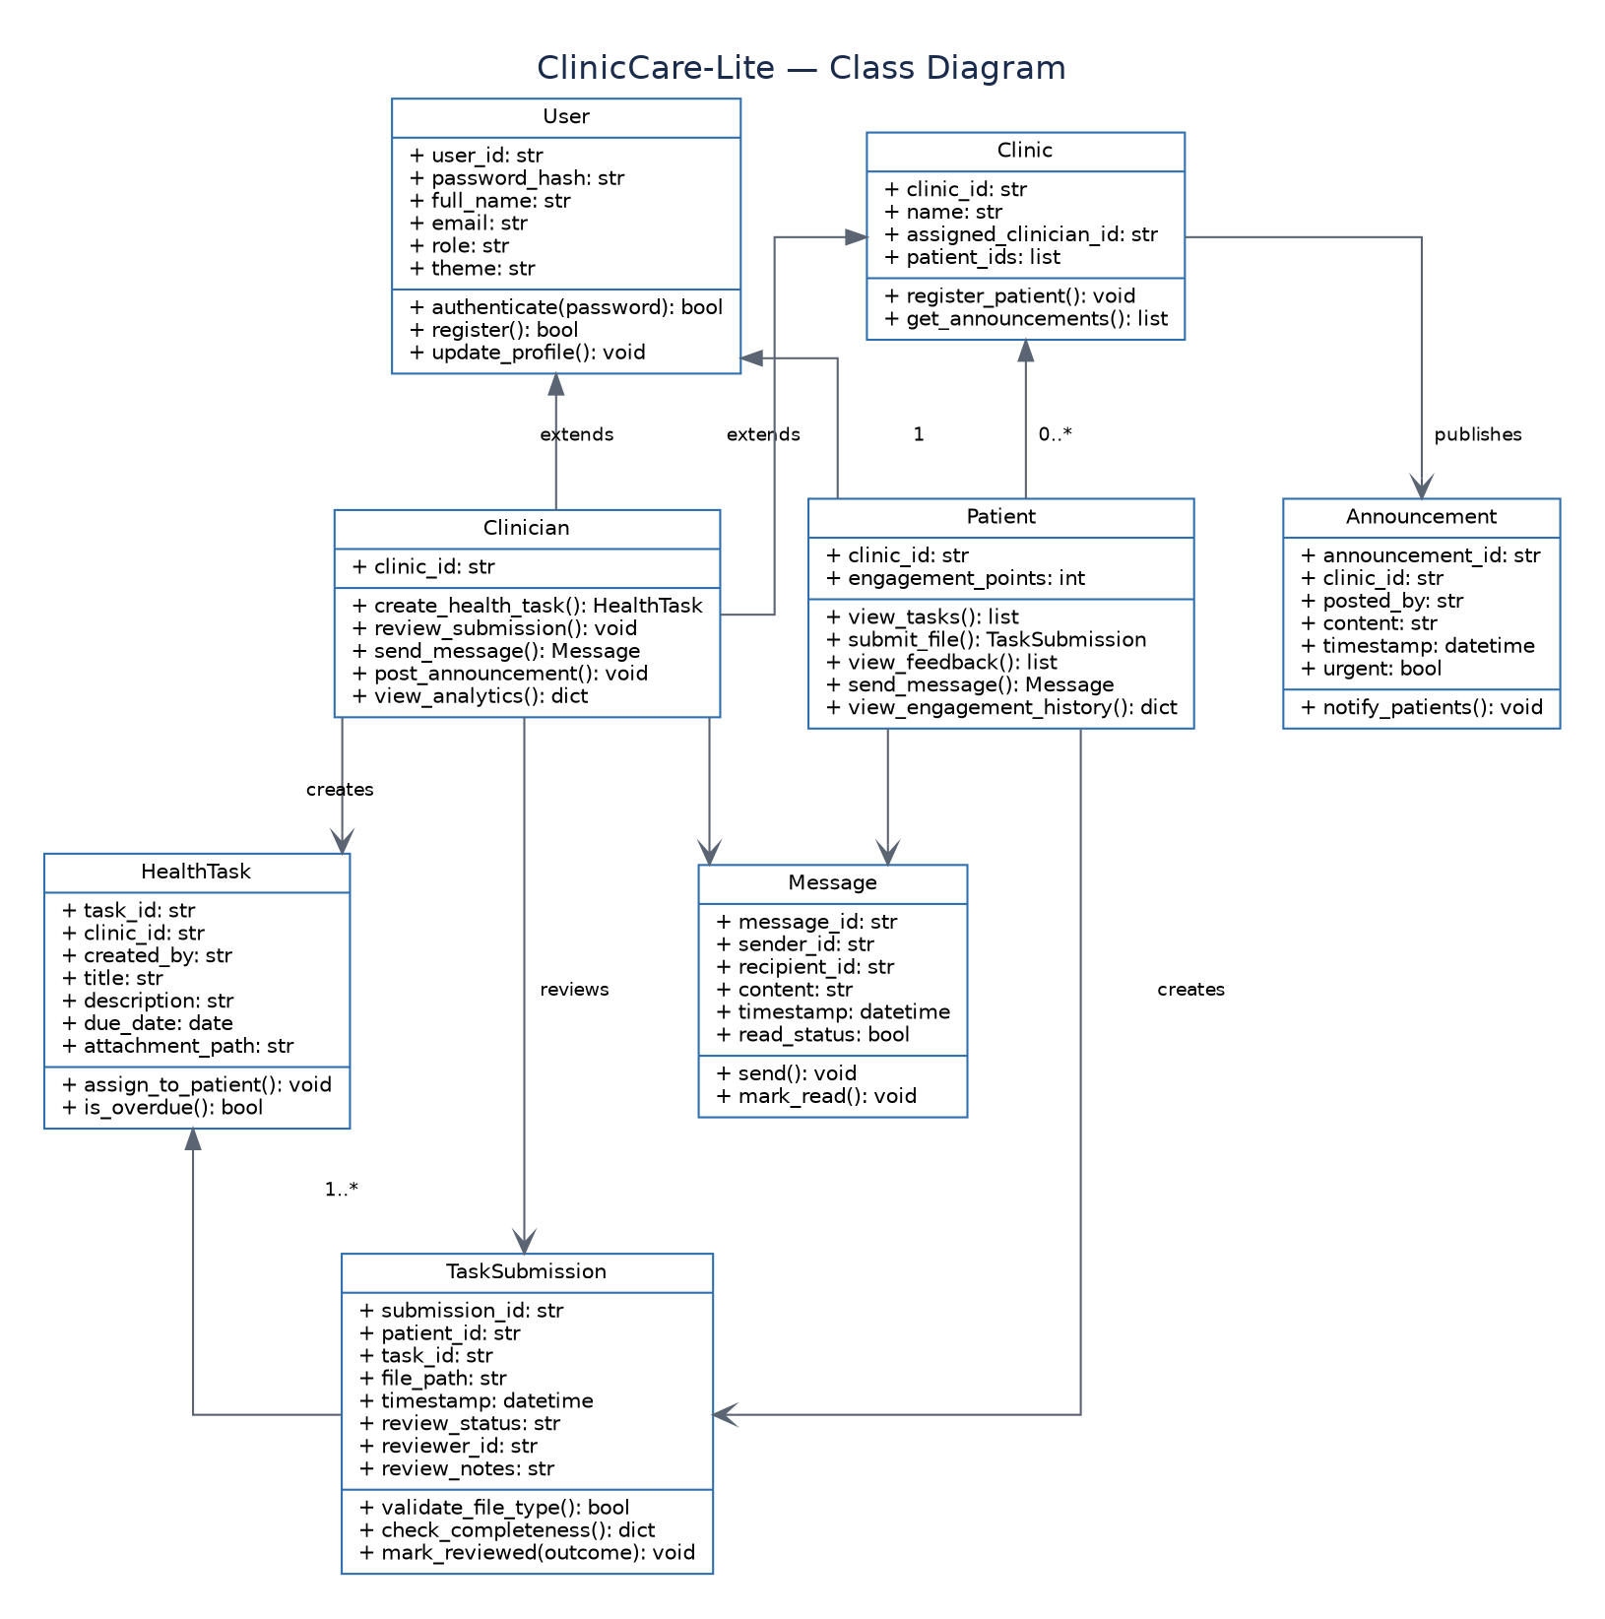
Figure 4. ClinicCare-Lite class diagram.

4.3 Integrated Architecture Diagram
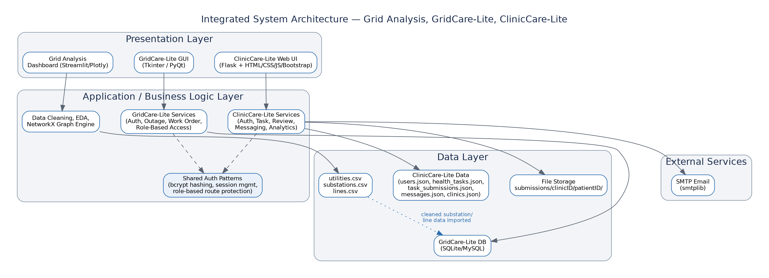
Figure 5. Integrated system architecture across all three components, showing the shared data layer.

4.4 Entity-Relationship Diagrams
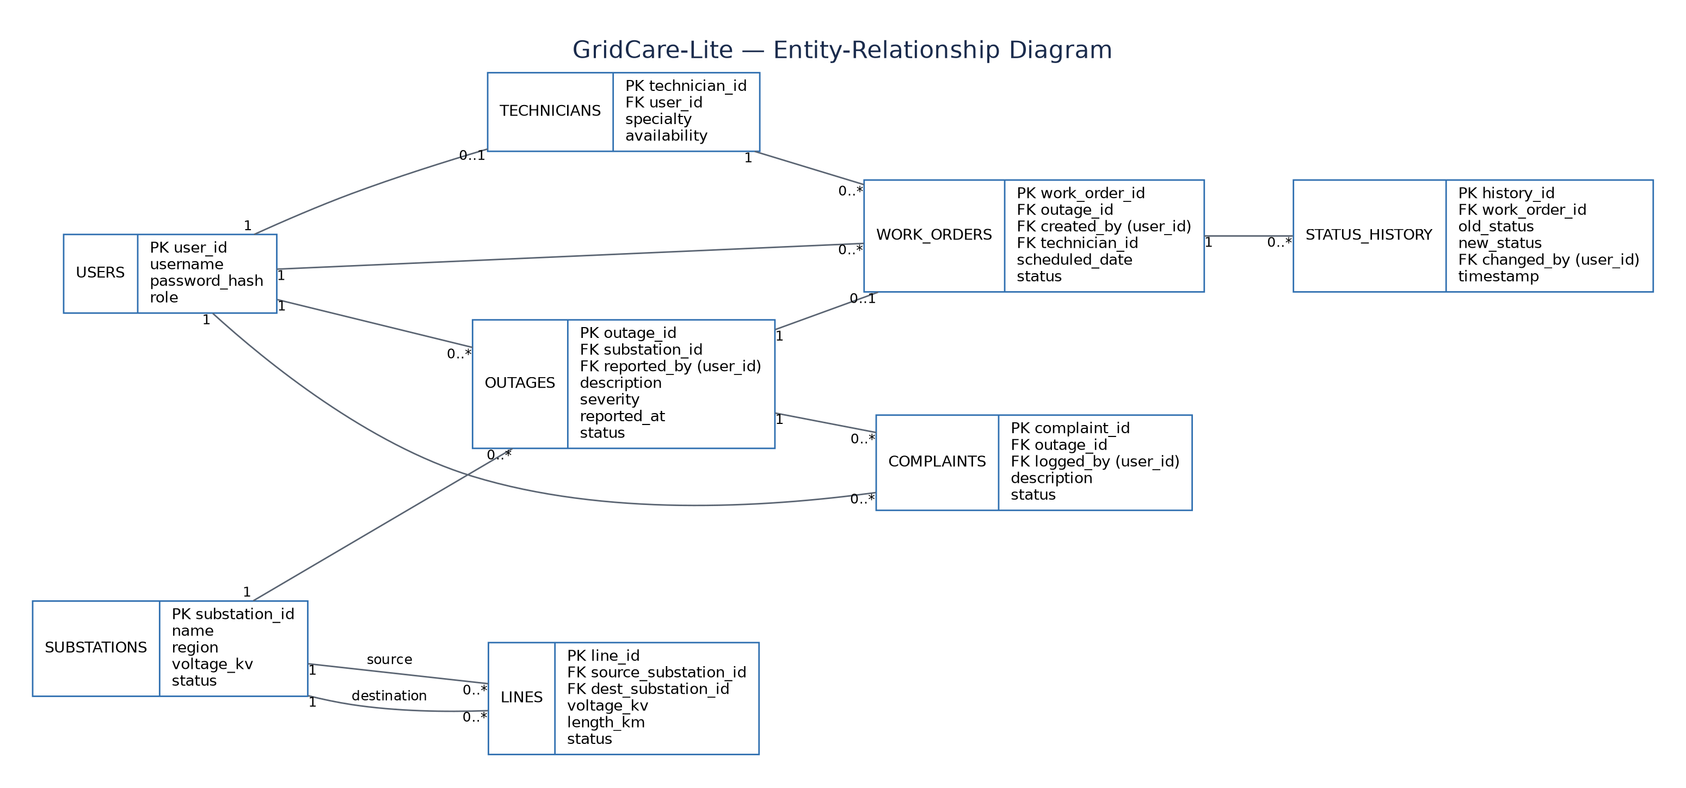
Figure 6. GridCare-Lite entity-relationship diagram (SQLite/MySQL schema).
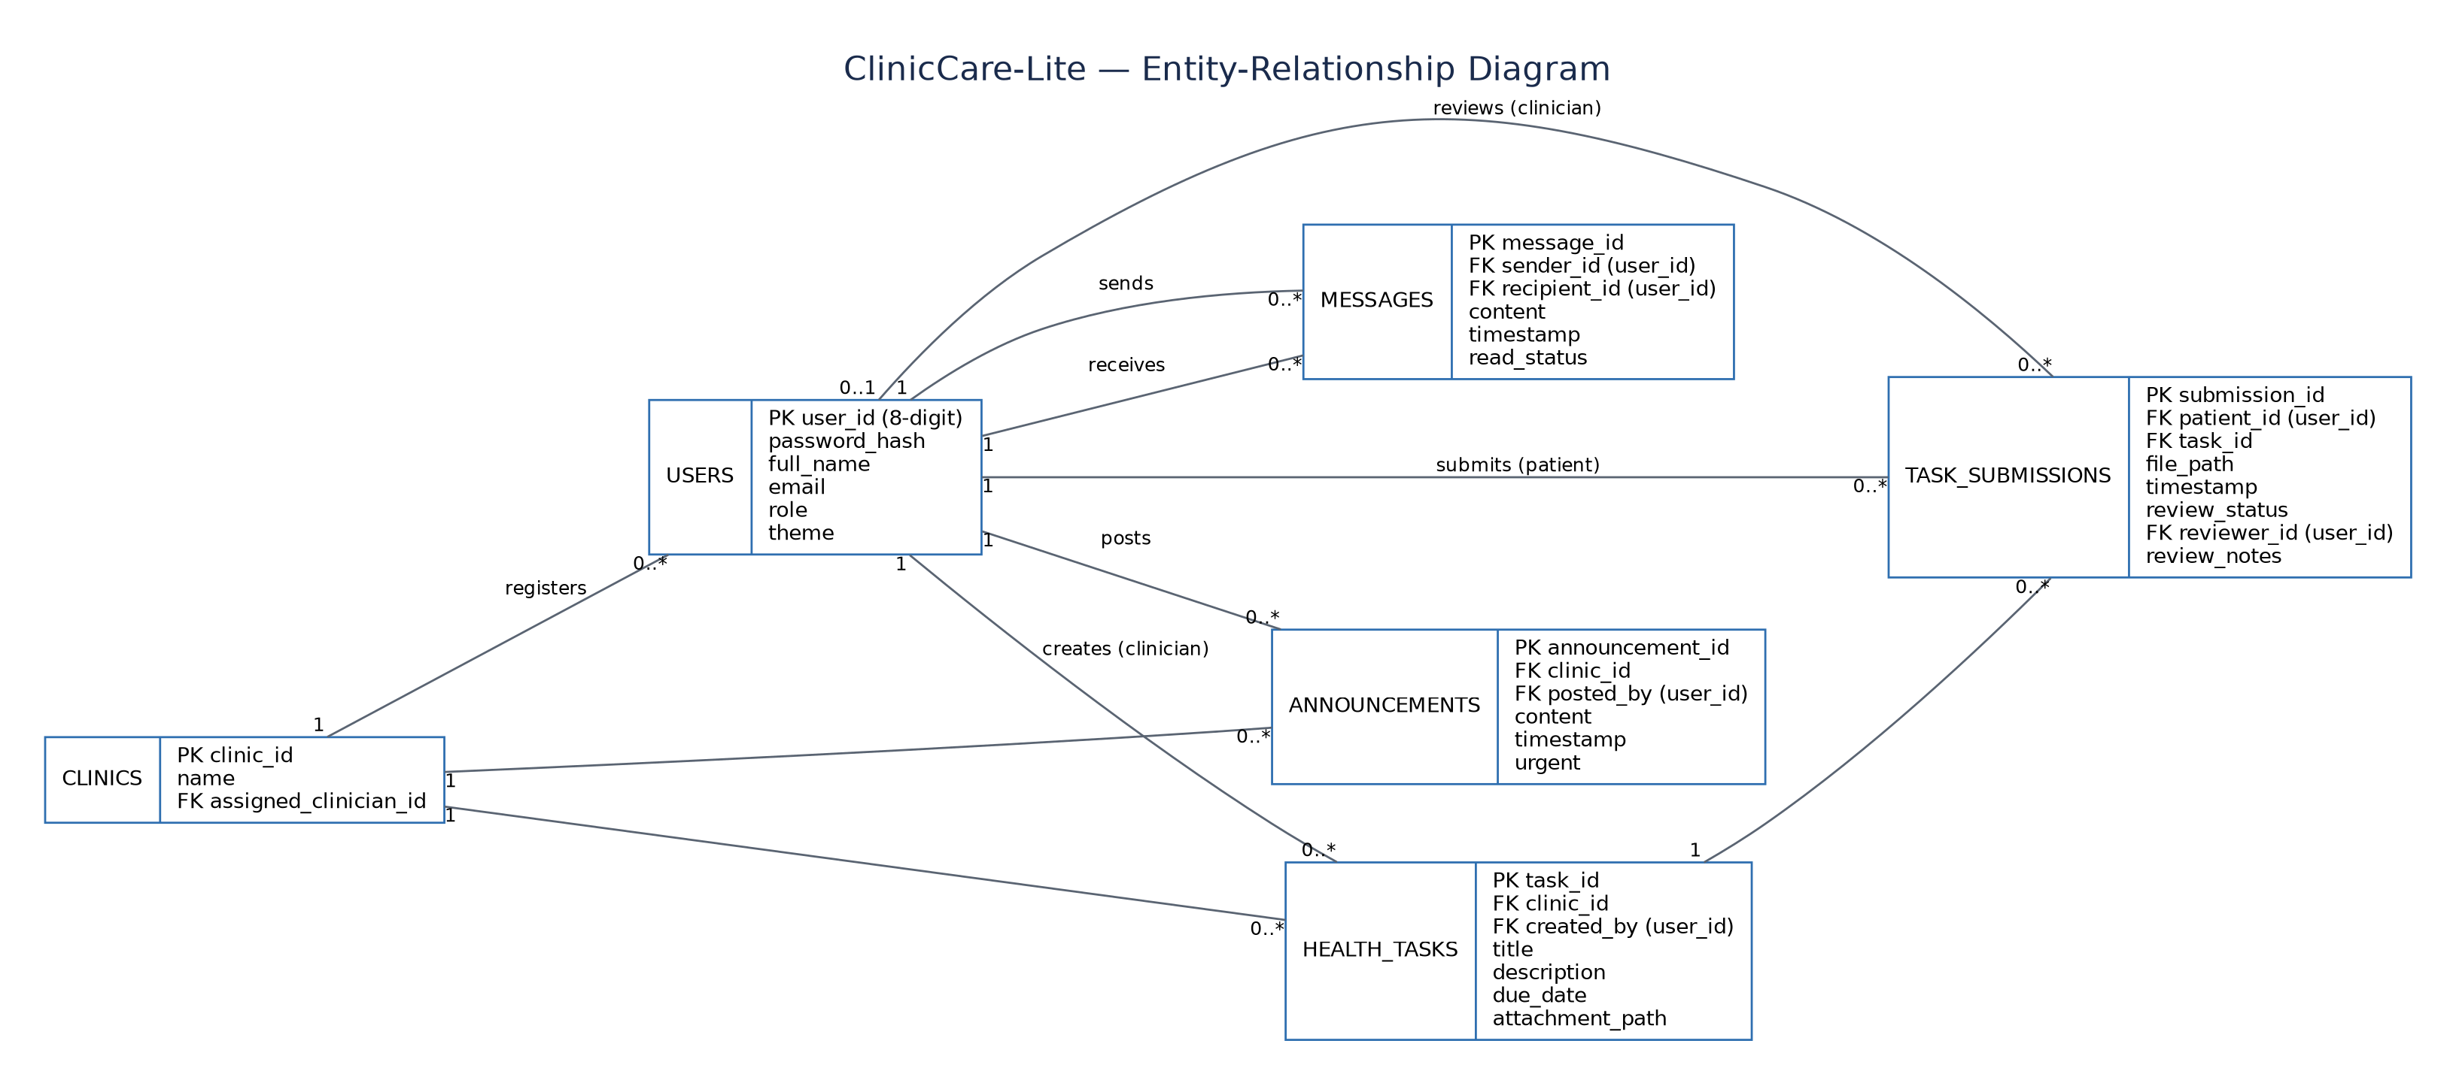
Figure 7. ClinicCare-Lite entity-relationship diagram (JSON-backed data model).

5. Development Framework Decisions

Component 1 — Grid Network Analysis
- Python 3 with pandas, numpy for cleaning and analysis
- NetworkX for graph construction and centrality/contingency analysis
- matplotlib, seaborn, and plotly for static and interactive visualization
- folium for the geographic substation/line map
- Jupyter Notebook as the primary working environment (reproducible, documented inline)

Component 2 — GridCare-Lite
- Tkinter for the GUI — built into Python, no extra install burden across teammates' machines
- SQLite for storage — file-based, zero server setup, adequate for a class-scale dataset
- Rationale: the team prioritized a low-friction local setup over PyQt's richer widgets, since onboarding four people onto a shared stack quickly mattered more than visual polish.

Component 3 — ClinicCare-Lite
- Flask for the backend — lightweight, easy to reason about as a class project, good fit for a browser-based responsive UI across desktop and mobile
- HTML/CSS/JavaScript with Bootstrap for frontend layout
- JSON files as the initial data store (User, HealthTask, TaskSubmission, Message, Clinic, Announcement) with the documented f.seek(0) + f.truncate() pattern to avoid file corruption on overwrite
- bcrypt for password hashing; Flask's built-in session handling for route protection
- Rationale: Flask over Tkinter was chosen so the app is reachable from a phone browser, which matters for a patient-facing tool.

6. Coding Standards
- Naming: snake_case for functions/variables, PascalCase for classes, UPPER_CASE for constants.
- Every function has a one-line docstring describing what it does, its parameters, and its return value.
- No hardcoded secrets, passwords, or API keys in source files — use a local .env file (gitignored).
- Functions should do one thing; if a function exceeds ~40 lines, consider splitting it.
- All user-facing input (form fields, file uploads, IDs) is validated before use — never trust raw input.
- Commit messages describe what changed and why, not just “update” or “fix”.
- One feature per branch; branches are merged via Pull Request with at least one teammate review.

7. Documentation Standards
- Each module/file starts with a short comment block: purpose, author, last-updated date.
- The README stays current with folder structure, setup steps, and team roles — updated the same week a structural change happens, not retroactively.
- Each component keeps a short data dictionary in docs/ describing every field in its data model.
- Design decisions (framework choices, schema tradeoffs) are logged in docs/ with a one-paragraph rationale — future teammates (and graders) should be able to see why, not just what.
- Diagrams are kept in diagrams/ and regenerated (not hand-edited) whenever the underlying model changes.

8. Initial Test Plan
Testing is continuous, not saved for the end. Each test case below records the objective, a sample input, and the expected outcome; actual pass/fail results and any defects found are logged as the team executes them week over week.

8.1 GridCare-Lite — Sample Test Cases
Test ID | Objective | Sample Input | Expected Outcome
TC-G01 | Reject login with wrong password | valid username, wrong password | Login denied; error message shown; no crash
TC-G02 | Reject outage logged against non-existent substation | substation_id = 9999 | Form rejected with a validation error
TC-G03 | Work order assignment updates technician's task list | assign work order WO-1 to Technician T-2 | WO-1 appears in T-2's “View Assigned Tasks” screen
TC-G04 | Status history logs every change | change WO-1 status In Progress → Resolved | New row appended to status_history with correct timestamp/user

8.2 ClinicCare-Lite — Sample Test Cases
Test ID | Objective | Sample Input | Expected Outcome
TC-C01 | Reject malformed patient ID | ID not ending in 2022-2028 | Registration blocked with a clear validation message
TC-C02 | Reject disallowed file type on submission | upload a .exe file | Upload rejected; only .txt/.csv/.pdf accepted
TC-C03 | Patient cannot view another patient's task | Patient A requests Patient B's task URL directly | Access denied / redirected
TC-C04 | Review outcome is categorical only | clinician marks a submission reviewed | Stored value is one of the 4 fixed categories, never a numeric score
TC-C05 | Session expiry protects routes | navigate to a dashboard URL without logging in | Redirected to login page

9. Ethical & Security Boundaries — ClinicCare-Lite
Because ClinicCare-Lite touches patient data and health-adjacent workflows, the team commits to the following boundaries for the entire project, not just at launch:

9.1 What the system will never do
- Diagnose, interpret symptoms, assign a risk score, or recommend treatment, medication, or dosage — in any screen, message, or automated response.
- Present a numeric or graded health score to a patient or clinician; review outcomes are strictly categorical (Pending / Reviewed-Normal / Needs Follow-up / Escalated).
- Allow a patient to view another patient's data, tasks, files, or messages.
- Store plaintext passwords, or log sensitive form content in plaintext application logs.
- Use patient engagement or completion data for public ranking, leaderboards, or cross-patient comparison.

9.2 What the system will always do
- Display a persistent, unmissable “not for emergencies — contact emergency services or your clinic directly for urgent issues” notice on every messaging screen.
- Restrict every patient-data route behind authentication and an ownership check (a patient can only ever query their own records).
- Validate and sanitise file uploads (type, size) before writing to disk.
- Log administrative actions (who reviewed what, when) for accountability, without storing more personal detail than the task requires.
- Treat any ambiguous feature request — anything that edges toward diagnosis or medical advice — as out of scope, and flag it to the instructor rather than build it.
These boundaries apply to every teammate working on ClinicCare-Lite, for the life of the project. If a feature request from the brief seems to require diagnostic logic, it should be flagged to the instructor rather than implemented.

