**Question based on video:**

You need to customize alexnet, resnet, or googlenet or any other network of your choice. Say for example how can you customize? You can reduce and increase number of layers, different optimizing techniques, different activation function, different hyper parameters. Based on your understanding. Choose any one the dataset, based on which is more interesting to you. You have to achieve same or more accuracy with customize network reference to original implementation.

**Q:** Why weather dataset is chosen and what kind of preprocessing was done needs to be added. (The instructor preprocessed the fruit dataset – 3rd link, for the task. So we need to explain why we chose weather data)

**A:** We have chosen this dataset because of uniqueness and not much work has been done on this dataset. And instructor didn’t purpose any dataset. More ever I have search online there is no paper written on this dataset, and no github code also publish on this dataset.

**Q:** Why VGG-16 has been chosen as the baseline it needs to be explained in the report. (It very important as you did not choose from Alex/res/google net)

**A:** Added in the report.

**Q:**. Proposed CNN architecture for Image classification:

1. Baseline architecture used.
2. Customized architecture
3. Assumptions/intuitions
4. Model summary

**A:** Added in the report. Note that this is only the suggestion by instructer not a well defined pipeline, a pipeline should be enough if it well define the knowledge.

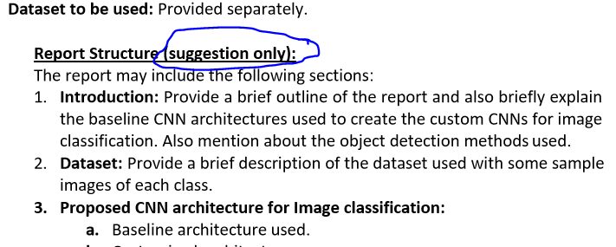

**Q:** assuming that this is not the final report, there should be different paras for each of these. You only wrote customized architecture with brief description of baseline one. But there should be more to this. Without images and tables, the report is just 236 words which is roughly ¾ of a page where it expected to have maximum 12 pages. Images and tables do not count towards page count.

**A:**  We can include details about code, and not useful things in the report, I don’t know How what extra things should be included. I have read many research papers that define the same way.

Note that we can’t include different definitions in the report like dropout, parameters etc, we have to tell that how our model is useful and better than previous one.

**Q:** In the code section you need to add comments where you changed the baseline architecture.

**A:** Added

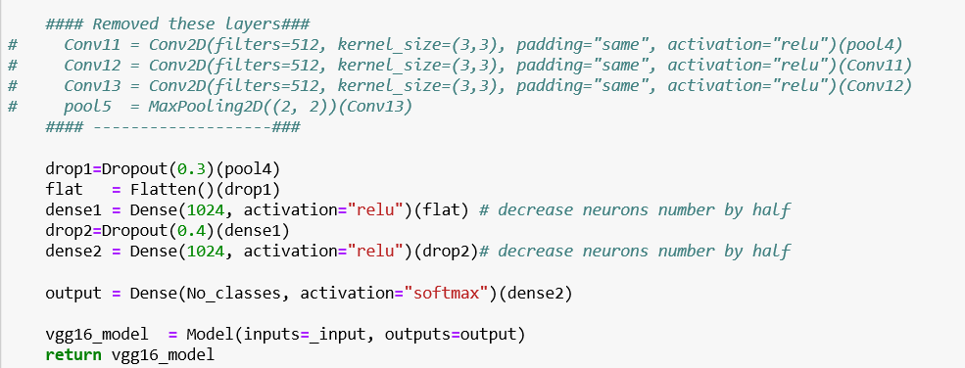

**Q:** As you have used .h5 files, there should be a cell describing why it being used and what is the work of it.

**A:** Added. Note that its only done to save training time, no need to train from start just load the model then start using it for testing.

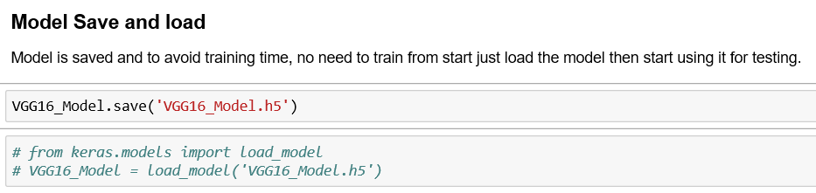

**Q:** In model summary section of the report, please be more detailed how and why the changes to basic network helps.

**A:** Details are already added in c. Assumptions/intuitions section. More details are also added in summary section regarding overfitting.

**Q:** Can you add a table among train accuracy, validation accuracy and testing accuracy in the code section.

**A:** there is no code section in report and these results are added in experiments results of image classification.

**Q:** explain dataset split in code and report. i can see you took 92 image for testing and there is no validation set. i get it. but please explain in code and report how you split it and reason behind this split

**A:** Added in dataset part and in the code as well, but it just a one time run code. No need to run it again. As random shuffle.

**Q:** At the end, there should be Total Number of Wrong Classification images printing out.

**A:** Added