**Auto Encoders**

Definition: Auto-Encoder is an unsupervised artificial neural network that learns how to efficiently compress and encode data. Then learns how to reconstruct the data back **from** the reduced encoded representation **to** a representation that is as close to the original input as possible.

In a nutshell, Auto-Encoders (AE) are neural networks that aims to copy their inputs to their outputs.

Usage: They are basically used for the purpose of shrinking our input (dimensionality) and training our data set to ignore any kind of noises. They are majorly used for feature extraction, image de-noising etc. (also a chief part in CNNs and LSTM network).

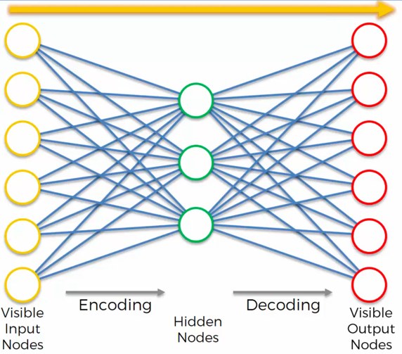

**Over-complete hidden layers:** There is no limit of nodes in hidden layers, that means there can be as many nodes as we want, even more nodes than input itself. The AE might cheat as due to more nodes in input layers, AE won’t have to compress (or encode) any input and the input will pass as-it-is from hidden layer to output layer. So, there are multiple solutions for this:

Sparse AE:

In sparse AE, at any given instance of input we use fixed number of hidden layers and leave the rest. Remember this is for one input vector, so there will be use of other nodes as well. In a single pass, some nodes pass and some don’t. So, it’s an example of feature extraction as at one moment, we are using a specific subset of input.

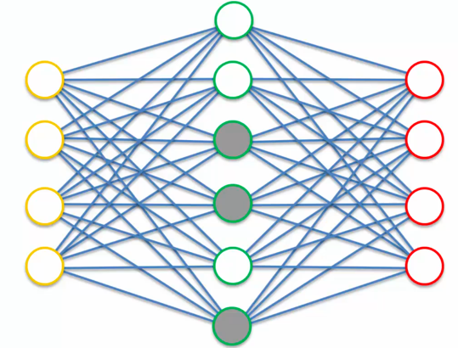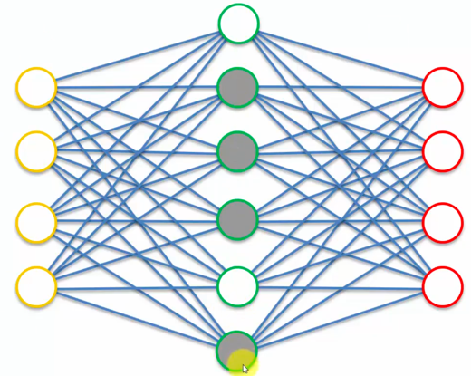

An advancement to sparse auto-encoders is the k-sparse auto-encoder. Here we choose k neurons with highest activation functions ignoring other activation functions using ReLU activation functions and adjusting the threshold to find the largest neurons.

De-noising AE:  
 In this Auto-Encoder, we modify the input vector by adding a layer before encoding the inputs. This layer takes the noisy inputs out of the equation and we send only randomly selected inputs. The learning is done by comparing output values not by intermediate layer but the input layer itself.

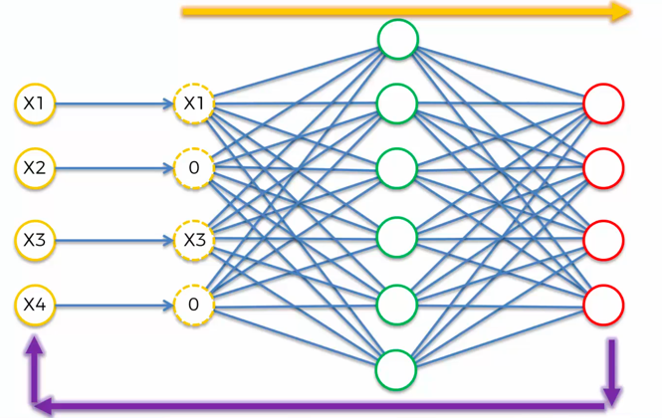

With Deep De-Noising Auto-encoders(DDAE) which has shown drastic improvement in performance has the capability to recognize the whispered speech which has been a problem for a long time in Automatic Speech Recognition(ASR). This has been implemented in various smart devices such as Amazon Alexa.

Stacked AE:

This is just an advanced form of sparse AE. There are additional layers for further encoding the input. Stacked AE mainly consists of three steps:

· Train auto-encoder using input data and acquire the learned data.

· The learned data from the previous layer is used as an input for the next layer and this continues until the training is completed.

· Once all the hidden layers are trained use the backpropagation algorithm to minimize the cost function and weights are updated with the training set to achieve fine tuning.

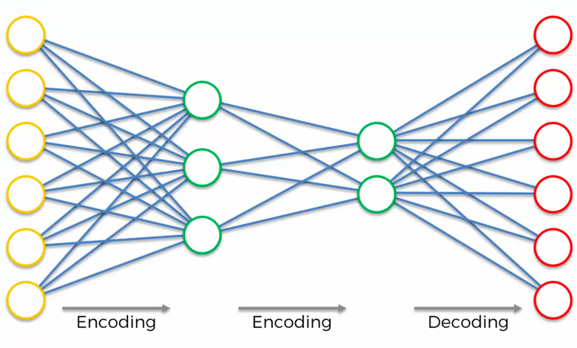

The recent advancements in Stacked AE is it provides a version of raw data with much detailed and promising feature information, which is used to train a classier with a specific context and find better accuracy than training with raw data.

Note: ***Deep AE are not stacked AE. (****For better understanding an image of Deep AE is given****)***