Name : AFAQ AHMED

ROLL # BSEF17A538

OS LAB 1

FIRST PART : BASIC SHELL COMMANDS

1: Command to see your user name.



2: Create a file name testingfile.

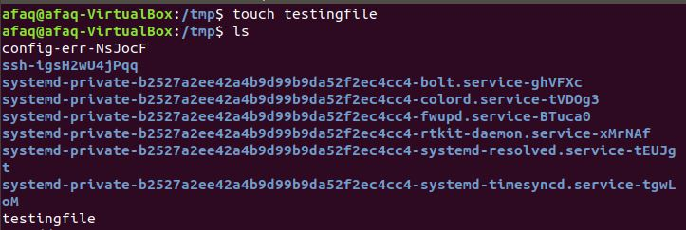

3: Check the type of testingfile.



4: Difference between rm and rmdir commands.

* rm is used to delete a file.
* rmdir is used to delete an empty directory.

A)

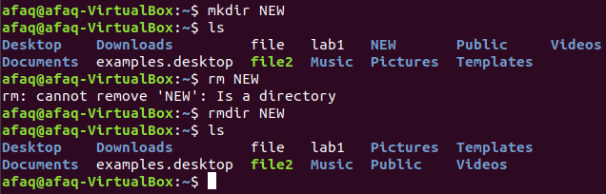

B)

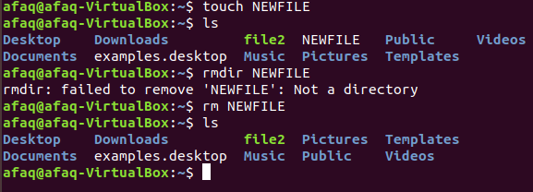

5: Single command to go back to home directory.

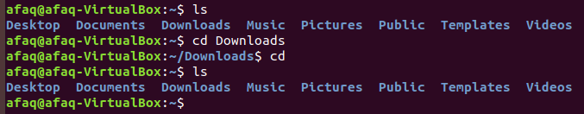

6: Command to rename a file.

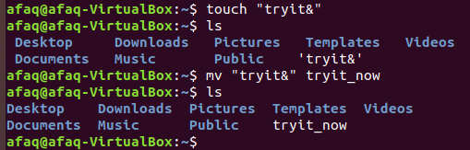

7: Give new name to shell command clear ‘myclear’.



8:

1. Before



After

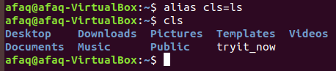

b)

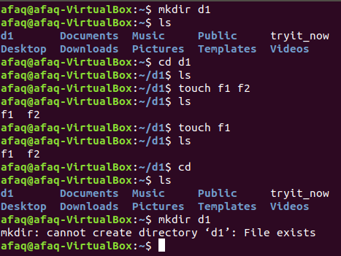

Portion 2: Questions

1:-

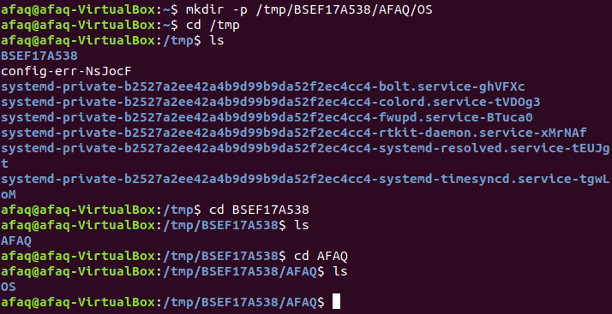

2:-

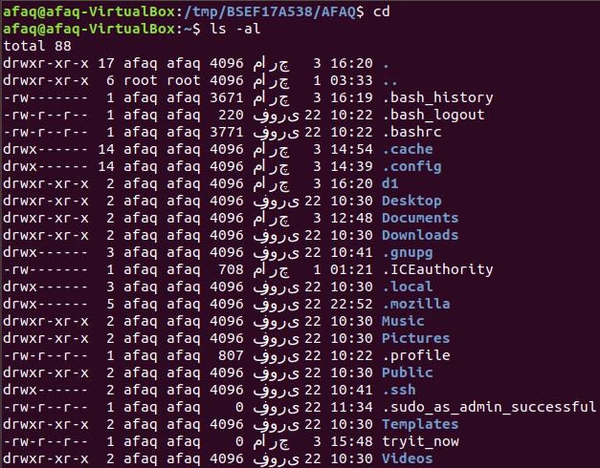

3:-

* rm -r /tmp BSEF17A538

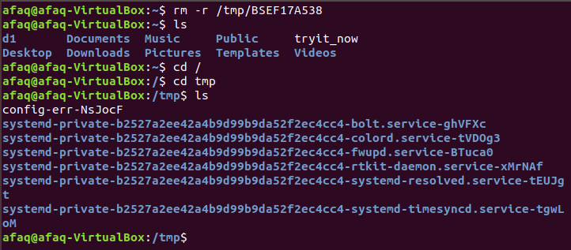

4:-

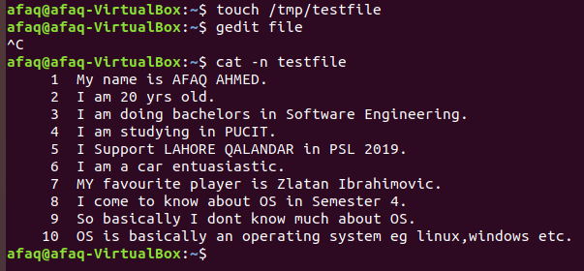

5:-

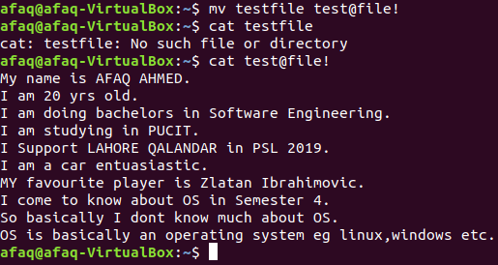

6:-

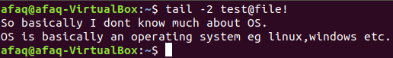

7:-

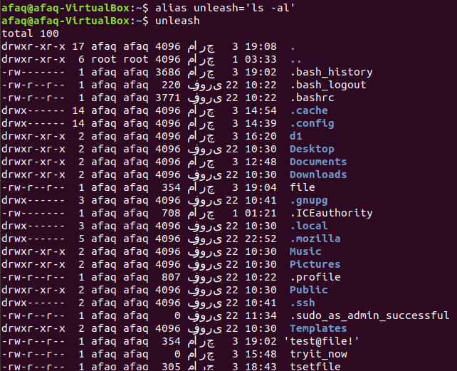

8:-

* man command is used to see the details of commands in the shell.

9:-



10:-

* rm -r command can be used to remove directory.

Part 3: Absolute/Relative Path

1:-

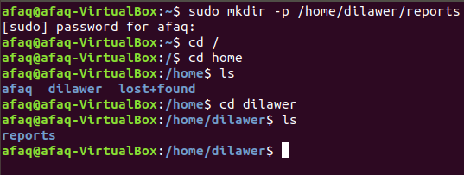

2:-

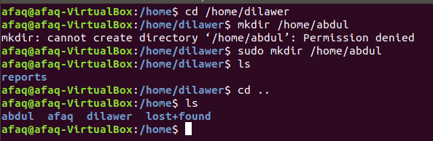

3:-

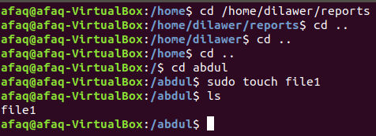

4:-

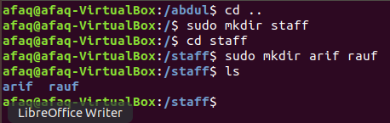

5:-

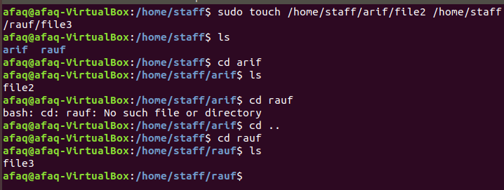

6:-

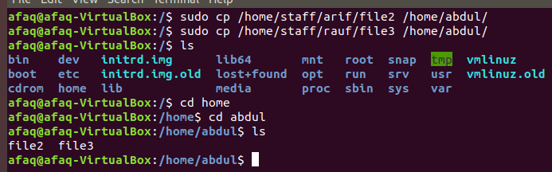

7:-

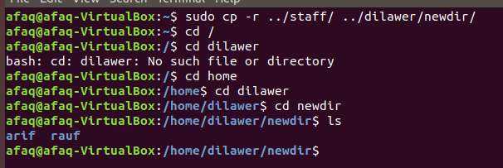

8:-

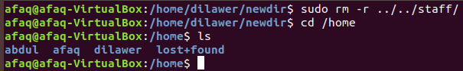

9:-

