# Assignment Output (Screenshots)

***Note: The outputs were taken on date: 9th August 2020 at 0300***

Screenshot 1:

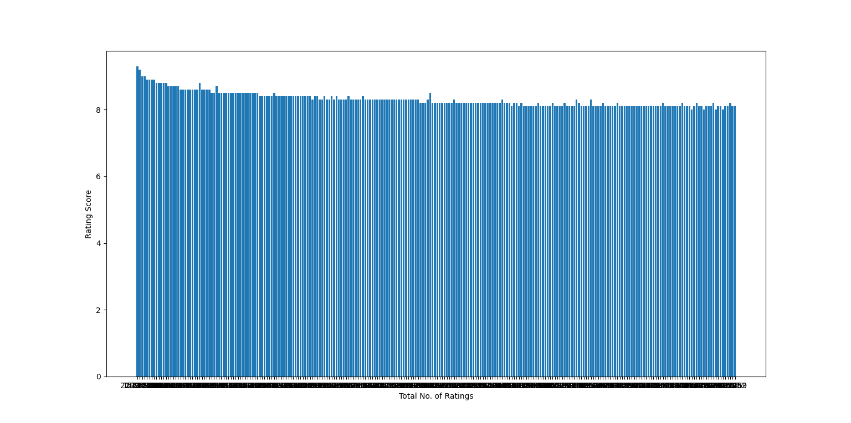

Screenshot 2: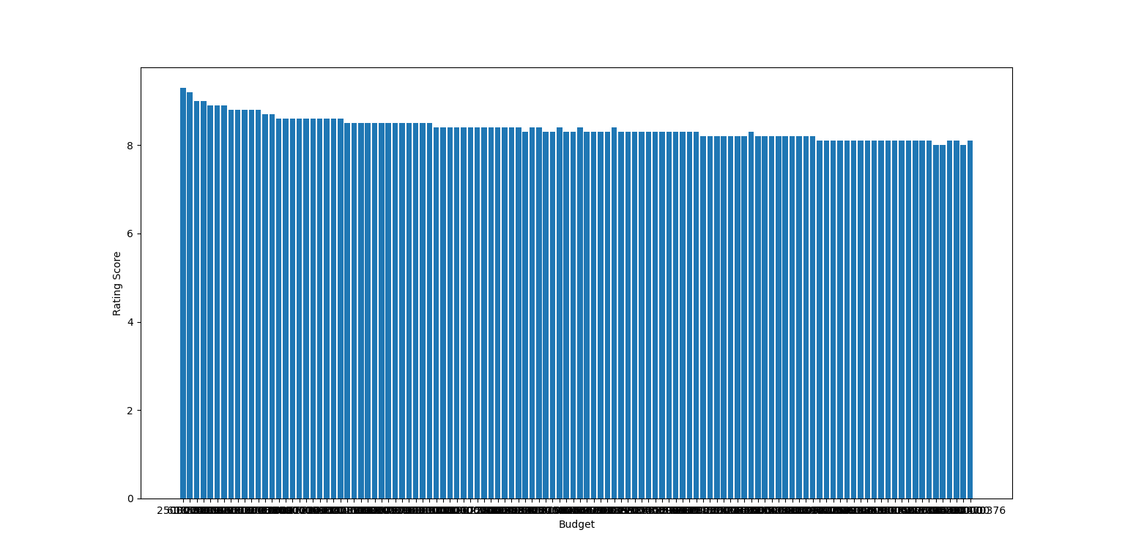

Screenshot 3:

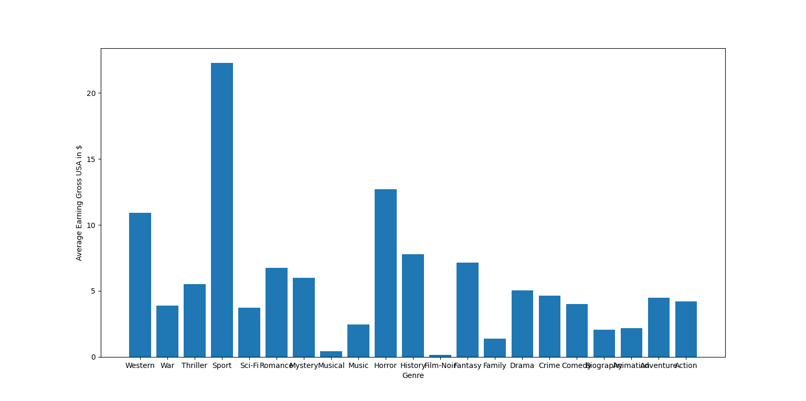

# Technology Stack Used:

For development of this assignment, VS Code was used to run python files. VS Code is commonly used tool for software development with additional bash as terminal to help with some git commands.

For python some of the libraries like pandas, numpy, currency converter, beautiful soup (for web scrapping) were used in the project.

Beautiful soap is easy to use and is good for starters. Pandas is used to simple data analysis techniques like making data frames and decision making on values. Currency converter is used to convert the values from different other currencies to USD. Numpy is just used to concatenate the array and also to check the value if it is real or not.

# Time Elapsed on Making this Project:

|  |  |
| --- | --- |
| **Category** | **Time Taken** |
| Learning | 12 hrs |
| Implementation | 22 hrs |
| Testing | 8 hrs |
| Total | 42 hrs |

# Improvements Required:

Below are the bullet points that for the area which could have been improved if i had more time.

* Many loops have used that could have been optimized to reduce run time of code
* Same lines repeated at multiple places. This should be done in a single line, there must be a syntax in python but I had this time constraint
* Instead of using the loop in dataframes, dataframe.iloc is a syntax that does the same changes on conditioning. I tried but was unsuccessful at that time.
* Request made to imdb should be in a proper manner with more user-agents and other headers to avoid blocking by robot. It works but still improvements can be done.
* The code for imdb-scrapping file and data-analysis file could be more clean and can be made in a way to be used in other files.

I was also busy with office because we are going through some crunch time so couldn’t provide enough time to this assignment as well.