The iterator in the correction stage works by relinearizing around the last corrected estimate, then calculating a new estimate. If the stopping condition is met, then it exits, otherwise, it iterates again.

Note that this algorithm differs from what is currently in my thesis. Instead of approximating , we are now using the full matrix exponential. The Q matrix and 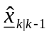 are calculated once before the iterations begin. 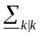 is calculated once after the iterations are complete. The only equations that are being iterated are as follows:

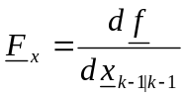
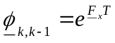
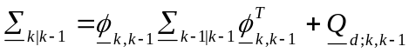
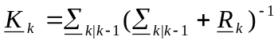
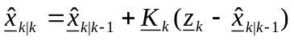.

By combining the above equations, we obtain the recursive format of iterator:

,

Where and 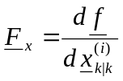.

The algorithm averages between 2 and 3 iterations/time step at an error of 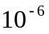.

I hope this clears up any ambiguities about the iterator.

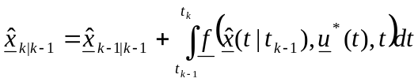 <- prediction equation

PREDICTION SECTION FROM THESIS:
The EKF prediction equations are similar in form to those of the classical Kalman Filter. However, the EKF needs to be linearized at every time step around the filtered estimates of the previous state. This means that the nominal state is equivalent to the last filtered state
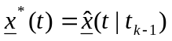, (1)

and as a consequence
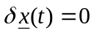. (2)

Replacing the nominal state with the previous filtered estimate in the definition of the nominal state (58) yields the differential equation
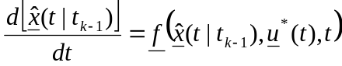. (3)

Subsequent integration results in the EKF prediction equation given by
. (4)

