Resumé
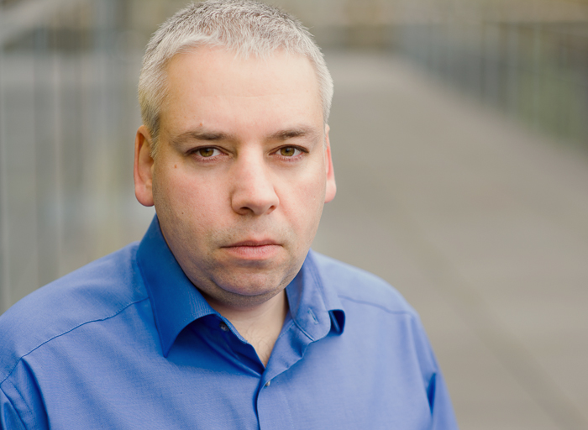
Dipl.-Ing. Alexander Farber
XXXXXXXXXXXXXXXX
XXXXX Bochum
Germany

Phone: +49-176-95740861
Mail: Alexander.Farber@gmail.com
Web: http://afarber.de

Work experience
Since 08.2014: Software developer at Volkswagen Infotainment in Bochum

Tasks: Developing apps for Android and iOS, etc.

04.2009 – 07.2014: Software developer at BlackBerry in Bochum

Tasks: Developing mobile software for BlackBerry in Java, C++, ActionScript, Flex.
Developing USB and MTP stack, FM Radio, OOBE, Settings and Setup app.
Some scripting with PHP, Perl, jQuery, PostgreSQL on Linux and Windows.

07.2008 – 03.2009: Sysadmin at novero (automotive) in Bochum

Tasks: Administrating Active Directory, DNS, DHCP and NIS for 400 users
Administrating Telelogic CM Synergy (Continuus), VMWare ESX
Administrating HP Quality Center (Mercury) and Oracle 9i database
OpenVPN deployment and RSA certificates management for 400 users
Sendmail, Nagios, Cacti configuration; Subversion, CVS and Bugzilla administration
Administrating several internal Apache servers (users authenticated against AD)
Administrating few external web servers with PHP, Perl and PostgreSQL, MySQL
Administrating and maintenance of build cluster (RHEL 4) for S40 phone software
Installation and support of PurifyPlus, Rose, ARM Compiler, Lint, gmake, etc.

05.2002 – 06.2008: Tools developer at Nokia in Bochum

Tasks: Support for S40, Symbian and Maemo developers, build managers and integrators
Administrating 2 phone software build farms (RHEL 4 and HP-UX 11)
Installation and support for many SW development tools; Programming local tools
Participation in global Nokia projects like porting of Symbian build system to Linux
Testing and maintenance of PVMgmake (clustered version of GNU make)
Acting as Nokia-global owner for Java development tools, Wine and UltraEdit
Installation of gcc as MinGW-crosscompiler for phone software emulation
Participation in regular Nokia-wide “Global Tools Initiative” meetings and virtual teams
Acting as a connecting link between local SW teams in Bochum and Nokia tool experts

09.2000 -12.2001: Software developer at Ericsson in Aachen

Tasks: Programming CGI and mod_perl scripts in Perl (with Sybase, MS SQL, ClearCase)
Programming command line tools in Perl, Unix-shell, awk

01.1996 – 08.2000: Student helper at Ericsson in Aachen

Tasks: Programming CGI-scripts in Perl (interacting with Sybase)
Programming command line tools in Perl

Education
1992-2000 Electrical Engineering (Technical Informatics)
study at the RWTH Aachen. Final grade: satisfactory
(Thesis theme: a FEM-viewer in C++ and OpenGL/Qt
with an integrated Python-interpreter. Thesis grade: 1.7)

1989-1991 Physics study at the Latvian State University -
discontinued because of emigration to Germany

1987-1989 (during the school time) study of physics
and mathematics at the distance learning school of
the Phys.-Tech. Institute in Moscow. Final grade: 1.0

During the school time I've also participated regularly
in physical and mathematical Olympiads and won
1988 the 1st place in Latvian Republic in physics

1979-1989 School No. 40 in Riga, final grade: 1.0 (gold medal)
(final grade confirmed in preparatory college Muenster 1991-1992)

System administration
Linux, OpenBSD, Solaris, Windows XP, Windows Server

Database experience
PostgreSQL, Sybase/MS SQL, MySQL, Oracle

Programming languages
C++, Java, Perl, PHP, Unix-shell, JavaScript and jQuery, ActionScript and Flex/Flash, etc.

Foreign languages
German and English fluently
Russian native speaker
Latvian basic knowledge

Hobbys
Developing social games for Android, iOS, desktop.

