Kali Linux Command:

1. ls : List information about files

List of ls option command:

-a = list all files including hidden file starting with ‘.’

-d = list directories - with ‘\*/’

-l = list with long format – show permissions

-r = list in reverse order

-s = list file size



1. cd : change directory

Extra cd / = change to root directory

cd .. = change to parent directory



1. mv : Move or rename files or directories

List of mv option command:

-f = force move by overwriting destination file without prompt

-i = interactive prompt before overwrite

-u = update-move when source is newer than destination

-v = verbose - print source and destination files

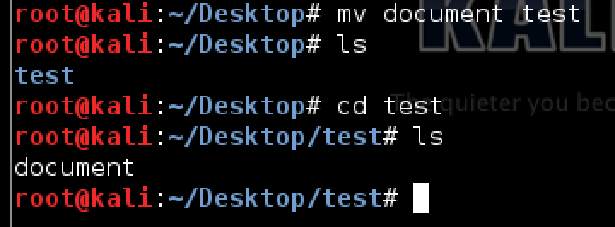

1. rm : Remove files

List of rm option command:

-f, --force = ignore non-existent files, never prompt

-i = prompt before every removal

-v, --verbose = explain what is being done

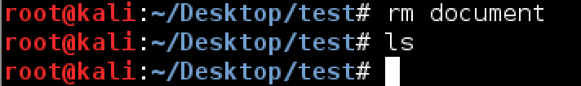

1. mkdir/rmdir :

mkdir : Create new folders

rmdir : Remove folders

List of mkdir/rmdir option command:

-m = set file mode (as in chmod). (only for mkdir)

-p = mkdir : no error if existing, make parent directories as needed

rmdir : remove directory and its ancestors

-v = mkdir : print a message for each created directory

rmdir : output a diagnostic for every directory processed

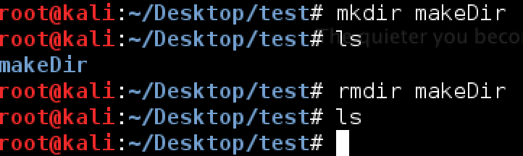

1. touch : Change file timestamps

List of touch option command:

-a = change only the access time

-c = do not create any files

-d = parse STRING and use it instead of current time

-m = change only the modification time

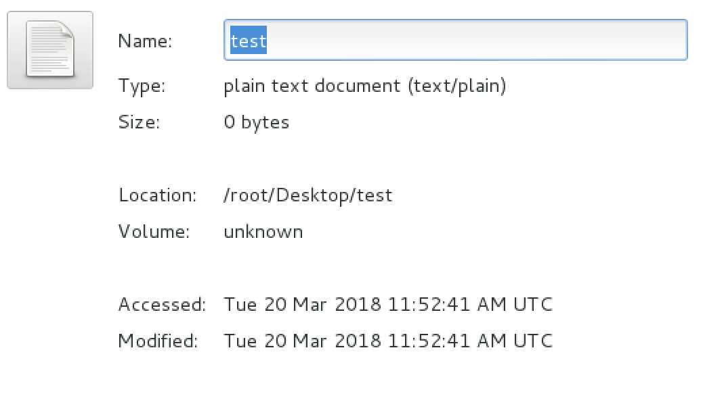



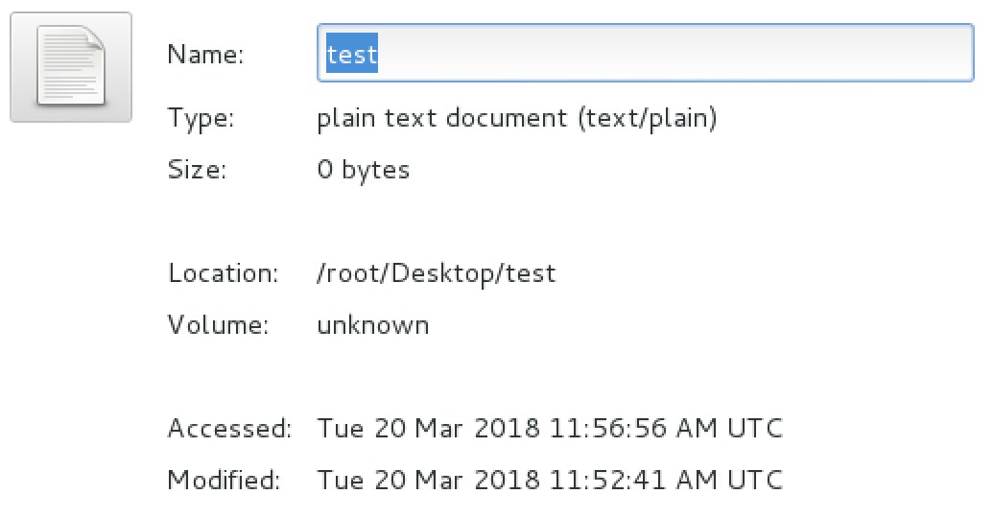

1. cat :  Concatenate and print (display) the content of files

List of cat option command:

-b = add line numbers to non-blank lines

-n = add line numbers to all lines

-E = show $ at the end of line

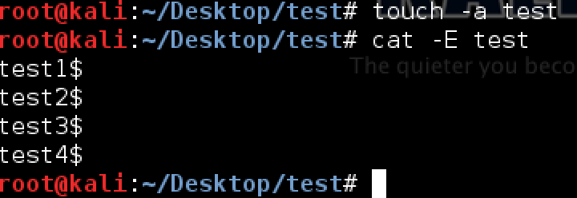

1. pwd : Print Working Directory

List of pwd option command:

-h = display a brief help message and exit

-V = display version information and exit

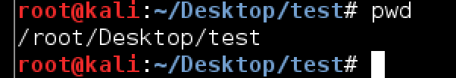

1. file :  Determine file type

List of file option command:

-f = read the names of the files to be examined from namefile

-F = use the specified string as the separator between the filename and the file result returned. Defaults to “:”

-m = specify an alternate list of files containing magic numbers.

-b = do not prepend filenames to output lines (brief mode)

-N = don’t pad filenames so that they align in the output

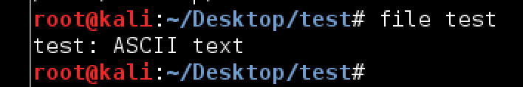

1. ln : Create a symbolic link to a file

List of ln option command:

--backup = make a backup of each existing destination file

-b = like – backup but does not accept an argument

-f = remove existing destination files

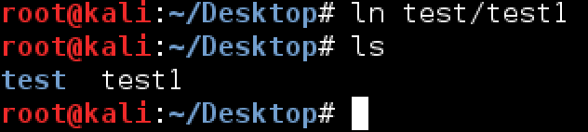

1. chmod/chown :

chmod : Change access permissions

chown : Change file owner and group

List of chmod/chown option command:

-f = chmod : supress most error messages

chown : do not print error messages about files whose ownership cannot be changed

-v = chmod : output a diagnostic for every file processed

chown : verbosely describe the action (or non-action) taken for every file.

-c = chmod : like verbose but report only when a change is made

chown : verbosely describe the action for each file whose ownership actually changes



1. more/less :

more : Display output one screen at a time

less :  almost the same as more command with some exception:

* can navigate the page up/down using less command, not possible in more command.
* can search a string in less command.
* more was fairly limited and any additional development has stopped.

List of more option command:

-num = specifies an integer which is the screen size (in lines)

-p = do not scroll, instead will clear the whole screen and then display the text

-s = squeeze multiple blank lines into one

List of less option command:

-a = causes searches to start after the last line displayed on the screen

-c = causes full screen repaints to be painted from the top line down

-e = causes less to automatically exit the second time it reaches end-of-file

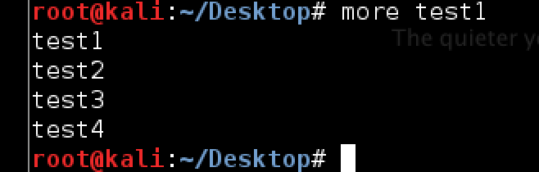

1. grep : Search files for lines that match a given pattern

List of grep option command:

-a = process a binary file as if it were text

-C num = print num lines of leading context before matching lines. Place a line containing – between contiguous groups of matches.

-b = print the byte offset within the input file before each line of output

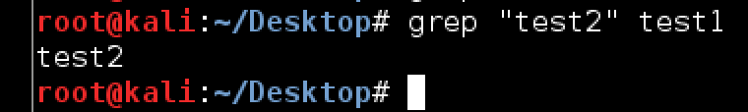

1. wc :  Print byte, word, and line counts

List of wc option command:

-c = print the byte counts

-m = print the character counts

-l = print the newline counts

-w = print the word counts

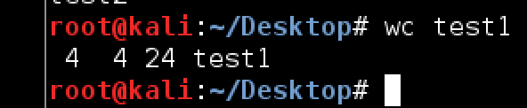

1. kill : Stop a process from running

List of kill option command:

-l = prints a list of signal names

-s signal = specify the signal to send, it may be given as a name or number

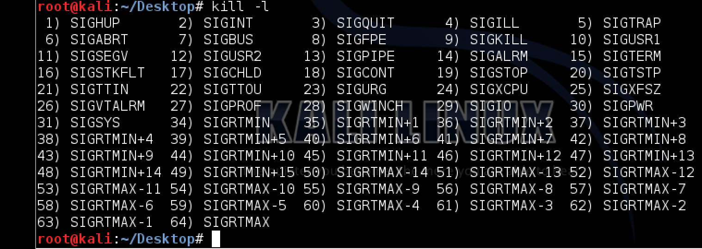

1. ps :  Process status

List of ps option command:

-d = select all processes except session leaders

-e = select all processes

-r = restrict the selection to only running processes

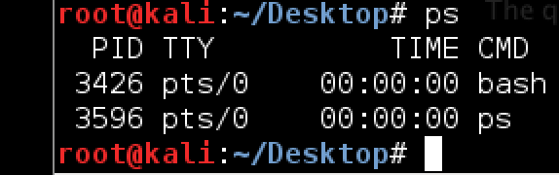

1. top :  List processes running on the system

List of top option command:

-b = starts top in ‘Batch Mode’

-n = specifies the maximum number of iterations, or frames, top should produce before ending

-M = show memory units (k/M/G) and display floating point values in the memory summary

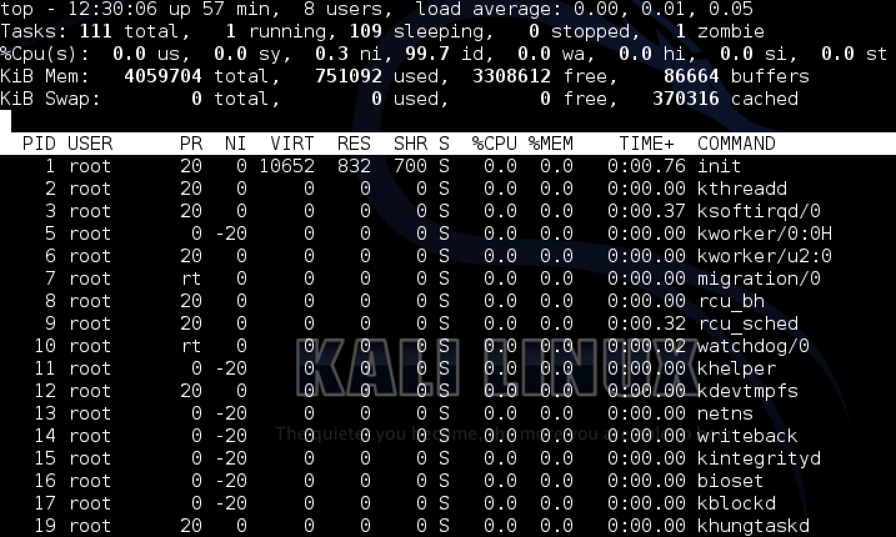

1. uname :  Print system information

List of uname option command:

-a = print all information in a default order, except omit -p and -i if unknown

-s = print the kernel name

-p = print the processor type or “unknown”

-i = print the hardware platform or “unknown”



1. uptime : Show uptime

List of uptime option command:

-h = display a brief help message and exit

-V = display version information and exit



1. ping : Test a network connection

List of ping option command:

-a = audible ping

-b = allow pinging a broadcast address

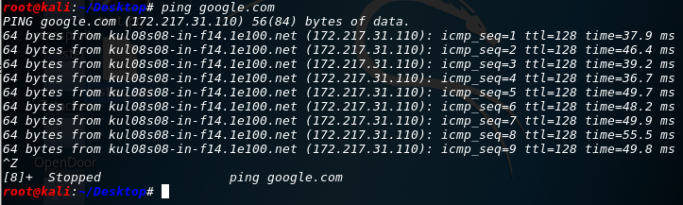-B = do not allow ping to change source address of probes. The address is bound to one selected when ping starts

1. netstat : Networking information

List of netstat option command:

(none) = by default, netstat displays a list of open sockets with all the configured address families of the active sockets

-g = display multicast group membership information for IPv4 and IPv6

-i = display a table of all network interfaces

-s = display summary statistics for each protocol

